Instructions
PLEASE READ THESE INSTRUCTIONS CAREFULLY BEFORE COMPLETING THE APPLICATION FORM (form PT.64 BELOW)
- The United Nations Certificate (UN/SA Certificate) is not a legal travel document but serves to certify that the holder is travelling on official business on behalf of the United Nations or related organization or Specialized Agency.
- UN Certificates are issued to individuals who are designated as experts on mission for the United Nations in accordance with section 22 of the General Convention or other persons who are travelling on the business of the Organization in accordance with Section 26 of the General Convention and with respect to other organizations in accordance with their applicable instruments on privileges and immunities.
- The UN Certificate is issued for the duration of the applicant’s service agreement or mission for a period of up to one year. Where a service agreement is extended beyond the expiration date of a UN Certificate, a new Certificate may be requested and the previous one submitted for cancellation. UN Certificates are not renewable.
- Every application for a UN/SA Certificate must be accompanied by a copy of the applicant’s service agreement, appointment letter or other appropriate documentation establishing eligibility.
- At any given time, an individual may hold only one active UN/SA Certificate.
- This form is only available electronically as PDF document. It should ONLY be printed after all information required in Part A (Applicant) is completed electronically, otherwise it will NOT be accepted. Only the current version of the PT.64 form (6-17)-E will be accepted.
- No manual changes may be made to the form. Especially not to field no. 10 “Contract/Assignment Expiration Date”
- Attach one photograph to the specifications provided on page two of this form.
- Because the UN/SA Certificate accompanies the holder’s national passport, the data of both documents must match. the data of both documents must match. A copy of the data page(s) of the applicant’s national passport, issued by the government of the applicant’s official nationality, must be provided with every application. The application form must reflect the applicant’s name exactly as it is printed in the machine-readable zone (MRZ, see below sample of an UNLP MRZ) of the national passport, i.e. first and last names are separated by 2 chevrons (<<) in ICAO compliant national passports. Additional information on ICAO passport standards are available on request.
UNLP MRZ: | 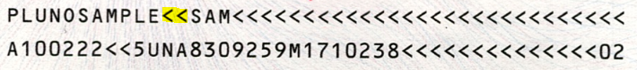
- For Umoja participating offices: The UN Certificate issuance software is linked to Umoja, therefore all relevant application data must exactly match the applicant’s current Umoja data.
- Submit the original form (no Xerox copies) through the appropriate certifying officer.
- The processing time of a UN Certificate application is five business days from submission of a duly completed and certified form to the issuing offices in New York or Geneva. Applications should be submitted no later than 16 days prior to the anticipated travel date. Additional time must be calculated for shipment to/from New York or Geneva and for the processing of visas.
- The issuing offices charge all client offices an express fee for any applications received with less than five business days processing time, this is in addition to any issuance fees that are standardly applied. Valid Billing information must be provided for express processing (Umoja subscribing departments only). Client offices will be provided with detailed quarterly billing reports. (Current rates are available upon request from the issuing offices).
- It is essential that ALL active (valid and expired) UN/SA Certificates are returned to the issuing offices in New York or Geneva or to the respective Specialized Agency for cancellation prior to separation from the Organization. If requested, the UN/SA Certificates will be returned to the former staff member after cancellation.
NOTE: The UN/SA Certificate is an important official travel document. In this respect, all possible care is to be taken to prevent its loss, damage or theft. If such a case arises, the issuing office must be contacted immediately for further instructions.
BE SURE TO PRINT PAGES 3 AND 4 OF THIS FORM DOUBLESIDED

Guide to the Issuance of UN Travel Documents
PHOTOGRAPHS
- Photographs are a vital part of the application. All photographs submitted with applications for United Nations travel documents must have been taken within six months of the date of the application. Failure to provide photographs that do not comply with these guidelines will result in processing delays. The acceptance of photographs is always at the discretion of the document issuing office.
- Certifying officers must ensure that the photographs are recent, of the applicant and meet the ICAO standards (as per these guidelines) before the application is forwarded for processing.
Photographs must be:
  - In colour
  - Printed on photo quality paper
  - 2 x 2 inches (51 x 51 mm) in size
  - Taken within the last 6 months to reflect applicant’s current appearance
  - Taken in front of a plain white background (no shadows may be visible)
  - Taken in full-face view directly facing the camera
  - With a neutral facial expression and both eyes open (teeth should not be visible as this will affect the biometric scanning and recognition of the photograph)
Subjects must not:
  - Wear hats and other head coverings, unless worn daily for religious purposes (the full face must be visible and no shadows may be cast on the face)
  - Wear headphones wireless hands-free devices or similar items
  - Wear glasses
Photographs will be rejected if they:
  - do not meet above requirements
  - are colour copies
  - are digitally scanned from another document
  - are snapshots, low quality vending machine or mobile phone photos, full-body photographs
- It is recommended that all passport photos are taken by professional passport photo services. When photos are taken in private settings, it is almost impossible to achieve the required quality results, unless multiple light sources are used to illuminate the subject. A single flash light will not suffice, to produce sufficient light for a bright, white background and will also cast shadows of the subject.
Paper Photo Head Size Template
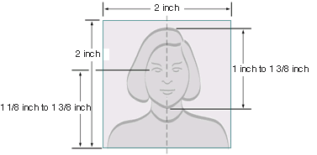
Well Composed Photo Composition Examples

Part A |  |  |  | APPLICANT (ALL DATES ARE IN DAY/MONTH/YEAR FORMAT)
1. LAST NAME (exactly as in the MRZ of the National Passport) |  |  |  |  |  |  |  |  |  |  |  | 2. FIRST, MIDDLE NAMES (exactly as in the MRZ of the National Passport)
3. SEX | 4. DATE OF BIRTH |  |  |  |  |  | 5. PLACE OF BIRTH (City, Country) |  |  |  |  | 6. NATIONALITY (official only)
 |  |  |  |  |  |  | ,
7. NATIONAL PASSPORT NO. |  |  |  |  |  |  | 8. PASSPORT EXPIRATION DATE |  |  |  |  | 9. DUTY STATION (City, Country)
10 APPOINTMENT EXPIRATION |  |  |  |  |  |  | 11. ORGANIZATION/DEPT. |  |  |  |  | 12. FUNCTIONAL TITLE
 |  |  |  |  |  |  | /
13. E-MAIL ADDRESS |  |  |  |  |  |  |  |  |  |  |  | 14. ANTICIPATED TRAVEL DATE
@
15.. INDEX NUMBER (For Umoja Clients) |  |  |  |  |  | 16. REMARKS
I certify that the above statements are true to the best of my knowledge. |  |  |  |  |  |  |  |  | Signature of Applicant |  |  |  |  |  | Date
Part B |  |  |  | CERTIFYING OFFICER
Rush Request* |  |  |  |  |  |  |  |  |  | I certify that all the above information is correct and that the applicant is a Staff Member.  I have read and am familiar with the “Guide to the Issuance of UN Travel Documents”
UNC required by
Day |  |  |  |  | Month |  | Year
For Umoja clients only: Billing Information |  |  |  |  |  |  |  |  |  | Signature of Certifying Officer |  |  |  | DATE
Fund:
Funds Center:
One of the following: |  |  |  |  |  |  |  |  |  | Print Name and Title |  |  |  | ORGANIZATION/DEPT.
Cost Center:
WBSE: |  |  |  |  |  |  |  |  |  | PHONE NO. |  |  | E-MAIL
Internal Order:
*Refers to the date the document is requested to be ready for pick-up from the issuing office. For processing in less than 5 business days an express fee will be charged.
Part C |  |  | FOR OFFICIAL USE ONLY – Do not Write below this line -
Received:
Notes:
PHOTOGRAPH SPECIFICATIONS
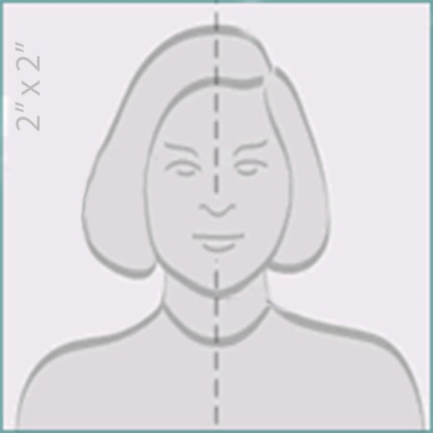  STAPLE BELOW SHOULDER LINE  or use double sided tape to affix photograph. |  |  |  |  |  |  |  | Attach one QUALITY colour photograph with the following specifications:  - Size: 2” x 2” / 5 cm x 5 cm  (if you can see the frame of this box, the photo is too small!)  - Chin to top of hair is from 1" / 2,5 cm to 1 3/8" / 3,5 cm on passport photo  - Plain white (!) background  - Front view, full face, no glasses, no headgear (unless for religious purposes)  - Photo must be less than 6 months old  - Image must be printed on quality photographic paper  PHOTOGRAPHS THAT DO NOT MATCH THESE SPECIFICATIONS WILL BE REJECTED.  For additional specifications refer to the ‘Guide to the Issuance of UN Travel Documents’, available on I-Seek.
The UN Certificate is not a legal travel document but serves to certify that the holder is travelling on official business on behalf of the United Nations or related organization or Specialized Agency. The image is the most important feature to identify the bearer.

Application Rejected

 | Missing supporting document(s):
Application data does not match
national passport:
Umoja record (personal data/contractual data):

 | Applicant has an outstanding UN Certificate, which must be submitted for cancellation before a new document can be issued. See attached Holder History.
 | UN Certificate no.: | Issued on:
 | Appointment expired
 | Form is not signed by authorised Certifying Officer
 | Photograph does not meet quality standards and/or specifications:
 | Missing/incomplete billing information:

Signature |  | Date
NOTES:

The required processing time of five business days will re-apply from the date of resubmission of an initially rejected application.

