2020 OAI Audit of UNDP’s Management of GEF Resources

Tracking Time on Oversight of Vertical Funds
March 2, 2021
Issue #1

Table of Contents
Background to the Time Tracking System 1
Who needs to use the Time Sheet System 1
In short, anyone in UNDP that is directly involved in the provision of oversight services (as defined below) concerning the realization of objectives financed by the vertical funds. 1
Objective of the Time Sheet System 2
What is covered by the Time Sheet System? 2
Core Oversight Functions to be Recorded in the Time Sheet 4
How to Enter Time in the Time Sheet System 9
Basic entry rules 13
Getting Started: Setting up the Time Sheet System 14
HELP DESK! 17

Background to the Time Tracking System

In response to the OAI GEF audit management action 2.2 which states: “BPPS will finalize the online tool to trace time spent delivering GEF oversight services and it will be subsequently implemented. The timeline is as follows: (i) Tracking system final development in PIMS+ by 31 January 2021, and full implementation by 31 March 2021”, BPPS will roll out a time tracking module to all units involved in Global Environment Facility (GEF) / Green Climate Fund (GCF) / Adaptation Fund (AF) projects.

Who needs to use the Time Sheet System

In short, anyone in UNDP that is directly involved in the provision of oversight services (as defined below) concerning the realization of objectives financed by the vertical funds.

Objective of the Time Sheet System

The primary objective of the system is to:
  - Fulfill reporting obligations to the vertical funds on how GEF/GCF/AF fees (treated in UNDP as GMS) that UNDP receives are put into practice in providing oversight of projects/portfolio;

In addition, the availability of such data collection system will also enable the achievement of the following auxiliary and related objectives:
  - Improve management of UNDP’s oversight functions across the organization (between CO, Regional Hubs, Regional Bureaus and Central Bureaus)
  - Inform on services that staff perform in practice including on additional functions related to planned or unplanned implementation support functions
  - Help improve UNDP’s overall organization of staffing to fulfill obligatory oversight functions as well as, when necessary and subject to all necessary approvals, implementation support functions.

What is covered by the Time Sheet System?
Overview
The time sheet system, applied in the context of the vertical fund portfolio, will be linked to the services that the vertical funds expect of UNDP in exchange for the oversight fee that the organization receives. This covers time spent on delivering vertical fund-specific Project Cycle Management Services (PCMS) and vertical fund related Corporate Activities, as per definitions of the Council and Board of the GEF, GCF and AF respectively. The functions include oversight services to ensure that project execution (by the Implementing Partner) meets the standards and requirements of the respective vertical funds.
The functions that are the subject of the time sheet system are those that are outside of, and in addition to, functions that the vertical fund grant covers. Functions that are a part of project execution, and are not a part of oversight include project management, implementation support services, procurement support, HR support, technical support towards the achievement of the project objectives, etc. Below section explains the difference between oversight and execution further.

Oversight versus Execution

UNDP essentially receives two types of resources from the GEF, each for a specific purpose, namely:

- the 'GEF Fee', which is provided to cover UNDP's costs in delivering GEF-specific Project Cycle Management Services (PCMS) and GEF Corporate Activities – i.e. oversight services to oversee project execution by the Implementing Partner, and
As highlighted in the DOA, the provision of ‘oversight services’ is lead by:
  - the UNDP RR, who assumes full responsibility and accountability to ensure the timely implementation of the project, as approved, and to ensure that the project complies with the GEF/UNDP policy frameworks (i.e. provide oversight and quality assurance of tasks undertaken by the Implementing Partner and/or Responsible Parties).
  - the RBX, which assumes full responsibility and accountability to ensure that the CO implements the project in compliance with all UNDP rules and regulations.
  - BPPS/NCE (Executive Coordinator), which remains accountable to the GEF and, for that purpose, performs technical oversight and oversight to ensure compliance with GEF policies and procedures.

- the project budget, utilized to conduct activities and achieve the intended results/outputs for the project, I.e. execution
Project management, under the ICF, is responsible for day-to-day management and decision-making for the project to ensure that the project produces results (outputs) specified in the project document, to the required standard of quality and within the specified time and cost. The project managers are therefore recruited under (and directly paid out of) the project budget) and report to the Implementing Partner.

In exceptional circumstances and only if prior approval of the GEF has been obtained, UNDP (CO) may be allowed to provide ‘execution support services’ to the project to assist the Implementing Partner in delivering specified outputs or implementing select project activities. These ‘services’ are agreed with the Implementing Partner in a Letter of Agreement (LOA) and UNDP staff engaged for the purpose of execution support are therefore considered as an ‘external service provider’ to the IP. UNDP is entitled to reimbursement for the costs of this service provision, which is negotiated as a ‘service fee’ in the LOA between UNDP and IP and fully included as such in the project budget.

If the CO provides execution support services, please keep in mind the following:
  - There has to be an institutional separation of functions between persons performing oversight services (see above) and those UNDP CO staff providing execution support services. No person can perform both oversight and execution support on the same project.
  - UNDP staff or non-staff personnel (including ICs engaged by UNDP for this purpose) performing execution support (e.g. typically HR support, procurement support, finance support, IT support, or other ‘operational’ support) should have a separate reporting line within the UNDP CO (‘operational reporting line’) than those persons performing oversight functions (‘programming/oversight reporting line’).
  - Where parts of the CO provide execution support, there will be a need for an enhanced oversight role for the RBX to ensure that execution and oversight at CO level are maintained at all times and to ensure that no conflicts of interest arise. Please specify who at RBX level will perform this enhanced oversight.

Functions that should not be entered in the timesheet

The timesheet is only meant to capture direct and substantive oversight service. Below are examples of staff that are NOT considered as providing direct oversight, and therefore should not be entering time:
- Admin staff that are only indirectly contributing to oversight activities (e.g. driver who took a staff who provides oversight to a workshop, intern that accompanied the staff to a workshop to take notes, assistant who scheduled RR’s time with OFP etc.)
- Staff funded by vertical fund project grants to execute the project
- Staff providing execution support as defined above (the person may provide oversight services for other projects, but cannot play both functions for a single project)

Core Oversight Functions to be Recorded in the Time Sheet

Time will be entered for below functions, following the GEF and GCF policies.

(a) Global Environment Facility Family of Funds (GEF TF, LDCF, SCCF, NPIF, CBIT)

The following list of oversight services is extracted from the GEF Fee policy paper approved by Council. UNDP is required to report on the use of GEF fees against the services/functions covered by GEF’s definition of Project Cycle Management Services. covered by GEF’s definition of Project Cycle Management Services.

Project Cycle Management Services (This means oversight services in the language used by the GEF)

- Oversight related to Project Identification and Preparation of Proposal (Please refer to RACI for details on accountability/responsibilities etc. depending on where you sit (CO, Regional Hub, HQ)
Generally, assist project proponent in all relevant project preparation activities, including:
- Consult with appropriate stakeholders in-country, including Operational Focal Points, or other relevant GEF Agencies, and keep them informed of the project activities throughout the project cycle.
- Identify opportunities for GEF financing, using country dialogue and other country planning/sector strategy documents as a basis and also through National Portfolio Formulation Exercise (NPFEs) prepared by countries or through countries’ programming documents.
- Discuss GEF eligibility criteria with the GEF Operational Focal point and other relevant stakeholders.
- Help project proponents prepare proposal following the GEF criteria, including agreement on incremental cost with government and relevant stakeholders.
- Consult within the GEF Agency on: (a) Internal quality assurance on draft PIF, on technical quality and consistency with GEF requirements; and (b) Co-financing resource identification.
- Undertake in-country consultation mission and convene meeting and stakeholder consultations to discuss: overall strategy for preparing the project; possible implementing agencies; apparent key risks and mitigation measures; alignment with the Agency country program, regional strategies; multi-sectoral approaches and regional solutions.
- Assist project proponent to prepare PIF, in consultation with appropriate stakeholders, including the GEF operational focal point and the GEF Secretariat, in line with the National GEF Portfolio Formulation Document, national priorities, GEF requirements; (a) Oversee the Collection of financial information on the ‘baseline project’; (b) provide scientific and technical advice in
- defining project strategy, outcome indicators and collecting information to define target and baseline; (c) Assist the proponent to fill out PIF template; and (d) Oversee the undertaking of initial environmental and social screening
- Assist with the preparation of PPGs, if any: (a) Assist Country proponents in identifying assessments and analysis needed and related inputs to achieve sound detailed design of PIF proposed components; and (b) Assist the proponent to fill out template for PPG request.
- Review co-financing opportunities and assist with negotiations.
- Obtain endorsement letter from operational focal point.
- Provide technical oversight on project preparation: (a) Oversee GEF specific analysis and data collection; review and comment on consultancy draft reports; (b) Assist the proponents to develop detailed project design and final project documents, including the GEF tracking tools for different focal areas; (c) Review proposed execution arrangement; (d) conduct a Fiduciary Risk Assessment of proposed executing partner; (e) manage and track process according to GEF milestones; review and submission of milestone extension request, responding to GEF Secretariat queries, obtain CEO clearance; and (f) Obtain co-financing letters from donors, NGOs, Agency and government;
- Ensure quality of concepts and proposals through Agency Quality Assurance Processes;
- Fill out GEF-5 Agency Notification for Dropping/Cancelling PIF/PPG (when needed).
- Obtain Agency internal approval of the PIF and PPG documents prior to submission to the GEF.
- Submit proposal (PIF/PDF/PPG) for CEO clearance/approval and work program inclusion.

- Agency Project Approval
- Conduct project appraisal and finalize project implementation arrangements, including mission travel.
- Prepare negotiation package, including final project documents, legal agreements, disbursement letters, invitation to negotiate, etc., and obtain internal clearance from relevant departments
- Prepare and execute legal and other documents for appraisal and approval by the GEF Agency internal approval authority, with particular attention to policy issues and capacity development.
- Assist project proponent establish project management structure in country, including assist the project management unit identify staff for the unit and ensure adequate staff capacity in executing the project;
- Finalize project documents for CEO approval/endorsement prior to Agency approval.
- Help project management agency draft TORs to select experts for implementation.
- Assist the project proponent to identify consultants to assist project preparation and implementation, if necessary.
- Assist project management agency with project start-up workshop.

- Oversight related to Project Implementation/Supervision
Generally oversee activities undertaken by local executing agency and assist the agency in all relevant activities related to project implementation, including:
- Conduct at least one supervision mission per year to supervise project implementation, including briefing OFPs on project progress.
- Provide technical oversight, as necessary, for project implementation; and as necessary, include technical consultants during supervision missions to advise government officials
- Prepare all relevant tracking tools with input from proponents.
- Oversee procurement to ensure implementation is in line with Agency policy.
- Financial Management and Control Framework of project expenditures; control environment, risk assessment, internal controls, monitoring, and information sharing and supervision of roles and responsibilities of fiscal agents and fiduciary trustees; risk assessment and proactive risk response.
- Prepare and pay advances to the executing agency and review financial reports.
- Arrange disbursement for projects, including disbursement to country executing agency and for direct payment to suppliers of goods and services and other financial transactions,
- Monitor and review project expenditure reports.
- Review and/or prepare annual project progress reports.
- Review and/or prepare periodic revisions to reflect changes in annual expense category budgets.
- Conduct mid-term review for projects, programs and enabling activities as appropriate, work with executing body to prepare mid-term tracking tools, and submission of mid-term review reports to GEFSEC.

- Oversight related to Project Completion/Evaluation
- Oversee preparation of project evaluation report prepared by the local executing agency for the project and provide technical oversights for the evaluation in close consultation with the country evaluation offices.
- Help prepare Terms of Reference for the mid-term and final evaluations incorporating GEF Evaluation Office Monitoring and Evaluation Policy, ‘Guidelines for GEF Agencies in Conducting Terminal Evaluations’ and GEF Agency Evaluation Policy in the Terms of Reference of the Evaluation. Translate project evaluations into English.
- Prepare Project Completion Report/Terminal Evaluation, with the involvement of the OFP and submit the report to the GEF Evaluation Office.
- Prepare all relevant tracking tools.
- Prepare project closing documents
- Prepare financial closure of the project

GEF Corporate Activities (Conducted by BPPS only)

- Policy Support

- Ensure implementation of Council and Assembly decisions into Agency operational policies and procedures.
- As requested, support and participate in reviews and analyses of projects, programs, and GEF special initiatives, requested by Council.
- Participate in convention meetings and activities at the request of GEF Secretariat, or after consultation and agreement with the GEFSEC.
- Participation in GEF Council meetings, network, inter-agency working group, focal area task force and STAP meetings; contribute to the preparation and discussion for the meetings as appropriate.
- Participation in the Assembly meetings and replenishment process, such as the preparation of GEF focal area and other strategies.
- As requested, provide technical and legal inputs and comments for preparation of GEF policy, program, strategies, business plan and other documents for Council meetings.
- Support to Evaluation Office
- Support to evaluations, reviews and studies initiated by the GEF Evaluation Office
- Comments to approach papers, technical papers and evaluation drafts.
- Annual preparation of terminal evaluation reviews of completed projects by Agency independent evaluation groups per existing mutual agreement with the GEF Evaluation Office.
- Participation in inter-Agency meetings and stakeholder consultations to discuss approaches and findings of evaluations.
- Engagement for the Overall Performance Study (periodic).
- Support to the development and periodic revision of GEF Monitoring and Evaluation Policy.
- Reconciliation of TE list and overall coordination with Agency evaluation office for TE/MTE reviews.
- Integration of GEF evaluation requirements into Agency systems.
- Support EO in oversight of Monitoring and evaluation.
- Response to evaluations and MAR.
- Undertake Corporate Agency evaluations, project and program evaluations.

- Oversight related to Portfolio Management
- Overall management of Agency project portfolio.
- Coordination of mobilization of project and program co-financing at country, regional or portfolio level.
- Review and acceptance of STAP advice on portfolio and project design.
- Response to queries from country GEF OFPs and others on GEF portfolio and policies.
- Maintain database for GEF project portfolio and Agencies’ internal website management.
- Liaison with GEF Trustee, reconciliation and participation in financial consultations.
- Compliance with GEF fiduciary standards and periodic reports to Council.
- Ensure appropriate mechanisms and budgets for monitoring, evaluation and supervision of the implementation of the portfolio, through periodic assessments, mid-term reviews, indicator and risk assessment and management.
- Support GEF portfolio monitoring and reporting, and activities associated with implementation of GEF Results-based Management (RBM) Framework guidance, including participation of project implementation review (PIR) exercise and submission of PIR reports.
- Ensure Monitoring and Project-At-Risk Systems in line with requirements of the GEF monitoring and evaluation policy; with Monitoring reports and a process to flag problems and response; and fiduciary oversight to guide the project risk assessment process.
- Support the mediation, and conflict and dispute resolution for issues brought to the attention of the GEF Secretariat.
- Fill out GEF Agency Notification for Amending / Dropping/Cancelling of projects and submission of relevant Trustee Report (as needed).

- Reporting
- Prepare and submit annual financial statements and audit reports to Trustee.
- Submit periodic financial reports to Trustee, including Agency approval of projects, cancellation or amendment of projects.
- Submit financial closure reports to Trustee and copy GEFSEC.
- Implement other relevant financial provisions included in the Financial Procedures Agreement between Agencies and Trustee, including among others, cash transfer request for projects and/or Agency fees, investment income statements, and conduct financial reconciliation between Agency and Trustee.

(b) Green Climate Fund

The following is based on the GCF’s Fee policy paper (relating to oversight) approved by the GCF Board. UNDP is required to report on the use of GCF fees against the services/functions (related to oversight) covered by GCF’s definition of eligible costs covered under the GCF Fees.

- Oversight related to Project implementation and supervision
  - Appraise and finalize project implementation arrangements, including mission travel;
  - Assist and advise the project proponent on the establishment of project management structure in the recipient country/countries;
  - Assist project management to draft terms of reference (TOR) and advise on the selection of experts for implementation;
  - Advise on and participate in project start-up workshops;
  - Conduct at least one supervision mission per year, including briefing operational focal points on project progress;
  - Provide technical guidance, as necessary, for project implementation’
  - As necessary, include technical consultants during supervision missions to advise government officials on technical matters and provide technical assistance for the project as needed;
  - Oversee procurement and financial management to ensure implementation is in line with the policies and timelines of the Accredited Entities (AEs) or DPs;
  - Disburse funds to the Executing Entities (EEs)/vendors (as applicable) and review financial reports;
  - Assist/oversee the audit process throughout the project life cycle;
  - Oversee the preparation of the required reports for submission to the Secretariat;
  - Monitor and review project expenditure reports;
  - Prepare periodic revisions to reflect changes in annual expense category budgets; and
  - Undertake a midterm review, including possible project restructuring.

- Oversight of Project completion and evaluation
  - Oversee the preparation of the project completion report/independent terminal evaluation, and submit the report to the Secretariat;
  - Prepare project closing documents for submission to the Secretariat; and
  - Prepare the financial closure of the project for submission to the Secretariat.

- Reporting
  - Include all the reporting requirements as agreed in the accreditation master agreement (AMA) and funded activity agreement (FAA).

How to Enter Time in the Time Sheet System

Pull Down Options

Below are the options to choose from when entering time spent on oversight functions, based on abovementioned GEF / GCF policies. The module will automatically show ongoing projects relevant to the user and items that are relevant to the project phase. Example activities as per RACI will be indicated to guide entry decisions. Time spent on direct oversight activities (e.g. meeting with Implementing Partner, document review) shall be entered on a daily basis.

Project Level Oversight

TIME SHEET CATEGORIES USED FOR GLOBAL ENVIRONMENT FACILITY (GEF) and Adaptation Fund (AF) PROJECT LEVEL OVERSIGHT, BY PROJECT
Project Identification and Development (inclusive of Project Preparation Grants) and Final Project Document Development | Concept/Project Identification Form (PIF) Development  Final Project Development
Project Supervision and Monitoring | Project Launch/Inception Workshop  Project Supervision  Administrative Oversight & Financial Management  GEF Core indicator oversight  Risk management
Reporting, as required by GEF | Project Implementation Reports (PIR)  Mid term evaluation  Ad-hoc reporting requests from GEF
Project Completion and Evaluation | Terminal Evaluation  Project Closure

TIME SHEET CATEGORIES USED FOR GREEN CLIMATE FUND (GCF) PROJECT LEVEL OVERSIGHT, BY PROJECT
Project Identification and Development [Not covered by fee] | Idea Note Development  Concept Note Development  Funding Proposal Formulation /Development
Project Supervision and Monitoring | Implementation Start-Up  Project/Program Implementation and Supervision
Reporting, as required under AMA & FAA | Annual Progress Reports (APR)  Interim Evaluation Report (IER)  Final Evaluation Report (FER)  Project Completion Report (or final APR)
Project/Program Completion and Evaluation | Reporting and Evaluation  Program closure

PROJECT LEVEL OVERSIGHT TO COUNTRY PORTFOLIO, BY SOURCE OF FUND
General Project Cycle Management | Strategic oversight to all projects in the country, when a single activity cannot be divided across individual projects

PROJECT LEVEL OVERSIGHT TO COUNTRY PORTFOLIO, BY SOURCE OF FUND [RBx staff only]
General Project Cycle Management – select country or entire region | Oversight activities that cover all projects in one country or in the entire region, that cannot be divided across individual projects

TIME SHEET CATEGORIES USED FOR PORTFOLIO / CORPORATE LEVEL OVERSIGHT, BY SOURCE OF FUND (Only by BPPS Staff)
Policy Support | Development, Revision and Operationalization of GEF policies, strategies, business plans and guidelines  Participation in meetings of GEF/GCF/AF governing bodies
Reporting | MTR/IERPIR/APRTE/FER  Reporting on EAs  Donor Reporting  Periodic reports
Portfolio Management | Pipeline and Programme Management  Financial and Data Management  Period portfolio monitoring and reporting (APR)
Outreach | Participation in Sub-Regional consultations/country dialogues and STAP/iTAP meetings  External communication and knowledge management products
Support to Evaluations | Evaluations, reviews, studies initiated by GEF Evaluation Office
General Project Cycle Management Support | N/A (For project level activities that cannot be split across individual projects)

Entry Options

Two entry options are available. The first option is to log into PIMS+ and enter in the system. The second option is to install an add-in and enter time in the Outlook Calendar.

Option 1: Log in to PIMS+ to enter

Suggested for users who do not use Outlook Calendar, and provide oversight to many projects with a relatively defined workflow (e.g. financial oversight). The user can choose to enter time one by one, or across auto-suggested projects in one table.

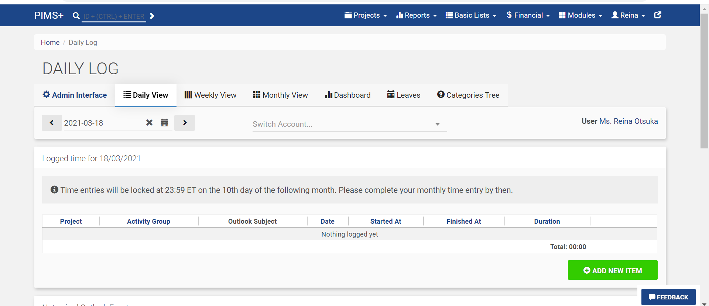

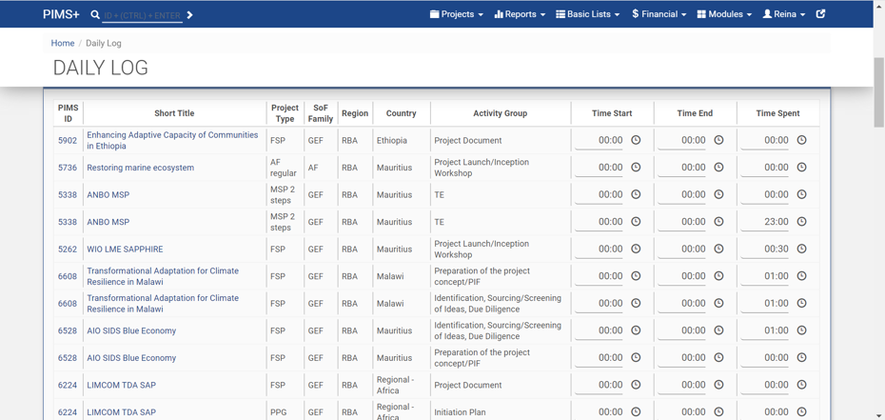

Option 2: Enter from Outlook Calendar Add-in

Users can choose to install an Add-in on the Outlook Calendar, and enter time from the Calendar without logging into PIMS+ (just like the Teams add-in, it will show up in your calendar item). This is suggested for users that frequently use Outlook Calendar and have a variety of workflows (e.g. programme staff, senior managers). The calendar title, start-end time and duration will be automatically recorded. The user will only need to select the project and activity.

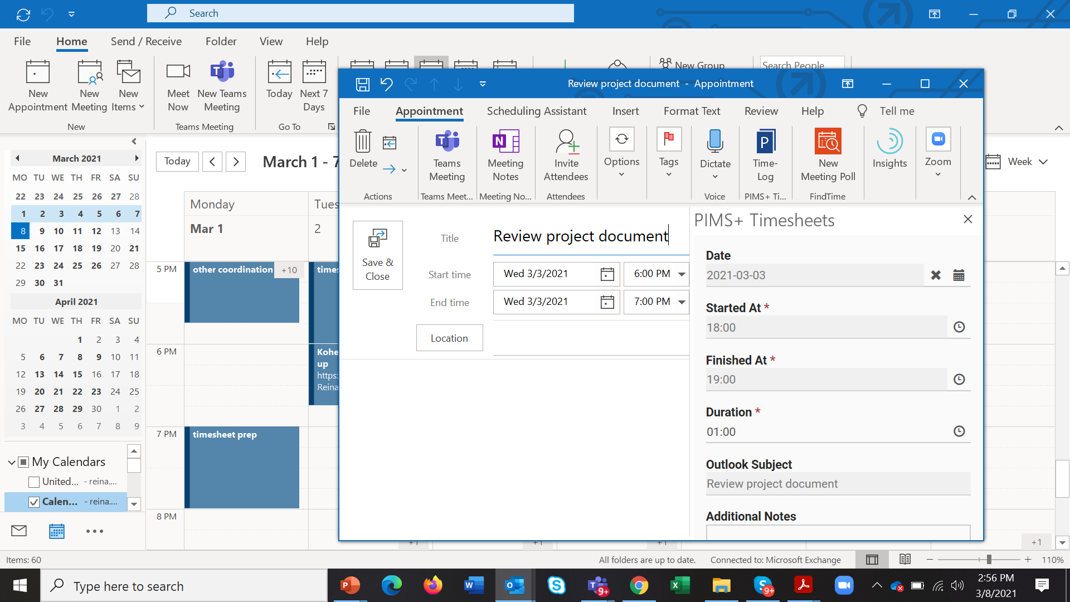

Basic entry rules

Data entry frequency and submission
- Time entry
Time should be entered as time spent on oversight activity, up to minutes [XX:XX]. It can be entered any time during the month (up to the 10th of the next month), however reconciliation of time spent should be finalized on a monthly basis.

- Verification cycle
Time entries will be locked on the 10th (EOD NY time) of the following month. For CO staff, RR will review and verify by the 20th of the month (or choose not to take action, in which case entries will be automatically verified). Entries cannot be changed thereafter. A dashboard and email notification will be available. Data will be unlocked after verification when the RR requests to the Executive Coordinator via the Regional Bureau.

Below are basic entry rules.
- The activity will be saved only after the user selects a project and activity that is associated with the activity (or category, subcategory and activity for corporate level oversight)
- Activity options are meant to be results oriented. When selecting the pull down option, the user shall think of what oversight result the specific activity (meetings, writing emails, reviewing documents etc.) is contributing toward.
- Do not double count time. For example when you are multitasking by listening to a 2 hours webinar while reviewing a document, please assign a % of the hours for each task. User shall not enter 2 hours for each activity.

Getting Started: Setting up the Time Sheet System

1) Log in to PIMS+ (https://co.undpgefpims.org/ )
- Click on ‘UNDP Log in’ and use your UNDP email credential to log in
- *If you are logging in to PIMS+ for the first time, a User Account Setting will be prompted. Please enter your CO
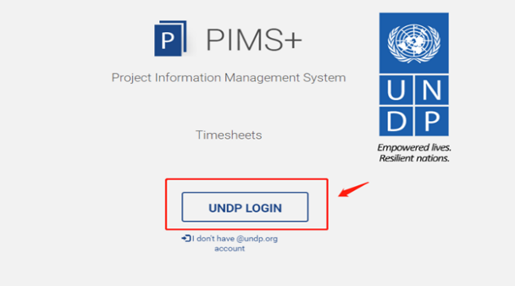

2) Navigate from ‘Module’ to ‘Timesheets’

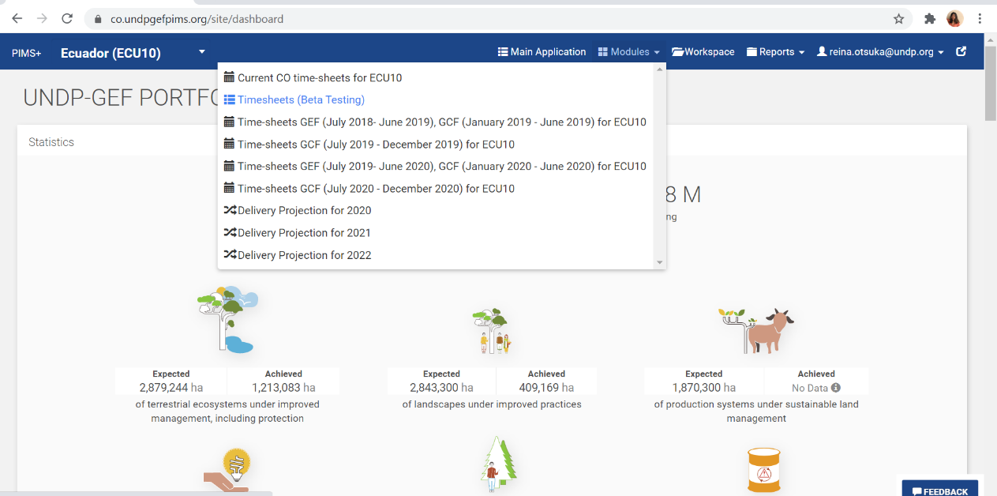

3) User account settings
- A user account setting pop-up will be prompted
- Enter your role (e.g. country office user, regional bureau XXX)
- Please select your time zone. If you are not located at your duty station, please select the actual location you are currently at.
- Click ‘save’ if you are only entering in PIMS+, and set up is complete.
- If you choose the Outlook Calendar option, go to next step before saving.
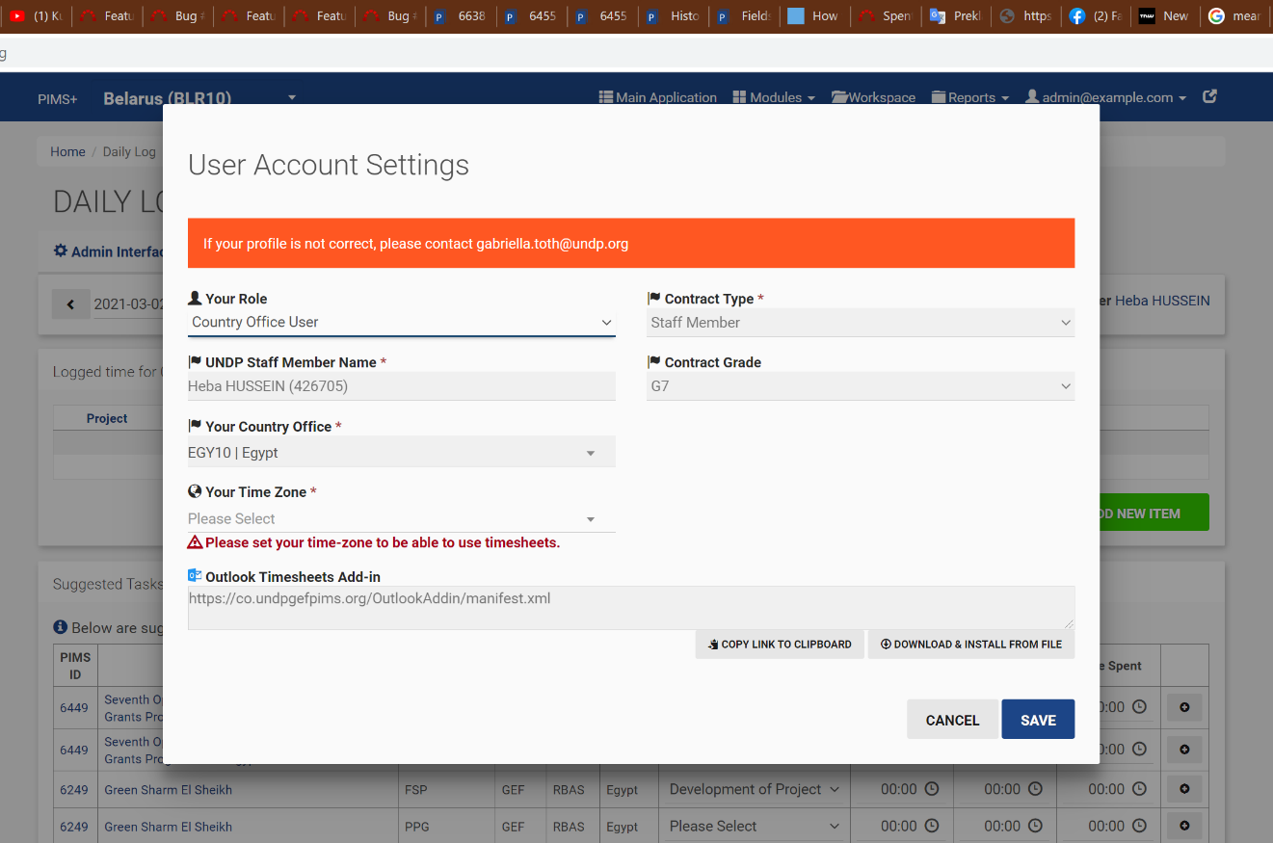

4) Copy the link under ‘Outlook Timesheet Add In’

- Steps after this are only for users who choose to enter in Outlook Calendar.
- Click on ‘Copy link to clipboard’
- Save

5) Go to Outlook
- In the email view, click on ‘Get Add-Ins’ icon

6) Add the add-in
- Click on ‘My add-ins’
- Scroll down to Custom add-ins. Click ‘Add a custom add-in’ and select ‘Add from URL’

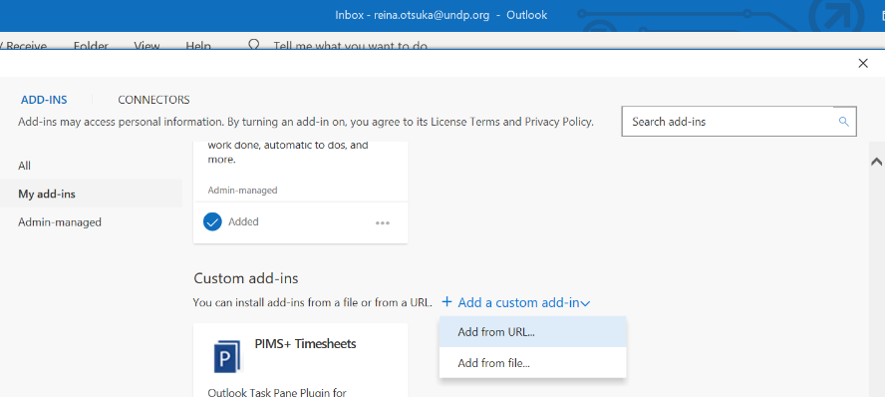

- Paste in the URL copied from PIMS+ User Settings.
- Click OK, then install.

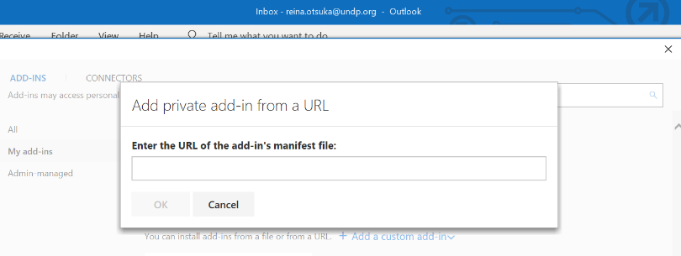

- The blue PIMS+ Timesheets icon will appear

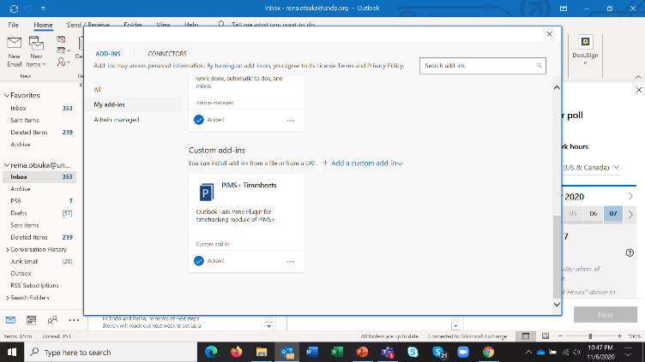

HELP DESK!
For any help required with using the time sheet, please contact: nce.digital@undp.org

Please note that A, B, C, and D are individual project specific Agency functions while E, and F are aggregated functions for the full GEF Portfolio of any given Agency. The latter two categories were earlier included in the list of GEF Agency Corporate Functions. These have been separated to distinguish them from Corporate Functions that only the existing 10 GEF Agencies are expected to perform

