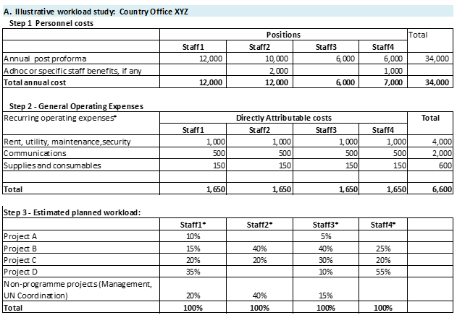
*Speed charts (Distribution sets) for recurring operating expenses with the above percentages could be set up in Quantum.
Position COA distribution will be updated with the same distribution percentages in Quantum HCM.

