Job Evaluation
- This policy presents the basic principles of job evaluation, the revised policy, detailed procedures, job evaluation tools and standards, including the use of generic job descriptions, reporting and oversight mechanisms, roles and responsibilities, templates and forms.

- This supersedes Section 10205, Chapter II of the Personnel Manual 1995 Edition, Volume I - Locally Recruited Staff members; Chapter V of the Personnel Manual 1995 Edition, Volume II - Internationally Recruited Staff members and all circulars on the subject.
- Job Evaluation is a mechanism for determining the grade level of each position in the organization, on the basis of clearly established criteria, and for ensuring that positions with the same level of responsibilities and accountabilities are graded at the same level. The job evaluation process also provides information about the nature and content of jobs, thereby facilitating other Human Resources Management processes.

- Job Evaluation is an important part of Organizational Design. It begins with elaboration of the strategy. The strategy sets the organization’s direction. Based on the organization’s strategy, the main functions are determined and optimum business processes of the organization are engineered and mapped. Another component of the Organizational Design is structure, which comprises the organizational components, their relationships and hierarchy. It sets the shape and the frame of the organization. When the structure is created, it is populated with jobs. Job design determines the content of jobs, levels of responsibility and accountability, functions, main results expected and impact of the results, relationships between the position and other staff in and outside the organization, main competencies required and minimum recruitment requirements. When jobs are created, they should be evaluated and classified. Thus, job evaluation is not a “stand-alone” process, rather it is very closely connected with other components of Organizational Design. Each component of the Organizational Design supports the others and together they support the organization’s goals and objectives. Thus, job design and evaluation must take into consideration other components of Organizational Design.
- The classification procedures and standards of UNDP are based on the systems developed by the International Civil Service Commission (ICSC) for classification of positions in the General Service and Professional and higher categories.

- In 1989 UNDP started the process of decentralization of job evaluation and delegation of authority to resident representatives to classify positions. The delegation was initiated with (i) UNDP/ADM/89/69 (2 August 1989), which assigned pre-approved levels of classification for certain UNOPS General Service positions, (ii) UNDP/ADM/92/75 (7 October 1992), which delegated authority for classification of extra-budgetary General Service positions, (iii) UNDP/ADM/97/24 (18 April 1997), which delegated the authority to Resident Representatives to classify positions in the General Service and National Officer categories except for positions at ICS 7 (G-7), ICS 8 (NOA), ICS 11(NOD) levels. All other positions are evaluated and graded by the Office of Human Resources (OHR).

Principles
7. The basic principles of the UNDP job evaluation system are:
- The level of responsibility and accountability of the positions in question is the primary basis for determining the level of the position.
- Every position should be supported by an up-to-date job description that clearly describes the content of jobs, levels of responsibility and accountability, functions, main results expected and impact of the results, relationships between the position and other staff in and outside the organization, main competencies required and minimum recruitment requirements.
- All decisions regarding the classification of positions are taken by the Administrator or, by delegation, on his behalf.
- All headquarters and international positions (Fixed-Term Appointments and Temporary Appointments) are evaluated and graded centrally by OHR.
- All the General Service and National Officer categories in country offices and Regional Centres, except for positions at ICS 11 (NOD) level, are classified by Country Offices/Regional Centres.
- The Resident Representative has the authority to approve classifications and can delegate classification authority to the Country Director, Deputy Resident Representative or Deputy Country Director.
- If new or revised job descriptions in country offices coincide with the generic job descriptions provided in UNDP Toolkit for Managing Change, Country Offices do not have to go through a classification process.
- Re-classification required: A significant change in more than two functions in the new job description has taken place vis-à-vis the old job description even though the grade level remains the same. Significant changes must occur in the main functions and levels of accountability and responsibility of the position and not in the specific results expected or specific duties/tasks.
- All National Officer positions at ICS 11 (NOD) level, even if they coincide with generic job descriptions, are classified centrally by OHR.

Job Evaluation, Budgetary Process and Position Management

- Job Evaluation processes are linked to budgets. When staffing needs for specific functions are translated into jobs and positions, and the grade levels of positions are determined by the job evaluation process, budget should be available to cover the staffing needs. To implement reclassification of positions, provisions in the budget must be made to accommodate upgrades. Since each position can be reclassified in conjunction with the budget, it requires a significant degree of forward planning. The number of the available positions approved by the Executive Board/headquarters should be considered.

- Managers approving (re)classifications of positions or submitting classification requests to OHR are responsible and accountable for validation of the positions availability and adequate budget availability to cover the expenditures of the positions in question.

- The Executive Board allows for changes in individual classified levels during the budget cycle taking into consideration counterbalancing of positions’ upgrading with downgrading on an organization-wide basis. However, in all cases of classification of positions to ICS 13 (D-1) level and higher, Executive Board approval will be required before the classification finding is formalized.

Annexes

Annex 1: UNDP Job Description Template Explanatory Note

Annex 2: Classification Request Template

Annex 3: Job Description Template

Basic Workflow
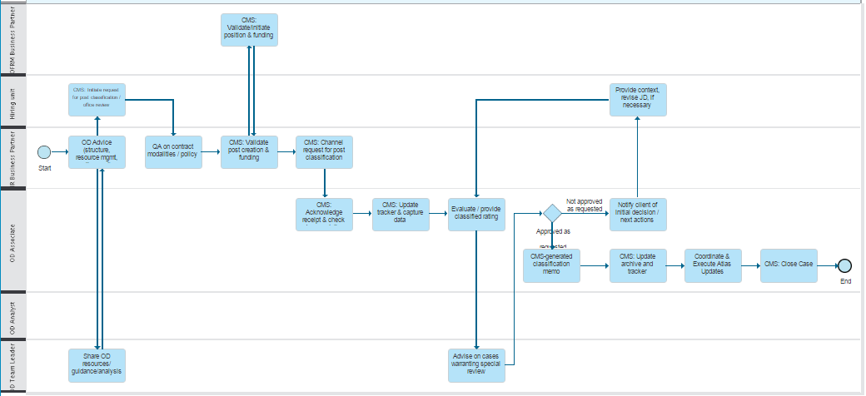

Useful links:

UNDP Job Classification site
ICSC Job Evaluation system

