**Payment and Taxes**

**Advance and Progress Payments**

1. Except where normal commercial practice or the interests of UNDP so require, no contract or purchase order shall be made on behalf of UNDP requiring an advance payment(s) for goods or the performance of contractual services. If an advance payment is agreed to, all reasons therefore shall be documented. If the contract calls for an advance payment exceeding USD 30,000, the Supplier shall be asked to provide a bank guarantee (valid for the duration of the contract) or certified cheque. The advance payment, in all cases, should not exceed 20 percent of the total contract amount. Examples of activities that may justify an advance payment are (1) mobilization costs (civil works); (2) start-up costs (services); or (3) design costs.

1. Any interest earned by a payee on an advance payment by UNDP shall be recoverable and, when paid to UNDP, credited to miscellaneous income in the UNDP accounts.

1. In the case of progress payments, the RR or Head of the Business Unit may, where appropriate (i.e., in the interest of UNDP) authorize such payments. Progress payments, however, should be linked to the successful completion of requested deliverables.

1. To recover an advance payment, progress payments and the final payment shall be subject to a percentage deduction equal to the percentage that advance payment represents over the total price of the contract.

**Taxes**

1. UNDP, as a subsidiary organ of the United Nations, is exempt from direct taxes such as income tax, and is entitled to reimbursement of indirect taxes, such as sales tax and VAT, on important purchases. This is derived from the Convention on the Privileges and Immunities of the United Nations, adopted by the General Assembly in 1946 (General Convention), Sections 7 and 8, respectively.

1. While in some countries, governments have provided an outright exemption to indirect taxes, in most countries, Business Units may be required to pay taxes and further seek reimbursement. Governments are required under the General Convention to provide a mode of reimbursement on important purchases. The policy of the United Nations, including UNDP, is that all of our purchases are “important”, as they are recurring and necessary for UNDP to carry out its official activities. Country offices should liaise with the Ministry of Foreign Affairs to ensure reimbursement.

1. Any difficulties with respect to exemption from taxation or reimbursement of taxes should be addressed to the Director of OLPS.

Structure Element - Relevant Policies

Structure Element - Flow Chart

​[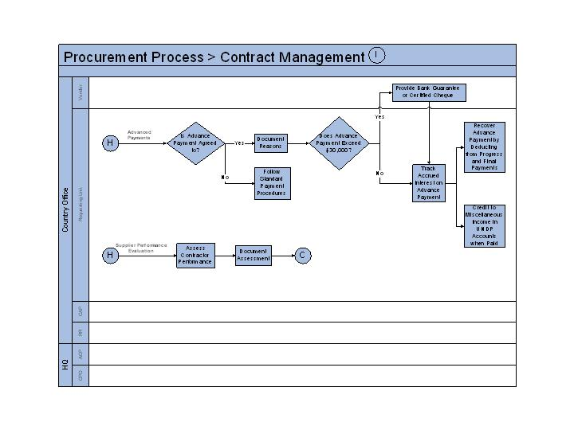](https://intranet.undp.org/global/popp/cap/PublishingImages/pmnt-tax_p1.jpg)

Structure Element - Procedures

**Payment Terms**

1. In the case of goods, payment should correspond to agree upon delivery terms. In all cases, except where delivery terms DDU or DAF are utilized, payment should be made within 30 days upon receipt of shipping documents and invoices. Similarly, in cases where delivery terms DDU or DAF for supply are used, payment may be made within 30 days upon receipt of goods.
2. Structure Element - Deliverables
3. Advance Payments
4. Progress Payments
5. Milestone Payments
6. Taxes
7. [UN Convention on Privileges and Immunities](https://www.un.org/en/ethics/assets/pdfs/Convention%20of%20Privileges-Immunities%20of%20the%20UN.pdf" \t "_blank)

1. Structure Element - Additional Info & Tools