UNDP-supported Guarantees Operational Manual
Contents
1. Introduction 3
1.1 Definition of guarantees 4
1.2 Objectives of UNDP-supported guarantees 5
1.3 Objectives of UNDP-supported Guarantees Operational Manual 6
2. Key Principles in Designing UNDP-supported Guarantees as Part of UNDP Projects 7
2.1 Offer UNDP-supported guarantees as part of broader development projects and not as stand-alone interventions. 7
2.2 Offer fully funded development guarantees. 7
2.3 UNDP-supported Guarantees shall generate “additionality” to deliver impact efficiently. 8
2.4 Target specific risks or barriers inherent in projects that the lenders are unable to assess or reluctant to bear. 9
2.5 Guarantees will seek to target underserved sectors 10
2.6 Engagement of reputable financial institutions (“Guarantee Issuers”) to issue guarantees. 10
2.7 Eligible lenders and borrowers for UNDP-supported guarantees. 11
2.8 UNDP Programming modalities 13
2.9 Preferably guarantee a portfolio of investments 13
3. Types of Guarantees Offered by UNDP through Guarantee Issuers 13
3.1 Credit (Loan) Guarantees 14
3.2 Procurement Guarantees 15
3.3 Performance Guarantees 16
4. Operational Guidance related to Structuring, Issuing and Managing UNDP-supported Guarantees 17
4.1 Origination of UNDP-supported Guarantees 17
4.2 Initial diagnostic of UNDP-supported guarantees 18
4.3 Target leverage ratio 21
4.4 Guarantee currency 23
4.5 Guarantee size 23
4.6 Guarantee tenor 23
4.7 Risk sharing (Pari passu) 24
4.8 Ensuring full cost recovery 25
4.9 Partnering with and/or engaging financial institutions for the issuance and management of UNDP-supported guarantees 26
4.10 Partnering with UNCDF to issue and manage UNDP-supported guarantees 28
4.11 Escrow account 28
4.12 Monitoring of guarantees and lending activities of the Lender 29
4.13 Periodic financial and programmatic/impact reporting to funding partner(s) 33
4.14 Treatment of recoveries post claim payouts 33
4.15 Guarantee closeout and treatment of undisbursed balances 33
4.16 Administration of guarantees 35
4.17 Publishing of guarantee information – internal and external 35
5. Agreements 36
6. Guarantee Pricing and Budgeting 37
6.1 Cost Recovery 37
6.2 UNDP Guarantee Reserve 38
7. Roles and Responsibilities 38
8. Management and Governance Structure of UNDP-Supported Guarantees 40
Annex 1: UNDP-UNCDF Collaboration Framework on Loans, Guarantees and Low-Value Grants (as approved by the EG in November 2018) 45
Annex 2: Key Principles to be Included in Guarantee Issuer Agreements and Guarantee Agreements 50
Annex 3: Good Practices for Lending 52
Annex 4: Procurement Guarantees 55

- Introduction

The 2030 Agenda for Sustainable Development sets out ambitious, transformative goals for the global community, matched by unprecedented financing needs. To meet this financing need, the Addis Ababa Action Agenda calls not only for far greater financial resources to advance the 2030 Agenda, but also for new and innovative instruments to deliver these resources. Through the initiation of a UNDP-supported Guarantees Program, UNDP aims to strategically create new opportunities to mobilize additional funds and broaden the base of actors contributing to development finance.
This offering of UNDP-supported guarantees is also in line with UNDP’s vision of supplementing "funding” (administering grant-funded development projects) with “financing” (in addition to providing funding, to assist countries to access, combine and sequence a diverse set of financial flows to achieve sustainable development results). In structuring and issuing UNDP-supported guarantees, UNDP means to complement UNDP’s use of grants and expand the scope of financial instruments currently in use to increase its relevance as a convener of development finance at the national level. Notably, guarantees provide more rational choices about appropriate financing tools — loans, guarantees, grants or a combination — used in project development. Market surveys continue to reiterate the importance of guarantees in mobilizing private capital towards the Sustainable Development Goals (SDGs). According to a recent OECD survey, cumulatively, since 2012 blended finance instruments have mobilized US$257.7bn in private sector resources. Guarantees have been either the largest or second largest catalyst in achieving this resource mobilization result and have become recognized as one of the most prevalent and effective instruments.
In addition to alignment with UNDP’s framework for programming, the financial viability of the underlying project as well as the costs of UNDP in supporting guarantees needs to be considered during the design of guarantee interventions. Guarantees should not be designed to make unbankable projects viable but should be thought of as addressing market imperfections and provided to projects that are commercially viable but face additional barriers to financing. Activities eligible for UNDP-supported guarantee financing shall have positive financial rates of return. Experience has shown that guarantees are not tools to solve the problems of weak enterprises, lack of an enabling environment, poorly performing banks or insolvent public entities. Striking the right balance between development impact of a guarantee and the financial sustainability will be critical in the design and implementation of UNDP-supported guarantee transactions. Along this vein, this UNDP-supported guarantees facility is intended to produce greater development impact and increase our on-the-ground performance in our member states in support of the 2030 Agenda and our own strategic plan.
As this UNDP-supported Guarantees Operational Manual will highlight in later chapters, many partnership opportunities exist in the design, issuance, and management of UNDP-supported guarantees, wherein UNDP works with other partners and entities (including financial institutions and UNCDF) to structure, issue and manage guarantees upon UNDP’s request. All UNDP-supported guarantees must follow the terms stipulated in the UNDP-supported Guarantees Policy and procedures and guidance provided in this supporting Operational Manual. Consistent with other UNDP non-core programming, the UNDP-supported guarantees program will be fully funded in advance by funding partners. As UNDP seeks to collaborate with other development partners that have significant comparative advantage in the management of guarantees, it is important to leverage each other’s strengths and capacities, and not duplicate capacities within organizations. In this context, when UNDP engages UNCDF as a Responsible Party, UNCDF is permitted to follow its own Guarantees Policy, as articulated in the UNCDF Supplementary Guidelines to the UNDP Programme and Operations Policies (POPP).

- Definition of guarantees
A guarantee is an obligation undertaken by a guarantor to satisfy the payment of a debt or the fulfilment of a contractual obligation on behalf of a debtor toward a beneficiary when the debtor fails to pay or comply with the terms of the contract. In other words, a guarantee could be considered as “insurance” that protects the investor or lender in the event a debtor fails to settle a debt or meet a contractual liability whereby the guarantee will cover the financial obligation (partially or in full), lowering the financial risk of the investment. Guarantees are important credit enhancement and risk mitigation instruments that may benefit lenders concerned about a borrower’s credit risk by transferring some or all of the risks (whether real or perceived) to creditworthy third parties (guarantors and insurers) that have a better capacity to assess and/or accept such risks, thereby enabling the underlying transaction to move forward. Additionally, guarantees can help borrowers obtain financing at better terms, although not necessarily cheaper (e.g. longer tenors, reduced collateral requirements, etc.), than would be possible without the guarantee.
Finally, guarantees can have an important catalytic effect in reducing barriers to lending within new markets, or lending to different sectors within a market, spurring greater investment for the SDGs. Among risk mitigation instruments, guarantees have been found to have some of the highest leverage ratios (well-functioning guarantee funds attain leverage rates of up to 10:1 or more). The relevance of guarantees is increasing as more emerging economies are focusing on accessing capital from private sources of finance in addition to traditional development finance sources.
Whilst this UNDP-supported Guarantees Operational Manual uses the term “guarantees” throughout, “Development Guarantees” defined as “official guarantees backing projects that promote the development and welfare of developing countries”, are the main focus.

- Objectives of UNDP-supported guarantees
UNDP-supported guarantees will support sustainable development by being one component within an overall project of activities that provide financing, related technical assistance and operational support to promote broad-based economic growth, contribute to social and environmental sustainability, enhance the effectiveness of the public or private sectors, or otherwise contribute to the overall development of member states. As guarantees can be used repetitively, call on less financial commitment than grants and loans, and do not rely on replenishing donor contributions if managed appropriately, they will offer greater flexibility to UNDP for the achievement of the SDGs.
There is a large reserve of untapped capital in the private sector, which presently is not available to certain sectors and markets. The use of guarantees can improve access to local private capital and provide the security to make that capital available for projects to develop key sectors and financial markets. Providing guarantees coupled with training and technical assistance designed to strengthen local financial institutions can improve the long-term supply of available credit in local markets.
A common main objective of many development interventions using guarantees is to get financial institutions to start lending to those sectors that they ordinarily consider too risky. At some point the term of the guarantee scheme will come to an end, and if the experience of the participating financial institutions gained during tenure of the scheme has been positive and they continue to serve those sectors, the development interventions will be deemed successful.

In providing UNDP-supported guarantees, UNDP’s key objectives are to:
- Attract lenders through minimizing the risk of extraordinary or excessive losses, and mitigating informational asymmetries in lenders that adversely impact new sectors or small and medium-sized enterprises
- Stimulate growth in economies where resources are not fully employed. For example, banks may be over-liquid, yet do not put their funds to full use because of the perceived high risk of potential borrowers
- Share risk in commercially viable lending schemes to encourage sound lending decisions to new sectors and/or markets, including countries where development assistance funding is scarce. In the case of UNDP, as seen below, UNDP’s financial risk when issuing guarantees will be fully covered by funds provided expressly by funding partners (non-core programme) to cover this risk
- Lower barriers to accessing finance for borrowers, particularly vis-à-vis credit guarantees that can assist certain borrowers as a partial substitute for collateral
- In the case of a UNDP-supported guarantee, the presence of such a guarantee would help to mobilize financing that would not otherwise be forthcoming, particularly private sector financing and especially local market capital, as local lenders would gain additional assurance as a result of a UNDP-supported guarantee
- Create a demonstration effect, particularly to local financial institutions, of a sustainable market/sector for lending
- Maximise impact per dollar invested as new capital is leveraged
- Facilitate public/private partnerships and blended finance
- Diversify financing sources by attracting participation beyond existing development financing
- Promote visibility, accountability, and transparency for investments for the SDGs through de-risking instruments that maximize results and impact

- Objectives of UNDP-supported Guarantees Operational Manual
This UNDP-supported Guarantees Operational Manual supports the prescriptive content contained in the UNDP-supported Guarantees Policy by providing operational guidance on UNDP’s management of UNDP-supported guarantees. It is an informative guide for both internal and external audiences. For UNDP personnel, the UNDP-supported guarantees policy and this operational manual complements the Programme and Operations Policy and Procedures (POPP) and the UNDP Financial Regulations and Rules (FRRs). The purpose of this UNDP-supported Guarantees Operational Manual is to accomplish the following:
- Set forth the vision, operating principles and procedures that will guide and advance UNDP’s engagement in UNDP-supported guarantees
- Ensure a coherent approach to the strategic management of UNDP-supported guarantees
- Clarify and harmonize concepts, terminology/definitions, roles and responsibilities
This UNDP-supported Guarantees Operational Manual is subject to periodic reviews and can be modified frequently should it be deemed necessary.
- Key Principles in Designing UNDP-supported Guarantees as Part of UNDP Projects
To ensure alignment with UNDP’s development mandate and Financial Regulations and Rules, a set of principles must be followed which specify the circumstances under which UNDP will support guarantees, namely:

- Offer UNDP-supported guarantees as part of broader development projects and not as stand-alone interventions.
UNDP may engage reputable financial institutions (“Guarantee Issuers”) to issue UNDP-supported guarantees only in situations where guarantees are required as part of the overall design of a project or as one of several development interventions/modalities (which may include other de-risking instruments, technical assistance, performance-based payments, grants, etc.) to achieve the desired development outcomes. UNDP shall not participate when a guarantee is the sole development intervention/instrument being deployed. Such situations can continue to be addressed by other development financing actors, including UNCDF. UNDP project teams should leverage global, regional and sectoral expertise while designing and incorporating guarantees within their broader development programmes to deliver holistic development interventions that are tailored for different country contexts and sectoral risks. When a UNDP-supported guarantee facility complemented by other development interventions is being designed, the relevant UNDP project team must establish appropriate linkages, including cross-effectiveness to ensure the intended results are achieved.

- Offer fully funded development guarantees.
UNDP-supported guarantees shall be offered only where funding partner(s) have provided funds to cover the full liability of the guarantee. Funding for UNDP-supported guarantees is constrained to its Other (non-core) Resources. These funds must be received in advance of UNDP engaging the banking partner (or UNCDF) [see Section 2.6] to issue the guarantee instrument. In such a funded guarantee scheme, the full cost of the liability is set aside by UNDP in a bank account (escrow account) for the sole purpose of funding any guarantees that may be called upon. The funding partner must be fully informed that the funds will be made available for meeting the guarantee requirements, and the funds may thus be drawn upon to settle risks incurred within the lending activities. Furthermore, offering fully funded guarantees is consistent with the funding of other UNDP non-core programming and will ensure compliance with UNDP Financial Regulations and Rules.

The fact that UNDP-supported guarantees are fully funded should not in any way create the impression that UNDP – in our role as a guarantor – takes on the full risk of the project or initiative to which the UNDP-supported guarantee is applied. In any guarantee scenario it is best for all parties involved to have something at stake through sharing the risks. In this way there will be incentives for the lender, the borrower and the guarantor to ensure that the risk of loss is minimized and to avoid moral hazard.

In the event of default by the borrower and subject to pre-agreed conditions (see Section 4.11), funds held in the escrow account will be called upon by UNDP’s banking partner (or UNCDF) that issued the guarantee, on the demand of the lender (or the vendor in case of procurement guarantee) to pay out approved claims. While UNDP does not incur a financial loss in such an event (see Section 1.2) as the UNDP-supported guarantee security is fully funded by the funding partner(s), reputational risks remain, which must be mitigated through robust project design, upfront communication and expectation setting with funding partner(s), monitoring, and governance and oversight mechanisms as provided for in the UNDP-supported Guarantees Policy and this Operational Manual.

- UNDP-supported Guarantees shall generate “additionality” to deliver impact efficiently.
UNDP-supported guarantees may only be offered in situations where they generate ‘financial additionality’ and/or ‘economic additionality’ and/or ‘development additionality’ and/or ‘value additionality.’ Financial additionality refers to whether the guarantees increase credit availability and enhance lending conditions to targeted entities, i.e., whether the activities would have commenced without the guarantees. Economic additionality refers to whether entities that receive guaranteed loans improve their performance (in terms of growth, investment, employment, among other indicators) upon receipt of the guarantee. Development additionality occurs if use of the instrument achieves a development impact that would not have occurred without the use of the instrument. Value additionality occurs if use of the instrument results in the provision of market information that was previously unavailable for an underserved market segment. ‘Additionality’ is a key design requirement. In addition, impact analysis of the causal impact of the guarantee should be conducted by UNDP, beginning with establishing the counterfactual baseline and considering a broad range of available interventions as part of the ‘theory of change’ of the project. As part of the initial diagnostic and design of the UNDP-supported guarantee, the targeted additionality to be generated from the guarantee instrument should be estimated and assessed compared to other available interventions. Additionality provided by UNDP-supported guarantees should lead to the underlying change in conditions such that guarantees will no longer be required as part of the exit strategy (please see “Section 4.2g – What is the exit strategy”). Ongoing financial and economic additionality studies should be conducted on a regular basis to ensure performance targets are met and to certify additionality of the UNDP-supported guarantee throughout the lifecycle of the project.

- Target specific risks or barriers inherent in projects that the lenders are unable to assess or reluctant to bear.
UNDP-supported guarantees may only be offered when UNDP is in a position to better assess the risks (e.g. due to its sectoral expertise or local knowledge) and suggest mitigation strategies, than the lenders in the market, or in situations where lenders have correctly assessed risk but still won’t enter the market because of conditions that UNDP may be able to help mitigate. In the latter situation, a UNDP-supported guarantee would act as a risk mitigation tool to incentivize the lender to enter high risk markets, particularly where there are greater social returns to be expected from the project. While guarantees can incentivize lenders to take on high risk projects, sufficient care must go into designing UNDP-supported guarantees that appropriately balance risk taking and prevent moral hazard (which can apply equally to the lender and borrower). Risk must always be shared with the lender. In all cases the underlying lending decisions need to be commercially viable, i.e. the borrowers must be able to repay the loans at commercial rates which would enable the lender to earn profit.

Also, it is important to note that while guarantees are good risk mitigation tools, they may not mitigate all types of risks. Lenders may in fact still be exposed to reputational risks associated with poor performing loan portfolios regardless of whether the loans are backed by guarantees or not. To minimize this reputational risk for lenders and reduce their reluctance to use guarantees, lenders may welcome other stakeholder commitments and interventions that ensure the success of borrowers’ projects. These commitments and interventions could include business management training to borrowers, and provision of mentors/business coaches to borrowers to support the development and implementation of business ideas.

Proactively identifying and addressing lenders’ reputational risks also helps in minimizing UNDP’s own reputational risks which may arise from its association with lenders. Since UNDP’s exposure to lender reputational risks may be high, strong risk management measures must always be in place. These measures begin with UNDP and the Guarantee Issuer performing due diligence assessments on potential lending partners and only selecting those lenders whose operations are consistent with Good Practices for Lending (as described in detail in Section 2.7 below) and whose lending scheme designs specifically target eligible borrowers. Once the UNDP-supported guarantee is issued, reputational risk exposure may also be mitigated by UNDP and the Guarantee Issuer’s regular monitoring of the lender’s activities. Monitoring activities must quickly detect adverse situations in the lending scheme that could compromise UNDP’s reputation and if the worst happens, the UNDP project team must have contingency plans than enable the prompt activation of response and communication systems to mitigate the risk.

- Guarantees will seek to target underserved sectors
In line with its development mandate, the purpose of the UNDP-supported guarantee portfolio is to catalyze funding only where inefficiencies exist in the market or where funding specific activities is new to the market. This can particularly be the case for designated sectors deemed government priorities such as Agriculture, Climate, Environmental Finance, Energy, Housing, Water, Education, Youth Empowerment, Micro, Small and Medium Enterprises (MSMEs) and Infrastructure. Sectoral diversification may reduce portfolio risk through diversification and have an impact on most sectors of the economy. UNDP-supported guarantees may also help create markets by providing liquidity for lending activities in sectors or populations not presently well supported by the financial sector. The UNDP-supported guarantee scheme should be correctly designed so that the underserved sectors can continue to have access to credit even after the completion of the guarantee intervention. Lenders may be more willing to utilize guarantees if the intervention is likely to open up new markets or if they were targeted at markets that could be made more viable by use of other stakeholder interventions.

- Engagement of reputable financial institutions (“Guarantee Issuers”) to issue guarantees.
UNDP does not have a credit rating and will not issue guarantees to the lender itself. Rather, it will engage reputable financial institutions (such as commercial or development banks, EIF etc.) or UNCDF, to be determined by selection criteria (detailed later in Section 4.9c) to provide a guarantee to the lender, which will be supported by UNDP’s funding received from funding partner(s). For ease of reference, financial institutions that issue and manage UNDP-supported guarantees are referred to as “Guarantee Issuers” in the UNDP-supported Guarantees Policy and this Operational Manual. Under this arrangement (see Figure 1), the Guarantee Issuer will issue guarantees, upon UNDP’s request, to lenders who are operating a lending scheme. Funds for the UNDP-supported guarantee are held in an escrow account with the Guarantee Issuer, who only disburses funds to lenders once the guarantee claims (if any) are approved. Please see Section 4.9 and Section 4.10 for more information.

Figure 1: Issuance of UNDP-Supported Guarantees
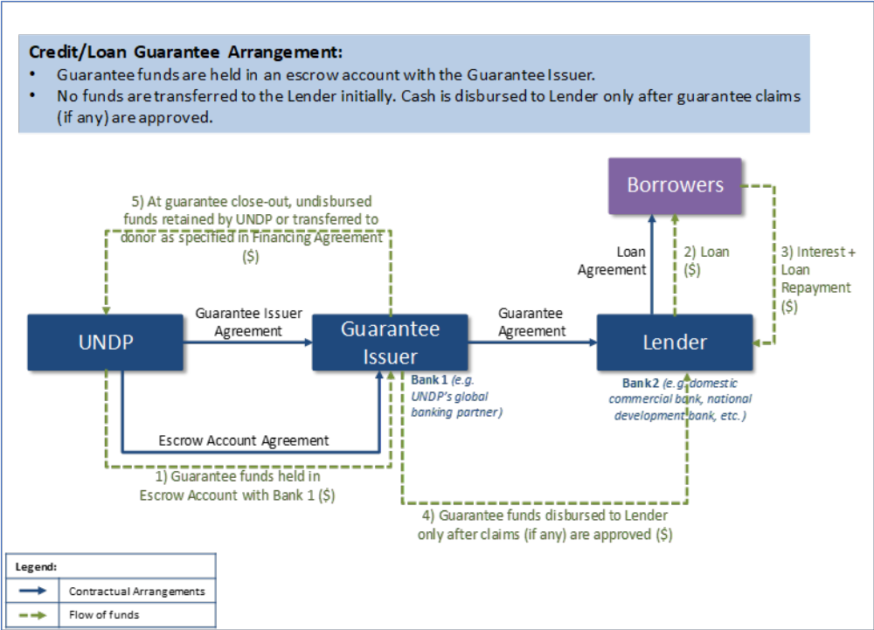
- Eligible lenders and borrowers for UNDP-supported guarantees.
The creditworthiness of borrowers and lenders is essential to the design of a sound guarantee scheme. In determining their eligibility, the following must be considered:

- Eligible lenders:
- Eligibility of lenders will be assessed firstly by UNDP, using its own due diligence policies, but also by the Guarantee Issuer using industry standard norms for credit assessment, as well as any additional requirements requested by UNDP that are specific to the scheme (to be shared as part of the Guarantee Issuer agreement). The lending operations of the lenders must be consistent with Good Practices for Lending as set forth in Annex 3.
- Specific criteria to assess the capability of lenders may include a review of its:
- Legal structure and governance
- Client and asset base
- Past performance in credit management
- Lending/contractual performance management policies and procedures
- Management structure and qualified personnel
- UNDP-supported guarantees can be provided to national development banks and international and domestic private financial institutions with good standing (investment grade) for:
  - Lending to sub-national government entities, public entities operating on a commercial basis, and the private sector (incl. SMEs) demonstrating strong financial discipline and management; and
  - A portfolio of lending (e.g. a bank’s credit facility for SMEs, youth entrepreneurs, individuals, etc.) as described in Section 2.9.
- Private sector lending entities will be selected through a competitive process and are subject to the Private Sector Due Diligence Policy.
- Eligible borrowers:
- As part of the project design, UNDP will identify the target population/characteristics of the borrowers to whom the project is aimed. Ideally the lender itself will make the final determination of eligibility for issuance of the loans, based on the agreed lending criteria and its own lending assessment processes.
- Where a UNDP-supported guarantee is being issued to support a specific lending scheme of a lender (such as a bank), the lender must have adequate processes and criteria in place to analyse the ability of the borrower to repay the loan, in addition to performing standard due diligence and Know-Your-Customer (KYC) assessments that are performed for borrowers per industry norms.
- In addition to the lender’s standard due diligence and KYC assessments, the lender must include clauses to prohibit certain conduct/activities of borrowers in the loan agreement. This is important to manage the reputational risk associated with the UNDP-supported guarantees. Such clauses must prohibit:
  - Violations of UN sanctions and human rights
  - Use or toleration of forced labor and child labor
  - Sale or manufacture of anti-personnel mines or components utilized in the manufacture of anti-personnel mines
  - Engagement in any sexual exploitation, sexual abuse or sexual harassment
  - Funding/supporting individuals or entities associated with terrorism as per the list maintained by the Security Council Committee established pursuant to Resolution 1267 (1999).
- UNDP projects may require the UNDP-supported guarantee to target specific underserved borrowers (for instance women and youth), non-sovereign entities or not so well-established entities for whom credit information may not be easily available and hence traditional credit assessment processes may not be possible. Such situations may require the lender to take increased risk and exercise flexibility on the eligibility criteria applied. However, the decision on who to lend to within the established parameters for the UNDP-supported guarantee facility will ultimately rest with the lender. For this reason, both UNDP and the funding partner(s) must not be involved in the management and day-to-day affairs of the UNDP-supported guaranteed lending facility.

- UNDP Programming modalities
UNDP-supported guarantees will only be offered to projects under Direct Implementation Modality (DIM) and full Country Office Support to National Implementation Modality (NIM). As specified in Section 2.1, UNDP-supported guarantees must be part of a project and supported by other development interventions (which may include other de-risking instruments, technical assistance, performance-based payments, grants, etc.) and may not be the sole activity under/for the project.

- Preferably guarantee a portfolio of investments
Within the context of a UNDP project, a UNDP-supported guarantee may be issued to a financial institution (typically a bank with a banking license) who will manage a lending portfolio. UNDP-supported partial credit guarantees will ideally cover a portfolio of investments (e.g. a bank’s credit facility for SMEs or youth entrepreneurs) as this would impact more beneficiaries compared to guaranteeing individual loans. The portfolio of loans will be covered by a UNDP-supported guarantee based on negotiated eligibility criteria (which may include factors such as loan size, class of borrowers, level of assets, sector or project activity, etc.) and the forecast rate of default.
- Types of Guarantees Offered by UNDP through Guarantee Issuers
UNDP primarily offers partial credit or loan guarantees (see Section 3.1) with risk shared with co-guarantors (if any), lenders and borrowers (see Section 2.4 and Section 4.7), that are designed to target underserved sectors in country or across regions and specific root-cause barriers. UNDP can also offer procurement guarantees, where UNDP and/or funding partners may wish to underwrite various parts of the procurement supply chain (see Section 3.2). Cognizant of the disparate needs on the ground, different types of guarantees are presented to illustrate the different scenarios in which UNDP-supported guarantees can be used. The use of UNDP-supported guarantee instruments can be modified and tailored to address a particular project’s financing needs.
  - Credit (Loan) Guarantees
Credit or loan guarantees are used for specific credit enhancement purposes in cases where the borrower, lender, and uses of loan proceeds are known. Credit guarantees cover losses in the event of a default on debt. Credit guarantees can be further classified into:
- Partial credit guarantees (PCGs): Partial credit guarantees cover part of the losses on debt payment. The guarantee coverage can be structured flexibly, effectively sharing the credit risk between the lender and the guarantor. UNDP can offer PCGs. An example of where UNDP can use PCGs would be through GCF/GEF funded projects, where it can offer PCGs as temporary mechanisms to incentivize lenders to start lending in particular sectors (e.g. climate or green energy) until the sector can stand alone and, lenders are better able to price their risks and the guarantees are no longer needed.
- Full credit guarantees (Wrap guarantees): Full credit guarantees cover the entire debt in the event of a default and cannot be offered by UNDP.
- Loan portfolio guarantees: Provided to financial institutions with partial coverage on a portfolio of loans that they provide to their customers. UNDP can agree to share in the risk of the bank loans, with a goal to encourage local banks to extend credit to an underserved sector. The individual borrowers under loan portfolio guarantees are not predetermined at the time the Guarantee Agreement is signed, but the borrowers must fall within a pre-agreed definition of “Eligible Borrowers,” such as borrowers that are small businesses operating in a specific geographic area or sector.
- Portable guarantees: The portable guarantee is used when the borrower is known and eligible, but the lender is unknown—it provides an identified potential borrower with a letter of guarantee commitment through which the borrower may seek the most advantageous terms from the local financial market. Through this instrument, a minimum credit rating can be established, and the risk calculation costs (to the borrower) are based on the assumption that the eventual lender is equally creditworthy.

- Bond guarantees: Bond guarantees support the issuance of bonds by financial institutions, private sector corporations, or sub-national entities. The use of proceeds, or funds generated from the bond issuance can be tied to development goals, assisting in raising local funds to initiate resilient infrastructure projects, which require substantial upfront capital investments. The bond guarantor commits to paying the interest or principal in the event of default of the issuer. It can be used to encourage the development of bond issuances in less sophisticated markets.
- Loan buy-downs: In a buy-down arrangement, a funding partner commits to paying off (“buying down”) part or all of the principal and/or interest of a loan, thereby increasing the concessionally, or grant element, of the loan. In other words, a buy-down is an instrument that serves to blend loans and grants. A tripartite agreement between the lender, the borrower, and the funding partner willing to pay all or part of the loans provided is signed. These arrangements are often tied to pre-agreed performance objectives to encourage investing or programming in a certain sector or geography.

  - Procurement Guarantees
Guarantees may also be used as a financial mechanism that enables governments to facilitate timely procurement of essential supplies that aligns better with the timing of availability of funding. Many governments are increasingly using domestic funding to procure essential commodities that contribute directly to development outcomes, medical and laboratory equipment, solar photovoltaic systems, smart cards, electoral supplies, etc. Many of these high-volume items have long lead times for delivery to partners. There is often a timing mismatch between the release of national budgets funds to procure necessary commodities and when the procurement and payment for commodities needs to occur. Guarantees may be used in procurement to improve credit terms for countries by helping them match payment to delivery of supplies for a pre-defined period, reducing uncertainty in demand or pricing. Also, by procuring these items globally, backed by guarantees from funding partners, a portfolio of procurement volume could be advanced providing more planning certainty to UNDP’s implementing partners, whilst also providing certainty to suppliers and securing improved pricing.
There may be instances where UNDP itself and/or funding partners would wish to utilize procurement guarantees to underwrite various parts of the procurement supply chain in a variety of ways, which may include:
- Option 1 – Funding partners can guarantee the procurement activities of countries through a pooled central procurement facility (bridge fund facility) established by UNDP that allows pre-delivery financing for member countries wishing to procure supplies or commodities through UNDP.
- Option 2 – UNDP and/or funding partners directly guarantee the procurement activities of individual countries or implementing partners (outside of a pooled procurement facility described in Option 1).
- Option 3 – UNDP can facilitate guarantees to suppliers on sales volume and price of essential commodities.
These options are further detailed in Annex 4. A similar approach to ‘Option 1’ is already underway by UNICEF and other UN entities, with guarantees provided for their global procurement of immunization supplies by funding partners. The pooled procurement facility will pre-finance the countries commitment for procurement needs and allow countries to make payments for the supplies upon delivery at expectedly lower prices due to longer term purchase commitment, which became possible through procurement guarantees.
As with other forms of UNDP guarantees, a full guarantee from funding partners would be required to establish such a facility, such as a counter-guarantee offered by a third party (e.g. foundation, international financial institutions, etc.), against firm procurement commitments of partners across a portfolio of projects. Without a guarantee facility provided by funding partners, UNDP will be exposed to the risk of non-payment (default) and in some instances may be exposed to foreign exchange risks as commitments made in local currency may lose value due to fluctuations in the market compared to the currency of the procurement. Therefore, the pooled procurement facility should be supported by guarantees issued by funding partners who can cover the risk of default or risk of loss in value of the facilities’ resources.
This reduces the financial risk to UNDP - in the event that the goods are received, UNDP will be able to draw upon the guarantee. However, reputational risks with the funding partner may emerge, should the beneficiary government not be in a position to meet its financial obligations on the delivery of the procured items.

  - Performance Guarantees
Performance guarantees are a common form of support used in commercial transactions to secure the performance of contractual obligations. For example, a guarantor can guarantee that the payments expected for a project will be made by a specific date once the trigger conditions for the payment are met. If the contractor fails to receive the payment by the expected date, then the guarantor may be liable for the unpaid amounts. An example of the use of performance guarantees in the energy sector is when a guarantor partially guarantees the revenue stream of a Power Purchase Agreement (conditional on payment conditions being met), which provides the investor the certainty of inflow required to borrow and eventually, repay its debts. The purpose of the performance guarantee could also be to cure a default if certain performance targets or project timelines are not satisfied.
At present, the use of performance guarantees is not permitted for UNDP.
- Operational Guidance related to Structuring, Issuing and Managing UNDP-supported Guarantees
Risk mitigation tools like guarantees do not in themselves make poorly structured projects or borrowers with unpredictable future prospects bankable, therefore both the projects and guarantee instruments need to be properly designed and managed if they are to be effective. Also, projects to be funded must be sufficiently bankable to enable the guarantors to properly assess the risks, identify recourse measures and offer defined risk coverage.
- Origination of UNDP-supported Guarantees
A Concept Note must be submitted by the country office to the regional bureau, Finance Sector Hub, Guarantees Project Team and Global Policy Network (GPN) after it originates an opportunity, which must include the following points:
- Description and Purpose of Project
  - Background and Rationale (briefly describe what the Project proposes to do and why)
  - Developmental Importance
  - Relationship to Mission Strategy/CO/Ongoing Activities
  - Collaboration with Other Parties, e.g., Funding partners, NGOs, Contractors, etc.
- Structure of Project
  - Lender/Financial Intermediary (provide brief background, if available)
  - Borrower (provide brief background, if available)
  - Intended Beneficiaries (if different from borrower, if available)
  - Type of Credit Facility (loan guarantee, bond guarantee, portfolio guarantee, portable loan guarantee)
  - Estimated Amount of Project Financing (maximum portfolio size - US$ amount)
  - Guarantee Ceiling (maximum UNDP contingent liability -US$ amount)
  - Guarantee Percentage (%) (covering principal only [preferred] or principal and interest)
  - Term of Guarantee (number of years)
  - Currency of Guarantee (US$ or local currency)
- Funding Source and Amount Available for UNDP-Supported Guarantee
- Preliminary Impact Assessment (e.g., according to the Impact Management Project methodology)
- Management Responsibility
  - Initial project monitoring plan
  - Clear identification of parties responsible for project development and implementation
- Proposed Technical Assistance to Support the Project, including the guarantee
- Estimated Time Frame for Project Implementation

- Initial diagnostic of UNDP-supported guarantees
An initial diagnostic must be conducted by the UNDP project team at country level on all UNDP-supported guarantee transactions to ensure effectiveness and efficiency of guarantees. It must assess the roles of UNDP-supported guarantees in the overall design of holistic development interventions, political, economic and business environments (e.g., local financial regulations and markets conditions, doing business data) and the type of risk that needs to be mitigated and the adequacy of the recommended guarantee variant (vs. other potential development interventions) in mitigating the risk. For UNDP-supported credit guarantees, the design of the lending programme and related guarantee will seek to target specific sectors/markets/beneficiaries in order to achieve the development objective. Key to the successful design of a guarantee program is the identification of the risk that lenders are most concerned about, and where UNDP’s knowledge can be used to mitigate that risk with a cost-effective guarantee product. In addition to the assessment of risks, cost benefit analysis of guarantees must be conducted. The initial diagnostic must be woven into the UNDP project development cycle, with a clear theory of change explaining how the objectives of the UNDP-supported guarantee are expected to be achieved.
UNDP will provide UNDP-supported guarantees only to the extent necessary. A UNDP-supported guarantee should not be utilized unless it is probable that the guarantee will have the desired development impact and that the transaction would not go forward without it (i.e. additionality). Any guarantee scheme must have a clear commercial orientation. Careful design of guarantees is critical to ensure the potential of guarantees is maximized and that they contribute to the achievement of desired objectives and development goals that would not otherwise be achieved without the guarantee. The questions listed below should be answered as part of the initial diagnostic of guarantees.
- What are the risks for the development interventions?
To reveal uncertainties relevant to development interventions, a risk assessment must be performed, which could include an assessment of political risks, macro- and microeconomic risks, risks in financial markets and business environment, regulatory risks and operational risks. This risk assessment could be similar to the one conducted on other projects/interventions within the same broader development programmes.
Among these risks for the development interventions, a root cause analysis must be carried out to identify the underlying drivers of the specific risks that lenders are most concerned about (e.g. regulations on capital flows, currency risks, legal risks, cash flow model of borrowers to identify the risks of default, etc.) and whether these can be mitigated through a guarantee instrument versus requiring other development interventions (e.g. policy change, etc.). Baseline data should be provided and examples of standard market transactions with terms should be gathered. The UNDP-supported guarantee product should then be tailored to mitigate the specific risks identified.
- Is a UNDP-supported guarantee the appropriate instrument to mitigate the identified risk and deliver holistic development interventions?
Following identification of the risks to be mitigated, an assessment must be conducted to establish clear linkages between the ultimate objective(s) of the guarantee and how the UNDP-supported guarantee intends to address the risks. This should lead to an evaluation of whether the UNDP-supported guarantee is the appropriate intervention for the project. A review of linkages with other development interventions to achieve the intended results must also be conducted.
- Has the lender correctly perceived risk and expected return?
If the lender has correctly perceived risk and the expected return from the project and determined expected returns are lower or risks higher than for other available projects, then UNDP must not intervene as this would shift capital from better investments to worse-off investments. UNDP-supported guarantees may improve outcomes if they support investments in projects in one or more of the following situations:
- When there are expected significant social returns in addition to financial returns, from which society benefits
- When the lender systematically overestimates risk associated with the project
- When the lender underestimates the expected returns
While it may be unlikely that UNDP can systematically outperform the lender/private sector in either assessing the risks or evaluating the expected returns of projects, it is important to note that the burden of proof to support any one of the three assertions above rests with UNDP.
- Will the guarantee create market distortions?
UNDP-supported guarantees should not pick winners and losers and create unfair competitive advantage over investments that do not receive the guarantee. Guarantee lending schemes can distort markets by introducing products or services with features that are not sustainable. For instance, a guarantor offering loans at lower than market interest rates will attract a lot of borrowers. This will be detrimental to other lenders who will either try to respond or suffer losses. This creates market distortions which could generate overall losses in the economies where guarantees are implemented.
UNDP-supported guarantees should not displace demand for capital and debt financing that could be fulfilled from other sources. Generally speaking, if a lender can offer finance on normal commercial terms without the need to make use of a guarantee, they will do so. A UNDP-supported guarantee scheme should only be considered for lending that would not otherwise occur. UNDP-supported guarantees should not be pursued if they will create market distortions.
- Is the UNDP-supported guarantee likely to be effective?
The most effective guarantees are those that correct some imperfection in the market or lead to the creation of a market where one did not exist. In order to assess whether UNDP-supported guarantees are likely to be effective, the following questions should also be answered as part of the initial diagnostic:
- Will the guarantee increase the volume of lending to the target sector/region/population during the lifespan of the guarantee?
- Will the volume of lending be sustained by the market after the guarantee lifespan is finished?
- Will the guarantee lower an investment’s perceived risk?
- Will the guarantee improve lending conditions/terms for the target borrower segment?
- Will the guarantee accelerate the venture into new markets?

- What are the costs vs benefits of using the UNDP-supported guarantee?
Guarantees usually entail significant costs, which include guarantee set-up costs, legal and structuring costs, monitoring costs and expenses related to managing the guarantee funds in an escrow account through an intermediary. The effort-intensive and cumbersome administrative nature of guarantees should also be considered. In addition to analyzing the cost effectiveness of the UNDP-supported guarantee, benefits such as how much the guarantee objectives will help contribute to society should also be assessed. An objective evaluation and feasibility study might reveal the advantages of the UNDP-supported guarantee or of alternative interventions or policies.
- What is the exit strategy?
In line with the exit strategy for the project, a clear exit strategy is required for the UNDP-supported guarantee to ensure that UNDP’s support to guarantees leads to the necessary changes in the marketplace so that the guarantee facility may no longer be required. This may be achieved by demonstrating that lending to a certain sector of the economy is productive and commercially viable; that other lending institutions are attracted to the marketplace to correct inefficiencies; that policy barriers to entry in a marketplace have been removed; and that the market inefficiency that existed is no longer a constraint.
Even with the best diagnostics, there is always the risk that an uncontrollable adverse event may happen (e.g. adverse change in regulatory framework, force majeure, industry consolidation, etc.). The UNDP-supported guarantee design also needs to include a proper exit strategy that addresses these potential risks. In cases where there is an uncontrollable adverse event or where a guarantee is recalled due to non-performance, a phased-out approach to exiting the guarantee may need to be considered.
Therefore, the guarantee exit strategy must address:
- A mature exit strategy that ensures that underlying development objectives continue to be sustainable in the medium term when the guarantee coverage period elapses, as guarantees are only meant to be short term interventions; and
- How premature guarantee exits due to unforeseen and uncontrollable adverse events will be handled.
When planned and implemented correctly, exit strategies have the impact of empowering both lenders and borrowers to be able to continue their operations without the use of the UNDP-supported guarantee. Some measures to gauge the success of an exit strategy may be:
- Whether the lending entity has been able to continue its lending operations after the UNDP-supported guarantee period has lapsed;
- If the guarantee impact has been sustained or improved after the guarantee coverage period has ended.
The timing of the guarantee exit is a critical design element and must be carefully established as it may help enhance increase a guarantee’s focus on establishing systems of sustainability. Conversely, too short a guarantee period may impose artificial timing constraints and cause unsustainable interventions. UNDP-supported guarantee extensions (if any) must be supported by a new risk and cost-benefit analysis.

- Target leverage ratio
The leverage ratio is defined as the relation between the amount mobilized by a financial instrument (guarantee) over the maximum amount that may have to be paid out by the guarantee. The higher the leverage ratio, the greater the effectiveness of the guarantee in attracting additional investment.
For UNDP-supported credit guarantees, UNDP’s target leverage ratio must range from 3.5:1 upwards, depending upon the targeted beneficiaries. This means that every dollar provided by UNDP as part of a guarantee must mobilize at least $3.5 additional capital from the lender. As a general guide, for loan portfolios to SMEs, a minimum leverage ratio of 5:1 or higher is recommended. Where necessary, a minimum target ratio of 3.5:1 may be considered for loan portfolios in LDCs that target new types of individual beneficiaries, such as individual farmers, households, youth and women to encourage entrepreneurship.
Figure 1: Calculating leverage ratio – an example
Figure 1 below gives a simplified illustration of the leverage ratio for a renewable energy investment project, where $3 million (maximum pay-out for the guarantee) has triggered $21 million in renewable energy investment. As both the pay-out of the guarantee instrument and the investments occur over time, the present value of the pay-outs and investments are used to calculate the leverage ratio. It is common for an organization issuing guarantees to establish a leverage ratio when formulating its policies on guarantees.
Visualization of Leverage Ratio
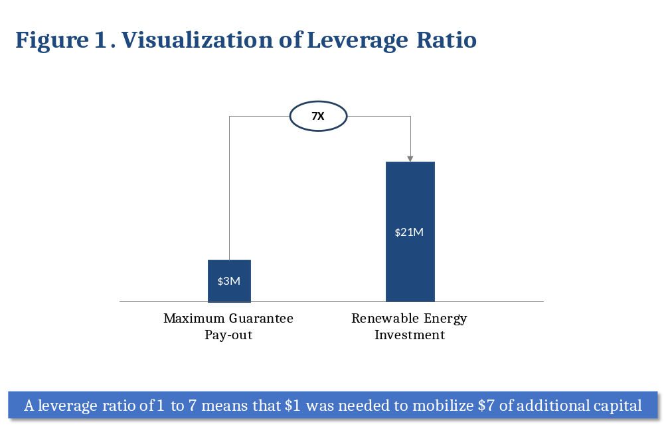

The target leverage ratio guidance above must be adhered to, and demonstrated within the proposal where the leveraged financing is coming from, and on what terms, as part of UNDP’s due diligence and determination of UNDP-supported guarantee approval.

- Guarantee currency
When issuing loans guaranteed by UNDP, the lender must do so in the local currency to avoid market distortion. UNDP-supported guarantees will be issued in the currency of the underlying loans as currency mismatches for the lender must be avoided. All guarantee related fees and payouts will be denominated in this guarantee currency to avoid currency mismatches and foreign exchange (FX) risks for the lender.
It is noted that these stipulations raise an FX exposure issue for UNDP as UNDP’s reporting currency is in US Dollars, while the guarantee may be denominated in the local currency. Whilst contribution/financing agreements with the funding partner should cover the risk of unfavorable movements in exchange rates, UNDP should monitor the relative trends between the guarantee currency and the US Dollar, with consolidated (forecast) currency risk incorporated in the overall assessment of portfolio risk. UNDP’s currency risk must be considered carefully, especially for longer term guarantees and larger size guarantees. Any proposed exceptions to issuing UNDP-supported guarantees in the currency of the underlying loan/transaction must be fully justified and brought to the Chief Financial Officer for consideration.

- Guarantee size
Guarantees must be correctly sized to deliver impact efficiently, and sized based on capital requirements and size of projects expected to receive the guarantee. UNDP may support medium-sized guarantees with maximum amounts payable ranging from $1 million to $10 million per guarantee to a given lender. This range is above the level where a guarantee is typically not cost effective to utilize, and below the level of larger development guarantees typically offered by multilateral development banks and other guarantors.

- Guarantee tenor
While the tenor of a guarantee may vary with each guarantee transaction, UNDP-supported guarantees must not have a tenor exceeding the UNDP project period. It is recommended that the tenor of a UNDP-supported guarantee typically range up to 5 years. The UNDP-supported guarantee tenor must not exceed 10 years and will ideally be the same as the tenor of the underlying loans. However, in some situations depending on the specific risk to be mitigated, the maturity of UNDP-supported guarantees can be shorter than the tenor of the covered instrument or transaction, thereby allowing capital to be recycled more quickly for similar projects. In such cases, there could be multiple guarantors where UNDP could take a position that it will partially guarantee the underlying transaction for a few years and the rest of the underlying transaction’s tenor is covered by other guarantors.
In cases where the proposed tenor of a UNDP-supported guarantee transaction exceeds 10 years, the transaction will need to be reviewed and approved by the Credit Risk Committee.

- Risk sharing (Pari passu)
For credit guarantees, UNDP may only support guarantees on a pari passu basis (i.e. equal footing basis) with the lender, with respect to the rights and obligations arising from a default situation. In the event of a default, UNDP-supported guarantees will cover risks only to the extent necessary to attract the required additional financing, up to a maximum of 50% of the potential losses, with the coverage ratio being determined for each transaction based on its specific impact/risk assessment. In all scenarios, including those involving co-guarantors, the guaranteed party (i.e., lender) must retain at least 25% of the remaining risk of potential losses. If a default materializes, losses will be funded in the same ratio.
UNDP shall offer guarantees only in cases where the lender continues to bear a portion of the risk of default on a guaranteed transaction in order to promote sound and prudent credit management. Given that guarantees are often aimed at leveraging private financing and in order to reduce moral hazard, UNDP-supported guarantees shall remain partial in nature (less than 100 percent and targeting 50% of a lender’s risk) and must be on a pari passu (‘side by side’) basis. Pari passu guarantees share the risk with the lender in an agreed proportion (for example, in a 50% pari passu guarantee, the guarantor covers half the loss and the lender the other half). UNDP-supported guarantees must allow for appropriate risk sharing where the proportion of risk taken provides an incentive to the lender to adequately structure and monitor the loans. Lenders that have “skin in the game” are more likely to adopt sustainable lending approaches. In addition, UNDP can also partner with co-guarantors, such as SIDA or USAID, to share risk. This would help UNDP maximize impact.
Please note that the guarantee to the lender, say targeting 50% of a lender’s risk, does not mean that the borrower is only liable for 50% of the debt. Where defaults occur, the lender is obliged to follow their standard commercial recovery procedures, including the realization of any security held and calling upon any personal guarantees which may have been provided, before they make a claim against the UNDP-supported guarantee. The borrower always remains liable for repayment of the value of the outstanding loan and, in the event of a default, any remaining loss faced by the lender after recoveries will be borne between the UNDP-supported guarantee and lender in the agreed ratio (50:50 in the above example).
The extent of any security or guarantee taken from the borrower is a commercial matter for the lender. In designing a guarantee scheme, the only exception from what might be the lender’s normal commercial practice is that lenders participating in a UNDP-supported guarantee scheme are prohibited from taking a charge over a principal private residence of a borrower or guarantor as security for a loan.
When assessing how risk should be shared, the lenders’ concerns should also be carefully considered. From a purely commercial perspective, lenders may not find guarantees attractive enough to sustain their normal business operations. For example, lenders may be concerned that guarantees provide ‘too much assurance’ such that the lenders would not be able to justify charging any risk premiums and therefore have to rely on administration fees as their source of income (a much lower revenue stream). Therefore, understanding the dynamic between lender’s interests and the risk coverage objectives of the guarantee is crucial.
Any proposed exceptions to the sharing of risk on a pari passu basis must be fully justified and brought to the Chief Financial Officer for consideration.

- Ensuring full cost recovery
UNDP-supported guarantees may only be offered through a UNDP project on the basis of full cost recovery. The budget for the overall project will be subject to GMS on expenses, per UNDP’s cost recovery policy. To ensure full cost recovery, costs related to the design, issuance and management of UNDP-supported guarantees will be recovered through the following means:
- i) Charging guarantee fees to funding partner(s) to cover UNDP’s administrative costs, set at the rate of 2% of the outstanding guaranteed amount; or
ii) Recovery of bank fees within the lending scheme; and
- Recovery of costs though project budgets; and
- Normal method of GMS charged on project costs though project budgets.
Please see additional details in Section 6.

- Partnering with and/or engaging financial institutions for the issuance and management of UNDP-supported guarantees
UNDP will engage qualified financial institutions (i.e. those with a banking license) to issue and administer guarantees required as part of a UNDP project, on the basis of the UNDP-supported Guarantees Policy, and in accordance with the procedure provided for in this Operational Manual and guidance from the BMS/OFRM Treasury unit. The financial institution (“Guarantee Issuer”) issues the guarantee in its name, upon UNDP’s request, and takes on the obligation to guarantee the payment of specific amounts in the event of default or non-performance of contractual commitments. Whilst UNDP will still be responsible for providing the funding for the guarantees to cover any potential pay-outs and providing technical expertise in the design phase of guarantees, all UNDP-supported guarantees will be issued, managed and monitored by the Guarantee Issuer(s). UNDP will not be involved in actual lending decisions beyond identifying target beneficiaries as part of the project document and the Guarantee Issuer Agreement, nor will the guarantee be issued in its name. The agreements with the financial institutions must specify the design elements from the programme, including specific sectors/beneficiaries being targeted, the risks being mitigated by the UNDP-supported guarantee, and the basis for risk sharing and subsequent claims.
  - When to engage with financial institutions?
UNDP will only engage reputable financial institutions or UNCDF for the issuance and management of UNDP-supported guarantees. When financial institutions are engaged, they must follow the requirements of the UNDP-supported Guarantees Policy. When UNCDF is engaged, it is permitted to follow its own Guarantees Policy, as articulated in the UNCDF Supplementary Guidelines to the UNDP Programme and Operations Policies (POPP).
  - Why engage with financial institutions?
The engagement of Guarantee Issuers is to benefit from their financial expertise with guarantees, knowledge of the local context and legal frameworks, contain set-up costs for the UNDP-supported guarantees portfolio, and help improve the quality of the risk decisions that UNDP has to make.
  - Which financial institutions should UNDP engage with?
UNDP must engage reputable commercial or development banks or multinational financial institutions with skilled staff and capacities for the management of credit portfolios to issue and administer UNDP-supported guarantees. BMS/OFRM Treasury will support all Country Offices with the identification and selection of the Guarantee Issuer. In most cases this will likely be an existing banking partner of UNDP. In addition, the choice of financial institutions can also extend to local in-country financial institutions who have proven and demonstrated technical, managerial, financial and fiduciary capabilities to administer guarantees and other credit instruments. In addition to issuing and managing the UNDP-supported guarantee, the selected financial institutions will also be entrusted with holding an advance deposit escrow account for the guarantee. Based on the terms of the Guarantee Issuer agreement with UNDP, the Guarantee Issuer will manage guarantee related cash flows which may include collection of guarantee fees, guarantee pay-outs, etc.
BMs/OFRM Treasury will obtain competitive bid pricing from at least two potential guarantee issuers, in addition to reviewing several criteria to assess the suitability of financial institutions to partner with UNDP as Guarantee Issuers. Some of the criteria is listed below:
- Solvency, credit rating and liquidity situation of the institution
- Previous experience and track record with guarantee instruments and lending, preferably in the target geography/sector
- Key personnel
- Policies and procedures related to fiduciary, financial and administrative matters related to guarantees
- Risk management
- Relationships with lenders and borrowers
- Geographical coverage and presence
- Electronic Banking and ability to interface with UNDP’s ERP System
- Customer Service

  - How to engage with financial institutions?
Guarantee Issuers who are selected will have been vetted and previously gone through a credit rating agency review to obtain an opinion of their financial strength. The selection process for the local financial institutions will always follow an open and international competitive bidding process. The Guarantee Issuer will be engaged by BMS/OFRM Treasury based on Annex 2: Key Principles to be Included in Guarantee Issuer Agreements and Guarantee Agreements.
  - What are the responsibilities of the financial institutions selected as Guarantee Issuers?
Financial institutions selected to act as Guarantee Issuers will be responsible for:
- Conducting pre-screening and risk assessment (including credit appraisal) of potential lenders, as well as any additional checks that are specific to the lending facility as requested by UNDP
- In consultation with UNDP, financial structuring of the guarantee, incorporating results of the initial diagnostic conducted by UNDP
- Drafting, negotiating and - upon authorisation by UNDP - signing guarantee agreements with lenders
- Upon approval by UNDP, paying out approved claims from funds held in escrow account
- Monitoring and reviewing the lending activities of the lender, including financial monitoring of guarantee covenants (see Section 4.12)
- Periodic consolidated reporting to UNDP based on terms of the Guarantee Issuer Agreement
- Following up on recovery of funds, where applicable

- Partnering with UNCDF to issue and manage UNDP-supported guarantees
Under certain circumstances, UNDP may leverage UNCDF’s experience with issuing and managing guarantees, for the design, structuring, issuance and management of UNDP-supported guarantees. This may be done by engaging UNCDF as a Responsible Party or as a technical service provider to UNDP as set forth in the Executive Group (EG) approved “UNDP-UNCDF Collaboration Framework on Loans, Guarantees and Low-Value Grants, 2018”. When UNCDF acts as a responsible party, UNCDF is permitted to follow its own Guarantees Policy, which is further articulated in the UNCDF Supplementary Guidelines to the UNDP Programme and Operations Policies (POPP). The Guarantee-related policies in the UNCDF Supplementary Guidelines relating to Loans, Investment Grants, and Guarantees would apply. A UN-to-UN Transfer Agreement must be signed between the parties.
Additionally, if after review by the Credit Risk Committee, UNDP determines not to move forward with a UNDP-supported guarantee due to exceptional case or material risks identified, UNDP shall consult with UNCDF to explore whether UNCDF may be able to support the guarantee.
UNCDF may also issue guarantees under a joint programme with UNDP, especially when the intervention requiring the guarantee is not consistent with UNDP’s FRRs. In these cases, as with other joint programmes, UNCDF’s regulations, rules and policies will apply. Such cases are not covered under the UNDP-supported Guarantees Policy and this Operational Manual.
Further details are provided in Annex 1: UNDP-UNCDF Collaboration Framework on Loans, Guarantees and Low-Value Grants.

- Escrow account
Funds to cover potential UNDP-supported guarantee pay-outs will be deposited by BMS/OFRM Treasury into an escrow account held by the Guarantee Issuer, using funds provided by the funding partner(s) and denominated in US dollars.
Escrow accounts ensure that money will be available for claim payments if/when the guarantee is called. The escrow account will be opened based on the signed Guarantee Issuer Agreement and the Guarantee Agreement and will be managed by the BMS/OFRM Treasury unit. UNDP and the financial institution will sign an Escrow Agreement which will detail the covenants that govern the opening, management, and closing of the escrow account. Funds can only be disbursed from the escrow account when UNDP authorizes the release of funds.
The only time that the UNDP-supported guarantee may be paid out is when appropriately called in accordance with (i) the terms of the guarantee issued by the Guarantee Issuer, and (ii) the terms of the Guarantee Issuer Agreement or, in the case of UNCDF, the UN-to-UN Agency Contribution Agreement. The funding partner will be informed when a UNDP-supported guarantee is paid out.
When a guarantee payment is triggered due to default or non-performance on a contract, the Guarantee Issuer will follow its normal procedures to verify that a pay-out is indeed due, then submit a completed Request for Payment of Claim form to UNDP for payment. Upon approval, UNDP will then authorize the release of funds from the escrow account to pay the guaranteed party (i.e. the lender).
Proper escrow account management must avoid commingling of UNDP regular deposits with UNDP-supported guarantee funds. The Guarantee Issuer must protect the guarantee funds by ensuring that the full amount remains untouched until instructions to disburse are received from UNDP. Escrow accounts must be interest bearing accounts, to ensure investment income is earned on unused funds for the benefit of UNDP.

- Monitoring of guarantees and lending activities of the Lender
In line with UNDP’s monitoring policies and procedures, UNDP-supported guarantee schemes are subject to monitoring to ensure they are on track to meet their objectives. UNDP and the Guarantee Issuer need to regularly monitor the performance of participating lenders and the UNDP-supported guarantee instrument to ensure the guarantee is on track to achieve its objectives. Timely examination of the data is useful to identify deviations and suggest corrective measures. The monitoring of the UNDP-supported guarantee scheme may be undertaken through (i) monitoring by the Guarantee Issuer of the lending portfolio; (ii) monitoring by UNDP and/or the Guarantee Issuer of the achievements of the lending facility; and (iii) financial monitoring by UNDP and the Guarantee Issuer of the guarantee instrument.

  - Monitoring and reviewing the lending activities of the Lender
UNDP defines the key monitoring activities that the Guarantee Issuer must routinely conduct on the Lender to ensure proper operational control of the UNDP-supported guaranteed loan portfolio. The Guarantee Issuer should monitor the critical parameters established for the lending portfolio (i.e. the lending criteria and eligibility requirements, see Annex 2 for more details) to ensure the Lender is executing strategies in line with the agreed lending portfolio objectives and UNDP’s project design and UNDP-supported guarantees guidelines. The requirements of what the Guarantee Issuer will monitor should be clearly specified in the project documentation and agreement(s) that UNDP signs with the Lender (e.g. Responsible Party Agreement) and the Guarantee Issuer (i.e. Guarantee Issuer Agreement).
The loan portfolio is monitored based on the information contained in progress reports received from lenders and by routine oversight exercises conducted by the Guarantee Issuer. The Guarantee Issuer must submit the monitoring report(s) to UNDP at the pre-agreed timing as defined in the agreement(s) between UNDP and the Guarantee Issuer in form and substance satisfactory to UNDP.
The Guarantee Issuer’s monitoring may be in the following forms:
- Compliance Monitoring: This kind of monitoring by the Guarantee Issuer entails reviewing the Lender’s compliance with any contractual obligations that are pre-defined by UNDP for the purpose of targeting eligible lending portfolios. For example, as part of the project design, UNDP should have identified target population/sectors/characteristics that the lending portfolio needs to focus on to be eligible for the UNDP-supported guarantee coverage, which should also be indicated as part of the requirements for loan applications. The Guarantee Issuer must periodically review and check that lenders are complying with these lending requirements and only issuing loans to populations fitting the criteria specified by UNDP.
Compliance monitoring also includes monitoring the borrower’s compliance to environmental, social standards to encourage sustainable and socially responsible business development, as defined in the lending criteria. The extent of this monitoring should be commensurate with the project’s environmental and social risks and impacts and with any compliance requirements such as labour and working conditions, pollution prevention, community health, safety and security, biodiversity conservation among others. The Lender and in turn the Guarantee Issuer should submit to UNDP an annual monitoring report - which is an annual environmental and social monitoring report:
  - Confirming compliance by the borrowers with the applicable environmental and social standards and laws
  - Identifying any material non-compliance or failure and the actions being taken to remedy any such deficiency

- Covenant monitoring must also include assessing whether the Lender is complying with the clauses as stated in the guarantee agreement, some of which may include:
  - Submitting any executed loan documents covered under the guarantee to the Guarantee Issuer within a specified timeframe
  - Submitting duly completed payment demand statements requesting payment when a call is made on the guarantee after a borrower defaults and the Lender’s recovery efforts fail, together with the supporting documentation required in a timely manner
A sample list detailing the Guarantee Issuer’s responsibilities in monitoring the Lender is included in Annex 2.

- Performance Monitoring: This includes measuring the effectiveness of the loan portfolio, recording information to track performance and comparing this against the previously established benchmarks or requirements of the loan facility as set out in the project documentation and agreement(s) between UNDP and the Lender. Tracking performance is important to ensure the effectiveness of guarantees as a part of broader development project. The loan portfolio performance should be measured and evaluated along the dimensions of outreach, effectiveness, and financial sustainability, which correspond to the expected outcomes of the UNDP-supported guarantee. Financial performance indicators can help demonstrate portfolio quality and efficiency, e.g. number of clients that have been able to access loans due to the UNDP-supported guarantee. Lenders should periodically report their performance and evaluate the achievement of the loan portfolio objectives. The extent to which the Guarantee Issuer may support performance monitoring should be set out in its signed agreement with UNDP (the Guarantee Issuer Agreement).

Whilst every Guarantee Issuer must be able to monitor the technical and financial aspects (e.g. covenant monitoring, financial sustainability monitoring, etc.) of the loan portfolio, the extent to which the Guarantee Issuer can also undertake the non-financial performance monitoring and all of the compliance monitoring activities depends upon their capabilities. For example, development finance institutions performing the Guarantee Issuer role may be more able to address the non-financial compliance monitoring (e.g. on ESG requirements, etc.) or performance monitoring (e.g. on development impact, etc.) referred to above than commercial financial institutions with less expertise in monitoring development. UNDP’s monitoring plan will thus need to cover the full spectrum of its monitoring requirements, clearly articulating those to be performed by UNDP and those to be performed by the Guarantee Issuer upon UNDP’s request.

  - Financial monitoring of the UNDP-supported guarantee instrument
Financial monitoring activities for the UNDP-supported guarantee instrument include monitoring and reporting on the financial performance indicators of the guarantee portfolio to assess its effectiveness and efficiency (see examples in the table below) as well as ensuring that fees are paid, reporting requirements are met, completion of conditions precedent (when applicable) is documented, making site visits, and closing out the guarantee facility upon expiration. The Guarantee Issuer will be responsible for monitoring and reporting on the financial indicators of the UNDP-supported guarantee.
The indicators to evaluate the financial performance of a guarantee may include:
Financial Indicator | What it measures | How it’s calculated
Leverage | Effectiveness | Amount mobilized by the guarantee (e.g., amount of guarantee loans extended) divided by the maximum amount that may have to be paid out in relation to the guarantee.
Transaction costs per guarantee issued | Operational efficiency | Operating costs over a certain period divided by the total amount of the guarantee issued over that period.
Average number of days to pay out a claim | Operational efficiency | Number of days from the moment a guarantee claim is submitted to the Guarantee Issuer to the moment the guarantee claim is settled.
Net loss rate | Net losses incurred | Pay-outs minus the proceeds from recovery over a year, divided by the average outstanding guarantee amount over that year. Good ratios are generally below 2%.
Pay-out rate | Losses incurred | Value of pay-outs over a year divided by the average outstanding guarantee amount over that year. The pay-out rate is calculated for each lender and should generally be below 3% and not exceed 7%.

- Periodic financial and programmatic/impact reporting to funding partner(s)
UNDP will provide regular reporting to its funding partners on the UNDP-supported guarantee performance as set out in the respective financing agreements. Using consolidated reporting from Guarantee Issuers, this may include information on topics such as additionality generated by the guarantee; claims submitted, approved and paid out; outstanding guarantee balance; etc.
Following normal materiality considerations, UNDP-supported guarantees shall also be disclosed in the notes to the financial statements.
The UNDP-supported guarantee scheme must include reporting mechanisms to generate data to allow potential problems to be identified and corrected before the guarantee is triggered. This reduces the probability of paying out the guarantee.

- Treatment of recoveries post claim payouts
The Guarantee Issuer must establish a process for the identification and reimbursement of “Recovered Funds” (defined below) to UNDP.
If a claim has been paid out with respect to a default on a loan or non-performance on a contract, and funds (defined here as “Recovered Funds”) are subsequently recovered directly by the lender, collateral agent or any other party, funds should be promptly reimbursed by the Guarantee Issuer to UNDP on a pro-rata basis.

- Guarantee closeout and treatment of undisbursed balances
UNDP-supported guarantees must adhere to the exit strategy identified as part of the initial diagnostic (See Section 4.2) and specified in the relevant guarantee agreements. This includes treatment of undisbursed balances as detailed below.
Closeout of guarantee and escrow account: The process to closeout a UNDP-supported guarantee and the escrow account should be initiated when it has been reasonably determined that all conditions and obligations of the guarantee have been satisfactorily completed. Both the guarantee issuer and the lender must verify that they have fulfilled their guarantee obligations and that all administrative actions have been accomplished. If any deficiencies are found as part of the closeout process, they must be documented and communicated to all parties. In the event that the parties cannot reach an agreed conclusion on any outstanding matter and if negotiation has failed, a formal arbitration process can be initiated by the parties at their own expense. Any dispute resolution process will be subject to the terms of the guarantee agreement signed by both parties.
If all the pre-closeout activities have been completed, the guarantee issuer must immediately inform UNDP that it will begin the process to close the guarantee. The UNDP project team must conduct its own assessment using the simple but not all-inclusive checklist below to ensure the required closeout activities are completed:
- No claims are pending on the guarantee
- All financial matters have been resolved
- Verification that any and all disputes have been settled
- Verification of escrow account balances
- Documentation adequately showing all contract obligations have been met
- Close out certification/letter issued by UNDP to the guarantee issuer with instructions to close the guarantee

Following the instruction by UNDP to proceed with closing the guarantee, the escrow account can be closed and the undisbursed escrow funds, including any interest if applicable, must be returned to UNDP. UNDP should issue a Request Letter for the release of the guarantee escrow funds that authorizes the return or discharge the funds to a specified bank account.
If the above steps have been completed, the financial closure of the UNDP-supported guarantee in the system should be triggered with clear documentation that the following have occurred:
- Expiry of the guarantee as a consequence of its maturity
- Expiry and release of obligations of the parties
- Effecting of payment to UNDP from escrow account

Refund of guarantee funds: When a guarantee coverage period lapses, the undisbursed guarantee funds must be handled in accordance with the terms of the financing agreement(s) with the funding partner(s). If the financing agreement(s) permits, undisbursed balances may be retained by UNDP within a centrally managed UNDP Guarantee Reserve, where the funds will be commingled for re-use for other guarantee interventions or to pay for the costs related to UNDP’s guarantee program. Alternatively, funding partners may require that undisbursed guarantee funds are refunded back to them, or transferred to the host government or to an implementing partner. Undisbursed funds must not be transferred to the lending bank.

- Administration of guarantees
The administration of guarantees within UNDP will be performed centrally given the inherent risks involved, frequent interactions with financial institutions and transactional costs associated with managing guarantee portfolios.
The existing corporate accountability framework applies for all projects, programmes or related activities that include the design and usage of a UNDP-supported guarantee facility. However, the administration of the UNDP-supported guarantee facility will be performed centrally to mitigate risk. This includes the process around approval of the UNDP-supported guarantee instrumentation, cash flows associated with the management of guarantees, management of the guarantee portfolio and related risks, etc. Please see Section 7. Roles and Responsibilities for further information.

- Publishing of guarantee information – internal and external
UNDP may disclose information to the extent required by financing agreements with funding partners or pursuant to the Charter of the United Nations, resolutions or regulations of the General Assembly, or rules promulgated by the Secretary-General of the United Nations. In addition, as a signatory to the International Aid Transparency Initiative (IATI), UNDP may publish the following information online on a regular basis to comply with the IATI standards (if required):
- Name and description of guarantee;
- Project number;
- Guarantee period;
- Country;
- Financial details (e.g. guarantee percentage, guarantee ceiling, amount of qualifying loan, etc.);
- Expected results (e.g. purpose of the loan); and
- Link to any public documents to help users find more information.

While recognizing the need to protect confidential information of all parties involved, UNDP may, in accordance with its Information Disclosure Policy, publicly disclose the information above to promote investments for the SDGs and to ensure visibility, accountability, transparency and to maximize results and impact.
- Agreements
There are various agreements that govern the issuance and management of UNDP-supported guarantees, and establish the relationships, roles and responsibilities of various participants in the UNDP-supported guarantee program. Such agreements include:
- Guarantee Issuer Agreement or Contract between UNDP and the selected Guarantee Issuer (or the UN-to-UN Agency Contribution Agreement in cases where UNCDF is the Guarantee Issuer) that lays out the roles, responsibilities, terms and conditions for each UNDP-supported guarantee issued. These are subject to the approval of BMS/OFRM Treasury unit. The key elements that must be included in Guarantee Issuer Agreements between UNDP and Guarantee Issuers are listed in Annex 2.
- Guarantee Agreement between Guarantee Issuer and the guaranteed party (i.e. the lender). The Guarantee Issuer is free to use its own guarantee template which must incorporate the key principles set forth in Annex 2.
- Financing Agreement between UNDP and the funding partner providing funds for the UNDP project that includes a UNDP-supported guarantee. This must include clauses documenting that part of the funding will be used for the issuance and management of guarantees, and must state the purpose of the financing, conditions governing receipt of guarantee funds, reporting requirements and guarantee exit arrangements (e.g. retention of undisbursed funds by UNDP, refund to the funding partner, etc.).
- Escrow Agreement between UNDP and the financial institution holding the escrow account. This may be incorporated within the Guarantee Issuer Agreement (based on the standard instrumentation offered by the Guarantee Issuer).
- UNDP Project Document
- Loan Agreements between the lender and borrowers furnished by the lender to the Guarantee Issuer. Lending arrangements must be consistent with Good Practices for Lending set forth in Annex 3.
Any substantive deviation from the standard agreement clauses/templates above (excluding the Guarantee Agreement and the Loan Agreements) requires consultation with the BMS Office of Legal Services.
- Guarantee Pricing and Budgeting
- Cost Recovery
As specified in Section 4.8, to ensure that UNDP-supported guarantees are established on the basis of full cost recovery, costs related to the design, issuance and management of guarantees must be recovered through the following means:
- i) Charging guarantee fees to funding partner(s) to cover UNDP’s administrative costs, set at the rate of 2% of the outstanding guaranteed amount. Guarantee fees shall be set as a percentage of the outstanding guaranteed amount and should be paid annually. GMS is not charged on top of the guarantee fee (see c) below. UNDP will only charge one guarantee fee instead of charging separate Guarantee Commitment, Origination and Utilization fees. UNDP guarantee fees may be charged to and paid by the funding partner(s); or
ii) Recovery of bank fees within the lending scheme. The lender (the bank) is charged fees on the outstanding guarantee payable. The timing of payment should be agreed between the lender and UNDP (through the Guarantee Issuer). The lender may pass the guarantee fee to the borrowers if it is commercially viable to do so, without making the loans too costly for the borrowers; and
- Recovery of costs though project budgets. The present policy on project costs applies, covering project inputs, project design, due diligence and risk assessment, administration, financial monitoring of guarantees, financing fees (e.g. the fees charged by the Guarantee Issuer), etc.; and
- Normal method of GMS charged on project costs though project budgets. Where the guarantee is called upon to fund losses, expenses are incurred, against which GMS may be charged. Given the guarantee fee is paid on the outstanding guaranteed amount, this does not double-charge GMS on top of the guarantee fee. Unused guarantee funds may be returned to the funding partner (and not earn GMS), or retained by UNDP for future guarantees subject to the written intent of the funding partner(s).
Level of Guarantee Issuer’s fee: The guarantee issuer’s fee are fees charged by the Guarantee issuer for the cost of administering the guarantee facilities at UNDP’s request. These must be included and recovered as part of the project budget (see Section 6.1b).

- UNDP Guarantee Reserve
In the event that UNDP is provided with unearmarked financing specifically to support UNDP’s guarantee operations, UNDP will establish and centrally manage a Guarantee Reserve, where funds will be commingled for re-use for other guarantee interventions or to pay for the costs related to the UNDP-supported guarantee program. The following payments will be made into the Guarantee Reserve, where permitted within financing agreements:
- Undisbursed guarantee escrow funds, including any interest
- Recovered funds paid to UNDP
- Funding partner contributions where the funding partner has explicitly instructed transfer of funds to capitalize the Guarantee Reserve.
- Roles and Responsibilities
The diagram below lays out the roles and responsibilities accompanying a centralized support structure that is tasked with working with country offices and regional bureaux to effectively deploy UNDP-supported guarantees as part of UNDP programming.

UNDP-Supported Guarantees – Deployment Structure
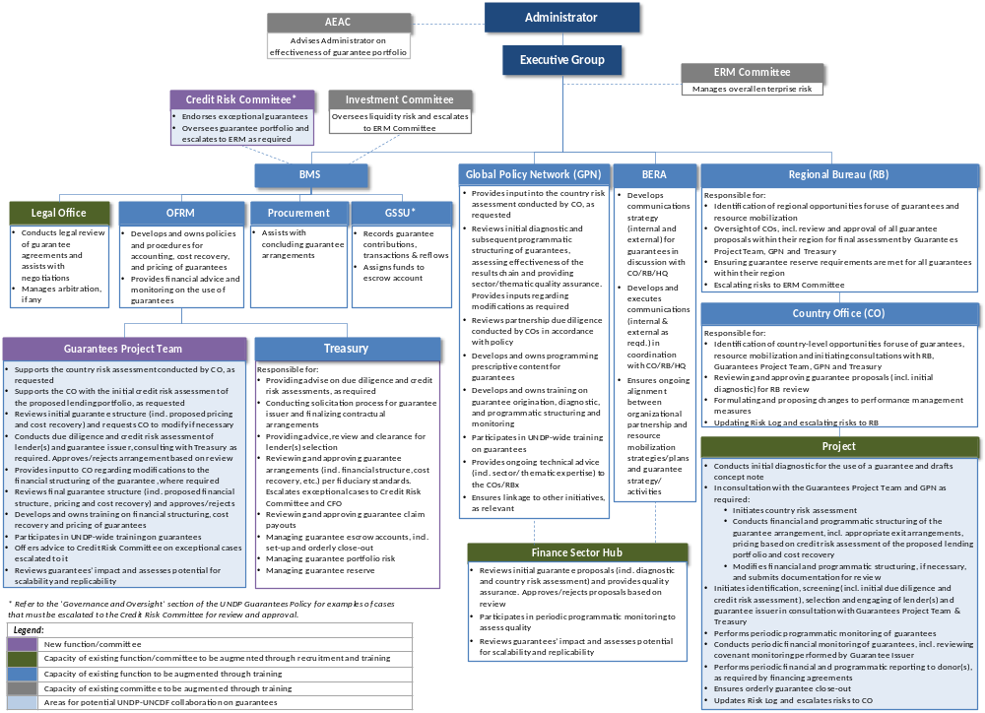

A key aspect of this structure is to rely on existing capacity in BPPS and BMS/OFRM, including Treasury. For example, the Global Policy Network (GPN) will assess the effectiveness of the results chain and provide sectoral/thematic expertise, advice and programmatic quality assurance to UNDP project teams that are planning to utilize UNDP-supported guarantees as part of their programming efforts, as they would for any other UNDP project. Capacity also exists in UNCDF that may be drawn upon. Additional centralized capacity is envisaged to be established (see below) to support and guide country offices and bureaux with utilizing UNDP-supported guarantees as part of their programming, while ensuring appropriate technical rigor and robust risk management with regard to the design and management of UNDP-supported guarantees.
Additional centralized capacity to support UNDP’s guarantee operations:
- Establishment of a new ‘Guarantees Project Team’ for the pilot phase to guide and assist country offices and bureaux with designing, structuring and issuing guarantees as part of UNDP projects.
- Establishment of a new ‘Credit Risk Committee’ to review exceptional UNDP-supported guarantees and provide ongoing oversight of UNDP’s guarantee portfolio.
- Hiring of expert(s) in the Finance Sector Hub to review initial UNDP-supported guarantee proposals (including initial diagnostics and country risk assessments) and provide quality assurance. Also provide support on POPP updates (if any), interpretation, and advice on compliance with programming standards and requirements.
Country offices and bureaux will also require capacity building through UNDP-wide training to help understand the appropriate use of UNDP-supported guarantees as part of UNDP programming. Further work at the country level will be carried out by the project team, supported by the teams based in HQ described above on policy, expert advice and risk mitigation strategies. This structure is consistent with the proposed central management and administration of UNDP-supported guarantees as recommended in the EG-approved ‘Concept Paper on Guarantees’, and identifies areas for UNDP-UNCDF collaboration on guarantees as laid out in the EG-approved “UNDP-UNCDF Collaboration Framework on Loans, Guarantees and Low-Value Grants” (Nov 2018).

- Management and Governance Structure of UNDP-Supported Guarantees
The following visual depicts the high-level business process flow for UNDP-supported guarantees:

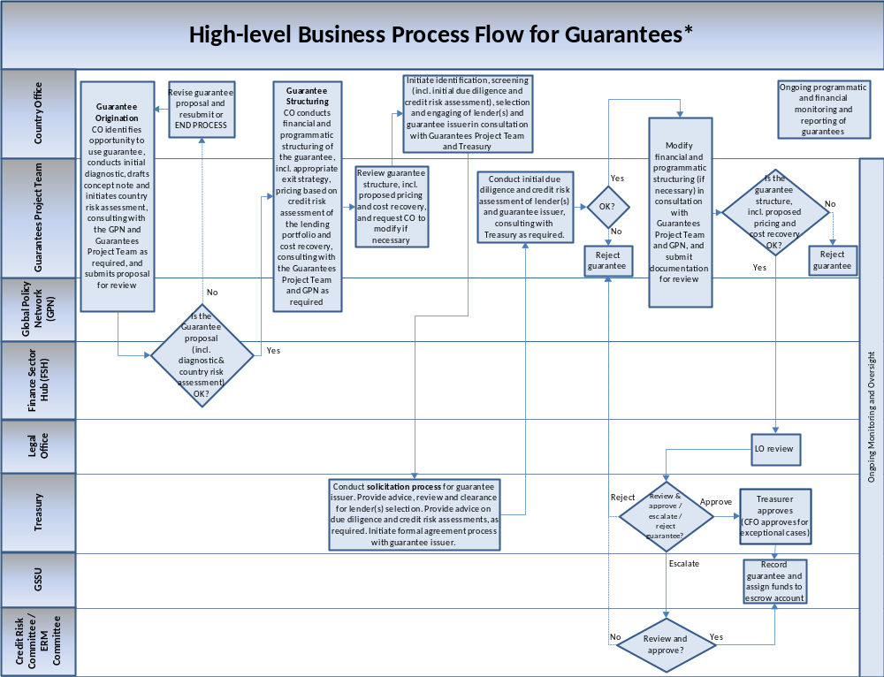
* This process flow depicts the specific steps required for the design, approval and management of UNDP-supported guarantees as part of UNDP projects. Process steps and approvals required as part of regular UNDP programming and risk management policies and standards (e.g. Bureau review and endorsement) continue to apply.
The accountability matrix below lists some of the key activities and accountabilities related to the effective origination, formulation and management of UNDP-supported guarantees. In addition, the relevant project phases have been identified for each activity to ensure alignment with the overall Programme and Project Management lifecycle.
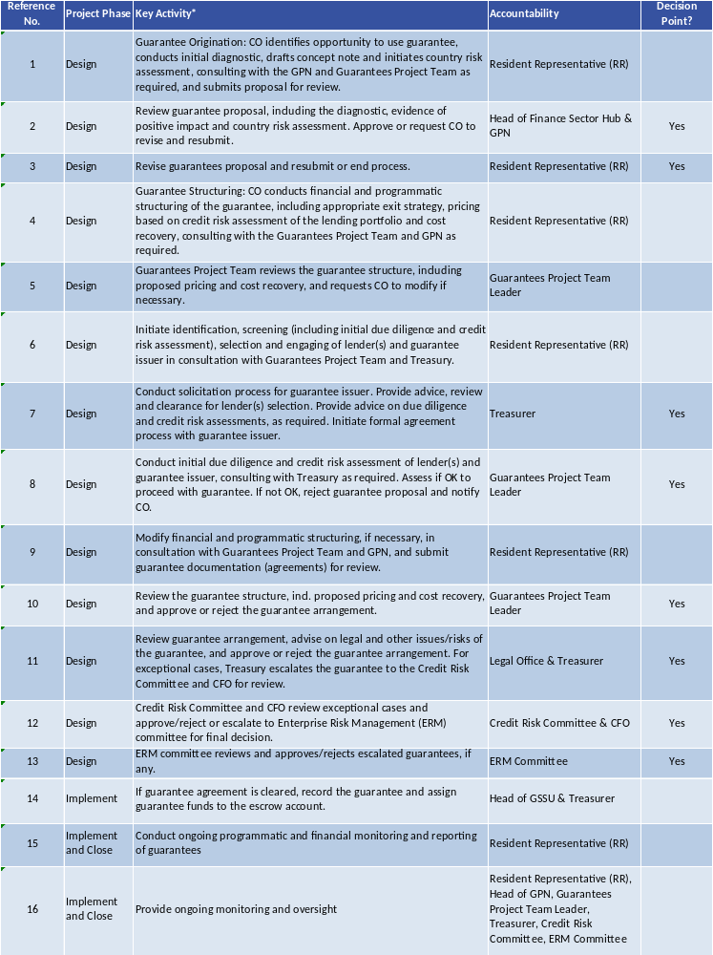
This table lists the specific steps required for the design, approval and management of UNDP-supported guarantees as part of UNDP projects. Process steps and approvals required as part of regular UNDP programming and risk management policies and standards (e.g. Bureau review and endorsement) continue to apply.
Risk management is an indispensable component of UNDP-supported guarantees. Risk assessments will be performed on lenders, the structure of guarantees and all aspects of credit activities, to identify the probability of adverse outcomes, such as default. Risks will be examined by country offices through their initial diagnostics. Per the process flow and accountability matrix above, the Guarantees Project Team, GPN, Finance Sector Hub and Treasury will also independently assess various risks in the UNDP-supported guarantee approval processes, based on their individual responsibilities as set out above. Process steps and approvals required as part of regular UNDP programming and risk management policies and standards (e.g. bureau review and endorsement) continue to apply.
If any exceptional cases or material risks are identified, the UNDP-supported guarantee proposal must be brought to the attention of the Credit Risk Committee for review. These UNDP-supported guarantee proposals will need to be endorsed by the Credit Risk Committee before the guarantee is approved. The Credit Risk Committee will consist of representatives from Treasury, Guarantees Project Team, GPN and members of other Regional Bureaux (the Regional Bureau which submits the guarantee proposal can be an observing member of the Credit Risk Committee). The Credit Risk Committee will be convened by any responsible division/office/bureau that identifies the risks. The Credit Risk Committee will be advised and supported by the Guarantees Project Team, a dedicated project team established to support the initial phases of roll out of the Guarantees Policy.
Exceptional cases or material risks identified that must be submitted to the Credit Risk Committee may include, but are not limited to;
- Risk coverage greater than 50 percent
- Excessive currency risk of funds held in the escrow accounts
- Large guarantee sizes exceeding USD 10 million
- Guarantee tenor exceeding 10 years
- Countries with very few banking partners where a fairly risky banking partner is selected
- Lending banks requiring full deposits to be made with them (instead of being held with the Guarantee Issuer)
- Any significant changes likely to occur or foreseen to happen (i.e. rapid changes in credit risks of banks or macroeconomic environment) during the approval process or implementation phase
- Exceptions that have been reviewed and cleared by the Chief Financial Officer, including those related to the sharing of risk on a pari passu basis (refer section 4.7 above) and the issuance of guarantees in the currency of the underlying loan/transaction (refer section 4.4 above).
If necessary, the Credit Risk Committee can escalate cases to the Enterprise Risk Management (ERM) Committee for its review. In response, ERM Committee may develop plans for managing material/escalated risks. The ERM Committee is chaired by the Associate Administrator with membership from UNDP senior management, and invited experts and other relevant representatives if needed.
The Credit Risk Committee will oversee the entire UNDP-supported guarantee portfolio, and the ERM Committee will manage overall enterprise risk including escalated risks.

Annex 1: UNDP-UNCDF Collaboration Framework on Loans, Guarantees and Low-Value Grants (as approved by the EG in November 2018)

- The key principles for the collaboration are as follows:
- Other than small micro-capital assistance loans under the Low-Value Grants Policy, UNDP does not issue loans currently. Any initiative involving UNDP that requires loan(s) that fall outside the scope of the LVG policy may be done through a joint programme with UNCDF, which has the mandate to provide loans.
- For programme/project components involving guarantees and/or low-value grants for micro-capital assistance, for there are two potential collaboration models:
  - Where UNCDF acts as a) a joint programme partner, or b) as an RP for the relevant UNDP project component; or
  - Where UNCDF is an RP technical service provider for UNDP under a UNDP project/programme, for specific activities related to the design or implementation of a UNDP-issued guarantee or low-value grants scheme.
- For guarantees and low-value grants (for credit purposes), the decision on which collaboration model is best depends on the funding status (i.e. whether it is a credit instrument or not), the programmatic mandate, the funding partner requirements and comparative advantage, which may include factors such as local presence, scale, availability of sectoral expertise, etc.
- This note provides guidance on potential options available, and does not imply exclusivity to either organization, who may work with other partners as the context demands.

- Decision Criteria:
- Notwithstanding any funding partner requirements, Table 1 below provides further detail on the decision criteria that may be used to determine the most appropriate UNDP-UNCDF collaboration modality.
Table 1 – Decision Criteria to Determine Appropriate UNDP-UNCDF Collaboration Modality
Financial instrument proposed as part of an initiative involving UNDP: | Decision Criteria |  |  |  | Collaboration Modality
 | Fully funded by funding partner? | Does UNDP have programmatic mandate? | Does UNCDF have programmatic mandate? | Who has comparative advantage? | Collaboration Modality
Loans (outside scope of LVG) | - |  |  |  | UNCDF may issue loans under a joint programme with UNDP
Guarantees | No | - |  |  | Neither UNDP nor UNCDF can issue unfunded guarantees. All guarantees must be fully funded.
Guarantees | Yes | Yes | No | - | UNCDF as an RP technical service provider for UNDP for specific activities
Guarantees | Yes | Yes | Yes | UNDP
Guarantees | Yes | Yes | Yes | UNCDF | UNCDF to act as joint programme partner or as an RP to UNDP for relevant component of the programme.
Guarantees | Yes | No | Yes | -
Low-Value Grants  (for Micro-capital Assistance Activities) | Yes | Yes | No | - | UNCDF as an RP technical service provider for UNDP for specific activities
Low-Value Grants  (for Micro-capital Assistance Activities) | Yes | Yes | Yes | UNDP
Low-Value Grants  (for Micro-capital Assistance Activities) | Yes | Yes | Yes | UNCDF | UNCDF to act as RP to UNDP for relevant component of the programme
Low-Value Grants  (for Micro-capital Assistance Activities) | Yes | No | Yes | -

- Application for UNDP-GEF Managed Vertical Funds
- It is important to qualify that in the case of all UNDP-GEF projects, the joint programme modality option with UNCDF is not possible due to the accreditation requirements of the various vertical environmental funds. In the case of the vertical environmental funds, UNDP only does joint programmes or projects with UN agencies who are accredited as an implementing entity for the fund in question. For UNDP-GEF projects, the applicable collaboration models with UNDCF would be limited to cases were UNCDF acts as a Responsible Party for a certain component of a UNDP project, or where UNCDF acts as a technical service provider.
- The seven vertical funds managed by the GEF Unit and to which this limitation would apply include: Global Environment Facility Trust Fund (GEF TF); Nagoya Protocol Implementation Fund (NPIF); Least Developed Countries Fund (LDCF); the Special Climate Change Fund (SCCF); the Capacity Building Initiative for Transparency (CBIT); the Adaptation Fund (AF); and the Green Climate Fund (GCF).
- Illustrative Roles and Responsibilities – Guarantees:
- Table 2 below provides more information on the potential roles and responsibilities of UNDP and UNCDF under the two collaboration modalities with respect to guarantees.
Table 2 – UNDP and UNCDF Roles & Responsibilities under Different Collaboration Modalities (Illustrative)
UNCDF’s Potential Role -> | Responsible Party – Guarantee Issuer | Responsible Party - Technical Service Provider
Defining Characteristics | UNCDF structures, issues and manages the guarantee for the relevant component of the UNDP programme.  The guarantee is recorded in UNCDF’s books. | UNCDF provides technical assistance to UNDP with respect to guarantee design and oversight of the guarantee issuer’s performance.  The guarantee is issued and recorded in UNDP’s books.
UNCDF’s Responsibilities | Performing the following functions:  - Pre-screening  - Due diligence  - Financial & programmatic structuring of the guarantee arrangement  - Risk assessment (incl. due diligence)  - Drafting guarantee agreement  - Investment Committee review  - Technical review of guarantee agreement  - Ensuring legal review of guarantee agreement by BMS/OLS  - Finalizing and signing guarantee agreement with development partner(s)  - Financial recording of guarantee and covenant monitoring  - Ongoing programmatic monitoring  - Termination of the guarantee arrangement  - Periodic financial and programmatic reporting to UNDP  - Transfer of unutilized funds back to UNDP | Advice to UNDP on the following matters:  - Financial structuring of the guarantee issuance arrangement, incl. exit arrangements  - Credit appraisal (incl. due diligence)  - Technical advice on the drafting of the guarantee issuance agreement  - Advising UNDP on risk management matters pertaining to the guarantee  - Assisting UNDP in negotiating agreement finalization with development partner(s)  - Advising UNDP on financial oversight of the guarantee issuer, ensuring periodic covenant monitoring, timely fee collection, managing claims (if any), funds disbursement, etc.  - Periodic financial reporting to UNDP
UNDP’s Responsibilities | - Origination/sourcing of guarantee opportunity  - Initial diagnostic (to confirm that a guarantee is the appropriate financial instrument to use to solve the development challenge)  - Resource mobilization  - Periodic financial and programmatic reporting to funding partner(s) | - Origination/sourcing of guarantee opportunity  - Initial diagnostic (to confirm that a guarantee is the appropriate financial instrument to use to solve the development challenge)  - Resource mobilization  - Programmatic structuring of the guarantee issuance arrangement, incl. exit arrangements  - Technical review of guarantee issuance agreement  - Management review of the guarantee issuance arrangement  - Finalizing and signing guarantee issuance agreement with development partner(s)  - Financial recording of guarantee  - Ongoing programmatic monitoring  - Exiting the guarantee issuance arrangement  - Periodic financial and programmatic reporting to funding partner(s)
Engagement Arrangements | - Standard UN to UN Transfer Agreement  - Guarantee funds transferred to UNCDF at agreement finalization | - Responsible Party for provision of technical assistance  - Guarantee funds retained and managed by UNDP through the project cycle.  - Funds for payout of approved claim(s) transferred by UNDP to the guarantee issuer when required
UNCDF’s Cost Recovery | - Standard UN to UN Transfer Agreement with recovery of:  - Direct costs  - Indirect costs | - Fee for services

- Operational Modalities and Cost-Recovery Considerations:
- As noted in the previous tables, in cases where UNCDF acts as a Responsible Party to UNDP in a project under direct implementation modality (DIM) or Country Office Support Services to national implementation modality (NIM), a UN to UN Transfer Agreement will be the applicable engagement instrument.
- In such cases it is expected that the full costs to UNCDF of performing the scope of work elaborated in the agreement are included in the Budget Section of such agreement and fully covered under the applicable project/program budget. This includes both direct costs and indirect support costs. The delivery of any project funds allocated under such a Responsible Party modality will be attributed to UNDP’s overall delivery in the context of the project.
- In the case of UNCDF acting as a technical service provider, the cost of UNCDF providing the service will be agreed and covered in the project budget.
- In cases where UNDP engages UNCDF as a Responsible Party to issue guarantees, UNCDF is permitted to follow its own Guarantees Policy, as articulated in the UNCDF Supplementary Guidelines to the UNDP Programme and Operations Policies (POPP).

Annex 2: Key Principles to be Included in Guarantee Issuer Agreements and Guarantee Agreements

The following key elements must be included in Guarantee Issuer Agreements between UNDP and the Guarantee Issuer, including in the UN-to-UN Agency Transfer Agreement when the Guarantee Issuer is UNCDF:
- Procedures for fund management and reporting to UNDP
- Liability limits of the different parties
- Procedures governing disbursement of funds by UNDP
- Procedures governing selection of lenders and disbursement of funds to lenders by guarantee issuer
- Expected guarantee leverage ratio
- Seniority of UNDP funds vs. other guarantors and debtors
- Operating costs (guarantee fees, origination, management and technical assistance costs, interest to be paid on guarantee funds)
- Services and cost-sharing to be provided by guarantee issuer (e.g. staff, office space and equipment, co-financing, etc.)
- Accounting and financial reporting requirements
- Profitability/financial criteria and benchmarks for the entire loan guarantee portfolio (e.g. overall payback time, IRR etc., of the portfolio of projects)
- What constitutes breach of agreement, covenants regarding return of funds
- Covenants regarding the Guarantee Issuer must include requirements to:
  - Maintain its books and records, and prepare its reporting in accordance with applicable standards
  - Periodically monitor the lending activities of the lender and ensure compliance to UNDP criteria and eligibility requirements
  - Retain all material information relating to the guaranteed loan(s)
  - Periodic progress reporting to UNDP and promptly furnishing UNDP with any information UNDP may reasonably request
- Mechanisms to resolve and arbitrate conflicts among the parties
- Profiles and qualifications of individuals responsible for operating the guarantee fund
- The non-waiver of UNDP’s Privileges and Immunities
- Indemnification if the Guarantee Issuer agrees to changes in terms without obtaining UNDP approval, or pays on an unjustified call by the Lender/Borrower or otherwise breaches the terms of the Guarantee Issuer Agreement/Contract
- Settlement of clams through arbitration

The payment terms and conditions under the Guarantee Issuer Agreement must align with the actual Guarantee Agreement (signed by the Guarantee Issuer and lending bank), and must specify the following guarantee terms and conditions. While the Guarantee Issuer is free to use its own guarantee template, at a minimum the following guarantee terms and conditions must appear in the Guarantee Agreement:
- Eligible transactions (sector, technology, project type, etc.)
- End Borrowers (size, eligibility criteria)
- Financing terms (guarantee percentage or risk or loan to be guaranteed, tenor, $ size range of individual guarantee (if applicable))
- Representations, warranties and covenants of the Lender (for example, clauses on how the Lender will diligently enforce rights under the Loan Agreement), which must include requirements to:
  - Maintain its books and records, and prepare its reporting in accordance with applicable standards
  - Periodically monitor the usage of funds by the Borrower and ensure compliance to the criteria and eligibility requirements laid out in the Guarantee Agreement
  - Retain all material information relating to the guaranteed loan(s)
  - Periodic progress reporting to the Guarantee Issuer and promptly furnishing the Guarantee Issuer with any information it may reasonably request. Permitting the Guarantee Issuer’s duly authorized representatives to examine copies of books, records, financial statements and any other material information related to the guaranteed loan(s)
  - Comply with al laws and regulations applicable to the borrower, including any applicable environmental and social standards and laws
  - In connection with the guaranteed loan, refrain from engaging in Corrupt Practices, Fraudulent Practices, Coercive Practices, Collusive Practices, or Money Laundering
  - Promptly notify the Guarantee Issuer upon learning of any loss or potential loss
  - Upon reasonable prior notice, permit the Guarantee Issuer or any authorized representatives of the Guarantee Issuer to visit and inspect projects and associated facilities under the guaranteed loan
- Claim requirements (i.e. the conditions under which the lender can call upon the guarantee to pay out a claim after a loan default occurs)
- Payment terms if the guarantee has to be paid in case the borrower defaults
- Guarantee pricing (Full cost recovery basis, including the percentage of guarantee fees, etc.)
- Process and distribution of recovered monies (settlement of disputes and legal mechanisms, seniority in recovery). Needless to say, since UNDP will not be a party to the guarantee that is issued, the Guarantee Issuer may insist on using non-UN dispute settlement terms in this bilateral relationship between it and the lender.
- Prohibitions set forth in Section 2.7 (b) (“Eligible Borrowers”) of this Operational Manual.

Annex 3: Good Practices for Lending

The following standards of good lending practices should be considered by financial institutions that want to incorporate adequate client protection practices into their lending process. The principles and standards below are applicable to a wide range of credit methodologies and can be adapted for use by financial institutions offering any type of loans:

- Product Information
- Financial institutions will present product information in a clear, fair and understandable manner to enable clients to understand the key features of the product, such as the interest rates, fees and charges that apply.
- Financial service providers should ensure that employees/agents are trained and are knowledgeable on all range of products on offer to clients.

- Product sale
- Clients will only be provided with a product that is deemed affordable and which meets the requirements of their needs.
- Financial institutions will ensure clients are provided with clear guidance on the information and documentation they will need to submit during the application process.
- Financial institutions will inform clients of the likely time it will take for a lending decision to be made and following receipt of the required documentation should ensure clients are kept up to date of the progress of their application.
- Financial institutions will take adequate care in all phases of their credit process to determine that clients have the capacity to repay without becoming over-indebted.
- Financial institutions should inform the clients if any security, for example, guarantee/debenture/indemnity, is required to support the borrowing or other liabilities and the reason why. The level of security required by the financial institution should be appropriate to the amount borrowed.
- Financial institutions will ensure that the client is provided with clear information on the circumstances under which the security will be released.

- Declined applications
- If an application of a product is declined, the financial institution should ensure the client understands the reason behind the decline. The client should be informed of their right of appeal and the financial institution should have a fair and effective process in place to review a decision to decline an application.
- Where appropriate, the client should be made aware of the alternative sources of finance available.

- Product execution
- Information provided to clients will be clear in terms of presentation and in clarifying the action the client needs to take. Client requests will be dealt with in a timely, secure and accurate manner.
- Financial institutions will ensure that any changes to the terms of the client’s agreement are clear, fair and transparent.
- Financial institutions will maintain security of client data but may share information about day-today operations of a client account(s) with credit rating agencies where applicable.

- Credit monitoring
- Financial institutions should ensure that a sufficient level of monitoring of a client’s debts is undertaken to help determine if the client is exhibiting signs of financial stress. Where relevant, appropriate support should be offered.
- Financial institutions should ensure relevant client facing employees and relevant third parties are sufficiently trained and skilled to help identify and deal with clients who may be showing signs of financial stress.
- Financial institutions should undertake monitoring and assurance work to ensure that their policies and processes are designed and are operating effectively in identifying and supporting clients who are showing signs of financial stress.

- Financial difficulty
- Financial institutions should have triggers, processes, policies and procedures in place to help identify clients who may be in financial difficulty and should promptly address the situation with the client.
- Clients identified as being in financial difficulty should be contacted and provided with information on support available to them. They should not be subject to harassment or undue pressure where discussing their financial situation.
- Financial institutions should work with and support a client’s turnaround plan where the financial institution believes that it has a good chance of succeeding.

- Portfolio Management
- Financial institutions should follow robust due diligence processes when selecting third parties for debt sale or debt collection activities to ensure that clients will continue to be treated fairly.
- Financial institutions should ensure that where the decision is made to sell a client’s debt and contractual terms require the client’s consent to do so, this is obtained prior to any sale taking place.
- Where an agreement allows for a financial institution to sell a client’s debt without their consent, financial service provides should ensure that:
    - the client is provided with reasonable notice that the financial institution intends to sell their debt and provided with clear information as to what the sale means for the product(s) that they hold with the financial institution and;
    - if the relationship with the client will be serviced by the third party, full contact details for the purchaser are provided.
- Financial institutions who sell non-performing debt should take appropriate and reasonable steps to ensure that the third party, to whom the client’s debt has been sold, deals with the client in a manner that is consistent with the relevant requirements of the relevant contractual terms.
- Where debt is sold and during the lifetime of the original agreement, a dispute arises between the client and the third party which the parties are unable to resolve, financial institutions should ensure that they have processes in place to allow the client access to the financial institution’s complaints procedure.

- Vulnerability
- Financial institutions should have a vulnerability strategy which defines their approach to the identification and treatment of individuals considered vulnerable.
- Financial institutions should have policies and processes governing the identification and fair treatment of individuals in vulnerable circumstances. These should consider the varying nature and degrees of permanence of different vulnerabilities.
- Where a financial institution is developing a new product, or reviewing an existing product, it should consider vulnerability as part of the design or review process, paying regard to target market, clarity, accessibility and the operation of the product.

- Governance and Oversight
- Financial institutions must have adequate governance, policies, processes and management information and controls to enable effective oversight of adherence to standards and delivery of fair client outcomes.
- Financial institutions should have an effective risk management framework appropriate to the size of the financial institution.
- Financial institutions should ensure that the product design stage takes into account internal and external risks which could impact upon a client’s ability to maintain their repayments so that new products do not lead to unsustainable borrowing.
- Financial institutions should undertake both post-launch and cyclical product reviews to ensure that their products are, and remain, fit for purpose.
- Financial institutions should ensure that their employees and their agents are adequately trained to deliver the client outcomes, and that any incentive schemes are driving the right behaviours to ensure fair client outcomes.

Annex 4: Procurement Guarantees

UNDP’s procurement volumes and demand for procurement services in health, elections, sustainable energy and crisis-response sectors have continuously risen over the years. This is largely due to an increase in requests from governments and other development partners for procurement of essential commodities, where the development partners lack adequate procurement capacity or where UNDP is in a position to get better value for money on high value and high-volume commodity purchases. Many of these high-volume items procured by UNDP have long lead times for delivery to partners. Whether UNDP undertakes the procurement or whether countries procure their own supplies, there is often a timing mismatch between the release of national budgets funds (to procure the commodities) and when the procurement and payment for commodities needs to occur. These short-term budget issues along with the high lead times for delivery to partners create technical difficulties and significant delays for implementing partners waiting for the commodities. Similarly, national governments alone may not have adequate purchasing power to secure the optimal price for supplies. By procuring these items globally, backed by guarantees from funding partners and/or UNDP, a portfolio of procurement volume could be advanced providing more planning certainty to implementing partners, whilst also providing certainty to suppliers and securing improved pricing.
UNDP and funding partners can utilize procurement guarantees to underwrite various parts of the procurement supply chain in a variety of ways which include:

- Option 1 – Funding partners guarantee the procurement activities of countries through a pooled procurement facility (bridge fund facility) established by UNDP
The UNDP-supported pooled procurement facility is a comprehensive bridge fund mechanism that allows pre-delivery financing for member countries wishing to procure supplies or commodities through UNDP. The facility allows countries to repay after critical supplies are delivered thereby reducing stock-outs and ensuring a systematic and sustainable provision of goods, drawing upon UNDP negotiated LTAs. The goal of the facility is to help member governments become independent in funding and procurement without disruption to the supply of essential commodities. A facility like this provides countries with assistance to strengthen their planning and budgeting processes to manage procurement of essential supplies. The facility will pre-finance the countries commitment for procurement needs and allow countries to make payments for the supplies upon delivery at expectedly lower prices due to longer term purchase commitment, which became possible through procurement guarantees.
As with other forms of UNDP-supported guarantees, a full guarantee from funding partners would be required to establish such a facility, such as a counter-guarantee offered by a third party (e.g., foundation, international financial institutions, etc.), against firm procurement commitments of partners across a portfolio of projects. Without a guarantee facility provided by funding partners, UNDP will be exposed to the risk of non-payment (default) and in some instances may be exposed to foreign exchange risks as commitments made in local currency may lose value due to fluctuations in the market compared to the currency of the procurement. To offset these risks, the pooled procurement facility should be supported by guarantees issued by funding partners who can cover the risk to UNDP of default or risk of loss in value of the facilities’ resources. This reduces the financial risk to UNDP - in the event that the goods are received, UNDP will be able to draw upon the guarantee. However, reputational risks with the funding partner may emerge, should the beneficiary government not be in a position to meet its financial obligations on the delivery of the procured items. Funding partners therefore play a critical role by either providing funding to capitalize the facility or by underwriting the procurement and repayment activities of the facility through guarantees.
Ensuring countries are self-reliant in procurement is increasingly important as countries graduate from donor support and invest more and more of their own resources into the procurement of essential commodities like vaccines (particularly middle-income countries). The pooled procurement facility supported by guarantees would:
- Offer member countries access to a dependable and affordable procurement system
- Provide alternative short-term financing terms
- Help ensure a continuous supply of essential commodities from reliable suppliers at better pricing
- Offer pre-planning support to countries to define procurement needs and programmatic activities earlier
- Strengthen member countries capacities in procurement, budgeting and planning
- Potentially improve stock management and reduce shortages due to poor planning
- Create a pool of flexible capital in the form of revolving funds which can be replenished when funding partners contribute to the facility and member countries make repayments
- Accelerate and strengthen UNDP’s global procurement work

- Option 2 – UNDP and/or funding partners directly guarantee the procurement activities of individual countries or implementing partners (outside of a pooled procurement facility described in Option 1)
Many governments are increasingly using domestic funding to procure essential commodities that contribute directly to development outcomes, for example medical supplies, medical and laboratory equipment, solar photovoltaic systems, smart cards, electoral supplies, education materials etc. For countries or implementing partners procuring their own supplies, the use of guarantees offered by UNDP and/or funding partners improves credit terms for countries by helping match payment to delivery of supplies for a pre-defined period and thereby facilitating timely procurement of essential supplies that aligns better with the timing of availability of funding. When UNDP is solely offering the guarantee, UNDP would require that the guarantees be fully funded by funding partners (as is the normal practice with other UNDP-supported guarantees), for example through counter-guarantees issued by third parties (e.g. foundation, international financial institutions, etc.).

- Option 3 – UNDP can facilitate guarantees to suppliers on sales volume and price of essential commodities
UNDP can also play a critical role in procurement by facilitating arrangements with funding partners to guarantee suppliers a certain volume of sales for several years in exchange for the supplier’s commitment to produce stipulated amounts of commodities. This would reduce prices for commodities particularly for markets in energy, agriculture, education, electoral support and women’s rights as well as healthcare. Such market shaping interventions which create demand (guaranteeing the offtake of X number of solar panels at Y price) encourage the production of supply in developing countries. In addition, volume guarantees like this give suppliers the certainty they need to invest in innovation and expanded production, which lowers per-unit costs but still ensuring commercial viability from the higher volumes that can drive bigger profits. With a long-term fixed price contract, funding partners can guarantee to make up any shortfall in demand from buyers. If demand continues to be strong, there will be no call on the funding partners’ guarantee. Mechanisms such as volume guarantees can help jumpstart powerful market forces and increase access to goods and services for millions of people.

OECD: Amounts mobilised from the private sector by official development finance interventions in 2018-19 Highlights August 2021
UNDP/GEF Climate Change Advisory Note: Guarantees
Source: OECD, “Guarantees for Development”, 2014.
A key argument for credit guarantee facilities is the presence of information asymmetries. Banks do not have full information about their potential clients’ capacity and willingness to repay. Research has shown that this phenomenon, known as information asymmetry, affects small firms more than large firms. It leads to a relatively low allocation of credit to smaller firms and SMEs, even though such enterprises may represent a healthy economic sector. Credit guarantee funds can rectify this market imperfection.
“Moral hazard” may occur if lenders are too insulated from the risk of a project as they may take less time and effort to carefully perform their own due diligence leading to them taking on excessively high-risk projects. Similarly, borrowers may lose their incentive to repay when they feel they are well covered by the guarantee. Therefore, proper design and implementation of guarantees should ensure that moral hazard is limited by sharing the risks amongst the lender, the borrower and the guarantor.
A diagnostic tool will be developed to support this process.
“The “amount mobilised” by a guarantee is the full nominal value of the instrument (e.g. loan) to which the guarantee relates, regardless of the share of this value covered by the guarantee”; Source: Mirabile, M., J. Benn and C. Sangaré (2013), "Guarantees for Development", OECD Development Co-operation Working Papers, No. 11, OECD Publishing, Paris.
Terms of reference will be developed for the Credit Risk Committee.
Special conditions may apply for UNDP-GEF where, at the request of and with the agreement of the funding partner, a limited first loss guarantee maybe approved on an exception basis. In such cases, UNCDF should be engaged to issue the guarantee.
To avoid making the guarantee costly either a i) or ii) can be charged. Fees are charged either to the (i) funding partner or (ii) to the lender who can pass the fee on to the borrower if it is commercially viable to do so.
Refer Annex 1 for details.
“The “amount mobilised” by a guarantee is the full nominal value of the instrument (e.g. loan) to which the guarantee relates, regardless of the share of this value covered by the guarantee”; Source: Mirabile, M., J. Benn and C. Sangaré (2013), "Guarantees for Development", OECD Development Co-operation Working Papers, No. 11, OECD Publishing, Paris.
International Labour Organization, “Guarantee funds for small enterprises. A manual for guarantee fund managers”
To avoid making the guarantee costly either a i) or ii) can be charged. Fees are charged either to the (i) funding partner or (ii) to the lender who can pass the fee on to the borrower if it is commercially viable to do so.
At the conclusion of the 5-year pilot phase, the Guarantees Project Team will be disbanded, and specialized resources will be distributed across bureaux.
The Low-Value Grants for Micro-capital Assistance Policy is governed by UNDP Financial Regulation 19.01.
i.e. full cost of the liability is funded by funding partner(s) in advance of the liability being incurred by UNDP or by UNCDF.
Technical service provider provides technical services to UNDP on a cost-sharing basis, which will be added to the project budget.
Adapted from the British Bankers' Association (BBA)
It should be noted that UNDP is not a procurement agent. Rather, the procurement services should be offered for areas where UNDP has a comparative advantage and is thus already a large buyer in these markets.

