UNDP Risk Appetite Statement Guidance

Detailed risk appetite statement guidance

October 2021

Contents
1) Introduction 3
2) Understanding the risk appetite statement 3
3) How and when do I use the risk appetite statements? 3
4) Applying the risk appetite statement 4
5) Learning from the risk appetite 8
6) Varying from the stated risk appetite 9
Annex 1: ERM Risk Categories 10
Annex 2: ERM Risk Appetite statement categories and level 11
Annex 3: Aligning the risk appetite to risk significance in the risk matrix 14
Annex 4: Risk appetite summary 15

Introduction
This guidance has been developed to support the consistent application of the Risk Appetite Statement (RAS) across UNDP. It has been written for all UNDP Personnel, partners and others who work with UNDP to help it deliver its Strategic Plan. The RAS and this guidance are part of UNDP’s Enterprise Risk Management (ERM) framework and is aligned to ERM methodology and risk assessment process.
Risk management enables the transformation of resources and ideas into high-impact results, delivered in uncertain conditions. The purpose of setting out a risk appetite is to support the effective management of these risks (threats and opportunities) through open discussions about the level of risk that UNDP is and is not prepared to take and to ensure that everyone takes a consistent approach to risk throughout the organization. This guidance should be used as part of your office, BU or project general ERM assessment to enable the effective delivery of all UNDP plans and objectives.

Understanding the risk appetite statement
In any situation, be it a project, programme or operational process to support delivery of UNDP’s objectives, you will need to carry out a risk assessment using UNDP’s ERM methodology, covering a variety of risks and so a variety of areas of risk appetite. We have used the example of developing a new UNDP office to help you understand how to apply the appetite statements as part of your risk evaluation. The guidance is a starting point and not a definitive statement regarding the RAS implementation and you will need to apply judgement, in discussion with others, when you use the RAS.

How and when do I use the risk appetite statements?
The risk appetite statements are used as part of the risk assessment exercise carried out by risk owners (Integrated work plan, new project/programme) to support risk-informed decision making; you should refer to the ERM Guidance for a detailed explanation on the ERM methodology. The risk appetite process should be integrated (not a separate process) into the office and BU risk assessment activities as follows:
    - Start by carrying out a risk assessment to identify what risks you are facing, describe your risks clearly and score them (likelihood and Impact), following UNDP standard ERM methodology.
    - Identify which categories/sub category of risk you have (Social and Environmental, Financial, Operational, Organizational, Reputational, Regulatory, Strategic, Safety and Security) using the ERM Risk Categories (see Annex 1)
    - Compare the risk significance to the risk appetite level for that risk category (see Annex 2)
    - Look at the Risk Matrix (see Annex 3), If the score exceeds the risk appetite, you will need to take a risk-informed decision to consider what more you could do to manage the risk so that it is acceptable. This includes accepting the risk if there is nothing that can be done, or you cannot reduce the risk sufficiently in an economical, timely and effective fashion or avoiding the risk by redefining the objective and/or the activity. Risk owners are responsible for making the resources needed to manage risks available and for putting the agreed controls in place.
    - If the score is within the risk appetite, consider if all the controls that you have in place are necessary. It may be possible and appropriate to relax the control environment, but you should always seek to control risks if it is economically viable and effective to do so.
    - Follow the usual ERM practices, document the process and your decisions clearly and keep the risks and their scores under review. They may change and so the level against the appetite may change and your risk controls may need to change. The reasons for these changes should also be documented to explain your decisions and for transparency.
The process is summarized in the flow chart below.
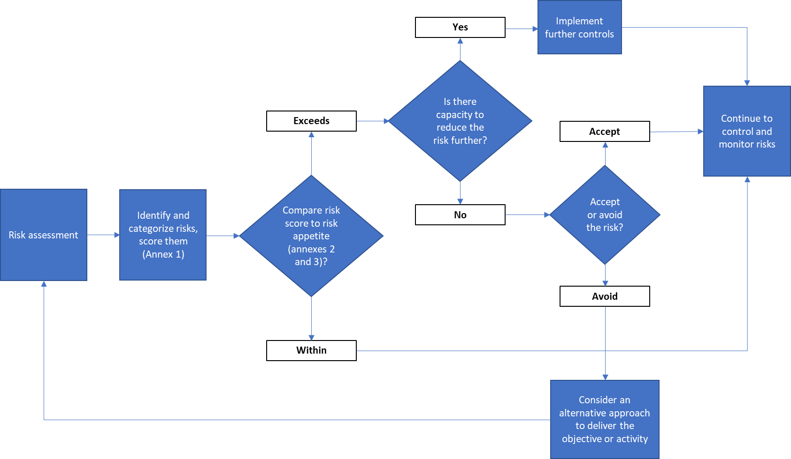

Applying the risk appetite statement
As illustrated in the Risk Appetite Statement, UNDP has set out eight areas over which the risk appetite has been defined (Annex 2). To help you understand and apply the RAS in practice, in this section, we will use two examples.
Example 1:
UNDP Oceania CO wants to open a project presence in a post-conflict mountainous region called Terra. Despite Oceania’s remarkable achievements, development challenges remain, including persistent disparities of ethnicity, gender and locality. Three quarters of the population are near poor lacking resilience to shocks. New forms of social, economic and environmental deprivation have emerged due to the civil war, affecting labor migrants and informal sector workers, particularly women.
You have been assigned as the Programme Officer/CO focal point to lead this process. Before establishing the project office, there are many aspects that need to be considered, all of which bring both opportunities and risks. These could include Government support and agreement to establish an office, key stakeholders and donors buy-in for the project presence establishment, security and safety concerns, office setup and operational requirements (procurement, legal, HR, etc.), financial investments, implications, and sustainability, UNDP’s programmatic offer and resource mobilization, competition and UNDP’s competitive edge, partnerships and implementation modalities including social and environmental concerns.
Looking at these aspects, what are the possible risks associated with the establishment of a project presence? What are the threats that may impact on your objectives and what are the opportunities that you can capitalize on to establish UNDP’s presence in Terra? To support you in this, we will select few risks, assess and match them against the risk appetite for the relevant category to evaluate whether the current level of risk is within the risk appetite or exceeds it and what it is then appropriate and cost effective to do to manage the risk. We are going to concentrate on financial, reputational, operational, and social and environmental risks.
The budget to establish a project presence based on an initial cost estimate when the proposal was prepared. You are now on the ground and have carried out in-depth market research and analysis and the level of uncertainty around the actual costs of the project presence establishment is becoming clear. You are particularly concerned that rental, office renovation and ICT infrastructure and security mitigation measures costs may exceed the assigned budget. You have summarized the risk as follows:
Event  The funds/budget to establish the project presence may be insufficient | Cause  Variance on building rental, renovation and security and running costs  Likelihood: 3 – Moderately likely | Impact  - Potential budget increase of up to 25%  - Cannot set up the project presence in the agreed time  Impact: 3 - Intermediate
Risk appetite (financial): Minimal to cautious | Risk level:  Moderate | Risk category and sub-category:  2. Financial  2.5. Delivery

You have used the ERM methodology to calculate the risk scores and have both an impact and likelihood score of 3. This gives an overall risk significance of ‘moderate’ (Annex 3), which equates to a risk appetite of ‘exploratory’. You have also determined that the risk category (from the risk column) is financial (Annex 1); the risk appetite for financial risks is minimal to cautious (Annex 2) and so it is clear that your financial risks currently exceed UNDP’s risk appetite.
You now need to decide how to manage this risk to bring it within acceptable levels (reduce the likelihood to 1 and/or reduce the impact to a maximum of 2) by changing your plans slightly, revisiting the office and renovation specifications OR increasing the initial budget in consultation with the CO and key stakeholders/donors because deviating from the original plan may cause reputational consequences for UNDP as they have committed to opening the project presence within a fixed time-frame, shared with the government of Oceania and, donors, stakeholders. Once you have put these treatment measures in place, you will then need to keep monitoring the situation to ensure that the controls are working as expected and the risks are being kept at an acceptable level, as you would for any risk.
The government of Oceania and key stakeholders is delighted that UNDP has decided to have a project presence in Terra; it believes that this reflects UNDP’s continuous commitment to support Oceania in achieving its development goals. However, as UNDP is perceived as new player in the development arena in Terra region, it is thought that implementing partners, CSOs and local actors may challenge UNDP’s inclusive approach in implementing it programmatic activities and interventions specially that there are several minority ethnic groups that live there, with little trust between them and the majority population of Oceania (Oceanics) in light of the civil war. The different stakeholders and beneficiaries may not be fully engaged with UNDP, hindering our projects’ activities and delivery of our commitments to the Oceania Government and donors.
Event  Implementing partners and local actors resistant to working with and accepting UNDP as a trusted development partner | Cause  - UNDP is perceived as new development player in the Terra region and is seen as not well-versed with the local context and political tension in between the different beneficiaries  Likelihood: 3 – Moderately likely | Impact  - Stakeholder engagement is reduced, and project activities and implementation are hindered  - Inability to meet delivery targets and commitments to the government and donors  Impact: 3 - Intermediate
Risk appetite (reputational): Cautious | Risk level:  Moderate | Risk category and sub-category:  5. Reputational  5.1. Public opinion and media

This risk has been analyzed using the ERM methodology: it is thought that most stakeholders can be kept engaged and the majority of the results can still be delivered (a deviation of up to 30% with an impact score of 3) and that there is a moderate likelihood (a score of 3) that this will happen. This gives an overall risk significance of ‘moderate’ which equates to a risk appetite of ‘exploratory’. The risk category is determined to be reputational as it refers to working relationships with partners. The risk appetite for reputational risks is ‘cautious’, so this level of risk is higher than UNDP’s risk appetite and need to be managed within acceptable levels.
You have also been making operational plans, including a recruitment strategy and plan. Due to the levels of deprivation and war in Terra, education level is not good and sourcing well-qualified candidates to join the UNDP project presence is challenging. The market has limited job opportunities and unemployment rates among young people and women are even lower. UNDP’s job fair is seen as a great opportunity for many locals but finding suitable and well-experienced applicants that meet job profiles and requirements, including gender balance, which were prepared in accordance with UNDP recruitment framework policy, may not be possible.
Event  Failure to timely recruit enough well-trained staff and meeting recruitment strategy | Cause  - Unavailable/limited pool of qualified candidates  Likelihood: 2 – Low likelihood | Impact  - Delays in programme and project implementations  - Inability to be fully operational on time  Impact: 4 – Highly likely
Risk appetite (organizational):  Exploratory to open | Risk level:  Moderate | Risk category and sub-category:  4. Organizational  4.7. Human Resources

Staffing risks fall into the organizational category, which has a risk appetite of ‘exploratory’ to ‘open’. While the impact of failing to staff the office with enough capable staff is very high (score of 4), the likelihood of this happening is low (a score of 2), a risk significance of ‘moderate’, which is within the risk appetite. There could be some opportunities to take greater risks with staff recruitment, perhaps by taking on staff with potential rather than proven ability, while investing in building their capacities and skills.
As you can see from the above examples, it is important to evaluate and score risks following the ERM methodology before comparing them to the risk appetite for that area. In this way you will understand where more controls are needed but also where you might be able to do less and/or take greater risks.
Example 2:
You are overseeing the design of an area-based project in Terra. The project is building the capacity of the local government to be able to manage services, including registration of land titles and village courts to provide justice services for minor disputes. There are 12 minority ethnic groups that live in Terra, with little trust between them and the majority population of Oceania (Oceanics) in light of the civil war that ended 2 years ago.

This project is critical for Oceania. The many disputes over land access in recent years have threatened to plunge the country back into civil war. Ethnic minority groups claim the Oceanics have stolen their land through state-run administrative processes in the capital to which minority groups have no access. By bringing the title process to the local government in the region, it should not only enable more equitable title management, but the new village access to justice program can help ensure land disputes are decided locally.

The project has, however, significant risk. After applying the Social and Environmental Screening Procedure, the country office could see that local communities were concerned that the local government offices were staffed with Oceanics and minority groups did not have confidence that they would be treated fairly. Village leaders also expressed concern that their people would not have the ability to navigate the land management system and dispute process because they spoke a different language than the language the documents and proceedings were in. This could lead to discriminatory impacts on minority communities, which is likely to exacerbate the conflict. The likelihood of unfair changes to community-based property rights is high.

You have summarized the risk as follows:

Event  Unfair changes to community-based property rights that are discriminatory towards minority communities. | Cause  - The land title process and  - local dispute resolution process is not adapted to be accessible or fair to minority communities.  Likelihood: 4 – Highly likely | Impact  - Minority populations lose access to their land they have used for generations.  - Loss of livelihoods based on use of the land.  - Loss of homes and the break-up of minority communities.  Impact: 4 – Extensive
Risk appetite (Social and Environmental):  Cautious | Risk significance:  Substantial | Risk category and sub-category:  1. Social and Environmental  1.1. Human Rights

In this case, the risk is higher than UNDP’s risk appetite. We must mitigate the risk to make it acceptable to UNDP’s risk appetite.

In this case, the project obtained permission from the authorities to translate all land title paperwork into the local language so they would be accessible to minority ethnic groups and to train local lawyers from minority groups in land management law. The project also received a commitment that 60% of the staff in the local government office would be recruited from minority communities, to better represent the population of the Terra district. UNDP set aside resources to train these new staff and mentor them for the duration of the project, while setting up an internal mentoring system so existing staff could mentor new staff on an ongoing basis.

These changes to the project changed the likelihood of the risk from 4 down to 1 (the impact remained unchanged), making the risk now acceptable to take with the mitigation measures in place.

Learning from the risk appetite
The risk appetite statement and this guidance are implemented in a spirit of learning and continuous improvement. They are not static documents and will change over time as UNDP’s risk culture matures and as its understanding of its risk appetite improves. Your contribution to learning and improvement is vital:
- By acknowledging and learning from failure in innovations, in projects and programmes and in implementing the RAS
- By giving greater attention to those risks in excess of the RAS that have been accepted and following up on the outcome
- By highlighting where controls and the governance framework have not been properly applied and a risk has materialized as an impact
- By identifying where further guidance is needed to support the consistent and useful implementation of the RAS.
In this way, the risk appetite will continue to develop to meet UNDP’s evolving needs and become embedded within the ERM framework as a vital support to risk-based decision making and the delivery of UNDP’s strategic plans.
Annex 3 summarizes the different level of risk appetite across each risk category, showing what an increased or decreased risk appetite might look like.

Varying from the stated risk appetite
The aim of a RAS is to provide a consistent approach to risk management across an organisation by everyone in every circumstance. However, there are occasions when the UNDP will decide to operate beyond its risk appetite, for example in a high-risk environment when staff need to be enabled to ‘stay and deliver’. On such occasions, where the agreed RAS is exceeded, this should be done deliberately, consciously and by ‘working out loud’ through well-documented discussions with the risk management team and the Risk Committee. Such areas of risk must be kept under constant review and any opportunities to reduce them nearer to the risk appetite must be taken.

Annex 1: ERM Risk Categories
1.Social and Environmental | 2. Financial | 3.Operational | 4.Organizational | 5. Reputational | 6. Regulatory | 7. Strategic | 8. Safety and Security
- Human rights  - Gender equality and women’s empowerment  - Grievances (Accountability to stakeholders)  - Biodiversity conservation and sustainable natural resource management  - Climate change and disaster risks  - Community health, safety and security  - Cultural heritage  - Displacement and resettlement  - Indigenous peoples  - Labour and working conditions  - Pollution prevention and resource efficiency  - Stakeholder engagement  - Sexual exploitation and abuse | - Cost recovery  - Value for money  - Corruption and fraud  - Fluctuation in credit rate, market, currency  - Delivery  - Budget availability and cash flow | - Responsiveness to audit and evaluations (Delays in the conduct of and implementation of recommendations)  - Leadership and management  - Flexibility and opportunity management  - Reporting and communication  - Partners’ engagement  - Transition and exit strategy  - Occupational safety, health and well-being  - Capacities of the partners | - Governance  - Execution capacity  - Implementation arrangements  - Accountability  - Monitoring and oversight  - Knowledge management  - Human Resources  - Internal control  - Procurement | 5.1. Public opinion and media  5.2. Engagement with private sector partnership  5.3. Code of conduct and ethics  5.4. Communications  5.5. Stakeholder management  5.6. Exposure to entities involved in money laundering and terrorism financing | - Changes in the regulatory framework within the country of operation  - Changes in the international regulatory framework affecting the whole organization  - Deviation from UNDP internal rules and regulations | - Alignment with UNDP strategic priorities  - UN system coordination and reform  - Stakeholder relations and partnerships  - Competition  - Government commitment  - Change/turnover in government  - Alignment with national priorities  - Innovating, piloting, experimenting | 8.1. Armed conflict  8.2. Political instability  8.3. Terrorism  8.4. Crime  8.5. Civil unrest  8.6. Natural hazards  8.7. Manmade hazards 8.8. Cyber security and threats

Annex 2: ERM Risk Appetite statement categories and level
The Statement places each category of risk on a risk-appetite scale that ranges from ‘minimal’ to ‘seeking’:
Open
Minimal
Cautious
Exploratory
Seeking

- Minimal risk appetite – areas where UNDP will apply a strong control environment to reduce or minimize the likelihood that a risk will occur and/or reduce the impact of any risk
- Cautious risk appetite – areas where UNDP seeks low-risk delivery options, and will pilot innovation only in a controlled environment
- Exploratory risk appetite – areas where UNDP strikes a balance between the potential upside benefits and downside costs of a decision and considers new solutions and options for delivery
- Open risk appetite – areas where UNDP has determined that the potential upside benefits outweigh the risks and informed risk-taking is appropriate. All potential options are considered
- Seeking risk appetite – areas where UNDP takes risks to explore new ideas and approaches, looking for innovation and recognizing that failures are an opportunity for learning and improving.
Risk Category | Overall Risk Appetite
Social and Environmental  UNDP plans all of its project and programmatic activities to safeguard those who are affected by them and to do no harm, socially or environmentally, always behaving in an ethical fashion.  It takes positive steps to engage with disadvantaged groups and does not tolerate any form of discrimination or harassment. UNDP will mitigate these risks by ensuring that its personnel and partners are conscious of the controls that need to be implemented to safeguard people and the environment and to ensure that the “do no harm” principle is applied.  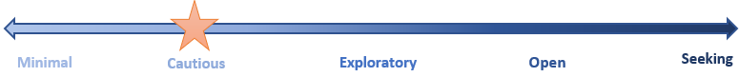 | Cautious
Financial  UNDP seeks to manage its financial resources effectively in order to deliver its objectives in a timely fashion while maintaining organizational sustainability and stability, minimizing fraud, and ensuring protection of assets. It allows some financial flexibility in pursuit of its objectives and when undertaking activities under development funds, but never in a way that threatens its core business activities, always aiming to deliver on the goals of the strategic plan. UNDP is transparent in all it does and safeguards its funds from the risk of fraud.  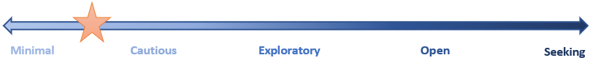 | Minimal to Cautious
Operational  UNDP encourages variance in operational delivery and quality to explore innovative approaches and work with new partners, provided this does not jeopardize stakeholder trust. UNDP continues to introduce new and innovative operational tools, procurement approaches, procedures, and mechanisms to strengthen delivery and continuity of operations and programme implementation. It regards failure as an opportunity to learn and develop.  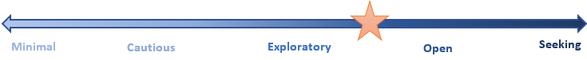 | Exploratory to Open
Organizational  UNDP takes an agile approach to stay relevant in all areas of intervention and takes informed risks to ensure organizational effectiveness, agility, learning and resilience. It ensures compliance with corporate governance rules and policies, and its ethical standards, while continuously exploring new and innovative ways of doing business to be a fit-for-purpose organization. | Exploratory to Open
Reputational  UNDP is a highly trusted and valued organisation and cannot compromise its ethical stance, credibility, and reputation among all its stakeholders (governments, donors, implementing partners, private sector, civil society, and beneficiaries, etc). UNDP wants to protect its organizational value and its reputation through effective and innovative delivery of its programmatic offer, meeting commitments, due diligence activities, partnerships and managing expectations, while exploring new options for delivery and partnerships and learning and developing from its pilots. | Cautious
Regulatory  UNDP will find legitimate ways through the legal and regulatory framework to deliver its strategic plans, including joining interpretations of regulations from other UN agencies with similar regulatory frameworks. | Cautious
Strategic  UNDP prioritizes the development and implementation of its strategy, seeking new and innovative ways to deliver high-value services, programmatic offers, and objectives, expanding, and diversifying its donor and partner pool while learning from any failures and always following its ethical principles.  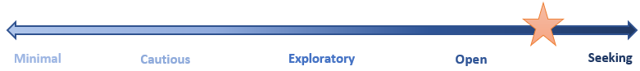 | Open to Seeking
Safety and Security  UNDP puts in place effective measures to reduce its exposure to security and safety risks affecting personnel, premises, assets and operations in order to enable the delivery of activities. Even in situations of significant risks, UNDP programmatic activities will deliver under appropriate and agreed mitigations and controls. UNDP will take necessary risks, including decisions at the appropriate level of delegated authority after all has been done to reduce risks to acceptable levels in accordance with the UNSMS Policy on Security Risk Management.  UNDP manages cybersecurity to safeguard the confidentiality and integrity of its information. | Cautious

Annex 3: Aligning the risk appetite to risk significance in the risk matrix

Impact | 5 | Exploratory | Open |  | Open |  | Seek |  | Seek
 | 4 | Cautious | Exploratory |  | Open |  | Open |  | Seek
 | 3 | Cautious | Exploratory |  | Exploratory |  | Exploratory |  | Open
 | 2 | Minimal | Minimal |  | Cautious |  | Exploratory |  | Exploratory
 | 1 | Minimal | Minimal |  | Cautious |  | Cautious |  | Cautious
 |  | 1 | 2 |  | 3 |  | 4 |  | 5
 |  | Likelihood
Risk significance |  | Low |  | Moderate |  | Substantial |  | High

Annex 4: Risk appetite summary

 | Minimal | Cautious | Exploratory | Open | Seeking
1. Social and Environmental | Do no harm, even minor for the greater good | Aim to do no harm, but trivial harm for the greater good tolerated | Aim to do no harm, but prepared to take some low risks to explore innovative ideas | Aim to do no harm, but prepared to take moderate risks to explore innovative ideas | Aim to do no harm, but prepared to take significant risks if the potential gains are great enough
2. Financial | Up to 5% budget deviation  Focus on financial security  Fraud and corruption not tolerated | Up to 20% budget deviation  Balance between financial security and value for money  Fraud and corruption not tolerated | Up to 30% budget deviation  Focus on value for money  Fraud and corruption generally not tolerated | Up to 50% budget deviation  Focus on value for money through new financial approaches  Fraud and corruption generally not tolerated | Above 50% budget deviation  Seeking new financial approaches  Fraud and corruption avoided
3. Operational | Tried and tested approaches to delivery only  No innovation  Tried and tested partners only | Aim to deliver to expectations but small deviations are tolerated  Low risk/controlled innovation | Tolerates deviations in operational delivery and quality to innovate  Minor failure tolerated | Encourages deviations in operational delivery and quality for innovation  Failure is an opportunity to learn | Focus is on finding new and innovative approaches, trying new ideas and building on failures
4. Organizational | Tried and tested approaches to delivery only  Inflexible internal control environment | Aim to deliver to expectations but small deviations are tolerated  Strong internal control environment | Tolerates deviations in operational delivery and quality to innovate  Cautious flexing of controls in relation to risk | Encourages deviations in operational delivery and quality for innovation  Control environment driven by risk | Focus is on finding new and innovative approaches, trying new ideas and building on failures  Control environment driven by balancing risk and cost
5. Reputational | No damage to UNDP reputation | No compromise to UNDP values but will tolerate minor reputational damage in pursuit of its plans | No compromise to UNDP values  Meet commitments by managing expectations  Learning from new approaches | No compromise to UNDP ethical values  Maintain credibility by managing major stakeholders  Prepared to damage reputation with minor stakeholders | No compromise to UNDP ethical values  Prepared to damage reputation with all but the most significant stakeholders
6. Regulatory | No tolerance to move outside the set regulatory framework | Will look for legitimate ways to achieve goals | Will explore minor changes to regulations to enable delivery | Will challenge regulations to deliver if success seems likely | Will challenge regulations to deliver if success seems possible
7. Strategic | Tried and tested approaches to delivery only  No innovation  Tried and tested partners only | Tried and tested approaches to delivery preferred  Low risk/controlled innovation  Low risk new partners if necessary | Will adapt tried and tested approaches to delivery and explore new ideas  Innovation where success seems likely  New partners where they may be beneficial | Open to new approaches and testing new ideas  Innovation for success is encouraged and failures are tolerated  Open to approaches from new partners who do not fit the usual model | Always looking for new ways to do things  Innovation to learn is encouraged and failures are useful  Look for new partners in new areas who are outside the normal modal
8. Safety and Security | Install controls to ensure no harm to any UNDP resources | Install controls to minimize harm to any UNDP resources but prepared to accept low risks | Install controls to minimize harm to any UNDP resources but prepared to accept moderate risks. | Install controls to minimize harm to any UNDP resources while prioritizing delivery but prepared to accept high risks | Install controls to minimize harm to any UNDP resources while prioritizing delivery but prepared to accept very high risks

The United Nations Security Management System (UNSMS) Policy on Security Risk Management endorsed by the Chief Executives Board for Coordination (CEB) outlines the Acceptable Risk Model in which security risks are balanced with programme benefits. In this model, risks are accepted when benefits outweigh the risks.
Cyber Security is outside the UNSMS Security Risk Management and risks are managed by UNDP.

