Route, Mode of Transportation, and Standard of Accommodation

- The three basic considerations related to official travel organized and paid by UNDP are defined as follows:

  - Routing (most economical route of travel from the place of origin to the official destination that does not exceed the most direct route by four (4) hours or more AND does not add a connection).
  - The preferred mode of transportation (e.g. rail, road, sea / inland water or air).
  - Standard of accommodation (i.e. authorized class of travel).

Example One:
A Bangkok based staff member has been asked to undertake a one-week mission to Kuala Lumpur. There are two direct flight options to fulfill the mission:

Airline | Flight duration | # of Connections | Fare
A | 8 Hours and 30 minutes | 0 | $303
B | 9 Hours 30 minutes | 0 | $144

In above example the official itinerary and fare is Airline B, which is the most economical, does not add a connection to the itinerary, and does not add more than four (4) hours to the journey time.

Example Two:
A New York based staff member been asked to undertake a one-week mission to Addis Ababa. There are no direct flights to the mission destination, only itineraries with one or more connections to fulfill the mission:

Airline | Flight duration | # of Connections | Fare
A | 41 Hours and 25 minutes | 1 | $3,800
B | 41 Hours 50 minutes | 1 | $3,600
C | 45 Hours 30 minutes | 1 | $3,500

In above example the official itinerary and fare is Airline B, which is the most economical, does not add an extra connection to the itinerary, and does not add more than four (4) hours to the journey time.

- Air travel is the largest source of greenhouse emissions associated with global UNDP operations. Therefore travel should be minimized and replaced with other forms of communications to the extent possible in order to reduce UNDP’s environmental impact. Where travel is necessary, travel modes and routes should be selected to reduce the environmental impact of that travel.

Route and Mode of Travel

- The normal route and mode of transportation for all official travel is the most economical route by air that does not exceed the most direct route by four (4) hours or more AND does not add an extra connection. When the journey duration is less than five (5) hours, rail and other ground transportation may be strongly encouraged where available and secure to reduce the environmental impact of that travel. An alternative route and mode of transportation may be approved when, in the opinion of the Secretary General, it is in the best interest of the organization.

- Under the provisions of Appendix D to the UN Staff Rules, a staff member is insured for travel by means of transportation furnished by or at the expense or direction of UNDP, when authorized in advance. This includes travel by automobile when not used for the personal convenience of the staff member.

Travel Planning

5. UNDP units and Country Offices (COs) are encouraged to establish a travel plan (not mandatory) in advance as part of their annual work plan.

Making Reservations

- An official itinerary is created when you are requested to travel on behalf of the organization. It defines the origin, official destination and any stopovers including official dates and times of travel. The traveller must provide the travel agency with the latest possible arrival date and time, the earliest possible departure date and time and preferred mode of travel to establish the official itinerary. The official departure date is normally the day on which travel must start to allow the traveller to arrive at the place of official business before commencement of duties. The official return date is normally the day after duties on official business have ended.

- Travellers or arrangers must make the travel reservations through the designated travel agency for their office. In Country Offices without a designated travel agency, or one participating in the travel card pilot program, the unit responsible for the travel arrangements must ensure the route, mode of transportation, standard of accommodation, and all other aspects of the policy are applied.

- The traveller should make travel arrangements as early as possible. As soon as the mission is approved, and even before the TR is actually created, flight reservations should be made with the travel agency in order to obtain the official itinerary and most economical fare for the trip. The booked itinerary identifies stopovers and is used to determine the estimated mission cost including terminal expense, DSA and transportation all of which are required to prepare the Travel Request (TR).

- In making flight reservations when the TR is not yet available, the traveller should inform the travel agency of both the official itinerary and any requested itinerary (if applicable) so that the travel agency may be guided accordingly in determining the official route, travel time and rest stops. The travel agency will however review these against the approved TR.

- Flight reservations and fares are often subject to ticketing deadlines. It is therefore important that the travel agency receive the approved TR as early as possible. Late receipt of TRs by the travel agency could result in flight reservations being cancelled and/or much higher air ticket costs.

Lowest Available Airfare

- Official travel by air will be by the most economical, including restrictive and nonrefundable, available airfares provided that the total additional time of the whole journey does not exceed the most direct route by four (4) hours or more AND does not add a connection. The traveller will be provided with the lowest fare in the applicable class of service (refer to the standard of accommodation section of this policy). In the event that the most economical fare does not include checked luggage it is within the discretion of the authorizing unit to approve a higher fare that includes one piece of checked luggage in the approved cabin.

- Travellers are expected to travel at any time during the travel day unless constrained otherwise by business requirements. Travellers will be provided with the lowest fare available in their authorized class of service, on or within a 24 hour window prior to, or following, the working day. If any business requirement constrains the purchase options for tickets the constraint must be approved. For example, due to a meeting schedule the traveller needs to depart or arrive during a certain timeframe. In these instances the time constraint must be documented on the TR and approved by an authorizing official.

- If security restrictions exist they will be communicated to the traveller by UNDSS during the travel security clearance process and can also be found in the UNDSS Travel Advisory - (Registration Required).
In the event of late night or early morning arrival, it is recommended that the traveller communicates with the recipient duty station to arrange for appropriate transportation or airport pick-up.

- When the arrival or departure is outside of 9am to 9pm, and the office deems they are unable to arrange appropriate transportation, or are unable to address the staff member’s personal security concerns, an exception may be approved. In these instances the arrival or departure time exception must be documented on the TR and approved by an authorizing official.

- There is a UNDP Global List of Commercial Airlines Pre-approved for Travel by UNDP Personnel published in the UNDP Intranet/Security Office. Refer to Commercial Air Travel Safety Guidelines for information on the categorization of commercial passenger airlines and approval procedures.

- In the event that the staff member finds a better fare from an outside source for travel originating from HQ in New York, in their authorized class of service, the designated travel agency will try to match it.

Standard of Accommodation

- The table below identifies the applicable classes of service with respect to flight duration, traveller type and purpose of travel. Flying time is calculated from the origin to the destination, based on the scheduled departure and arrival times, with up to two (2) hours added for transit time (i.e. the time one spends in an airport waiting for a connecting flight).
The most direct route is defined as the shortest journey time from origin to destination with the least number of stops.
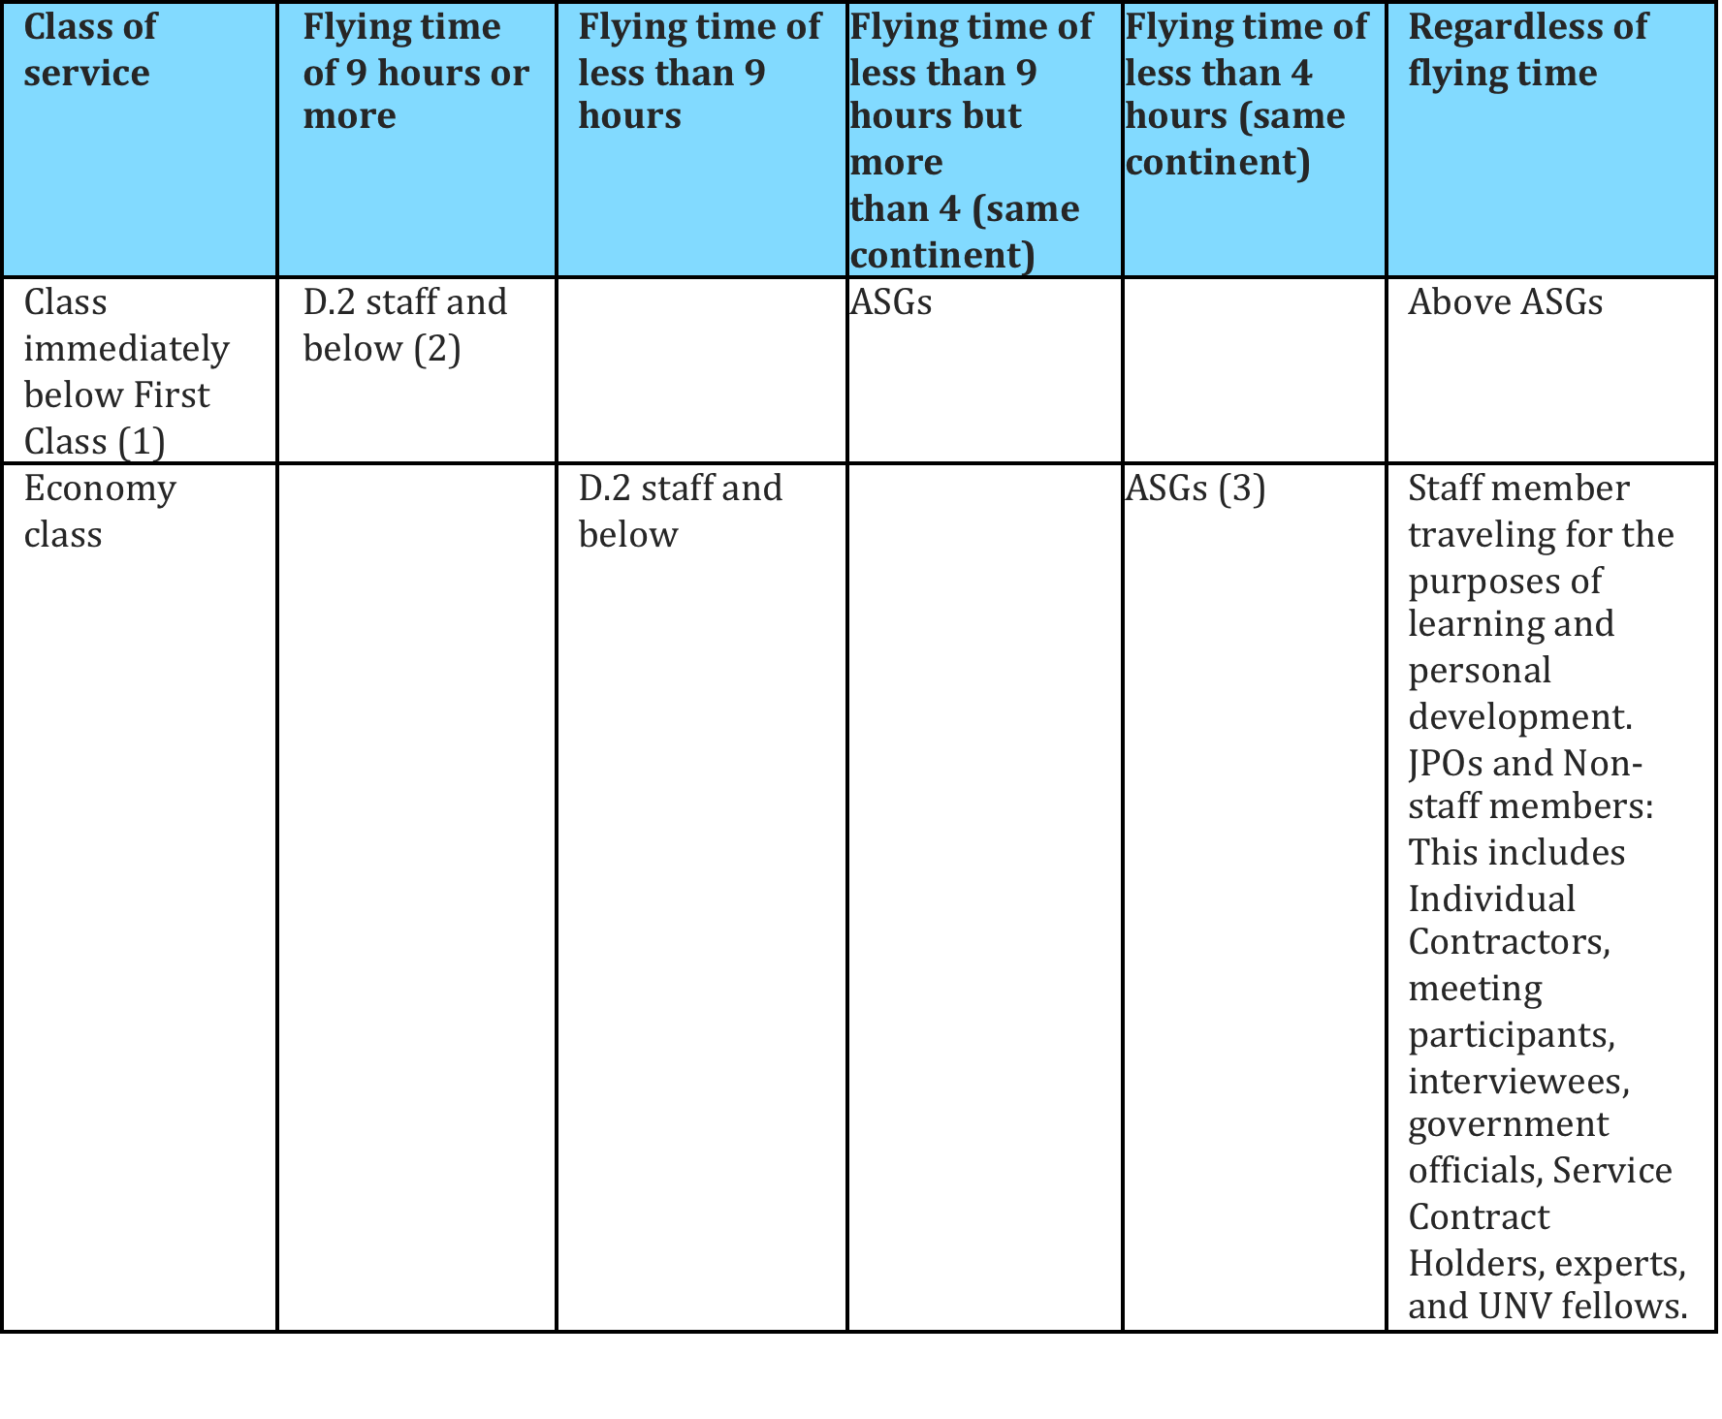

⁽¹⁾ In the event the service is fulfilled with a two-cabin plane with only a First and Economy cabin the entitlement is the cabin above Economy.
⁽²⁾ For round-trip travel, when the duration of either outbound or inbound journey is nine hours or longer, the class immediately below first class shall be provided.
⁽³⁾ This excludes overnight travel, where the traveler must work upon arrival.
⁽⁴⁾ Executive Board Members who travel on UNDP sponsored official missions will be given the same standard of accommodation as UNDP staff.

- The normal route and mode of transportation for all official travel is the most economical route provided the whole journey does not exceed the most direct route by four (4) hours or more AND does not add a connection. For simple round trip itineraries, when the outbound journey duration differs from the return flight, the combined flying time of all legs is totaled to identify the most direct airline for the mission. The calculation of flying time shall include scheduled stops for change of planes and other purposes. The reason for calculating the total journey duration (outbound and inbound) in these instances is to identify the airline with the most direct service because fares are typically cheaper when ticketing with one airline round trip versus issuing two one way tickets.

- Deviations from the approved route, mode of transportation or standard of accommodation may be made for personal convenience as long as it does not increase costs to the organization or increase the travel time allowance beyond what it would have been with the approved route.

- Use of a more economical fare does not entitle a traveller to further transportation or to purchase another ticket using any savings. If the traveller elects to downgrade the class of service, reducing travel costs as well as substantially reducing the traveller’s environmental impact, the lowest fare will then be calculated in the down-graded class of service based on the same route and airline carrier.

- A tolerance threshold in the cost of tickets is provided for the sole purpose of allowing the traveller some flexibility in the choice of departure/arrival airports/carrier and/or rest stops, where applicable. If the difference between the fare for a requested itinerary and the fare for the official itinerary is US$500, or less, it is at the authorizing unit’s discretion to approve and pay for the requested itinerary fare. If the difference exceeds the threshold of $500, even by one dollar, the traveller will pay the full difference in fare.

Example:
  - If the official fare is $1,500, it is at the authorizing unit’s discretion to approve and pay the requested fare if it is no more than $2,000.
  - If the official fare is $3,300, and the requested fare is $3,900, the traveller pays the total difference of $600; as the threshold has been exceeded.
  - If the official fare is $5,000, and the requested fare is $5,500 or less, the traveller does not pay for the difference in fare if the authorizing unit elects to authorize the higher fare, as the difference does not exceed $500

- If a traveller combines personal and official travel, the personal segments must be booked at the same time as the official portion. Please note that the tolerance threshold in the cost of tickets referred to above cannot be used to fund personal travel segments.

- In the event that the official portion of the trip is cancelled or postponed, UNDP will not be responsible for any expenses/losses that may be incurred by the traveller in connection with the personal portion of the itinerary. The traveler is responsible for any delays, penalties or additional expenses incurred as a result of personal deviations. A traveller who deviates from the approved travel route for his/her personal convenience is not covered by UNDP liability under Appendix D to the Staff Rules, during the legs of the journey which correspond to the deviation from the approved route.

- Travellers that choose an indirect route who are otherwise eligible for a stopover will be entitled to such stopover with appropriate DSA (not to exceed the DSA at the stopover by the most direct route or destination if a direct flight was possible) provided that the stopover that has been made complies with the requirements in the table provided in the Travel Time & Rest Stopovers section.

- When warranted by special circumstances (refer to A/67/356 for information on exception to air travel), the Chief, General Operations, BMS, may exceptionally authorize an upgrade from economy to business class travel with no additional cost to the traveller. A completed TTS.3 must be submitted containing the justification with all necessary supporting documents. Exceptional upgrades to first class shall be authorized only by the Secretary General in advance of travel. All approved exceptional upgrades shall be reported quarterly to the UN Under-Secretary General, Department of Management, for inclusion in the annual report to the UN General Assembly.

Advance Ticket Purchase / Changes to Travel Itineraries

- It is strongly encouraged to confirm travel itineraries as early as possible and purchase (not only book) airline tickets at least 21 days in advance of travel when traveling in the class below First and at least 14 days in advance when traveling in Economy Class to have the best opportunity to confirm the lowest fare. Wherever possible, changes to advance bookings should be avoided. In the event that a change is required, incurring fees which are greater than the funds encumbered during the authorization process, the change must be approved by the appropriate authorizing official.

- It is the traveller’s responsibility to notify the designated travel agency of a trip cancellation prior to the scheduled departure date. If the ticket is non-refundable UNDP may be able to rebook the ticket and use the unused portion, after any applicable fees and charges, to a future trip with the same provider. Where possible, the designated travel agency will provide the requirements and process to re-use the ticket. In the absence of a designated travel agency the airline should be notified of a trip cancellation prior to the scheduled departure date and will guide appropriately if the ticket can be refunded or re-used for future travel.

Travel Time and Rest Stopovers

- Travel time is determined on the basis of the most economical route, either by air or by the fastest available surface mode of transportation when air travel is not used that does not exceed the most direct route by four (4) hours or more AND does not add a connection. When the journey duration is less than five (5) hours, rail and other ground transportation may be strongly encouraged where available and secure to reduce the environmental impact of that travel.

- Journey time is calculated by combining the flying time of all legs of the journey to a destination by the most economical route that does not exceed the most direct route by four (4) hours or more AND does not add a connection, plus up to two (2) hours of transit time, provided the journey is not interrupted for official stops of more than 24 hours. If a journey is interrupted en route for official business for more than 24 hours, the standard of accommodation is based on the duration of the travel to that official stop location. The flying time excludes travel time to and from airports, and waiting time prior to departure. It is necessary to specify the “hour of departure” and the “hour of arrival” to determine travel time, as these will be considered as the time when the airplane, train, vessel, vehicle used by the traveller is scheduled to leave from or arrive at its regular terminal.

- In calculating journey time for the purpose of determining rest stops a maximum of up to two (2) hours will be added for the duration of transit time in each scheduled waiting period between connecting flights, subject to the condition that travel has been undertaken by the most direct and economical route. For example, if there are two (2) connections a maximum of two (2) hours is added for the duration of transit time incurred during each connection to determine the journey time.

- Actual travel time spent by a staff member during a normal working day will not be charged to annual leave.

- A staff member will be granted a compensatory day off if required to travel on a non-working day to or from the duty station to a place of mission. This compensatory day off may be exercised immediately after the non-working day or within four (4) months of return to the duty station, upon approval. If a staff member is required to travel on two (2) consecutive non-working days, the staff member will be entitled to two (2) compensatory days off if the actual travel time was 24 hours or more in duration.

- For example, if a staff member is required to travel on Sunday to enable him/her to attend a meeting on Monday, one day of compensatory day off shall be given to the staff member. If it is necessary for the return travel to also take place on a non-working day, the staff member shall be allowed another compensatory day off. If the compensatory day off on the outbound travel was not taken immediately after the non-working day, it can be taken separately or together with the compensatory day off for the return travel in which case the two (2) compensatory days off can be taken on two (2) consecutive days upon completion of the entire journey.

- Staff members traveling by air, or mostly by air, shall be entitled to rest periods before commencing duties, or a stopover for rest purposes.

- A rest stopover is normally taken in the course of an air journey and should be noted and approved on the TR. However, when there are two different modes of transportation involved, and the total travel time is at least 16 hours, a stopover for rest purposes may be taken at the end of the air portion of the journey while awaiting onward travel by another mode of transportation.

- UNDP liability under Appendix D to the UN Staff Rules shall cover only authorized stopovers for the authorized duration and waiting periods for connecting flights. If the staff member chooses to stay for a longer period for his/her personal convenience, UNDP will cease to have any liability beyond the authorized period of that stopover. UNDP liability under Appendix D does not apply to non-staff members.

Summary of Travel Time and Rest Stopovers

Duration of journey | 6 hours but less than 10 hours | 10 hours but less than 16 hours | 16-24 hour journey
Number of rest stops | No rest stop permitted.  The staff member is not required to commence duty within 12 hours of arrival at the duty station. | No rest stop permitted.  The staff member is not required to commence duty within 24 hours of arrival at the duty station | 1 rest stop permitted  Option 1 If no rest stop taken, the staff member is not required to commence duty within 24 hrs. of arrival at the duty station.  Option 2 If the rest stop is taken and the final stage of the journey exceeds 6 hours but is less than 12 hours, the staff member is not required to commence duty within 12 hours of arrival at the duty station; if the final stage of the journey exceeds 12 hours, the staff member is not required to commence duty within 24 hours of arrival at the duty station.

Travel by Train or Bus

- Travellers are strongly encouraged to travel by train and other forms of public transport when the duration of the journey is less than five (5) hours. When traveling by rail within the United States the traveler is entitled to standard below First class. When traveling by rail outside of the United States, the traveller is entitled to business class, including sleeper where appropriate, or first class accommodation should no business class service be offered.

- Travel by Boat When authorized to travel by boat, the traveller is entitled to the standard of accommodation the cost of which does not exceed the amount that would have been paid for air travel (if air transportation is available).

Travel by Automobile - Using Privately-Owned Vehicles

- Travellers required to travel by privately-owned automobile are entitled to reimbursement based on the UN established operating rates per mile for automobile travel. These rates vary geographically, reflecting local prices and conditions that determine running costs, depreciation and repairs. All these have been factored into the rates of operating costs, and no additional compensation is available beyond the established rates. The UN reviews these rates, and OHR keeps all offices regularly informed of any changes.

- Reimbursement for travel within a radius of thirty-five miles (35) of the official duty station is based on actual mileage. For travel beyond a thirty-five mile (35) radius, the mileage used in calculating operating costs for travel is that by the most direct and economical route. Commuting costs between residence and place of business will not be reimbursed.

- In addition to vehicle operating costs, other expenses such as DSA, road/bridge/tunnel tolls will be reimbursable. The total reimbursement is limited to the maximum travel expenses to which the staff member would have been entitled had he/she traveled by air by the most direct and economical route (if air transport is available).

- Where the journey requires that a portion of travel be by train, ferry, ship or a combination thereof, reimbursable expenses will include port charges and the cost of passage for both the traveller and the automobile, subject to the maximum amount indicated in the preceding paragraph.

- The distance covered by train, ferry or ship is included in the computation of distance traveled, for purposes of determining DSA, unless the cost of passage includes either food and/or accommodation.

- A traveller who is authorized to travel by automobile is entitled to travel time, not chargeable to annual leave, equal to the time which would have been required had he/she traveled by air by the most direct route (if air transport is available)

- All running costs, depreciation, repair, and other automobile expenses shall be the traveller's responsibility.

- UNDP encourages travellers to car-pool where possible and reasonable. When there is more than one (1) traveller in a vehicle, reimbursement of vehicle operating costs will be made to one traveller only.

- The UNDP will not provide automobile insurance for travellers’ using their own vehicles for official travel.

- The provisions of Appendix D to the UN Staff Rules will not apply for privately-owned vehicle transportation sanctioned or authorized by UNDP solely at the request of, or for the convenience of the staff member.

- Refer to ST/AI/1998/2 for the administrative instruction on reimbursement for travel by private motor vehicle.

Travel by Automobile - Using UNDP Vehicles

- Maintenance and operating costs for UNDP vehicles are managed by the duty station. The duty station authorizing the use of the vehicles pays for these costs.

Exceptions to the Standard of Accommodation

- To request an upgrade to a higher level of accommodation (refer to A/67/356 for information on exception to air travel), the unit authorizing the official business travel should complete TTS.3 by submitting well in advance of travel to the Chief of GO/BMS by creating a case through UNall

- If the upgrade creates a savings to UNDP, then an exception form does not need to be completed (excluding any upgrades to first class). The travel agency at HQ in New York or CO and other BUs outside of HQs will request authorization directly from TSS/GO/BMS. In CO, this would be done by the Resident Representative or his/her delegate. Upgrades to first class are not permitted, without the approval of the Secretary-General as stated above.

- For upgrades for medical reasons, the traveller should obtain a medical report/certificate from his/her doctor. The completed standard of accommodation exception request should be submitted directly to the Office of the Director, Medical Services Division well in advance of the proposed travel, using the standard for accommodation exception request (TTS.3 form). The Office of the Director, Medical Services Division will then review the case and forward the recommendation to the requestor, who will in turn forward the request to the Chief, General Operations, BMS who will make a final decision.

- Travel Support Section/GO will advise the requester if the standard for accommodation exception request (TTS.3) has been approved. In the case of HQ travel in New York, if approved, TSS will authorize the designated travel agency at HQ to ticket accordingly. TSS will keep a record of the approved upgrades for reporting to Chief, General Operations, BMS. Roles and Responsibilities

- The roles and responsibilities detailed below are applicable in exceptional cases when a lower fare is identified in a higher class of service than the approved standard of accommodation.
Responsible Party | Responsibilities
Traveller | Provides the travel agency with the latest possible arrival and the earliest possible departure time and preferred mode of travel.
Travel Counselor | Notifies TSS (New York reservations) or CO and other BUs outside of HQs organizing travel (reservations outside of New York) if there is a lower fare in a higher class of service, upon request by the traveller.  Documents the ‘in policy airfare’ ticket amount, airline and corresponding itinerary.  Issues ticket per TR instructions and emails itinerary/invoice to traveller.
TSS (bookings made through HQ in New York) or Resident Representative or their designate (bookings made outside of New York) | On an exceptional basis, gives the designated agency authorization to issue the lower fare in a higher class of service when exceptional circumstances occur. Authorization for air travel in first class shall be authorized only by the Secretary General in advance of travel, following established procedures.
Travel Processor | If the higher class of service is available at a lower cost (excluding first), makes reference to the higher class of service on the Travel Request and has it approved.

56. The roles and responsibilities detailed below are focused on exceptions to the standard of accommodation at an additional cost to the organization.

Responsible party | Responsibilities
Traveller | Provides the travel agency with the latest possible arrival and the earliest possible departure time and preferred mode of travel.
Travel Counselor | Documents the ‘in policy airfare’ ticket amount, airline and corresponding itinerary and the airfare ticket amount based on the requested standard of accommodation.  If business requirements prevent the lowest fare from being accepted, documents the itinerary with the difference in airfare between lowest and the traveller preferred airfare.  Issues ticket per instructions on the Travel Request and emails itinerary/invoice to traveller.
Organizer of Travel | Prepares standard of accommodation exception request (TTS.3) and supporting documents. Has the Head of Office sign the request and submits to Chief, General Operations/Bureau for Management Services for approval. In cases of exceptions for medical reasons, forwards to UN Medical for clearance.
Head of Office | Signs request for exception to standard of accommodation (TTS.3 form).
UN Medical Services  Division | Evaluates the request for exception to the standard of accommodation for medical conditions. Sends the recommendation to the requestor.
Chief, GO/BMS | Evaluates request for exception in the standard of accommodation (TTS.3) and makes a determination (i.e. approves or declines). If request If request is for first class makes the determination if the request will be submitted to the Secretary General for approval.  Returns decision to the requestor (approval or denial of request).
Secretary General | Authorizes exceptional upgrades to first class.
Travel Services Section | Tracks approved TTS.3 exceptions to the standard of accommodation and reports to the UN.

Templates and Forms

Request for exception to the standard of air accommodation (TTS.3 Form)

