The Harmonized Conceptual Funding Framework and Cost Recovery Methodology

- A joint decision of the Executive Boards of UNDP/UNFPA, UNICEF and UNWOMEN approved a new harmonized conceptual framework for defining and attributing all costs, both programme costs and organizational costs (DP-FPA/2012/1), and a new harmonized methodology for calculating cost-recovery rates on other resources (non-core) (DP-FPA/2013/1; DP/2013/9).

- Within the context of the Integrated Budget (DP/2013/41 and EB decision 2013/28), integrating in one framework the DP/2012/25 - Programming Arrangements and the institutional budget, the new funding and cost recovery frameworks have a significant impact on how Country Offices, Regional Centers and HQ activities are funded to successfully deliver on the results outlined in the UNDP DP/2013/40 - Strategic Plan.

- The Integrated Budget is reflective of the evolution of UNDP’s Business Model, reaffirming the realignment of resources and acknowledging synergies and linkages between development and institutional results at country, regional and global levels, and the associated resource requirements and cost attribution. It recognizes that institutional activities represent essential strategic enablers for the achievement of development results and facilitates the process of continuous realignment of institutional capacities required to help programme countries achieve development results.

- The new approach of the Integrated Budget results in two critical elements:

  - An increase in the share of regular resources available to fund programmatic
(development) components of the integrated budget and;
  - Intends to ensure that all activities of the organization are appropriately costed and correctly attributed to the wide range of funding sources that fund our development work.

- Funding for Country Offices, Regional Centers and HQ organizational activities are available through the:

  - Integrated Budget (regular resources),
  - Application of the cost recovery methodology (cost recovery income earned through charging of the GMS fee on other resources or Extra-budgetary resources – POPP Cost Recovery from Other Resources - General Management Support (GMS),
  - Income generated from provision of support services to UN Agencies (Provision of Services to UN Entities ) and
  - Direct project costs that directly contribute to the achievement of development results of projects and programmes and are funded from regular (core) and other (non-core) resources. The application of Direct Project Costs institutionalizes more equitable funding of organizational costs between regular and other resources. (Planning and Paying for Delivery Enabling Services to Projects )

- The UNDP programme and organizational components are attributed and defined per the following five cost classification categories and twelve sub categories:

Programmes activities | 1a – Dedicated support embedded in development programmes and projects  1b – Implementation and implementation support activities
Development effectiveness activities | 2a- Strategic Country Programme Planning and  Quality Assurance  2b – Programme Pipeline Development and Management  2c – Programme Policy Advisory Services
United Nations Development Coordination activities | 3a – UN System Coordination & Representation  3b – Operation Support and Services to the UN System
Management activities | 4a – Leadership and Country Representation  4b – Programme Direction and Accountability  4c – Operations Management & Administration
Special Purpose activities | 5a – Capital Investments  5b – Non UNDP operations administered by UNDP (UNV, UNCDF)

- These cost classification categories provide a firm foundation for increased transparency, coherence and alignment of budget categories at a global level with UNDP’s Business Model. Furthermore, it improves the alignment of resources to results and budgeting of projects in a way which will make the real cost of projects more transparent and ensure that the required substantive, policy and implementation capacities are captured.

- Table A below illustrates the harmonized conceptual funding framework and cost recovery methodology (note: United Nations Development Coordination category is not reflected in this illustration as it is not harmonized with UNICEF, UNFPA and UNWOMEN, rather it is agency specific).

Table A: Harmonized conceptual funding framework and cost recovery methodology
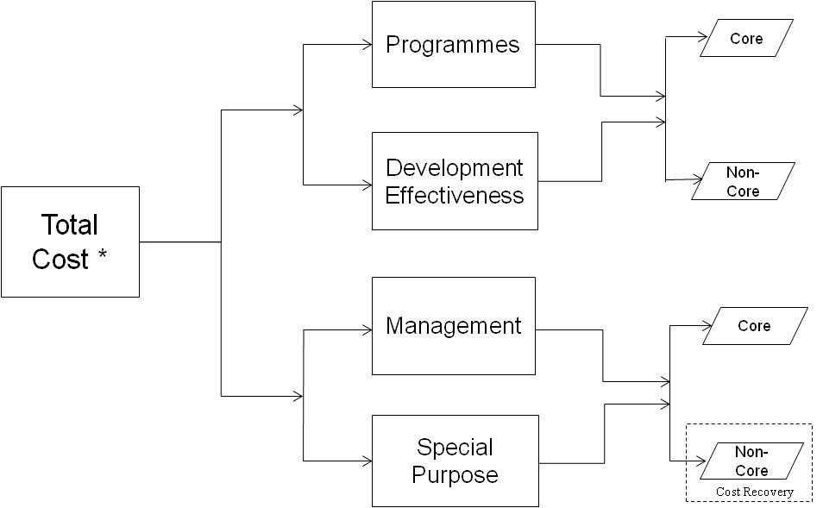
Note: Core refers to Regular Resources and Non-Core refers to Other Resources in the chart above.
- Table A illustrates that the total cost of UNDP’s activities are funded from regular and other resources.

- Regular resources fund activities of the organization falling under all the harmonized cost classification categories (Programme, Development Effectiveness, Management, and Special Purpose). These activities and their regular resource allocations are approved by the Executive Board (EB) every four years in the form of an Integrated Budget and take place at all three levels of the organization, programme country level, Regional Centers and Headquarters.

- Other resources fund activities of the organization falling under the programmes, development effectiveness and management activities.

- For programmes and development effectiveness activities, these costs are directly attributed and charged to programmes and projects. These activities and their other resource allocations are approved in the form of cost sharing and trust fund agreements between governments, UNDP and other donors, both third party and programme country. They take place primarily at the programme country level, but also in Regional Centres and HQs.

- For management activities, these activities and their other resource allocations are approved in principle by the EB in the form of the cost recovery policy through the harmonized methodology for calculating cost-recovery rates on other resources (non-core) (DP-FPA/2013/1 and EB Decision 2013/9) and its application to cost sharing and trust fund agreements between governments, UNDP and other donors. The cost recovery policy authorizes the charging of a general management services (GMS) fee on all cost sharing and trust fund activities that generate cost recovery income, and its use to fund management activities.

The Harmonized Cost Recovery Methodology
- Cost recovery refers to the requirement for the organization to recover costs from other resources that are not directly linked to providing the required organizational structures for projects and programmes. The fundamental aim of cost recovery is to achieve a proportional funding of organizational costs between regular and other resources. This demands that UNDP must avoid using regular resources to subsidize activities funded from other resources, including the use of regular resources to cover costs related to the management and support of programme activities funded by other resources.

- Within the context of the harmonized methodology for calculating cost-recovery rates on other resources (EB document DP-FPA/2013/1 and EB Decision 2013/9) organizational costs between regular and other resources will be more equitably funded, through two main strategies:
  - Increasing the cost recovery rate from the minimum 7% to 8% (effective 1 January 2014), therefore allowing more organizational costs to be funded from the cost recovery income earned on managing the other resources (and less from regular resources);
  - Direct project charging of eligible organizational costs to regular and other resources funded projects and programmes, in particular the development effectiveness category. Direct Project Costs are part of the project budget input and are directly linked to the achievement of development results (Prepare Fully Costed Budgets for Projects and Annex 1).

- The above are also two types of costs that UNDP distinguishes between in the implementation of its activities:
  - Organizational costs that are directly linked to the project budgets, achievement of development results and arise from the implementation of projects and programmes funded from regular and other resources. These are Direct Project Costs. (Refer to Planning and Paying for Delivery Enabling Services to Projects).
  - Costs that are in addition to direct project costs, and are incurred by an organization as a function and in support of its other resources funded activities, projects and programmes, and cannot be traced unequivocally to specific activities, project or programmes. These are General Management Support (GMS) costs. (Refer to POPP Chapter on Cost Recovery from Other Resources - General Management Support (GMS).

- The fundamental principle and benefits of the application of the cost recovery methodology contribute to a more equitable sharing of costs of management activities between regular and other resources. By funding qualified development effectiveness activities, where appropriate, directly from regular and other resources programmes and projects (applying the Direct Project Costing Policy and Methodologies), the cost recovery income (extra-budgetary resources) previously used to finance development effectiveness activities shall be used to fund management activities that presently are financed from regular resources. These regular resources will then be re-allocated to finance programme activities - a major benefit of the cost recovery framework.

- The cost recovery methodology enables organizational costs to be aligned to appropriate results frameworks and funding streams and UNDP to more sustainably finance the requisite organizational structures and capacities to successfully deliver on programme results. Furthermore, the policy on multi-funding of eligible posts provides the flexibility to align costs with results frameworks and related funding sources (POPP Multiple Funding Lines for Positions), and assist COs in applying the Direct Project Costing Policy and Methodologies.

- Critical to the success of the cost recovery methodology will be UNDP’s ability to balance the interests of all donors, regular (core) and other resources (non-core) by:
  - continuing to take measures to contain organizational costs through effectiveness and efficiency measures; assuring regular (core) resources donors that they are not carrying a disproportionate share of organizational costs and continuing to make the maximum amount of regular resources available for programmatic activities; and
  - assuring other resources (non-core) donors that the costs being shifted to programmes and projects are justified, and that they are not being charged twice for the same thing (i.e. the cost recovery GMS purpose/utilization does not duplicate the Direct Project Costing purpose/utilization). The GMS fee recovers organizational infrastructure costs while direct project costs are part of the project budget input.

- This section covers policies regarding the harmonized conceptual funding framework and cost recovery methodology and policies and procedures related to the cost recovery income (GMS) earned on Other-Resources-funded programmes and projects.

- The Direct Project Costing Policy and Methodologies can be found as a separate sub section under the Resource Planning section.

Reference Documents
Roadmap to the integrated budget: Joint UNDP, UNFPA and UNICEF review on the impact of cost definitions and classification of activities on harmonized cost-recovery rates (DP/FPA/2012/1)
The road map to an integrated budget: joint review of the impact of cost definitions and classifications of activities on the harmonized cost recovery rates (DP/2013/41)
UNDP integrated budget estimates 2014-2017 (DP/2013/41)
Programming arrangements, 2014-2017 (DP/2012/25 and Corrigendum 1)

