Guidance on Quantum Burden Schedule/GMS Setup
(Updated 14 July 2023)
Contents
Introduction 1
A. Steps to add GMS Rate for a new Project 1
GMS Rate Setup in Awards 2
External Funding 2
Internal Funding 4
Setting up GMS Distribution Modality in Contracts 6
External Funding 6
Internal Funding 7
B. Revising the GMS Rate of a current project 8
Scenario 1: Immediate GMS adjustment (no expenditure) 8
Scenario 2: GMS adjustment (recalculation of GMS required) 8
C. Reviewing Project Costs 9
D. Wrong Exchange Rates on GMS (non-USD Direct Payable Invoices) 10
Making Corrections 11
E. One-Time GMS Adjustment using Zero-Dollar Invoice Modality (ZDI) 12
Steps to Enter GMS Adjustments 13
Impact on GL Budgetary 13
Impact on PPM Costs 14

Introduction

The purpose of this document is to guide users in all areas related to GMS - setup, adjustments, processing and analyzing results. This document is not meant to be a policy document.
It is important to note that GMS is termed Burden Scheduling in Quantum. Therefore, all field labels in the system can be seen under the term Burden Schedule/Burden Scheduling.

Steps to add GMS Rate for a new Project

GMS is set up for a specific donor and fund within a given project.
- In Quantum, the donor and fund code are determined at Award Level. The GMS rate is also determined at Award Level.
- The required project is linked to the Award as well.
- Thus, if a project has multiple funds or donor codes, multiple awards with specific GMS rates need to be created and linked to the same project.
Project A
Award #1 – Fund 30000, Donor ‘abc’
GMS – 8%
Award #2 – Fund 30000, Donor ‘123’
GMS – 8%

Alternatively, we could also have ONE award with ONE GMS rate linked to multiple projects.
Award – Fund 30000, Donor ‘xxx’
Project #1 – Resp. Party 011577
Project #2 – Resp. Party 001981
GMS – 8%

GMS Rate Setup in Awards

External Funding
Navigate to
Grants Management à Awards.

In the Overview page, on the far right, click on the Actions icon and select Manage Awards
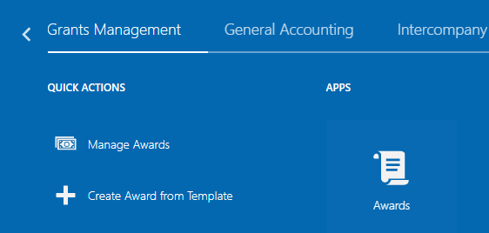
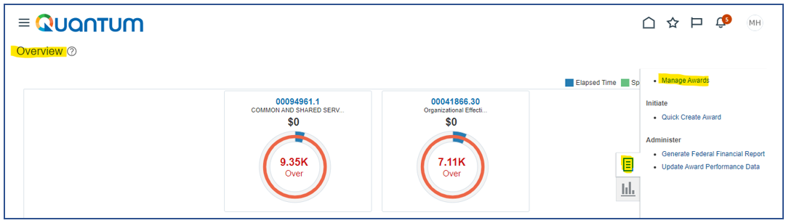
Enter your Award number and click on Search (magnifying glass icon). To access you award, click on the Award Link.
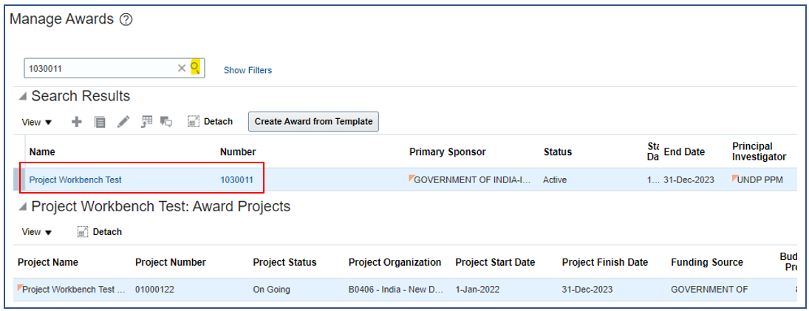
In your Award Overview page, click on Edit to access your Award details.
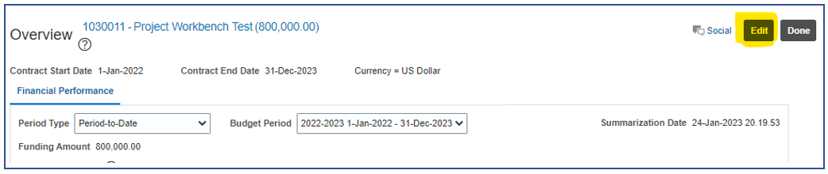
When managing your award, the GMS rate is set up at the -- > Financial

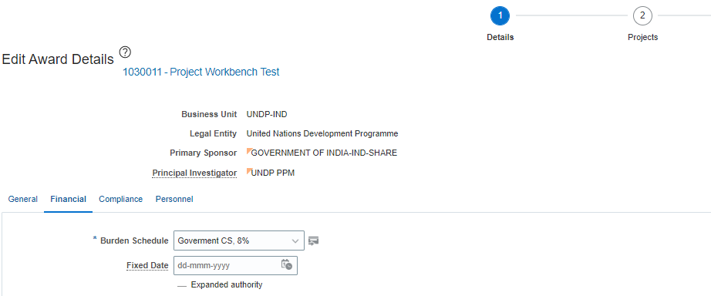
The Burden Schedule is a pre-setup drop down box for selection of the agreement type and the related GMS rate.

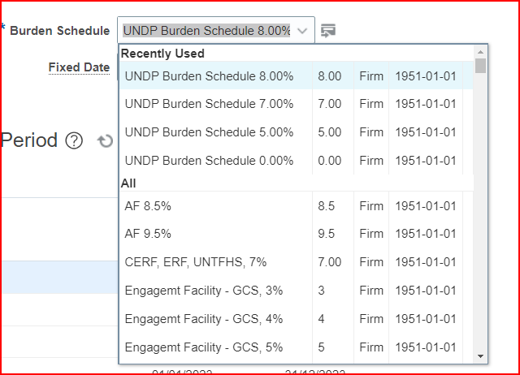
TIP: You can input the percentage, eg. 8% in the Burden Schedule box and all agreement types with 8% will be displayed for you.

Type UNDP and select Burden schedule that begins with UNDP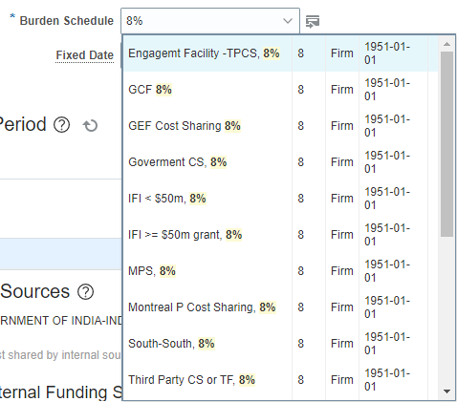

NOTE : If there is any rate in the list that is not available for the selected agreement type and/or the rate, please send an email to the Partnership and Donor Interaction Team (bms.ofrm.pdi@undp.com).
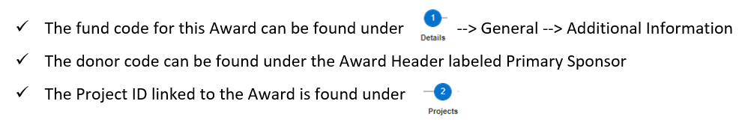

Internal Funding

If your Award has been setup for Internal Funding where GMS is required to be calculated, additional setups are required on your Award.
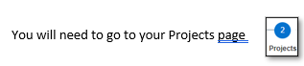
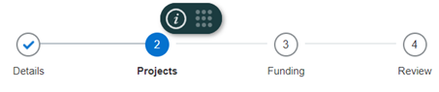
If there are many Projects linked to the same Award, please ensure you highlight the correct Project.
Click on the Drop down to display the details of the Project.

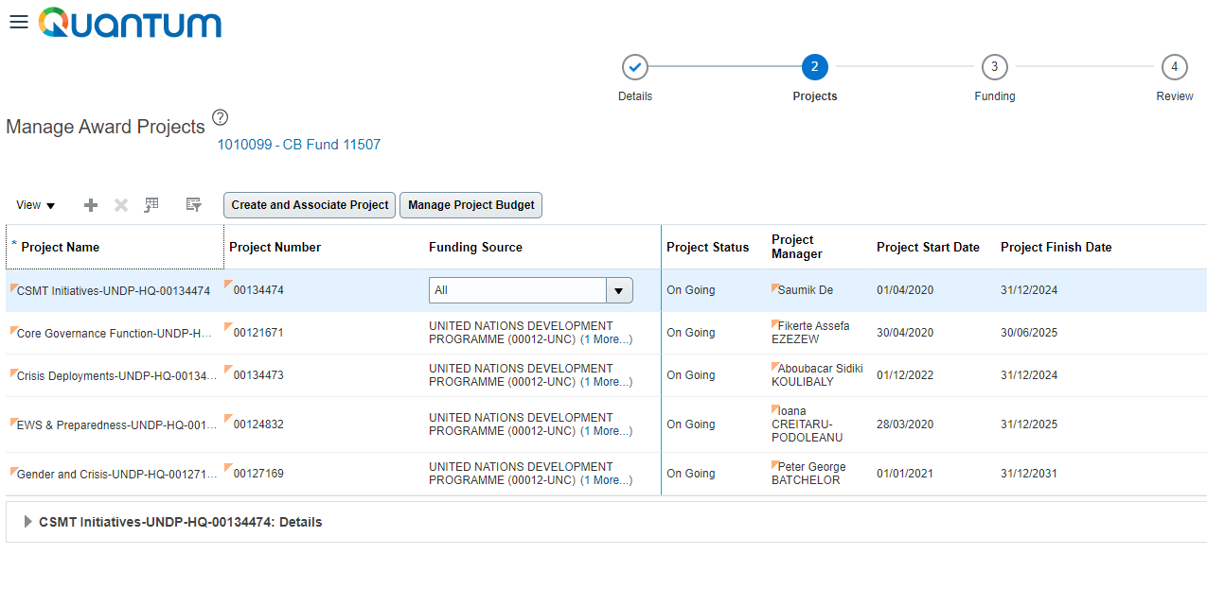
Go to the Financial tab of your Project Details.
Click to expand “Burden Schedule Overrides” to see the checkbox for ‘Enable Burdening’.
Ensure the ‘Enable Burdening’ checkbox is ticked for your Internal Funding Source.
(Please do not set GMS rate under the Burden Schedule Overrides).
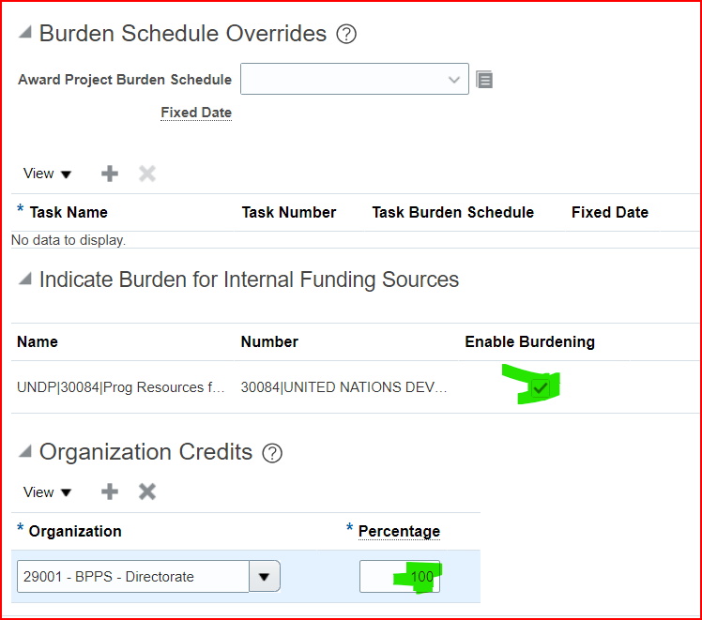

Setting up GMS Distribution Modality in Contracts

External Funding
Once the Award has been completely created, you will need to notify GSSC through UNALL to setup the GMS Distribution Modality in the related contract. If there are supporting documents related to GMS, you will also need to attach these documents in your UNALL Case. If a GMS Waiver is required, ensure all documentation is also attached in UNALL.
Distribution Modality defines which department the income portion of the burdening (formerly known as GMS) will be credited to and at what percentage.
The Project Number, Donor, Fund, GMS Rate and Eff Date are all taken from the Award Module. GSSC will select the Distribution Modality and populate the Department IDs with the predetermined percentage.
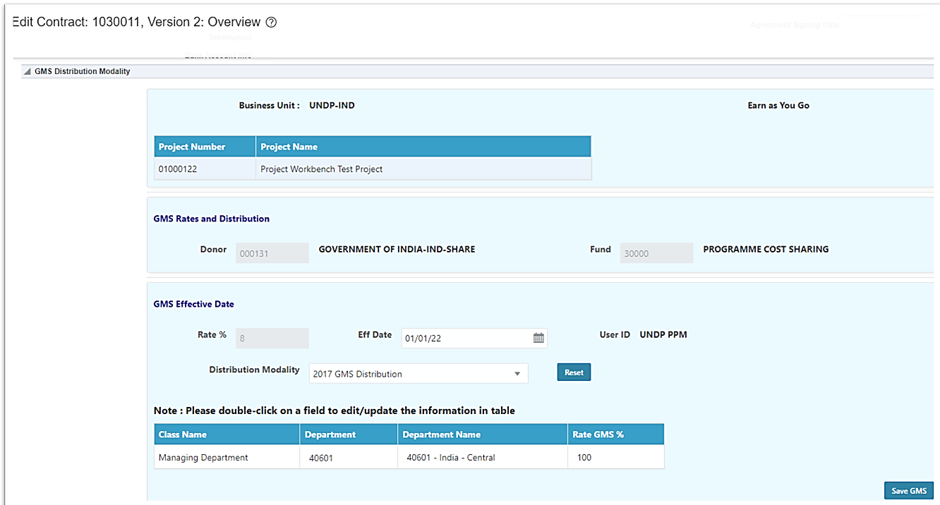
If there are 2 projects linked to the same Award/ Contract, both Projects will appear in the Contract segment and different distribution modalities can be setup for each project.
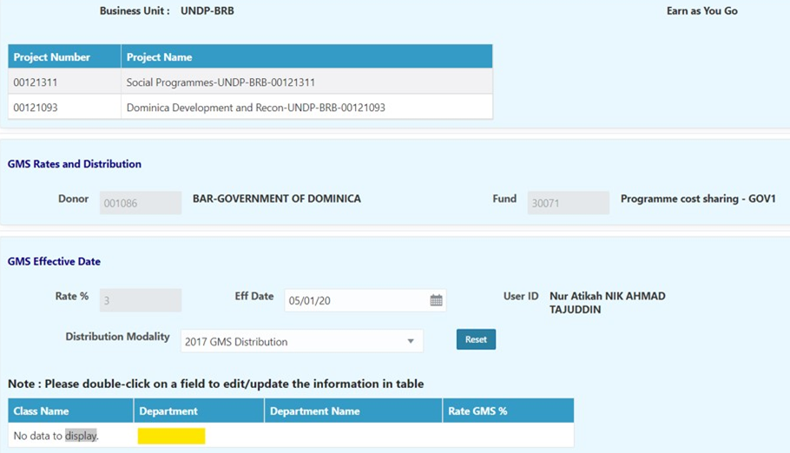
Once the Contract is completed, GMS will be calculated based on the rate you have setup when expenditure is incurred on your project.

Internal Funding
If your Award has been setup for Internal Funding, the Contract is pre-approved.
However, if GMS is required for your Internal Funding Source, you will need to contact GSSC through UNALL, to setup the GMS Distribution Modality for you.

Revising the GMS Rate of a current project

There are 2 scenarios for a GMS Rate change.
- No expenditure has been incurred yet on the project or the Burden Schedule process has not yet been run for the expenditures that have been created for the month.
- Burden Scheduling has already been run on the expenditures for the project. Adjustment of previously charged GMS has to be done and posted to reflect the new rate after a select effective date.

Scenario 1: Immediate GMS adjustment (no expenditure)

In this case, when no expenditure has yet been incurred on the project, please make amendments to your GMS Rate in the same field as your initial setup.
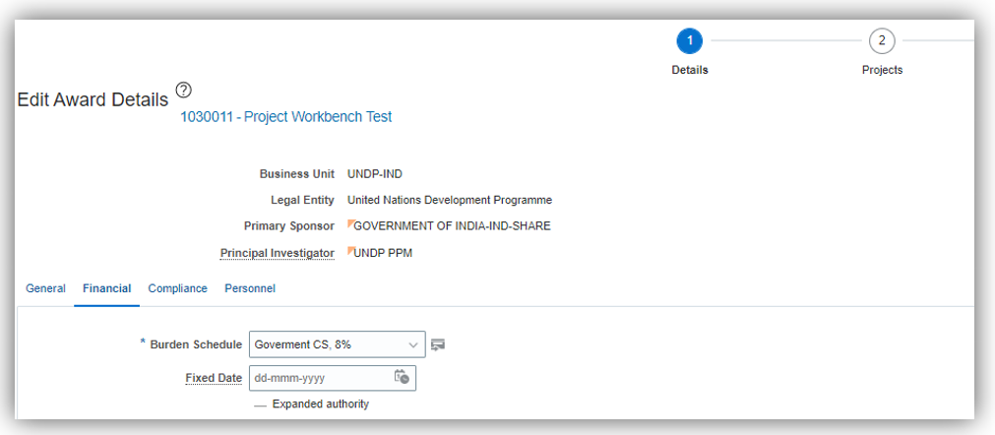
Choose a new rate from the Burden Schedule and Save.

Scenario 2: GMS adjustment (recalculation of GMS required)

For this scenario, please contact bms.ofm.pdi@undp.org
A Zero-Dollar Invoice (ZDI) should be created for GMS adjustment, and the GMS rate updated.

C. Reviewing Project Costs
To review your GMS costs and adjustments, navigate to
Projects -- > Costs
In the far right of the screen, under your Task icon, select Manage Project Costs
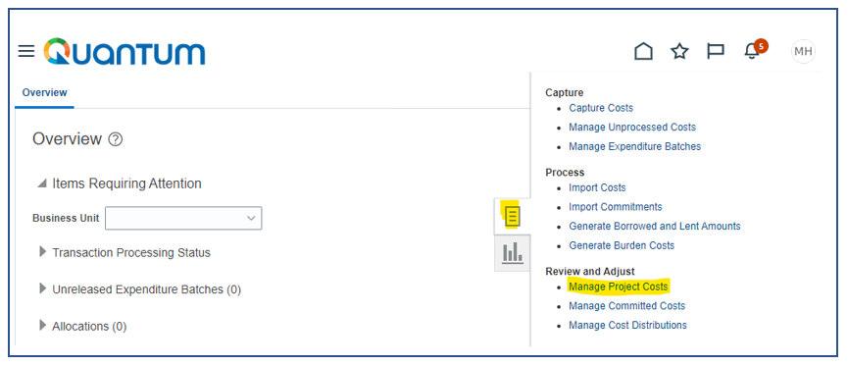
Put in your Project Number and click Search.
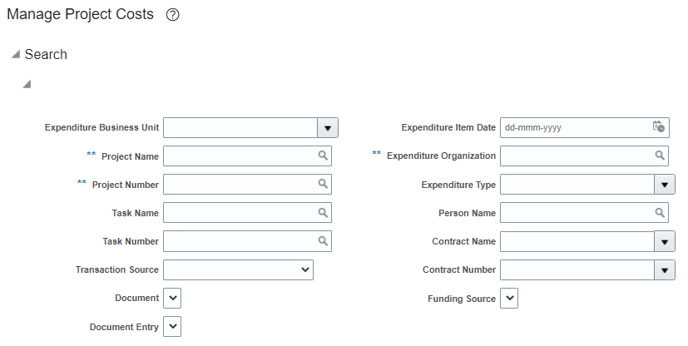
Below is an example of how your GMS expense lines will look like in the Projects Module:
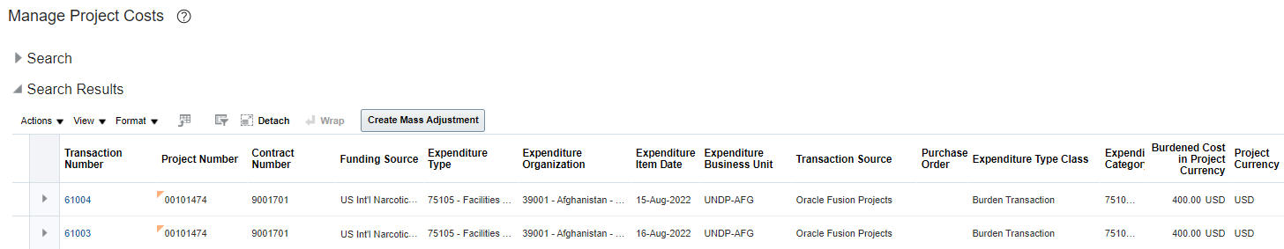
Batch processes will be run to generate the accounting entries.
You can see your final double entries in General Ledger
This is the Journal based on the same example:
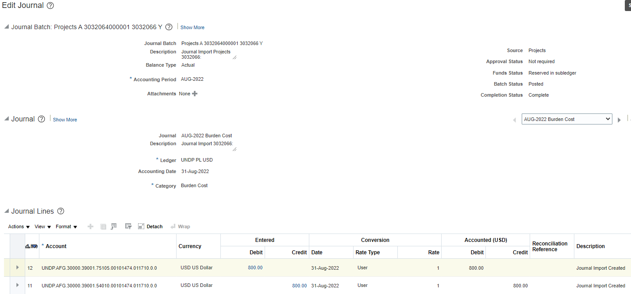

D. Wrong Exchange Rates on GMS (non-USD Direct Payable Invoices)

There is one critical point to note when creating invoices that impact the calculation of GMS.
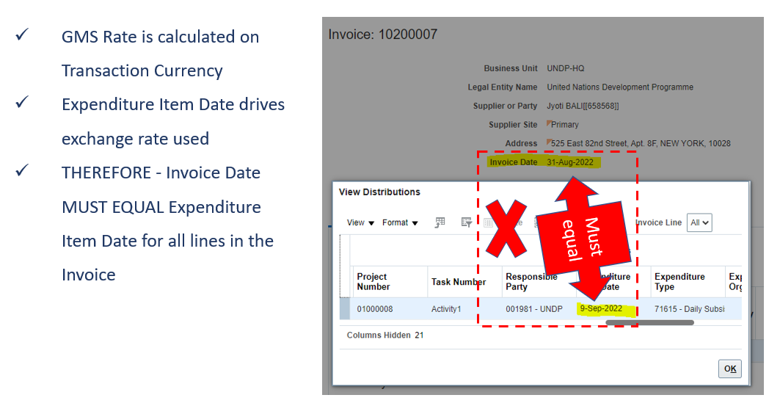
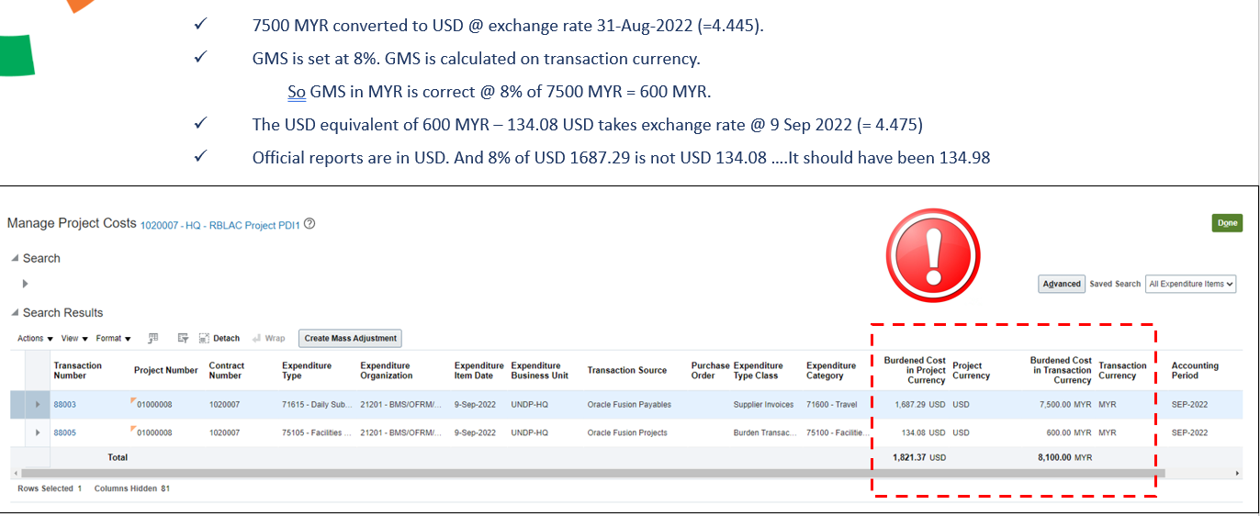
The exchange rate in Invoice on GMS is based on the “Expenditure Item Date” rather than the “Invoice Date”. If the Invoice Date is changed, change the Expenditure Item Date in the Invoice Lines immediately to avoid incorrect exchange rate applied for burdening (GMS charges).
When the transaction currency is in Non-USD. The GMS amount is calculated on transaction currency (e. g. MYR) using the exchange rate based on the “Expenditure Item Date” even though the transaction amount is converted to the USD Equivalent amount using exchange rate based on the “Invoice Date”.
Note that some COs may have one exchange rate in one month (1st calendar date), some COs have two exchange rates in one month (1st and 15th of month). Please be cautious whenever we change the Invoice Dates, we must ensure that the Expenditure Item Date of the invoice/distribution line(s) is changed to equal Invoice Date.
- If the “Expenditure Item Date” differs from the “Invoice Date” but both dates will apply same exchange rate, there is no corrective action required (everything is okay). For example, Expenditure date is 12 Jan and Invoice date is 9 Jan, and only one exchange rate is effective from 1/1/2023 till 31/1/2023.
- If the “Expenditure Item Date” differs from the “Invoice Date” and both dates will apply different exchange rates, we will have to correct the Expenditure Item Date to equal to Invoice Date before the invoice is paid.

NOTE: There is a Conversion Date in the Invoice Header. Please ensure that your Conversion Date is also the same as your Invoice Date.
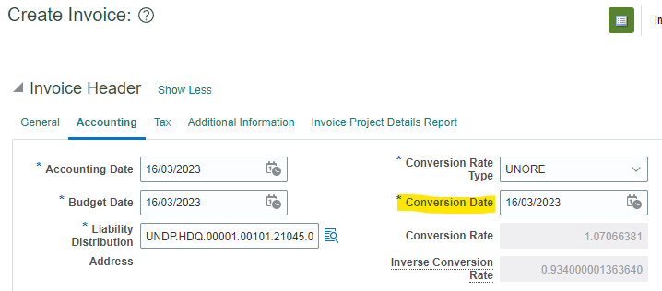

Making Corrections
There are 2 ways to make corrections:
- If the Invoice Line can be found in your Manage Project Costs Search Results (refer pg.12), this indicates the invoice line has been posted in PPM. In this case, you will need to go back to your AP Invoice and create 2 lines. One line to reverse the line in error (with the same, wrong Expenditure Item Date) and another line with the correct Expenditure Item Date (= invoice date).

Example: The Invoice Date for this AP Invoice is 26 Sept 2022. However, Line 2 was accidentally posted and imported to PPM with Expenditure Item Date 1-Sep-2022. Since the line had already been imported, create one line (Line 3) to reverse with Expenditure Item Date as 1-Sep-2022 and create another line (Line 4) with the correct Expenditure Item Date 26-Sep-2022.
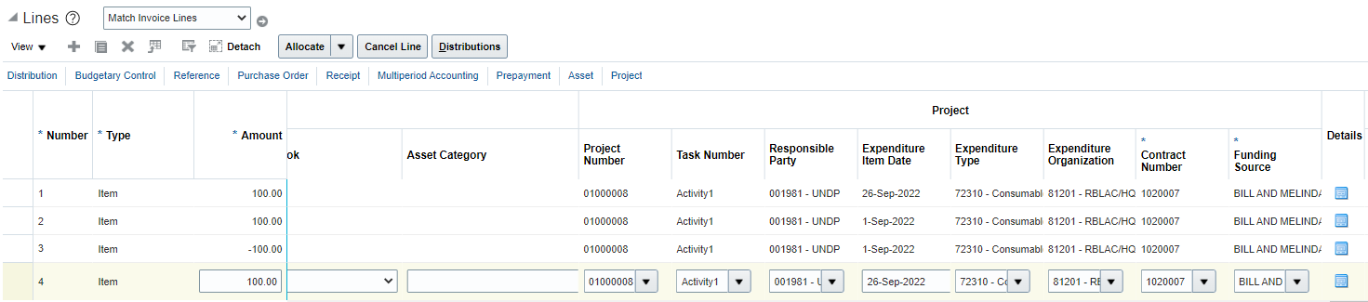

Note: You can only make changes on the same AP Invoice itself IF the Accounting Date of the invoice is still open. If the period is already closed, please make this adjustment in a new invoice, using current accounting date but the backdated invoice and Expenditure Item Date.

- If the Invoice Line is not found in your Manage Project Costs Search Results (refer pg. 12), you can go back and edit the line directly where the Expenditure Item Date was entered in error and change the date to be the same as the Invoice Date.

E. One-Time GMS Adjustment using Zero-Dollar Invoice Modality (ZDI)

The purpose of this section would be to guide you in creating a manual one-time adjustment for GMS entries. For example, the GMS is under/over-charged pre 2023 in Atlas. The change of GMS rate in Quantum will not correct the inaccurate GMS expense carried over from Atlas to Quantum.
Other examples of usage of ZDI for GMS entries could be:
- Award was not setup correctly and no GMS was calculated for the funding source.
- Exchange rate differences in GMS calculation.
At regular intervals or before the project is financially closed, this one-time GMS adjustment using zero-dollar Invoice can be used.
- Adjustments can be for the current year, whereby you will use account code 75110.
- Adjustments can also be for prior year, whereby you will then use account 75115.
ZDI entries will be reflected both in PPM and in GL.

Steps to Enter GMS Adjustments

Navigate to Payables à Invoices.  Create a new Invoice. | 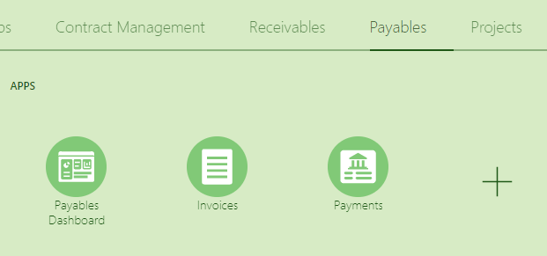
Enter your Invoice Header information.  Be aware of the following:  - Supplier = UNDP Project Adjustment  - Amount = 0  - Type = Standard | 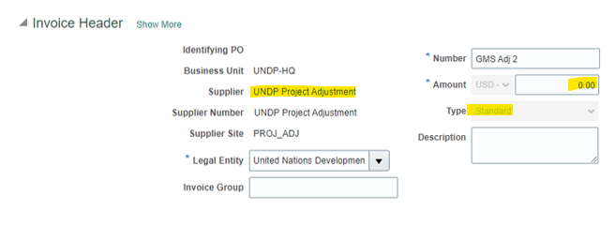
Enter Lines - Distribution

75110 - GMS current year adjustment
75115 - GMS prior year adjustment

Enter Lines - Project  For your GMS Adjustment lines, please ensure you enter the Project information for line with GMS expense account 75110 or 75115.  For line with GMS revenue account 54010, please do not enter Chartfields. | 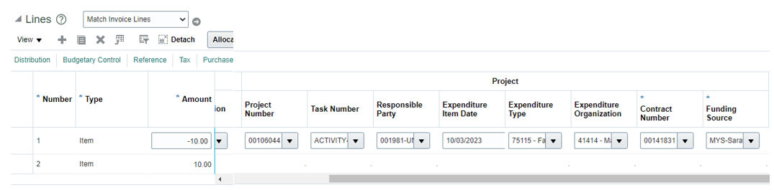
Once your invoice is balanced, please Validate/Check Funds and submit for approval.
Approval of Zero-Cost invoices should be Manager Level 2 and/or above.

Note: Please do not amend anything in your Invoice Pay Group or Payment Method.

Impact on GL Budgetary

Only the expense entries will be reflected under the Expenditure category in GL Budgetary.
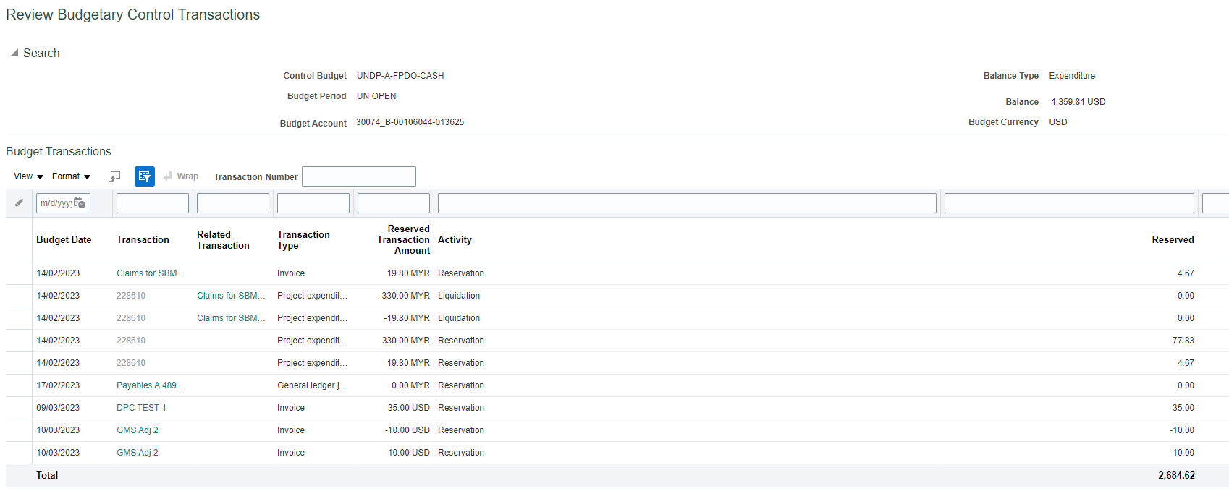

Impact on PPM Costs
Only the line with project information will be imported into PPM.
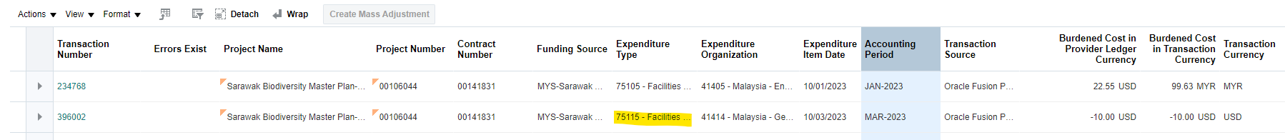
751xx and 761xx entries will not go through the burdening process. The burdening schedule will charge on expense account other than GMS (751xx) and FX (761xx) in PPM.

