Receipt of Goods, Services and Works
- This policy overrides the previous policies relating to receipt of services, receipt of goods and application of Incoterms, receipt of goods DAP and application of Incoterms, receipt of goods FOB and application of Incoterms and receipt of works.
- To ensure compliance with IPSAS, it is critical that goods, services, and works are receipted and recorded as an expense in the correct accounting period i.e., when the goods were delivered, services were performed, construction works milestones were reached.
- The Receipt accrual process is scheduled to run regularly once the Accounts Payable module closes and will capture those receipts that are not yet invoiced. To ensure the accuracy of the receipt accrual liability, UNDP offices must ensure that they have receipted all goods, services, and works by the last day of the calendar month in Quantum or before AP module closes (backdating the receipt date to the accounting closure month), otherwise the receipt accrual process will not capture all the accrued expenses and corresponding liabilities to ensure completeness of financial transactions in our UNDP financial statements and project delivery will be understated.
- UNDP offices must ensure that all supporting documentation for transactions forming the receipt accrual balance are maintained and readily available locally, as they will be required for verification and audit purposes. Supporting documentation for all assets (individual asset item => US$5,000) and other non-asset goods or services transactions (each receipt => US$20,000) will be required to be uploaded into Quantum during receipting.
Receipt of Goods
- A receipt is entered in Quantum when the goods are received by UNDP in accordance with the terms and conditions set out in the contract or purchase order (PO).
- It is important that the receipts are entered promptly in the system when the goods are received.
- It is mandatory to enter receipts in Quantum within 48 hours of the actual receipt of goods, so that the expense, asset and liability recognition is done correctly in accordance with the UNDP expense accounting policy.
- Prompt receipting of goods in the system also determines when to capitalize an item (for capital assets) and facilitates the evaluation of supplier performances.
Receipt of Services
- When UNDP procures “services”, receipts must be entered in Quantum on the date when services are properly rendered according to the contract and accepted by UNDP.
- For services such as individual contracts (IC), it is important to enter receipts when services were performed or deliverables are achieved against milestones, if any per the contract, e.g., submission of reports, assessments, certain number of hours, etc.
- If the contract runs for a longer period, but several deliverables or payments are agreed upon, then receipts occur at each deliverable. For instance, for a six-month IC with monthly payments for which a PO has been raised, a portion equivalent to the monthly payment needs to be received each month before the payment of the IC.

Receipt of Works
- Construction works (collectively, “Works”) need to be received/recorded at the stage when milestones, according to the contract, are completed and accepted by UNDP as part of the regular project monitoring activities.
- The term “Works” refer to all the activities associated with the construction, reconstruction, demolition, repair or renovation of infrastructure or activities such as site preparation, excavation, erection, building, installation of equipment or materials, decoration and finishing, as well as services incidental to works such as exploratory drilling, mapping and similar services. It covers all aspects of construction such as civil, mechanical, electrical, and associated Works.
- It is of utmost importance that the Program or Project Manager enters the correct date and amounts for works completed to ensure both the supplier performance and the UNDP expenses and accrued liability for the construction services are accurately reflected in Quantum.
- Such Works are often specialized in nature, UNDP acceptance and receipt should only be performed by a qualified personnel that have the requisite knowledge of the Works. Amounts receipted in Quantum should be based on the progress certificate or site assessment report, as appropriate.
- Retention represents an amount deducted and withheld from each progress payment made to a contractor and this is common in Works. Retention may also be referred to “retention sum”, “retention monies”, “holdbacks”, etc. Normally these funds are withheld by UNDP until the end of the contract and released and paid to the contractor after a certain period. The final retention amounts may only be paid over to the contractor after the end of the contractor’s liability period also known as the defects notification period. It is important to note that even though the contractor will be paid at a future period in time, receipts recorded in Quantum and based on progress certificates should be inclusive of retentions, as the milestone has been reached but the funds are held back as a risk mitigation strategy or safeguard for UNDP to cover for any potential issues that may be encountered during the contractor’s liability period.

Receipt of Goods and Application of Incoterms
- Careful attention to Incoterms under which goods are being procured is required, as this will dictate the date when the receipts are to be entered in the Quantum. UNDP is adhering to the INCOTERM 2020. The Receipt should be recorded in Quantum on the date when the risks of ownership is transferred to UNDP per the Incoterms. Incoterms are discussed in the sections below.
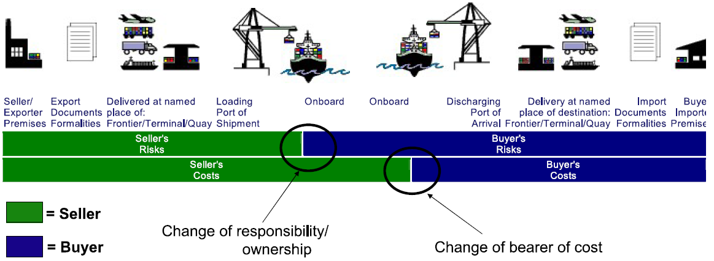
©UNDP/PSU
Free on Board (FOB)
- The FOB is commonly used in the sale of bulk commodity cargo such as oil, grains and ore. In FOB, the seller clears the goods for export and is responsible for the costs and risks of delivering the goods on the ship at the named port. Carriage to be arranged by the buyer. Buyer pays for the cost of pre-shipment inspection, except if the inspections are required by the country of export. The Buyer pays all costs associated with securing documentation originating in the country of export as required for import.
- The Receipt date is the date when the goods are placed on board the vessel, because on that date the risk is transferred from the supplier to UNDP.
- Examples of the named port of the shipment are “Vessel ABC” Buenos Aires Argentina, Gdansk Poland.
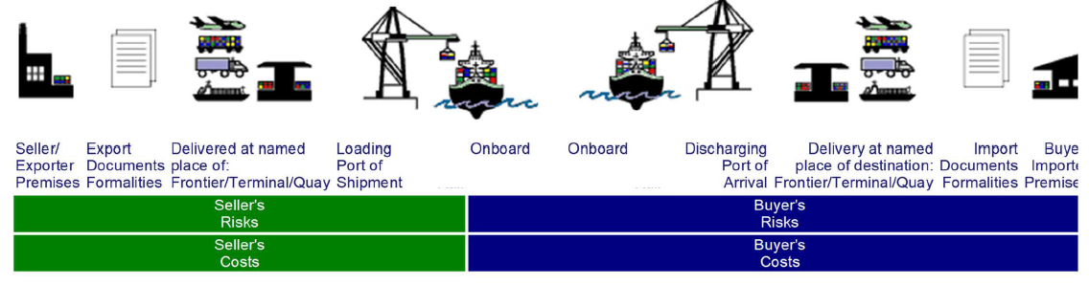
©UNDP/PSU

Delivered at Place (DAP)
- DAP can be used on all means of transport. The seller clears the goods for export when the goods are placed at the disposal of the buyer on the arriving means of transport and the goods are ready for unloading at the named place of the destination. All risks to that point are for the account of the seller. The Buyer must pay costs of unloading and import formalities.
- The Receipt date is the date when the goods have arrived at the specified place, whether they are unloaded from the forwarder’s truck, vessel or other means of transport. This is the date at which the ownership for the goods procured is transferred to UNDP.
- Example of the named place of destination is “UN Warehouse Harare, Zimbabwe.”
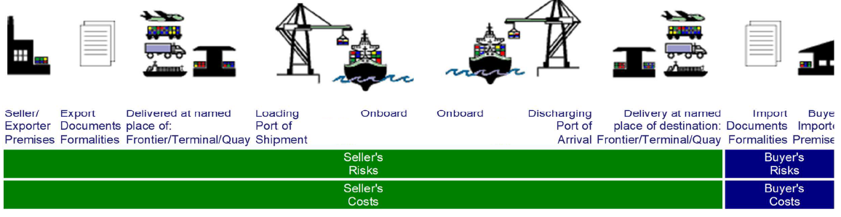
©UNDP/PSU
Ex Works (EXW)
- EXW can be used for all modes of transport. Under EXW, the seller minimizes his risk by only making the goods available at his own premises. The seller neither clears the goods for export nor loads the goods onto a truck or other transport vehicle. The carriage is to be arranged by the buyer who will pay for Licenses and Custom Formalities and must obtain at its own risk and cost all export and import licenses and authorizations.
- The Receipt date is the date when the seller/exporter makes the goods available to the buyer/importer at the seller’s/exporter’s premises/factory/warehouse.
- Example of the name place is “ABC Factory Paris, France”.
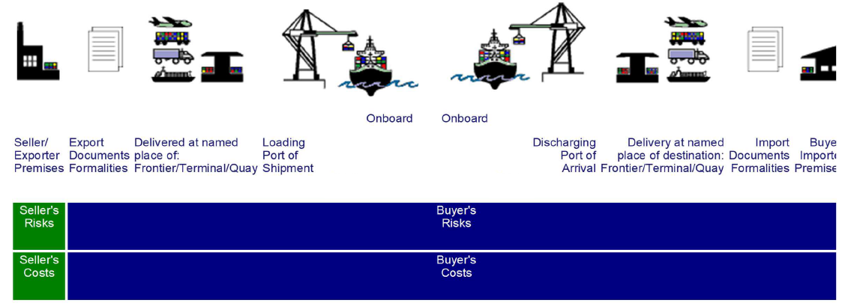
©UNDP/PSU
Free Carrier (FCA)
- FCA can be used for all modes of transport, including multimodal. The Seller must provide export licenses, documentation and authorizations and carry out all export formalities and procedures. In addition, the seller also pays all costs until the goods have been delivered to the carrier as well as all costs relating to export including duties, taxes, and custom formalities.
- The Receipt date is the date when the seller clears the goods for export and then delivers them to the carrier as specified by the buyer at the named place.
- Examples of the named place are “ABC Shipping Line Hamburg Germany, AZ freight forwarded Tokyo Japan”.
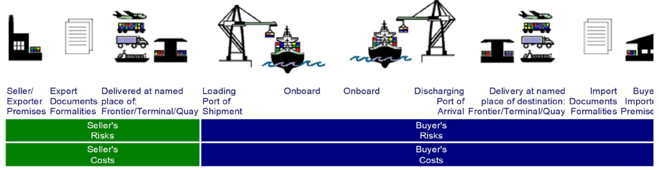
©UNDP/PSU
Cost and Freight (CFR)
- CFR is only used for ocean and inland waterway transport, and commonly used in the sale of oversize and overweight cargo that will not fit into an ocean freight container. The seller clears the goods for export and pays any cost of export licenses and authorization. In addition, the seller is also responsible for paying the costs associated with transport of goods to the named port of destination.
- The Receipt date is the date when the seller delivered the goods on board at the port of shipment.
- Example of the named port of destination is “Port-au-Prince Haiti”.
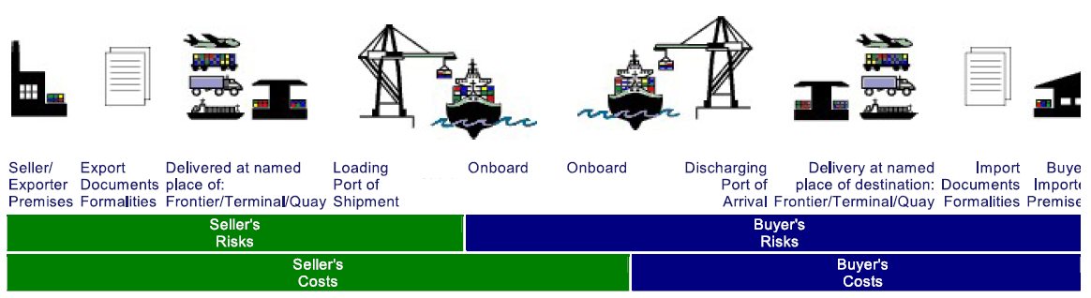
©UNDP/PSU
Cost, Insurance and Freight (CIF)
- CIF can only be used on sea freight. The seller clears the goods for export, arranges the insurance and is responsible for procuring and paying for insurance cover during the voyage to the named port of destination; the buyer may exercise prudence and purchase additional insurance coverage.
- The Receipt date is the date when the seller delivered the goods on board the ship at the port of shipment.
- Example of named port of destination is “Hong Kong Seaport”.
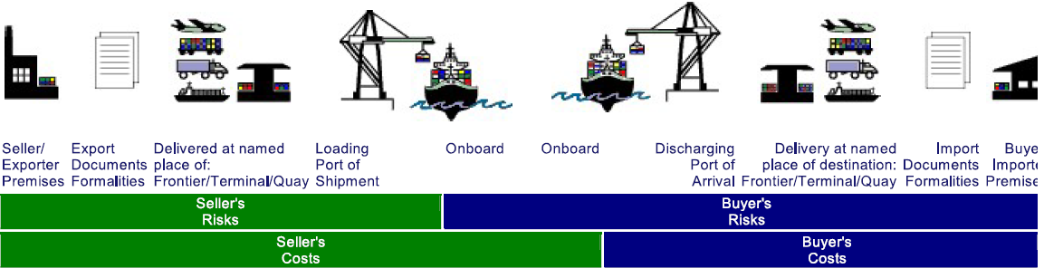
©UNDP/PSU
Carriage Paid To (CPT)
- CPT can be used for all modes of transport. The seller must obtain at its own risk and cost any export licenses and authorizations and carry out all export formalities and procedures. In addition, the seller needs to arrange and pay for the main carriage but without assuming the risk of the main carriage. Once the seller delivers the goods to the carrier, the buyer becomes responsible for all additional costs.
- The Receipt date is the date when the seller delivered the goods to the carrier.
- Example of the named place of destination is “Kampala Airport”.
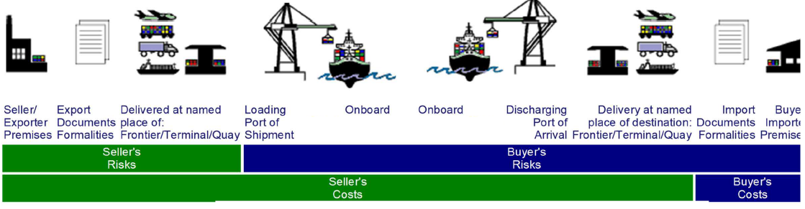
©UNDP/PSU
Carriage and Insurance Paid (CIP)
- CIP can be used for all modes of transport. The seller clears the goods for export, delivers them to the carrier, and is responsible for paying carriage and insurance to the named port or place of destination, but without assuming the risk of the main carriage.
- The Receipt date is the date when the goods are delivered to the named place of destination.
- Example of the named place of destination is “UN Kabul Warehouse”.
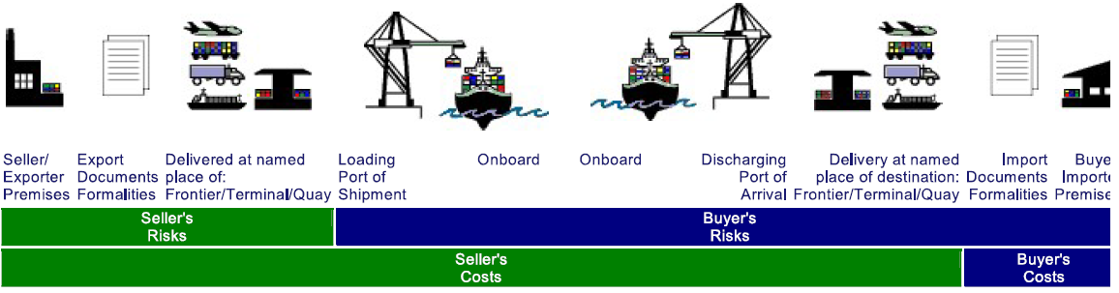
©UNDP/PSU
Delivered at Place Unloaded (DPU)
- DPU can be used for all modes of transport. The seller clears the goods for export whilst the buyer arranges the import formalities. The seller delivers when the goods are unloaded from the arriving means of transport and are placed at the disposal of the buyer at the named place of destination. All risks to that point are for the account of the seller, including unloading.
- The Receipt date is the date when the goods are unloaded and placed at the disposal of the buyer.
- Example of the named place of destination is “Port Maputo”.
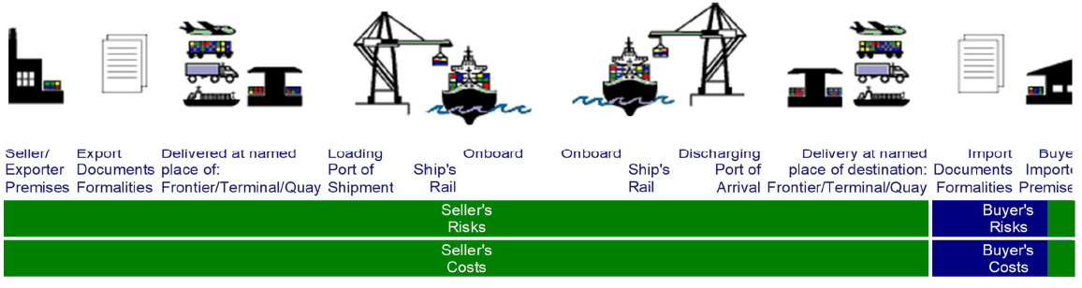
©UNDP/PSU

Year End Guidance
Purchase Order
- Goods or services received before year-end must be receipted in Quantum no later than the Year End AP closure (backdating the receipt date to the accounting closure month). UNDP offices should not wait for the invoice from the supplier to record the receipt in Quantum. Country Offices are required to use their best estimate of the goods or services received with the good coordination on the field and finance unit to ensure that the Receipt Accrual process captures all receipts when run once AP module is closed.

Non-Purchase Order Invoice
- UNDP offices are not required to enter a receipt date in Quantum for non-PO purchases/payments, however, UNDP offices are required to ensure that all invoices for goods or services received in current year from suppliers are processed as per the deadlines stated in the Annex B of the Year End Closure Instructions. For example, if a non-PO payment is made in January pertaining to a good/service received in the prior year, the payment should be recorded in the year that the goods or services were received. If the period is closed, the GSSC hould notify OFM of such payments and the total quantity and value.
- UNDP offices must contact their suppliers (including consultants) to provide invoices for work completed or goods delivered. For purchases below the USD 5,000 PO threshold and other non-PO purchases/payments such as utility expenses where the supplier is a government or government agency, UNDP offices are encouraged to at least for the year end create a PO and receipt the expense in Quantum. This will help ensure expenses or delivery is recorded in the correct financial year and the related budget is committed for planning purposes.

Works
- If a progress certificate or site assessment report is not available as of 31 December (i.e., the end of UNDP’s financial year), the project manager is still required to estimate the progress of works completed as of 31 December in order to receipt the works in Quantum so that the financial records are accurate and project delivery is recorded. The last available progress certificate or site report can be used as the basis to estimate the additional value of un-receipted works undertaken as of 31 December. As construction works are specialized in nature, the estimate should only be performed by personnel that have the requisite knowledge of construction works. This is normally done by the site engineer and confirmed by the project manager as appropriate. UNDP offices should try to perform the receipt in Quantum by 31 December, however, for the circumstances where the County Offices that need more time to finalize the estimated receipt amounts before entering the receipt date in Quantum, an additional Receipt Accrual process is scheduled to run on 25th January (for the work performed in current fiscal year, for example, Works related of 2022 will have additional RA run on 25th January 2023).

Consultants
- UNDP offices must ensure that all consultants are contacted in the year end to submit invoice or timesheets for the work completed for current fiscal year so that the receipt is entered in Quantum before AP module is closed.

NGO financial reports (FRs) or FACE forms – Non-PO
- For expenses that are recorded based on the receipt of FR/FACE forms from project Implementing Partners and Responsible Parties, UNDP offices must ensure that these FR/FACE forms are received on time to ensure that expenses are recorded in the correct accounting period. UNDP Offices should closely monitor these project Implementing Partners and Responsible Parties to make sure that these FR/FACE forms are submitted to the UNDP office on time to enable expenditure recording.
- It should be noted that the project implementation modality or cash implementation modality (Direct payments modality) does not change the way expenses are to be recorded. The expenses should be recorded in the period that the IP/IA incurred the costs and not when UNDP signed and accepted FACE form. That is the reason that FACE forms are to be submitted within 15 days after the quarter-end so that it can be recorded before the prior period closes and at year-end, OFM always close AP later for this specific reason. If the period is closed, the GSSC should notify OFM of such payments and the total quantity and value to determine if an accrual is required.
- In the event that a UNDP office does not receive the FACE form on time, the UNDP office is required to estimate or accrue the amount of expenses incurred by the project Implementing Partner and record the estimated expense in Quantum based on the last available FACE form or similar expenditure report. This can be used as the basis for estimating the value of un-recorded expenses as of 31 December. The expense accrual should be processed via GLJE using the December 31st current fiscal year and reversed on January 1st following fiscal year. The estimated accrual should be done by recording an expense and reducing the advance (i.e., NEX advance). The estimate should be performed by personnel that have the requisite knowledge of the project in conjunction with the finance unit. This is normally done by the project manager and verified by the finance personnel. The UNDP office should not be creating a new liability to avoid the risk of payment by the GSSC.

Best practices guidance
- Enter receipts in Quantum in the same month that the goods are received (follow INCOTERM) or services are rendered. Do not backdate the receipts.
- Close those POs which have no further commitments immediately.
- Do not use non-PO invoice when paying for items associated with the receipted POs.
- Double check the PO invoices to ensure that accurate receipts are associated with it. Do not choose a wrong receipt.
- Ensure that the requisition and PO are created correctly to eliminate hiccups in the receipting and invoicing process, which may lead to incorrect receipt accrual recognition.
- Create prepayment invoice when goods and services are receipted for prepaid items.
- UNDP office Finance colleagues must liaise closely with Buyers and Project Managers to identify Incoterms documented in the PO as items not yet physically received by the Office may still need to be receipted in Quantum in the correct accounting period.
- UNDP office Finance colleagues must implement mechanisms for monthly monitoring of receipts to ensure expenses are recorded in the correct accounting period.
- POs must be broken down into multiple lines to differentiate between various items or services when more than one type of good or service is being procured. UNDP offices must comply with UNDPs policy for the creation of PO's and record receipts in line with the multiple lines, instead of grouping multiple items into batches which makes receipting of goods and services difficult; this results in errors in recording expenses. The policy: Purchase Orders (Commitments, Maintenance and Closure), Main Procedures > Step 3) states that:
"PO Line: When more than one type of good or service is being procured, multiple lines must be used to differentiate between the various items or services. A PO Line contains information specific to the item or service procured (i.e., description, category code, quantity, unit of measure). The Buyer should be as precise as possible regarding the quantity and description for each item or service. Where multiple items/services are being purchased from a supplier, but only some of them require a Prepayment, separate POs should be raised for prepaid and non-prepaid items.​”

Internal Control Framework (ICF)
Refer below to the following accountabilities of the project manager per UNDP’s Operational Guide of the Internal Control Framework (ICF):
Page 18: “6. Receipt Goods, Services & Works: Verify receipt of goods, services, & works: Project Managers are responsible for verifying, documenting, and recording satisfactory receipt of goods, services, and works…. Depending on the size of the project and the volumes, Project Managers may delegate this function to other project staff. Where the volumes are significant, this delegation should be in writing and copied to the Operations Manager, so that the finance unit is aware of the delegation. Copies of this delegation should be maintained and securely filed. In many offices, the staff member who physically receives the goods confirms receipt of goods and forwards such confirmation to the Project Manager for written approval before recording the receipt….
Remember: The receipting of goods, services, and works must not be performed by staff members with the ‘Buyer’ profile. The receipt date plays a very crucial role in (i) triggering the recording of expenses where applicable, (ii) recording of fixed assets, (iii) title and insurance, (iv) management and control and (v) all the rights associated with the item.”

References
- UNDP Internal Control Framework Policy
- Procurement POPP
- Construction Works Policy
- Guidance Note – Construction Works Policy

