Accounts Receivable
- Measurement of receivables is an important area of IPSAS implementation and an assessment of accounts receivable has to be performed at year-end for those which are considered doubtful and those that must be written-off. Receivables will be measured at fair value less any allowance for estimated irrecoverable amounts. An allowance is established when there is objective evidence, based on a review of outstanding amounts at the reporting date, that UNDP will not be able to collect all amounts due according to the original terms of the receivables.
- UNDP will apply the specific allowance method by identifying specific contributions which have become doubtful. This involves the review of each donor and its ability to fulfil the commitment.

Allowance for doubtful debts
- The first step in creating an Allowance for doubtful debts is to identify individual donors where there may be doubts as to whether all amounts will be recovered. This will then be used in identifying the individual amounts that will make up the allowance for doubtful debts.

Write-off of accounts receivable
- The second step is identifying if any balances outstanding should be written-off. Write-offs will only take place after all reasonable steps have been taken to recover the amounts outstanding and there is considered to be no chance of recovery.
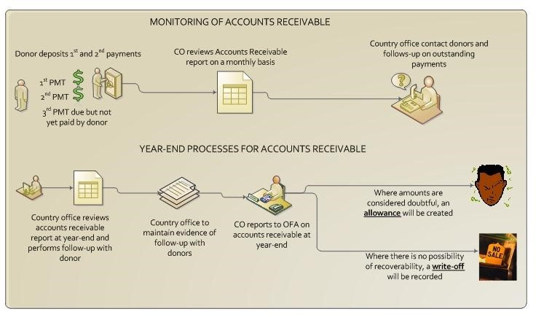
- The Global Shared Service Centre (GSSC) will be responsible for recording the revenue for the following non-core contributions:
- Programme country government cost sharing
- Third party cost sharing agreements
- EC Agreements
- Trust funds
- The GSSC staff will follow the revenue recognition policy to record contributions in the Quantum Module for the revenue to be recognised timely and accurately in the UNDP financial statements.
- As a result of these processes and entry of information into the Module, accounts receivable will be created in the General Ledger. These amounts will represent amounts, as promised by donors according to the schedule of payments in the agreements, but that have not as yet been received.

Monitoring of accounts receivable
- The responsibility for monitoring, follow-up and reporting on accounts receivable is with programme and finance staff in each CO/Business Unit and not the Global Shared Service Centre. A report of accounts receivable should be generated by the CO/Business Unit on a monthly basis. The reports will age accounts receivable by donor and can be used to follow-up with donors. The report will age amount outstanding as follows:
- The REPORT OUTPUT will contain the following fields and age the amount in the following columns:
Operating Unit Donor Name Contract # 0-3 Mths 3-6 Mths 6-12 Mths 1-2 Yrs 2-3 Yrs >3 Yrs Total AR
- Project managers (First Authority) should be following up with donors on outstanding accounts receivable
- The Approving Manager (Second Authority) should sign the accounts receivable report as evidence of the monthly review

Adjustments to be made to accounts receivable
- In certain instances an amendment can be processed to adjust accounts receivable for the following reasons:
- Change in scope of project
- Budget revisions done in conjunction with the donors
- Adjustments to funding reflecting introduction of new donors
- These are amendments and should be processed via a UNAll notification to GSSC, which will then start the normal amendment process in the Module. See POPP Chapter on Non-Core contributions

Steps to be taken by business units for monitoring of accounts receivable:
- Monthly steps:
- Generate the monthly accounts receivable ageing report
- Identify long outstanding receivables and follow-up with donors
- Contact donors to ascertain when payments will be made
- Keep documented evidence of follow-up with donors
- Pay particular attention to long outstanding amounts and take all reasonable steps in trying to recover these amounts
- Sign the report as evidence of follow-up being taken
- Operation managers (managers with second authority) should sign report to ensure that steps have been taken on follow-up
- All evidence of follow-up and review should be filed as supporting documentation for accounts receivable management
- Year-end steps
- A report should be generated at the end of each reporting period
- Strict follow-up should be performed with donors
- Documented evidence should be maintained where there are concerns that donors will not be able to make payments
- Information should be provided to HQ with documented evidence for each individual donor where doubt exists about recovery and where amounts should be included in the Allowance for doubtful debts.
- Information should be provided to HQ with documented evidence for each individual donor where amounts are considered irrecoverable after all reasonable steps have been taken for recovery and where amounts should be Written-Off.
- Information on allowance for doubtful debts and write-offs will be submitted as part of the year-end closing instructions.
- OFM will review information and process the necessary journal entries for the Allowance for Doubtful Debts and the Write-off of accounts receivable.
Roles and Responsibilities
Revenue Management Process | CO/BU Programme | RR/BU Approval | DRM | BU Finance | CO Finance | HQ Treasury/OFM | GSSC Rev. Specialist | GSSC Manager
Negotiate agreements/amendment s | √ | √
Clear non-standard agreements/amendments |  |  | √
Sign all agreements/amendments |  | √
Set Up and finalize project Budget | √ |  |  | √
Upload signed agreements/amendments to GSSC |  |  |  | √
Enter Agreement in Contracts Module/process amendments & set  agreement to ready |  |  |  |  |  |  | √
Set Contract to Active (contract approval) |  |  |  |  |  |  |  | √
Notify BUs of Contract Activation |  |  |  |  |  |  | √
Record contributions received in Bank Acct. |  |  |  |  | √ | √ | √
Mark Milestone to complete (generate GL entries) |  |  |  |  |  | √ |  | √
Apply Cash using AR Report to identify AR item ID |  |  |  |  | √ | √
Review Report on outstanding receivable | √ |  |  | √ |  |  | √
Review report on pending/past due milestone | √ |  |  | √ |  |  | √
Follow up with Donor on outstanding payments | √
Follow up with donor on pending/past due milestones e.g. approval of report by EC, past due payments | √
Access reports on financially closed projects |  |  |  |  |  |  | √
Close agreements in contracts module |  |  |  |  |  |  |  | √
Review Ageing of receivables |  |  |  | √ | √ | √
Communicate to OFM on outstanding AR for doubtful debt provision and write offs | √ | √ |  | √ | √ |  | √
Review and approve provisions and write-offs submission |  |  |  |  |  | √
Reconcile GL to AR and balance accounts |  |  |  |  |  | √

