Management of Petty Cash

Due to the nature of UNDP’s mission and its unique and challenging operating environment worldwide, the country offices (COs) are often required to use cash to make payments in order to achieve programme/project goals when there are no other viable alternatives.
The POPP Guidelines for Cash Arrangement (‘Guidelines’) aim to capture various operational challenges observed in UNDP CO’s and to provide suitable solutions that emphasize flexibility, accountability, risk monitoring and mitigation. It must be noted that the establishment of any type of the cash arrangements covered within the Guidelines must be substantiated based on the operating needs. It is not an entitlement that every office and/or project can or must have such arrangement(s) especially for development projects. Every effort must be made to incorporate the project requirements into existing payment frameworks without using any type of the cash arrangements or to use 3rd party service provider. Further, in evaluating such operating needs, considerations given to flexibility and ‘convenience’ must be counter-balanced by the considerations for accountability, internal control and security risks. Finally, the use of any type of cash arrangements with the Guidelines does not preclude CO’s from following the applicable Procurement rules.

Financial Rule 125.09

“Petty cash advances may be made available to officials designated by the Treasurer or his or her designate from petty cash accounts. The Treasurer may, where adequate safeguards are provided, authorize petty cash advances from petty cash accounts to non-staff personnel up to an amount determined by the Treasurer. These cash accounts shall be maintained on an imprest basis. The amount and purposes of each account shall be defined by the Treasurer. The amount held shall be the minimum compatible with working requirements.”
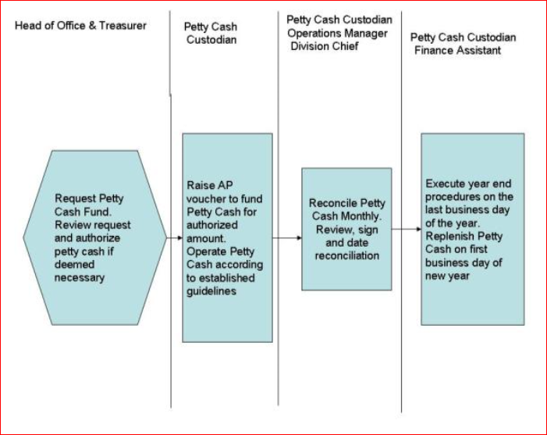

The Guidelines cover the following possible cash arrangements, please refer to specific POPP sections for individual policy and procedures:
Petty Cash Fund (PCF) for CO’s Main Office (also known as Management Project)
Petty Cash Fund for Development Project (PPCF) for Remote Locations
Project Cash on Hand (PCH) (monetary requirement > PPCF amount)
Project Cash Advance (PCA) (one-time project activity requirement)

As of 1 September 2018, increased levels on cash arrangement and the related Delegation of Authority (DoA), are entering into effect as follows:

PCF | - Increased limit from $1,000 to $2,500  - Per payment limit increase from $100 to $250
PPCF | - Increased limit $1,000 to $2,500  - Per payment limit increase to $250  - DoA to RR to appoint NPSA/IPSA holder as custodian
PCH | - Increased limit from minimum $1,001 to new minimum $2,501 upto maximum of $5,000  - No limit on single payment  - DoA to RR upto maximum limit of $25,000  - DoA to RR to appoint NPSA/IPSA holder as custodian upto $2,500
PCA | - Maximum Limit remains at $25,000  - No limit on single payment  - DoA to RR to appoint NPSA/IPSA holder as custodian upto $5,000  - Liquidation period extended from current 2 weeks to 1 month from the date of issuance of advance

The perpetual nature of cash arrangements which are maintained as an imprest basis, such as: PCF, PPCF, and PCH, do not require approval every year after the first approval, unless basic conditions under which they were established change. Such basic conditions are: change of the designated custodian, change in amount, change of project, change of the location, and the change in the fundamental business case (for example, lack of sustainable banking system, emergency cash in safe) under which exceptional approval was granted by the Treasury.

The Regional Bureau may decide to exercise the options to grant the revised cash arrangement limits on a selective basis to the Country Offices.
The Treasurer may suspend the new mainstream cash arrangement limits for a Country Office that has
- a ‘red dashboard’ for cash exception(s), for three consecutive months, or
- an audit observation related to a cash arrangement

Either event will cause suspension. The suspension will last for one-year during which time country offices will be required to revert back to the former limits (refer Annex 2). After the one-year of suspension period, Country offices will be re-assessed for inclusion back to the mainstream amounts.
Any cash arrangement needs beyond the established limits or Delegation of Authority must be requested through submission of Annex 5 for Treasury exceptional approval.

Country Offices in crisis who need higher cash limit should submit such request as per the guidelines specified under section 6.2 Support to programme implementation of the Standard Operating Procedure For Immediate Crisis Response.

