Parallel Fund Management
- Under Parallel Fund Management, each organization independently manages its own funds, whether coming from Regular or Other Resources. This option is likely to be the most effective and efficient when interventions by participating UN organizations are aimed at common results, but with different national, sub-national and/or international partners.
- The joint programme document would consist at a minimum of a common work plan agreed by all participating UN organizations, an aggregated/consolidated budget showing the inputs from the various parties involved, the coordination mechanism and signature of participating organizations.
- Further information is available in the UNSDG Guidance Note on a New Generation of Joint Programmes (October 2022) and associated annexes.
- All UNDP programme or development funds (i.e. regular resources such as TRAC or other resources such as cost-sharing or trust funds) can be directed to parallel funding.

Cost Recovery
- UNDP’s cost recovery policies and procedures (GMS and Direct Project Costing - DPC) apply.

Accountability
- As there is no joint funding, UNDP’s standard accountability for its programme resources applies. Refer to the POPP Revenue chapter for recording of revenue under IPSAS.
- Standard UNDP procedures for project documents apply (refer POPP Programme and Project Management chapter)
- In order to ensure that all JPs can be identified and tracked in Quantum, during project formulation, the JP modality is selected in the Joint Programme field within the PPM “Project Results” Section:
Projects>Project Results>Output>Output Metadata>Joint Programme field to select the JP modality from the dropdown menu.
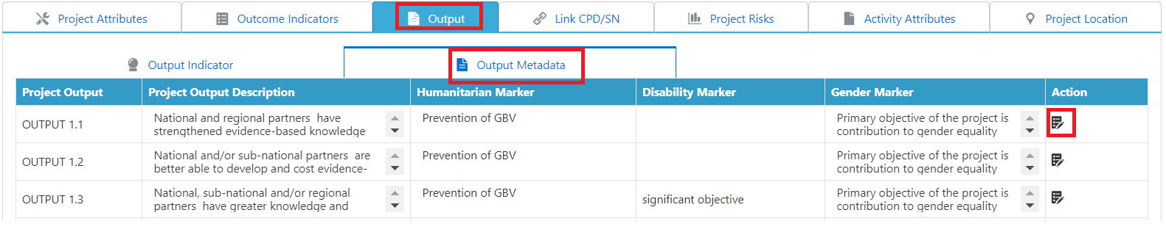

Agreements
- A Joint Programme document is entered into. Where UNDP is directing other resources to the joint programme, standard UNDP co-financing agreements (cost-sharing or, where required by the donor, closed trust fund), and clearance and signatory procedures apply. Standard UNDP project documents are signed in all cases.
- Each participating UN organization prepares financial reports annually and at programme end for its programme components. UNDP’s standard reporting procedures (see section of these Policies and Procedures on Statutory and Financial Reporting) apply for its programme, and the annual and final financial reports will be certified.
- Responsibility should be assigned for the preparation of aggregated/consolidated Financial Reports for submission to the Joint Programming Steering Committee and its subsequent submission to donors.

