**Maintenance and Usage of the Chart of Accounts**

1. The Chart of Accounts (COA) plays a role in Quantum financial systems for control, budgeting and reporting. The correct use of the COA is critical for accurate financial, management and donor reporting. The individual values, which in combination, describe a specific financial activity, are referred to as **“chart field”.** All Quantum Financial Users should have a good understanding of chart fields and fully understand the purpose of each chart field.

1. Transaction level data is recorded at a chart field level in all Quantum financial systems, and ultimately as the data pass from one system to another, it is summarized by chart field in the **General Ledger**. The General Ledger is a repository of all monetary transactions processed directly in the General Ledger or in sub-systems such as Accounts Payable (subledger used primarily for disbursements), Accounts Receivable (subledger used for recording receipts), Global Payroll, and all other subledgers in Quantum. The General Ledger is the final record from which financial statements are prepared.

1. With reporting and analytic tools, chart fields provide access to accounting data needed for budget control, management reporting, and statutory (or formal and final financial) reporting. Reporting tools reference chart fields directly or indirectly through the rollup mechanisms available with trees (see Chart field Tree Structures below). In addition, chart fields are used in the definition of budget control and journal edit combination rules either directly, by referencing specific values, or indirectly, through trees.

1. **Chart field Tree Structures** are used to establish a hierarchical structure, which visually represent a set of summarization rules for a particular chart field. For instance, an UN Account Tree has 5 level of parent nodes as illustrated below:-



1. Similarly, user-defined logic on account could summarize details of assets, liabilities, reimbursements and other revenue in ways meaningful for selection of items for various reporting requirements. Trees do not store amount data but provide the summarization hierarchy for reporting, by summarizing amounts from their components.

# Chart field Descriptions

6. The chart field structure under Quantum Chart of Accounts consists of the following:

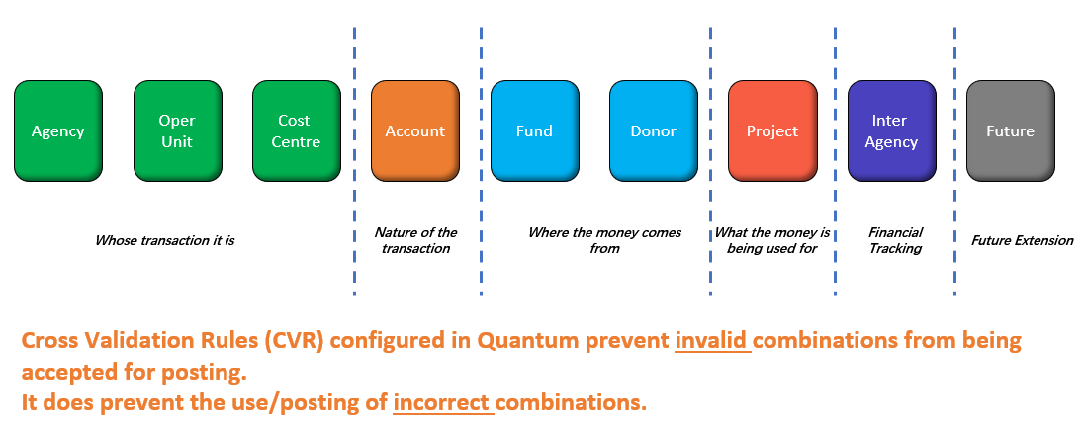

## Agency

1. The Agency chart field represents a “separate set of books” for a legal entity requiring separate accounting and operational information in the General Ledger (GL). Agency is currently identified for Quantum implementation use as UNDP, UNV, UNCDF, UN Women, MPTF, UNU, UNSSC, UNITAR and UNFPA.

1. The implications of the General Ledger Agency concept in Quantum are the following:
   1. Agency is the primary balancing segment
   2. Transactions are entered and stored under agencies;
   3. Operators for GL-related transactions are granted security access by agency;
   4. Budget checking and spending authority is established by GL agency;
   5. Report generation is defined by GL agency;
   6. Batch processing is defined by GL agency;
   7. The handling of journal entries error processing (i.e. whether errors are posted to a suspense account or recycled) is set up at an agency level;
   8. Base currency is also set up at a GL agency level.

Account

1. The Accountchart field identifies a unique asset, liability, equity, revenue or expense account. It is a required field that is primarily used for financial and management reports.

1. It is used in combination with other chart fields to process transactions. It classifies the nature of operational transactions. In other words, it shows how a transaction would be reported on the balance sheet or income statements. It is also important for the year-end closing process to identify accounts with balances which should be taken forward or those revenue and expense accounts that do not have carried forward balances. There are three types of accounts:
   * 1. Balance Sheet accounts include assets, liabilities and fund equity/net assets accounts;
     2. Revenue accounts include financing sources. Revenue accounts are usually created for each revenue category;
     3. Expense/Expenditure accounts include financing uses.

Fund

1. The Fund chart field is used to classify funding resources. Funds are segregated for the purpose of conducting specific activities or attaining certain objectives in accordance with special regulations, restrictions, or limitations. This chart field is also used to control spending in UNDP.

1. The inclusion of the donor chart field for budgeting cost-sharing funds has been requested to ensure alignment of donor funds for such funds to income and expenditure. This has been implemented in 2006 for all cost-sharing funds, as well as “closed trust funds” that are controlled by cash for budget control purposes.

1. The Fund chart field in Quantum maintains the fiscal and accounting entities for financial resources. It is a secondary balancing segment, meaning balance sheet and income statement can be produced by fund.

1. The main funding categories in UNDP are:
   * 1. Regular Resources;
     2. Other Resources that are further categorized into the following:
        1. Cost sharing;
        2. Trust funds;
        3. Others: government cash counterpart, United Nations Volunteers (UNV), Junior Professional Officers (JPO) and Management Service Agreements (MSAs).

Operating Unit

1. The Operating Unit chart field lies between the Agency and the Cost Center. It is useful for identifying units responsible and accountable for financial transactions. For UNDP, an operating unit could be a regional bureau, a country office, or a similar functional area. The relationship of the operating units (e.g. regional grouping) is established using the tree structure.

Cost Centre

1. The Cost Centre chart field is maintained for departmental expenses, budgets and cost groupings and rolled up to country and bureau. It represents the financial management view of the organization. Quantum financial system subledgers use cost centre as defined in the human resources system and maintained by the Office of Financial Management (OFM). PeopleSoft technology is used to ensure that the two databases remain in sync. Typically, an operating unit would be the country office (e.g. ‘AFG' for UNDP Afghanistan) and cost centre would be the various units set up in the country office (e.g. Afghanistan

Central Department; Democratic Governance Department, Finance Department, Human Resources Department, etc.).

1. There are two types of cost centre chart field values:
   * 1. Budgetary Cost Centre
     2. Expenditure Cost Centre

1. The Budgetary Cost Centre codes start with a “B”, preceding the cost centre code, while the Expenditure Cost Centre codes are five-digit numeric. The first three numbers of the expenditure cost centre code are the same as the last three numbers of the budgetary cost centre code.

1. Budgetary cost centres are used for budgeting only. They represent a group of expenditure cost centres. Funds are allocated at budgetary cost centre level and any cost centre within a group of expenditure cost centres rolling up to the budgetary cost centre can spend funds assigned to that budgetary cost centre.

1. For example, budgetary cost centre code B0300 has been issued a budget of $100,000. Expenditure cost centre codes ranging from 30001 to 30099 can spend up to $100,000 - the funds allocated to budgetary cost centre B0300.

Project

1. The Project chart field is tied to the Quantum Project and Portfolio Management (PPM) subledger and used for project accounting. The Project chart field identifies objectives for projects to which funding sources are applied. It is essentially used for activities that are temporary in duration and for which revenues and expenditures may be accumulated over more than one fiscal year. Projects start and end dates may not correspond to a fiscal year. Beginning and ending dates are entered for the project values that limit financial activity.

1. The Project chart field is also broken down into specific activities. This feature facilitates the tracking of project financial information without changing the chart of accounts.

1. Project is the top level at which budget and expenditure can be recorded and Activity is the lowest budgeting and reporting level for projects.

1. Detailed project data (including all chart field values) are maintained in the Quantum PPM subledger and tracked at project summary level in the General Ledger. However, the data maintained in the PPM subledger, is classified by business unit defined at the sub-ledger level, providing the flexibility of using different level of project activity based on the requirements of each business unit. For instance, using the project business unit feature, projects are classified by project owners (i.e. country office and Headquarters, UNV, etc.)

1. There are generally three types of projects:
   1. Development Projects - funded from core, trust fund or cost sharing resources;
   2. Management Projects - mostly funded from biennial support budget or extra-budgetary funds;
   3. Cost Recovery Projects -used for transactions processed on behalf of UN agencies.

Interagency

1. The Inter Agency chart field is used for inter-unit accounting and is populated during journal processing, when inter-office or inter-fund transactions are being processed. Quantum provides the capability to record all inter-office or inter-fund generated journals in a single intra-fund, intra-operating unit or inter-unit with other GL Agency and track the interagency fund, office or agency using the interagency field. For instance, if UNDP makes payment out of its bank on behalf of another UN agency, the inter-agency chart field in UNDP records would capture the name of another agency.

Donor

1. The Donor chart field is used to track donors' revenue as well as expenses apportioned to different donors/funding sources and to facilitate donor reporting. All projects funded on cost sharing basis (or project level co-financing) should show the correct donor at all times. This is critical for donor reporting.

1. Starting from 2006, the donor code for cost-sharing, as well as certain trust funds (e.g. European Commission) is also part of the chart-fields used for budgetary control. Other funds, viz. regular resources and the other trust funds (or fund level co-financing) are managed through allocation. The donor field for such funds would be ‘UNDP' donor, i.e. ‘000012'.

# Other important fields

Budget Period

1. The Budget Period field is required for maintaining budget entries and identifying a period for budgeting purposes. The Budget Period will ensure that those transactions that affect budgets fall within the defined start and end dates.

Currency Code

1. Currency code is a PeopleSoft-delivered field used to facilitate multi-currency processing. Multicurrency will be used in all Quantum financial subledgers.

Fiscal Year and Accounting Period

1. All transactions within PeopleSoft are posted by fiscal year and accounting period, based on user-defined processing calendars. There is only one calendar identified in Quantum - a fiscal year (January 1 to December 31). Other calendars may be built as needed and will be used for appropriate reporting.

Ledgers

1. Ledgers are associated directly with an agency and store posted amounts by ledger classification. In Quantum, UNDP has USD primary ledger to record financial transactions from all subledgers (payables, fixed assets, project, receivables, payroll and cash management) and USD secondary ledger limit to record corporate transactions only.
2. Ledgers are defined as “balanced”, so the system will enforce edits to ensure that dollar journals are in balance for “Actuals”. The period(s) open for journal processing is (are) also defined at the ledger level by agency. Journal error handling, combination edit processing options, currency options and approval options are also defined at this level.

Responsible Party

1. The responsible party (or implementing agent as was known in ATLAS) is used to track advances and payments made to the implementing agency. This is a required field for expenses charged to all UNDP projects. In Quantum, this field is no longer a GL COA but modelled as vendor in Project and Portfolio Management (PPM)

Task id

1. The task id (or activity id as was known in ATLAS) details the task breakdown of the project and output. In Quantum, this field is no longer a GL COA but will be tracked in Project and Portfolio Management (PPM).

**Chart fields**

1. Any changes to the chart fields must be approved by OFM.

# Account Code

1. The chart field table for account codes is local segment for all Agencies in Quantum, hence, each agencies can add, modify or delete the account code.

1. Users are required to do the following:
2. ***Revenue*** - contributions received from donors should always be recorded using account 51005 and entering the relevant operating unit, cost centre, fund ID and the donor code. If the fund code is cost-sharing or project level co-financing, the project ID, project business unit and a default activity should also be entered.
3. ***Expenses*** - are recorded using appropriate expenditure account in the 6xxxx or 7xxxx series. All expenses should include all chart fields without any exception. The cost centre entered for expenses should be the expenditure cost centre (not the budgetary cost centre).Other asset or liability accounts in the ***1xxxxx or 2xxxx series*** should include, as a minimum, the following chart field values: account, operating unit, fund and cost centre.
4. Business Owners for the various chart fields need to make sure that no duplicate values exist. A review of the donor chart field values should be regularly undertaken by the business owners to “inactivate” the duplicated values.

# Summary Table of Chart fields

|  |  |  |  |  |  |  |
| --- | --- | --- | --- | --- | --- | --- |
| **Chartfield** | | **Number of Characters** | | **Description** | **Business Owner** | |
| Agency | |  | | For USD UNDP PL - UNDP, UNV |  | |
| Operating Unit | | 3 | | Operating Unit | Office of Human Resource (OHR) | |
| Account | | 5 | | Accounting element to classify assets, liabilities, equity,  revenue and expense | Office of Financial Management (OFM) | |
| Fund | | 5 | | Fund | OFM | |
| Cost Centre | | 5 | | Organizational element | OHR | |
| Project | | 8 | | Project identifier | Finance Business Advisor (FBA) | |
| Donor | | 6 | | Donor | Parnter and Donor Interactive (PDI) | |
| Currency Code | | 3 | | Local currency | Treasury | |
| Fiscal Year | | 4 | | Fiscal year of ledger balance | OFM | |
| Accounting Period | | 8 | | Accounting period of ledger transaction | OFM | |
|  | |  | |  | | |  | |