User Guide on DES (DPC) Entries In Quantum

Contents
Introduction 1
Inter-module Data Flow 1
Entering DES Entries 2
Creating Invoices 2
Confirming Flow in GL and GL Budgetary 3
Confirming Flow into Project Costs and Project Budget 4

Introduction

The purpose of this document is to point out specific key fields users have to be aware of when creating DES entries.
We will be using an AP Invoice modality with
- Zero header amount – meaning lines balance by debit and credit
- A specific supplier - which has been setup to differentiate approval workflow rules and also work around other AP requirements (payments, bank reconciliation).
- All account codes - Expense, Revenue, Asset and Liability. However only Expense account codes will require project information and update PPM. All other account codes will only update GL.

Inter-module Data Flow

- Expenditure will update PPM – Costs and Budget Balance
- GMS would be able to be run on the expenses booked
- Expenditure Item Date = Invoice Date

- Update General Ledger
- Update GL Budgetary
Accounts Payable Regular Invoice Lines

Entering DES Entries

Creating Invoices
Navigate to Payables à Invoices.  Create a new Invoice. | 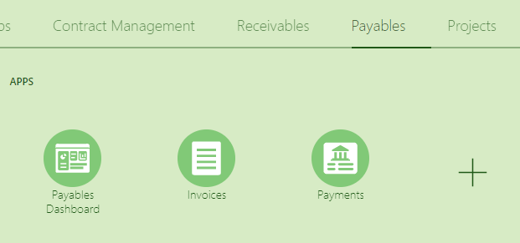
Enter your Invoice Header information.  Be aware of the following:  - Supplier = UNDP Project Adjustment  - Amount = 0  - Type = Standard | 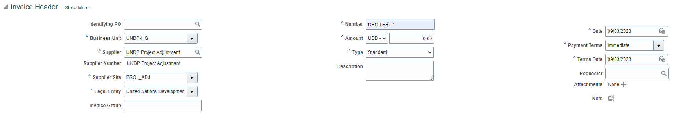
Enter Lines - Distribution  Enter the lines for 64397 and 74596 ensuring the debit and credit lines are balanced (zeroed out) at the DPC account code level. | 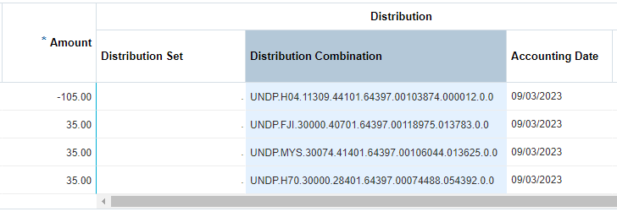
Enter Lines - Project  When you use expense accounts in your distribution, please ensure that you enter Project and Contract information so that this transaction is reflected in PPM. | 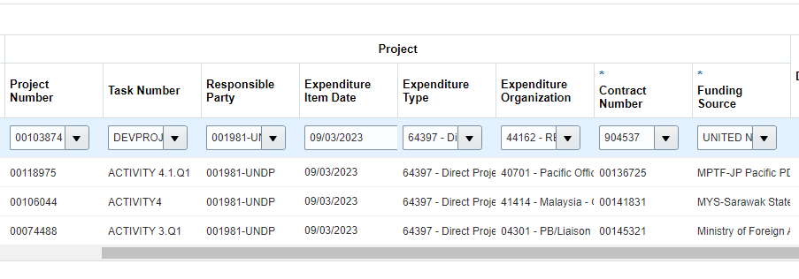  *Please be aware your Expenditure Item Date MUST EQUAL your Invoice Date (and Conversion Date)

Once your invoice is balanced, please Validate/Check Funds and submit for approval.
Approval of Zero-Cost invoices should be Manager Level 2 and/or above.

Note :
- Please do not amend anything in your Invoice Pay Group or Payment Method.
- Please ensure the Conversion Date ALWAYS EQUALS your Invoice Date.

Confirming Flow in GL and GL Budgetary

Upon Budget Status = Reserved in the invoice, GL Budgetary will be updated.
Invoice
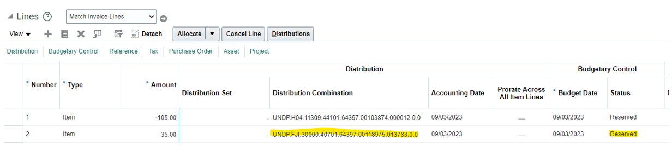
GL Budgetary
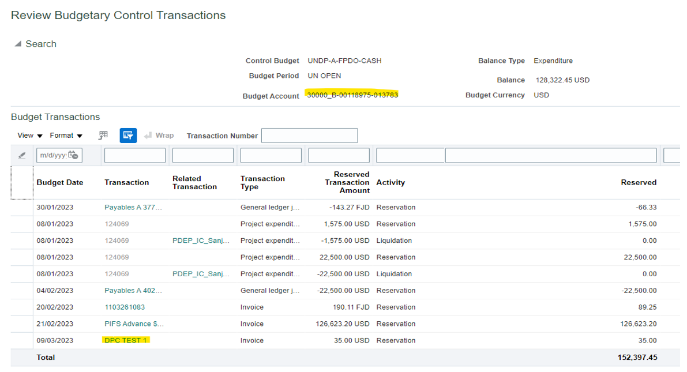

And once the invoice is posted, GL Ledger will also be updated:
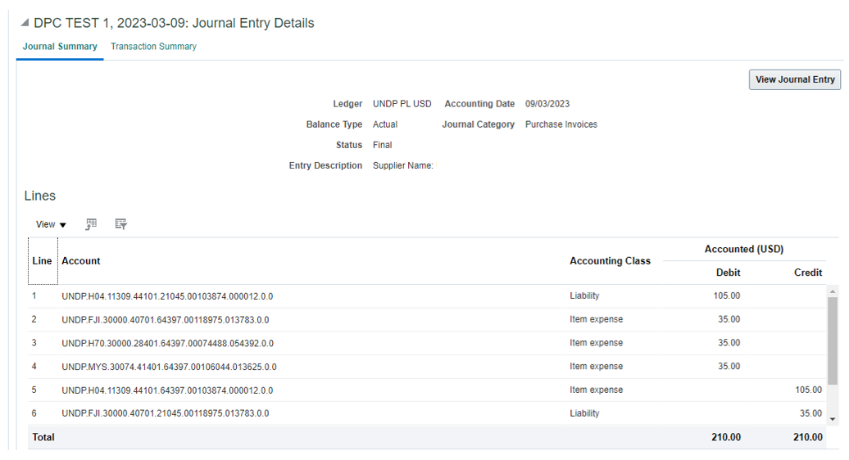
This is essentially still an ‘invoice’ so there are liability entries that will be created (under account 21045). But these entries will have no impact to GL Budgetary.

Confirming Flow into Project Costs and Project Budget

Costs into PPM will be updated correctly if you have entered the project and contract information into Invoice Lines-Project.
Invoice
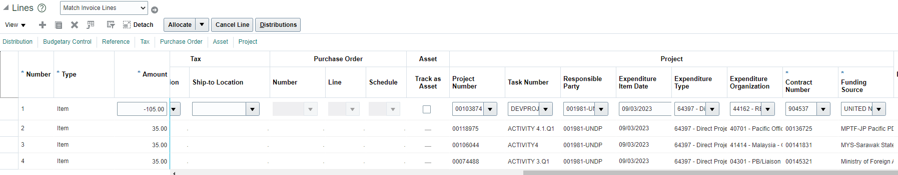

Project Costs
Navigation : Projectsà Costsà (Task Manager)à Review and Adjust: Manage Project Costs
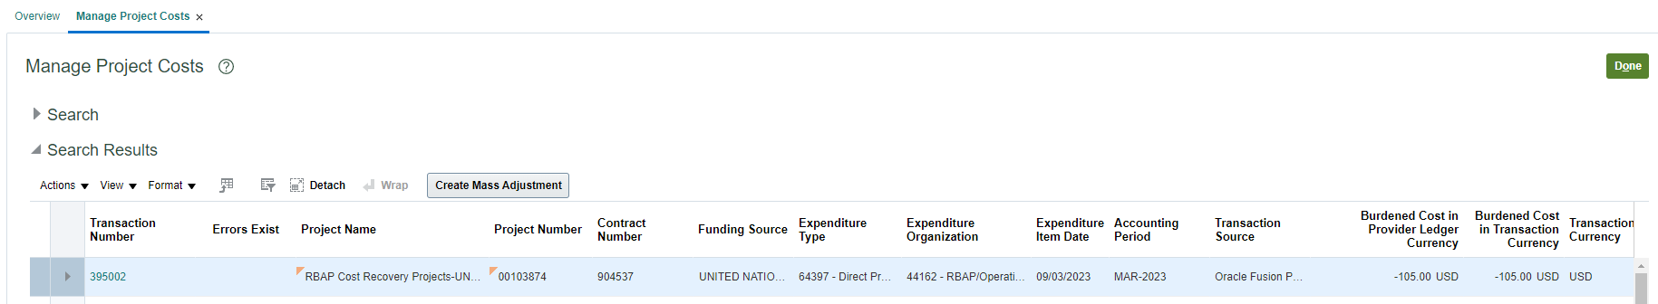
Project Budgets - Awards
