

**United Nations Development Programme**

**PIPELINE MANAGEMENT GUIDELINES**

***(as of 01 September 2023)***

**BUSINESS CASE**

1. In order to maintain relevance as a development organization supporting countries in the attainment of their sustainable human development objectives in a very dynamic and complex development environment with multiple inter-dependent challenges, UNDP has embarked on a concerted effort to more effectively embrace innovation, identifying and advancing strong ideas to achieve greater development impact on the ground. This is to be done through continuous business development; diversifying partnership base and reaching out to non-traditional partners and donors; proactively engaging with clients to generate and manage demand for UNDP services; and adopting new ways of developing a continuous stream of innovative business solutions, integrated policy and management services and high value and impact signature products.
2. New business development takes a special place in UNDP’s comprehensive 4-stream corporate agenda aimed at maintaining UNDP substantive relevance and financial sustainability. In addition to business development, this agenda includes finalizing the next Strategic Plan/Integrated Budget, monitoring our current programmatic/financial situation through a robust pipeline management, and deep structural adjustment.

Business development is intrinsically linked to and supported by ***pipeline management.*** In UNDP’s context, ***“pipeline” refers to the totality of planned projects, programmes, and initiatives that UNDP is expected to pursue within a foreseeable time in the future***. Effective pipeline management is a powerful tool for converting business units/offices into extravert mechanisms establishing strategic partnerships and mobilizing resources for accelerating sustainable human development. It ensures low transaction cost and high ownership content.

Together, business development and pipeline management support two key objectives:

**Strategic direction** – systematic business development and pipeline management ensure that UNDP remains focused and the programme portfolio globally, regionally and locally is consistently framed in the sustainable human development (SHD) philosophy. UNDP provides stewardship of social, economic and environmental sustainability and the organization's development strategy is to pursue “triple wins” advancing all three aspects of sustainability at a time.

**Financial direction** – sound business development and pipeline management enhance the ability of UNDP to leverage and maximize various partnerships and opportunities for development financing. It also contributes to ensuring financial sustainability of the organization through enabling better informed and  more accurate resources projections and making necessary adjustments in internal resource planning.

1. In UNDP pipeline usually includes ***two types of planned interventions***: (1) scaling up or replicating successful existing programmes/projects; and (2) new project ideas, development solutions, integrated service lines, and signature products.

**DEVELOPMENT OF PIPELINE**

1. Development of pipeline is not a one-off exercise, but a continuous process guided by the ***substantive framework of the Strategic Plan and UNDP brand.*** It isanchored on two main pillars: specific ***needs*** on the ground and ***opportunities*** for business development. “*Needs*” could derive from many different sources, including a government request, internal UN/UNDP analysis, discussion or introspection, a recommendation of an external analysis, “big data” analysis, real time monitoring of on-going interventions, a previous project; etc. “*Opportunities*” are linked to UNDP’s strategic priorities and substantive competency, conducive environment locally to address an issue/challenge, availability of funding, etc.
2. In the development of pipeline, it is critically important to identify and effectively leverage ***partnerships*** early in the process to build coalitions, ensure broader ownership, facilitate implementation support and guarantee sustainability of results over time.
3. In the conditions of limited regular resources, UNDP should ***use core funding*** strategically. Regular programme resources should be used as “seed money” to develop new interventions and bring in additional funding from other sources. In line with this, it is proposed to institute a “never alone” approach to pipeline development that allows to forge multiple partnerships within a wider network of stakeholders and capitalize on larger funding opportunities. In line with this approach, no pipeline projects should be funded solely with core programme resources.
4. Successful pipeline development does not happen in a vacuum. On-going projects should be used as “incubators” of new ideas and initiatives. Creating a ***safe experimentation space*** within each project makes pipeline development both more effective and efficient due to the use of already existing platforms, fosters innovation and provides more conducive environment for the development of new solutions.

1. Another prerequisite of successful pipeline development is ensuring ***active communications*** around UNDP mandate, key areas of work and collaborative advantages, key services and “signature products”, and results achieved. Active communications posture increases the visibility of UNDP brand and naturally provides essential entry points for cooperation with partners.

**MATURITY OF PIPELINE**

1. A sound pipeline portfolio is likely to include projects of different maturity, ranging from initial ideas to interventions with secured funding and implementation capacity ready to be launched.
2. It is important for each office/unit and UNDP overall to have a clearer idea of the maturity of its pipeline. It allows making better-informed decisions about investment areas which have a higher return potential in terms of development impact and, hence, have to be prioritized.
3. A proposed pipeline ***maturity model*** is conceptualized around the notion of development interventions deriving from needs (Criterion 1) and opportunities (Criteria 2 to 4), whereby a development intervention is mature and is, thus justified, when a need fully converges with an opportunity. It is built on the following ***five criteria***:

1. ***Criterion 1***: **Demand for services**. A sound project should respond to a clear current or anticipated development need. A mature pipeline project should not only be clear about the nature of the need but also reference information/data supporting the conclusion about the need.
2. ***Criterion 2***: **Enabling environment.** For a development intervention to have a good prospect of success, it is important to ensure that local environment is right for raising a particular issue or implementing a specific solution. While thinking of enabling environment it is useful to consider the commitment of critical actors to sustain the concept/approach beyond the completion of the project. For example, is there a national partner with a strong political clout that is fully on board and committed to take the project forward?
3. ***Criterion 3: Availability of substantive expertise in UNDP.*** The strength of a pipeline project is higher from the opportunity point of view if it falls within UNDP’s recognized substantive competency and can easily draw on existing knowledge or innovation capacity. This does not mean that projects that venture into new areas of expertise and would largely rely on outside expertise leveraging other comparative advantages of UNDP should be excluded from pipeline portfolio. On the contrary exploring novel ideas and innovative non-traditional approaches is to be encouraged and active, pursued. This criterion only indicates that for the maturity of the project as a pipeline opportunity to increase, focused thinking is required on what it would take to identify and mobilize expertise for the project to attain its objectives.
4. ***Criterion 4: Availability of critical partners.*** This criterion encompasses three types of partnerships that need to be secured for a pipeline project to reach a required maturity level:
   1. For a pipeline project to be mature there should be clear understanding of how and by whom it will be implemented. Some of the specific questions that need to be answered include whether the **implementing partner(s)** and potential responsible parties have been identified and whether any investment should be made in building their capacity. If DIM/CO support to NIM project is envisaged, an informal review of the existing capacity in the UNDP office is necessary. In doing so, a CO should analyze not only the capacity available in the office, but also at the regional and global level in service hubs.
   2. A key to success of any project intervention is the timely and effective engagement with key partners. In assessing the maturity of a pipeline project it is important to have an appreciation of the partnership landscape to determine which **substantive partners** have to be involved to ensure or facilitate success. The analysis should include, for example, a brief review of other development partners - multilateral and bilateral - addressing the same issue/area of work, as well as a review of academic and non-government organizations dealing/interested to deal with similar/related issues.
   3. Availability of funding to support the project is one of the key criteria of pipeline maturity from the opportunity point of view. The maturity of the pipeline project directly depends on the degree of certainty that necessary resources will be available for all envisaged activities and interventions. The highest rating will be awarded to a project with a firm commitment from a donor for funding.
5. ***Criterion 5: Degree of the idea’s/concept’s development.*** One of the key principles of innovation is to "make ideas tangible" as early in the process as possible. In line with this principle, sound pipeline management involves capturing ideas as they come up, translating them into brief concept notes and then focus on further developing them through a reiterative process.
6. To facilitate review of the level of pipeline maturity, a simple 2-scale pipeline maturity test could be thought of based on the above criteria:

**Table 1. Pipeline Maturity Test Template**

|  | **Criteria** | **Test questions** | **Yes**  **(green)** | **No**  **(yellow)** |
| --- | --- | --- | --- | --- |
| 1. | Demand for services | * Is there evidence (e.g. government request, national plan, UN analysis, etc.) confirming the need for a project implemented? |  |  |
| 2. | Enabling environment | * Is there evidence that the local environment conducive to implementing a project in this area? Are there any particular risks that may prevent the projects from successful implementation? |  |  |
| 3. | Availability of substantive expertise in UNDP | * Does the project fall within a UNDP core area of expertise? Does UNDP have clear “signature products” in the area? |  |  |
| 3. | Availability of critical partners | * Have the implementing partner been confirmed for this project? |  |  |
| * Have the key partners, e.g. NGO networks, private sector companies, other UN agencies, multi-lateral organizations, etc. that UNDP will have to engage with as part of the project? |  |  |
| * Is there a partner who committed providing funding for the project? |  |  |
| 6. | Degree of the idea’s/concept’s development | * Have the strategy, results (outputs) and key activities of the project been defined? |  |  |

1. Projects that score high on most of the above five criteria are mature and are considered part of the Class A pipeline. They are close to the actual launch when they become part of the active programme portfolio. Less mature projects, which score low on about half of the criteria, especially on the degree of development and availability of funding partners are less mature and are part of the Class B pipeline.  Projects that score low on most of the indicators are "ideas" to be further developed (Class C pipeline).
2. Initially, pipeline projects that relate to the replication or scaling up of existing programmatic interventions/solutions tend to score higher on many criteria, as they are usually a good indicator of demand to which UNDP should respond, they capitalize on tested solutions, there is capacity already built to support implementation of such projects and there are usually partnership networks already established. Strong pipeline portfolio should always include a share of project exploring innovative new solutions and approaches. This would facilitate continuous business development, opening up new opportunities and developing new services lines for UNDP.

**PIPELINE MANAGEMENT AND RESOURCE PROJECTIONS**

1. Regular review and analysis of the pipeline portfolio allows an office/unit to more accurately project the availability of resources - both for programme and internal institutional needs.
2. In coming up with such projections, the general principle is that the more mature the pipeline project is, the more probable it is that its implementation will start in a given year and, thus, the larger its resource mobilization potential is. When projecting non-core resources a higher discounting factor will be applied to less mature projects. The table below aims to capture these principles:

**Table 1. Non-core and XB projection**

|  |  |  |  |  |  |  |
| --- | --- | --- | --- | --- | --- | --- |
| **Project** | **Projected budget**  **(broken down by year)** | | **Adjusting factor in non-core**  **(*broken down by year*)** | **Revised non-core value** | **Cost-recovery**  **Rate**  **(*broken down by year*)** | **Projected XB (GMS) earning** |
| **Core** | **Non-core** |
| **Class A pipeline projects** | Inputted value  or  exported from the partnership opportunities module | Inputted value  or  exported from the partnership opportunities module | 10% | Calculated | 7%  3%  8%  Exceptions | Calculated |
| **Class B pipeline projects** | Inputted value  or  exported from the partnership opportunities module | Inputted value  or  exported from the partnership opportunities module | 30% to 50% | Calculated | 7%  3%  8%  Exceptions | Calculated |
| **Class C pipeline projects** | Inputted value  or  exported from the partnership opportunities module | Inputted value  or  exported from the partnership opportunities module | 70% | Calculated | 7%  3%  8%  Exceptions | Calculated |

1. The non-core and XB (extra-budgetary) projection algorithm can be run in Quantum+ UNITY “Partnership Opportunities” module, with the adjusting factor being linked to the level of maturity of the respective pipeline project.

**LEVERAGING THE QUANTUM+ UNITY “PARTNERSHIP OPPORTUNITIES” MODULE FOR PIPELINE MANAGEMENT**

1. Quantum+ UNITY “Partnership Opportunities” module provides a sound platform which could be used both for capturing and managing pipeline at the unit level as well as for corporate analysis. The Quantum+ UNITY “Partnership Opportunities” module captures key information about pipeline/Quantum+ Opportunities, including: brief description, maturity stage, implementing and funding partners, target funding (budget), approximate signature date, external partner contacts involved in the negotiations, currency, email communications, documents, related CPD output, and more.  Several other fields can be added and linked to specific questions in the pipeline maturity model, thus allowing running a series of standard reports on the general pipeline status as well as on specifics of various parts of the pipeline portfolio and individual projects.
2. Quantum+ UNITY offers standardized dashboards and reports that aggregate and visually represent various segments of the pipeline, including but not limited to International Financial Institutions, Funding Windows, Corporate and Non-Corporate Foundations (Philanthropy), Private Sector, European Union, and more. It also enables users to create their own reports and Dashboards. UNITY is personalized at the Country Office, Regional Bureaus, and Headquarters to provide the most relevant data automatically on end users’ home screens, reports, and list views. For a detailed reference of all the capabilities of UNITY navigate to the [UNITY Reference Guide by following this link.](https://undp.sharepoint.com/sites/Docs-Partnerships/Shared%20Documents/Forms/AllItems.aspx?FolderCTID=0x012000139FC97E2251B945937DA5EC719FE475&id=%2Fsites%2FDocs%2DPartnerships%2FShared%20Documents%2FUser%20Manual%20UNITY%2Epdf&viewid=00925229%2D1879%2D4959%2D96d2%2D2fb77e7b21df&parent=%2Fsites%2FDocs%2DPartnerships%2FShared%20Documents)

Below is the list of most important Dashboards (collections of reports) available in UNITY at the time of this writing. Dashboards and reports in UNITY are real time:

## Country Office

The below reports are personalized and automated. If you are located in a Country Office, UNITY identifies your location and filters the reports to reflect data relevant to your Department:

* [Pipeline Profile Dashboard - My Department](https://undp.lightning.force.com/lightning/r/Dashboard/01Z6N000000D1kPUAS/view)

20 KPIs with supporting reports of your Department pipeline.

* [Pipeline Quality Control Dashboard - My Department](https://undp.lightning.force.com/lightning/r/Dashboard/01Z6N000000D1WhUAK/view)

20 KPIs about the quality of the Department pipeline

* [Resource Mobilization Target Performance – My Department](https://undp.lightning.force.com/lightning/r/Dashboard/01Z6N000000XuvtUAC/view)

CPD Output Targets compared to Pipeline per year and CPD Output

* [Budget Forecast – My Department](https://undp.lightning.force.com/lightning/r/Dashboard/01Z6N000000D1nOUAS/view)

Resource Mobilization Forecast depending on Signed agreements and pipeline. By Annual tranche.

* [External Partner Contact Information - My Department](https://undp.lightning.force.com/lightning/r/Report/00O6N000000TC9qUAG/view?queryScope=userFolders)

List of External contacts associated to Partners based in your Country.

* [All Pipelines (Exploratory, Funding, Non-Funding) – My Department](https://undp.lightning.force.com/lightning/r/Report/00O6N000000ZteFUAS/view?queryScope=userFolders)

List of all partnership negotiations for your Country Office/Department

* [Touchpoints with Partners (Log a Call for My Department)](https://undp.lightning.force.com/lightning/r/Report/00O6N000000TNlgUAG/view)

All meetings/calls/touchpoints with external partner contacts related to your Dept.

* [Next Steps with Due Dates (Tasks for My Department)](https://undp.lightning.force.com/lightning/r/Report/00O6N000000TNlMUAW/view)

All actions associated with partnership negotiations for your department

## Regional HQ Personnel

* [Touchpoints with Partners My Region (Log a Call by Department)](https://undp.lightning.force.com/lightning/r/Report/00O6N000000TNq2UAG/view)

All meetings/calls/touchpoints with external partner contacts related to your Region

* [Next Steps with Due Dates My Region (Tasks by Department)](https://undp.lightning.force.com/lightning/r/Report/00O6N000000TNqCUAW/view)

All actions associated with partnership negotiations for your Region

* Quality Control Dashboards [RBA](https://undp.lightning.force.com/lightning/r/Dashboard/01Z6N000000D1JiUAK/view?queryScope=userFolders), [RBAS](https://undp.lightning.force.com/lightning/r/Dashboard/01Z6N000000D1JYUA0/view), [RBAP](https://undp.lightning.force.com/lightning/r/Dashboard/01Z6N000000D1JTUA0/view?queryScope=userFolders), [RBLAC](https://undp.lightning.force.com/lightning/r/Dashboard/01Z6N000000D1IkUAK/view?queryScope=userFolders), [RBEC](https://undp.lightning.force.com/lightning/r/Dashboard/01Z6N000000D1JdUAK/view?queryScope=userFolders)

Regional colleagues and COs can use this dashboard in their pipeline review sessions.

## Central, CO and Regional HQ Personnel

* [UNITY Highlights](https://undp.lightning.force.com/lightning/r/Dashboard/01Z6N000000D1kZUAS/view) / [UNDP Financial Sustainability Metrics](https://undp.lightning.force.com/lightning/r/Dashboard/01Z6N000000D2i0UAC/view)

Pipeline KPIs drawn in real time from all contributing UNDP Departments.

* [Global Funding Pipeline Profile (by Bureaux)](https://undp.lightning.force.com/lightning/r/Dashboard/01Z6N000000wtxJUAQ/view)

Detailed view of global funding pipeline that can be filtered by Region and Stage

* Pipeline by Department: [ExO](https://undp.lightning.force.com/lightning/r/Dashboard/01Z6N000000D1wBUAS/view), [BERA](https://undp.lightning.force.com/lightning/r/Dashboard/01Z6N0000004U48UAE/view), [BPPS](https://undp.lightning.force.com/one/one.app#eyJjb21wb25lbnREZWYiOiJkZXNrdG9wRGFzaGJvYXJkczpkYXNoYm9hcmQiLCJhdHRyaWJ1dGVzIjp7ImRhc2hib2FyZElkIjoiMDFaNk4wMDAwMDA0VTZUVUFVIiwiZGlzcGxheU1vZGUiOiJlZGl0In0sInN0YXRlIjp7fX0%3D), [RBAS](https://undp.lightning.force.com/lightning/r/Dashboard/01Z6N0000004TzrUAE/view), [RBA](https://undp.lightning.force.com/lightning/r/Dashboard/01Z6N0000004U0gUAE/view), [RBAP](https://undp.lightning.force.com/lightning/r/Dashboard/01Z6N0000004U0kUAE/view), [RBEC](https://undp.lightning.force.com/lightning/r/Dashboard/01Z6N0000004U0hUAE/view), [RBLAC](https://undp.lightning.force.com/lightning/r/Dashboard/01Z6N0000004U0fUAE/view)

A list of 7 Dashboards, one for each Bureau/Region listing partnership negotiation related intelligence ina graphical form supported by tens of reports.

* [Accelerator Labs Pipeline and Signed Opportunities Dashboard](https://undp.lightning.force.com/lightning/r/Dashboard/01Z6N000000D2e3UAC/view)

Real time aggregate and detailed reports of all Accelerator Labs partnership negotiations and agreements.

* [International Financial Institutions (IFIs)](https://undp.lightning.force.com/lightning/r/Dashboard/01Z6N000000D1TYUA0/view?queryScope=userFolders) Dashboard

Aggregated data from all Departments on partnership opportunities associated to IFIs.

* [Private Sector](https://undp.lightning.force.com/lightning/r/Dashboard/01Z6N000000D1YdUAK/view) Dashboard

Aggregated partnership opportunity data associated to the Private sector.

* [European Union](https://undp.lightning.force.com/lightning/r/Dashboard/01Z6N000000Xv33UAC/view) Dashboard

Aggregated partnership opportunity data associated to the European Union.

* [Corporate/Non Corporate Foundations](https://undp.lightning.force.com/lightning/r/Dashboard/01Z6N000000D1hGUAS/view) (Philanthropy)

Aggregated partnership opportunity data associated to Corporate/Non Cor Foundations.

* [Pipeline by Signature Solution](https://undp.lightning.force.com/lightning/r/Dashboard/01Z6N000000D1YJUA0/view)

The system extrapolates the projected funding against each Signature Solution.

* [Global - Funding Stream Projection](https://undp.lightning.force.com/lightning/r/Dashboard/01Z6N000000D1xnUAC/view)

Funding projections by year based on the available pipeline.

* [Global Quality Control](https://undp.lightning.force.com/lightning/r/Dashboard/01Z6N000000D1b3UAC/view) / [Global Key Performance Indicators](https://undp.lightning.force.com/lightning/r/Dashboard/01Z6N000000D2ehUAC/view?queryScope=userFolders) / [Trends](https://undp.lightning.force.com/lightning/r/Dashboard/01Z6N000000XuvsUAC/view)

KPIs and metrics on the health of the pipeline.

**Annex 1. Creating a Partnership Opportunity**





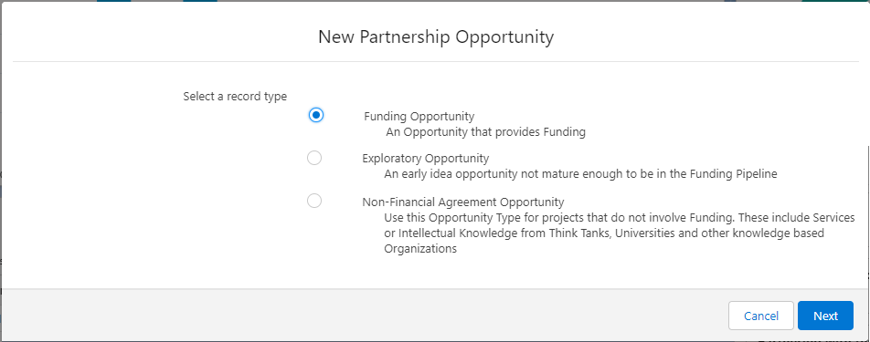



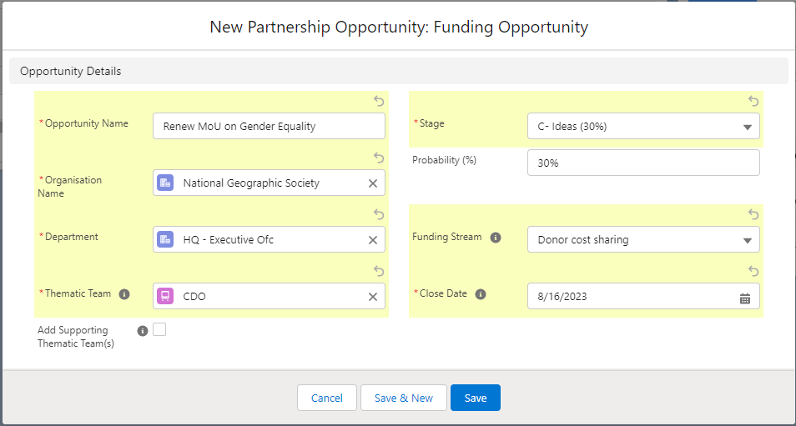



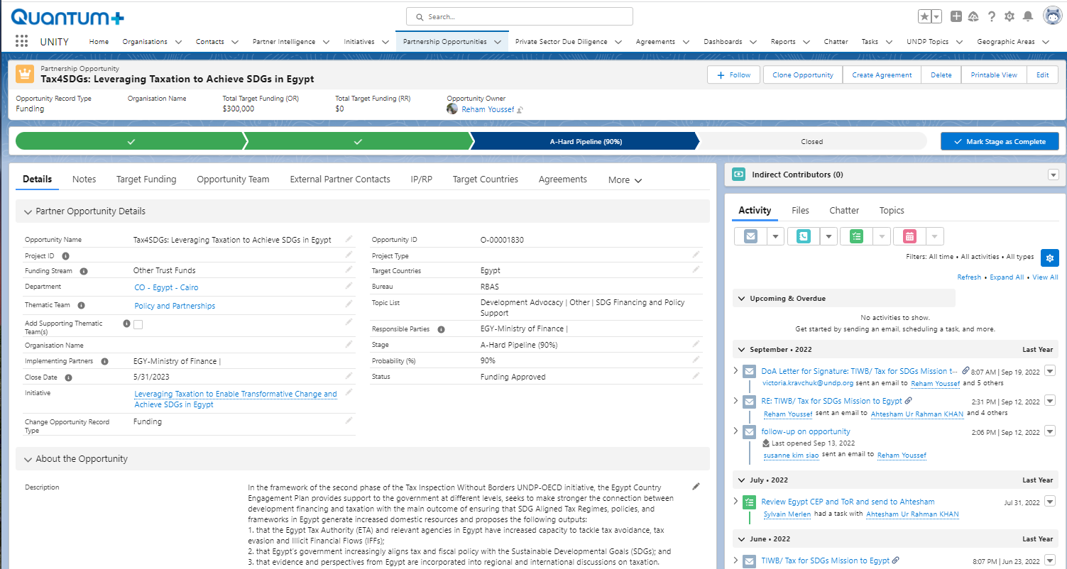

**Annex 2. View of the Pipeline of a Department (List View)**

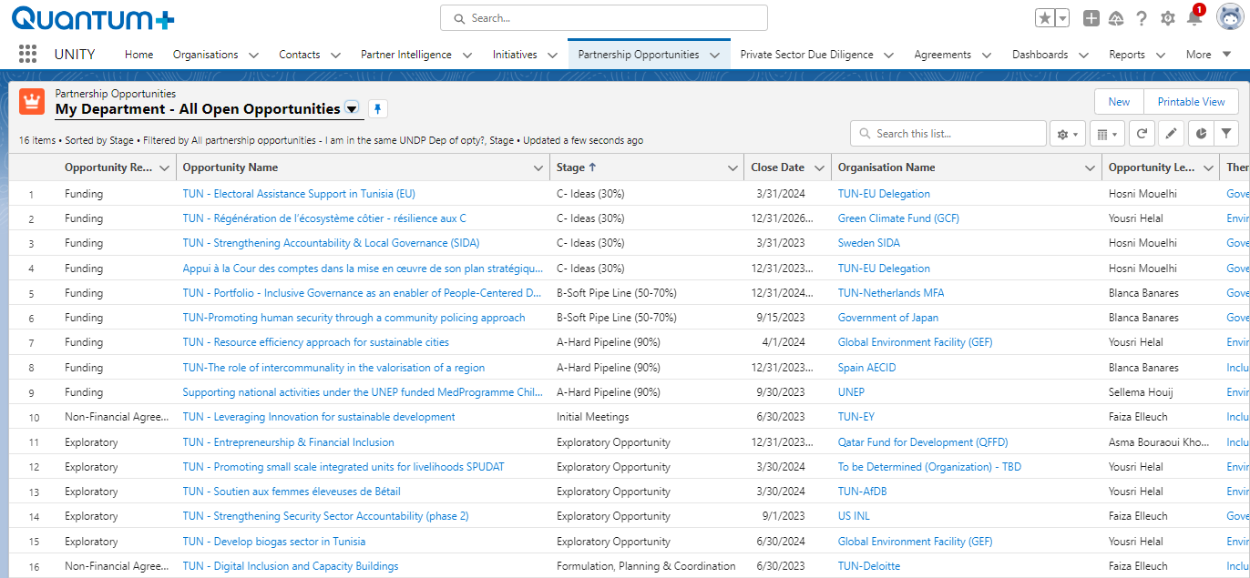

**Annex 3. View of the Pipeline of a Department represented graphically on a Dashboard**

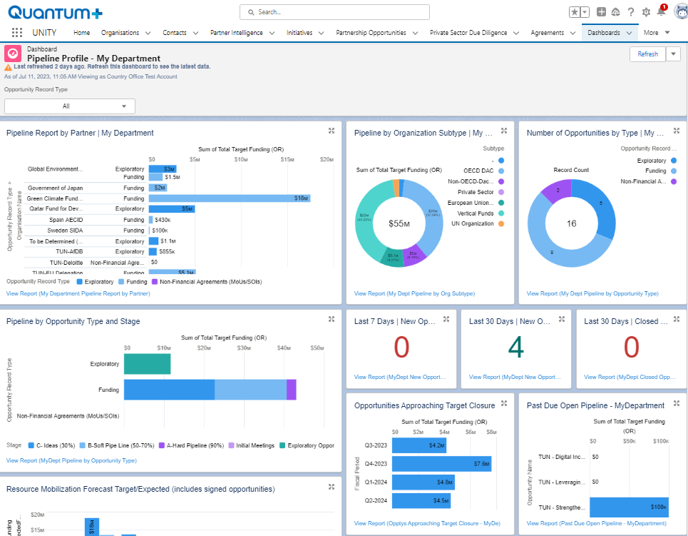

**Annex 4. Mobile Application**

