# Interim Quick Guide for General Ledger Journal Creation Steps for DES in Quantum

(DES: Delivery Enabling Services, formerly known as DPC/Direct Project Cost)

To create a journal for DES, navigate to General Accounting > Journals.

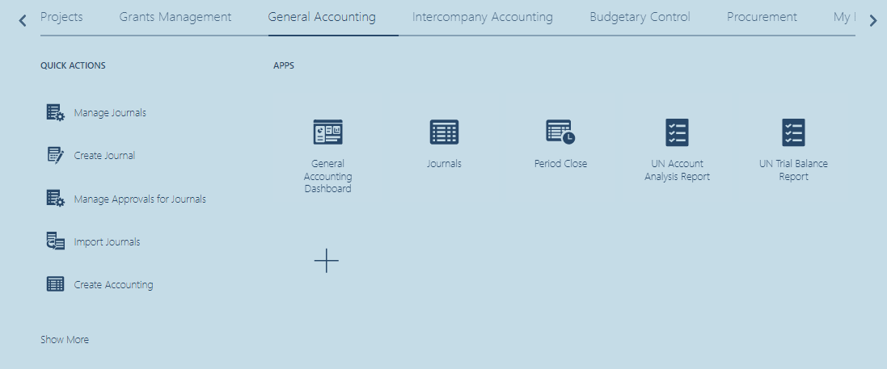

In the Journal Main page, look for the Task Icon on the right. Click on the Task icon and select Create Journal.

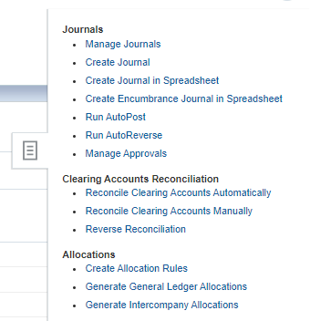

## Create Journal

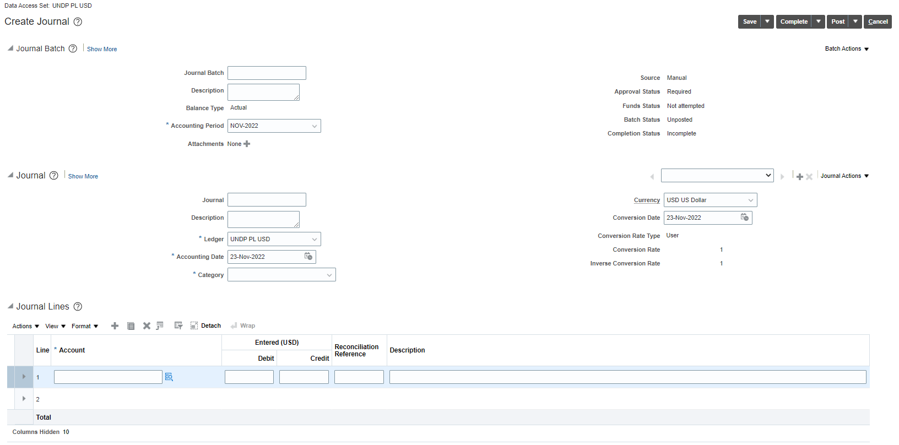

Journals in Quantum can be categorized by a Journal Batch.

For each Journal Batch you can add several Journals and Journal Lines.

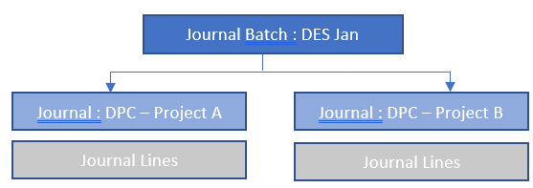

If you are creating this Journal Batch for only ONE journal, you can leave the Journal Batch fields blank.

## Journal

|  |  |
| --- | --- |
|  |  |
| Journal : Enter a Journal ID | Currency : |
| Description : Enter the description of the Journal | Conversion Date : |
| Ledger : UNDP PL USD | Conversion Rate Type : |
| Accounting Date : | Conversion Rate and Inverse Conversion Rate |
| Category : Adjustment |  |

Important Note: The Category field defines the approval rules. When Adjustment is selected, all users with Journal Approval rights will be able to approve this journal. No approval notification will be triggered. Please alert your supervisor by email to approve the journal for you.

Journal Lines

When entering journal lines, please ensure that the **account** entered for the debit and the credit are the same.

