**Pass-Through Fund Management: UNDP as a Participating UN Organization**

1. Structure Element - Description
2. The pass-through fund management arrangement can be used to support one of the three types of UN inter-agency pooled fund modalities: (i) a single stand-alone joint programme (JP); (ii) a One UN Fund; or (iii) a Multi-Donor Trust Fund (MDTF).
3. A Joint programme is a set of activities contained in a common workplan and related budget, involving two or more UN organizations and (sub-) national partners. The workplan and budget form part of a joint programme document, which also detail roles and responsibilities of partners in coordinating and managing the joint activities. The joint programme document is signed by all participating organizations and (sub-) national partners. In addition to the pass-through arrangement, two other fund management options exist for joint programmes: (i) parallel; and (ii) consolidated. More information on all three types of joint programmes can be found in the [UNSDG Guidance Note on a New Generation of Joint Programmes](https://unsdg.un.org/resources/guidance-note-new-generation-joint-programmes) (October 2022) and [associated annexes](https://unsdg.un.org/resources/annexes-guidance-note-new-generation-joint-progammes).
4. An MDTF is a type of pass-through modality designed to support a clearly defined programmatic purpose and results framework through contributions - usually received from more than one contributor - that are co-mingled, not earmarked to a specific UN entity and held by a UN fund administrator. MDTFs provide more flexible, coordinated, and predictable funding to support the achievement of a set of broad national, regional, or global results based on a clear theory of change. One UN Funds are country-level MDTFs in Delivering as One countries, for which the One Programme is used to define the Fund’s programmatic scope. More information on MDTFs can be found in the [UNDG Guidance on Establishing, Managing and Closing MDTFs](https://unsdg.un.org/resources/undg-guidance-establishing-managing-and-closing-multi-donor-trust-funds).
5. In a pass-through arrangement, UNDP can play two roles which always will be clearly delineated, (i) UNDP’s role as a Participating UN Organization (PUNO) implementing JP, One UN Fund, or MDTF activities in line with its operational mandate; and (ii) as Administrative Agent (AA) on behalf of PUNOs. (Other UN organizations can perform the AA function as well).
6. When UNDP is the AA, the Multi-Partner Trust Fund Office (MPTFO) is always involved. All requests for UNDP to act as an AA for an MDTF, One Fund or Joint Programme need to be routed to MPTFO in a timely manner. MPTFO will review the request and the MPTFO Executive Coordinator will take a decision on whether to accept the request. If MPTFO advises that the pass-through fund modality is not appropriate (if, for example, it does not meet the UNSDG established thresholds for JPs, One UN Funds or MDTFs), it will advise the concerned partners on possible alternative ways, in line with UNSDG guidance, for structuring the financial arrangements in support of a proposed partnership.
7. In an MDTF, one Fund or pass-through joint programme, the programmatic and financial accountability rest with the PUNOs and (sub-) national partners for their respective components. For UNDP, standard accountability for programme resources applies, as well as cost recovery policies and procedures. UNDP Country Offices should ensure that the aforementioned key accountability as well as other important elements such as cost recovery and reporting requirements are clearly articulated in agreements signed with the donor and/or implementing partners.
8. UNDP’s financial and programmatic responsibilities are limited only to the extent of the funds that UNDP will directly implement and records income and the corresponding expenses only for those funds for which it is programmatically and financially accountable.
9. UNDP’s cost recovery policies and procedures (GMS and Direct Projecting Charging) apply. The cost-recovery rate for the pass-through arrangement (currently 7 per cent) is established by the UNSDG and is reflected in the UNSDG standard legal agreements for the pass-through fund management modalities. GMS is chargeable on all fund codes, including on costs incurred on the steering committee booked under direct cost budgets in fund 11100.
10. Structure Element – Procedures: The UNDP country office or headquarters unit is responsible for establishing an output (i.e., Work Breakdown Structure (WBS)/Task Level 1) in Quantum for each joint programme or multi-donor trust fund project to receive and implement funding.

**Set up the project in Quantum**

1. Finalize the project structure and ensure it is approved in Quantum prior to the application of the revenue. Separate projects (or outputs) should be established as required.
2. Depending on the nature of the funding, as defined by the project steering committee, funds received from the AA are recorded and budgeted as programme funding, One UN change management funding or support to the steering committee. Funds are recorded and budgeted to the applicable fund code.
3. Support to the steering committee: Fund code 11100
4. MPTFO Advisory Services Fund: Fund code 11955
5. One UN change management funding: Fund code 16350
6. GSSCOVID Country Response: Fund code 28644
7. Programme funding (all other MDTFs if the above fund codes are NOT applied): Fund code 30000
8. Funds received from the AA are recorded and budgeted to the applicable Quantum donor code.
9. Where another UN organization is the AA, the UN organization is reflected as the donor code
10. Where MPTFO is the AA, for MDTF and joint programme arrangements in existence prior to June 2000, donor code 010714 (UNDP as AA for joint programme pass-through)
11. Where MPTFO is the AA, for MDTF and joint programme arrangements commenced in June 2000 and subsequent, BMS/OFM establishes a unique donor code in Quantum for the joint programme.
12. Where MPTFO is the AA, it communicates to the country office or headquarters unit the amount of the JP or MPTF allocation and the Quantum MPTFO project number. The project number is only used in narrative and financial reporting back to MPTFO. To facilitate reporting back to MPTFO, for new Quantum projects, the country office or HQ unit will select the relevant MPTFO project number from the drop-down list under the “MPTF Quantum Project Number” in Quantum PPM under “Financial Project Settings/Additional Information” (see red circle highlight below). For existing Atlas projects converted to Quantum, the “MPTF Project Reference Number” field carries the relevant Atlas MPTFO project number (see blue circle highlight below).
13. 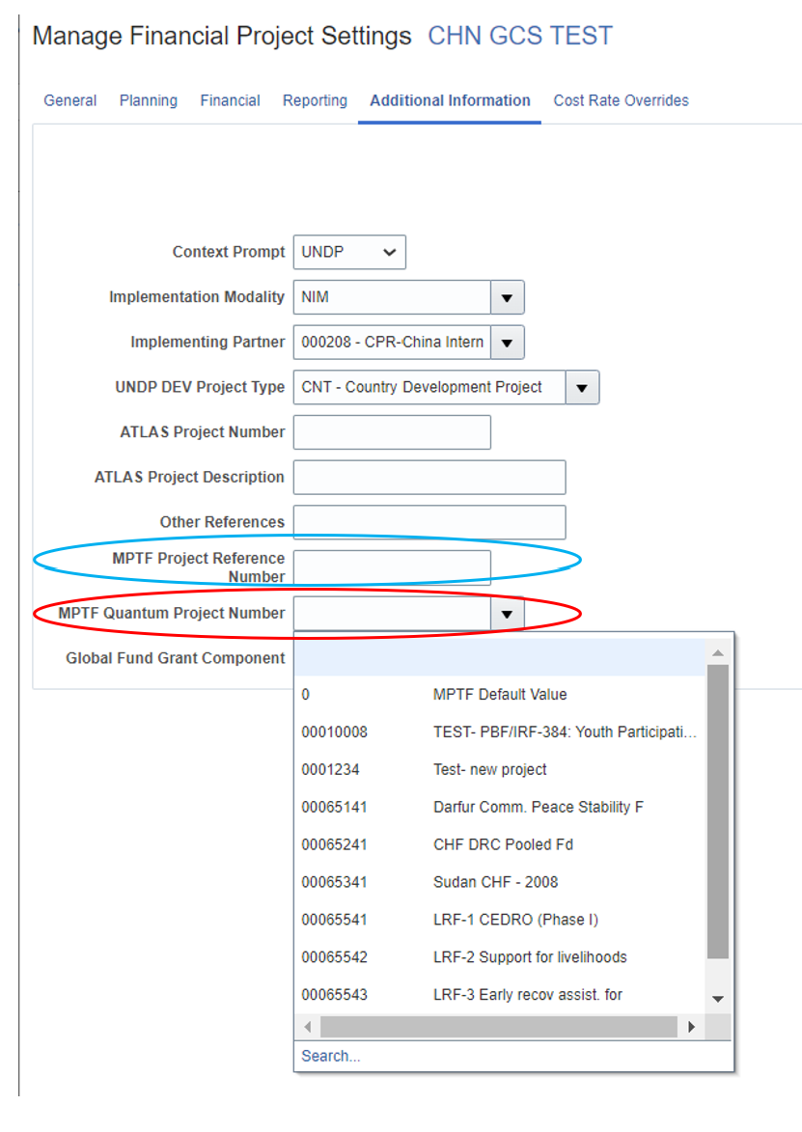
14. Standard UNDP programme and project management and financial resources management procedures apply for UNDP projects. Standard implementing partner arrangements are in effect (national implementation, direct implementation, NGO implementation, and Agency implementation).
15. All involvement of non-governmental organizations in pass-through arrangements is programmed through the UNDP project(s). The non-governmental organization takes on the standard roles of implementing partner, responsible party or contractor, depending on whether the action involves programmes or procurement.
16. Interest earned on project balances is not refunded to the AA, as per UNDP Financial Regulations and Rules.
17. UNDP regular resources (such as TRAC) or other resources (such as cost sharing or trust funds), can be subsequently added to a UNDP cost sharing project.
18. All joint programmes should be identified and tracked in Quantum. During the project formulation, the JP modality is selected in the Joint Programme field within the PPM “Project Results” Section: *Projects>Project Results>Output>Output Metadata>Joint Programme field to select the JP modality from the dropdown menu.*

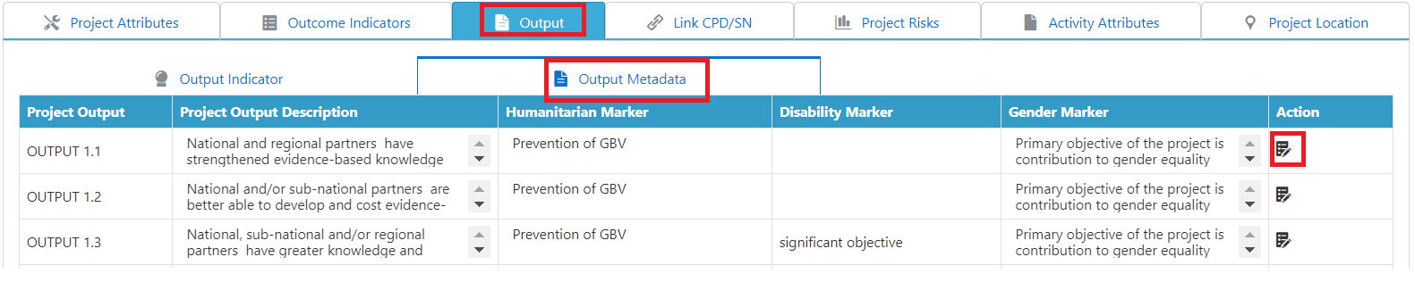

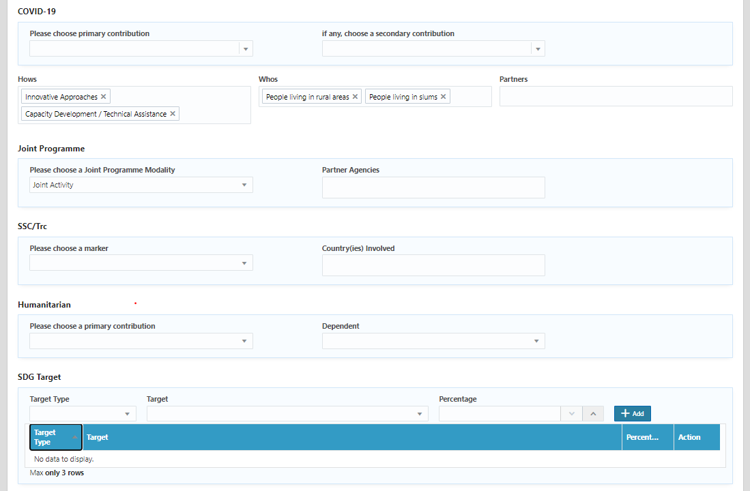

**Select correct mapping of UNDP outputs and MPTFO project ID**

1. The MPTFO project IDs and UNDP output IDs (i.e., Work Breakdown Structure/Task Level 1) should be available at the time of funds disbursement. UNDP country offices should create Quantum output IDs at the pipeline / project initiation stage. All project proposals submitted to MPTFO should carry output IDs.
2. Preferably, one UNDP output ID will correspond with only one MPTFO project ID (i.e., MPTF Quantum Project Number) and donor code, without programing other sources of funds in the outputs. This will prevent errors in financial reporting and enable faster and more efficient closure of projects upon completion of activities.
3. Offices can comingle non-MPTF resources with outputs that use MPTF funds as long as each output uses funds from only one MPTF project ID, and different donor codes (respective Quantum donor codes for those donors) are used for non-MPTF donor funds.
4. Offices can use one MPTF project fund in more than one UNDP output as long as each output will be funded by only one MPTFO project ID, and all UNDP outputs thus funded will have the same MPTFO project ID under “MPTF Quantum Project Number,” (or “MPTF Project Reference Number” field for converted Atlas projects).

**Correct and Incorrect mapping scenarios in Quantum:**

*Note: all references to “Userfield1” below should be read as the “MPTF Quantum Project Number” field in Quantum PPM “Financial Project Settings/Additional Information” (or “MPTF Project Reference Number” field for converted Atlas projects).*



**Associate outputs with project IDs**

1. UNDP outputs (i.e., Work Breakdown Structure (WBS)/Task Level 1) are associated with MPTFO project IDs through the Quantum PPM module “MPTF Quantum Project Number” field in “Financial Project Settings/Additional Information” (or “MPTF Project Reference Number” field for converted Atlas projects). This step is required before any disbursements are made or expenses are incurred to ensure that no financial information is lost. Once a UNDP output with a given MPTFO project ID is entered in the “MPTF Quantum Project Number” field (or “MPTF Project Reference Number” field for converted Atlas projects), the information should not be changed to another MPTFO project ID or removed, even after initial MPTFO funds are completely used. The original MPTFO project ID in these Quantum PPM fields should remain to enable reporting of financial information for past periods.
2. The “MPTF Quantum Project Number” field (or “MPTF Project Reference Number” field for converted Atlas projects) in Quantum PPM module is the only link between UNDP Output ID and MPTFO Project ID. Without this association in Quantum, financial information to MPTFO will be unreported, incorrect and incomplete. Country offices must make this association at the time of creating the chart of accounts for the UNDP outputs in Quantum PPM, to ensure no financial information is lost. No revenues should be recognized, nor should disbursements or expenses be incurred before setting up the above association.

**Record revenue**

1. The BMS/Global Shared Service Center will set up the receivables in Quantum contract module equal to the allocation from the MPTF or JP governance mechanisms. Funds received from the MDTF or JP through MPTFO are accounted for under IPSAS. Revenue will be applied after the project ID is entered in the “MPTF Quantum Project Number” field (or “MPTF Project Reference Number” field for converted Atlas projects) in Quantum PPM. Subsequent tranches will be similarly applied.
2. Subsequent tranches of revenue received from MPTFO for the same MDTF1 project are recorded to the original UNDP output (i.e., Work Breakdown Structure/Task Level 1) in Quantum. There is no need to set up new UNDP projects for these tranches. Transfer of revenue to other outputs within the CO or HQ Business Unit should be avoided. If necessary for programmatic purposes, the transfer must adhere to the following:
3. The transferring output and the receiving output must have the same MPTFO Project ID recorded in the “MPTF Quantum Project Number” field (or “MPTF Project Reference Number” field for converted Atlas projects).
4. Transfer to/from – Fund/Donor account (51035) should be used and must appear on both sides of the accounting entry (debiting the old project and crediting the new project). Net effect of the entry will be nil.
5. Subsequent tranches of revenue received from MPTFO for the same MPTF project are recorded to the original UNDP output. There is no need to set up new UNDP projects for these tranches.
6. If transfers are required from one MPTFO project ID to another, based on a project steering committee decision, MPTFO or the AA (if it is not MPTFO) should be consulted. The funds must be returned to MPTFO to manage the change in allocation.
7. Offices should not use MPTF donor codes with non-trust fund resources (see the [list of current donor codes](https://popp-test.acquia.undp.org/node/2681)) or comingle funds from two project IDs in one UNDP output using one donor code.

**Comingling of Revenue**

1. Offices should not comingle/ associate revenue of non-MPTF funds with MPTF donor codes. Offices are not allowed to comingle funds from two different MPTFs/projects in one UNDP output (i.e., Work Breakdown Structure/Task Level 1) in Quantum using one MPTF donor code.
2. Offices should not associate other revenue accounts with MPTF donor codes (like donations, interest earnings, residual balances on completed projects) using GLJEs at their level. The only valid revenue accounts that can be used with MPTF donor codes are:
3. 51005 ( contributions applied by BMS/GSSC) ,
4. 51040 (refunds to MPTFO) when transferring balances to 21030, and
5. 51035 (transfers) while transferring resources between outputs. The transferring output and the receiving output must have the same MPTF Project ID in the “MPTF Quantum Project Number” field (or “MPTF Project Reference Number” field for converted Atlas projects).

**Seek appropriate authority for cash transfers to other agencies**

1. Offices have no authority to transfer cash received from MPTFO to other UN agencies directly. Any change in allocation must be approved by the project steering committee and refunded back to the administrative agent, typically the MPTFO.

**Apply the correct expense accounts**

1. Account 51035 should not be used to transfer expenses from one UNDP MPTFO output to another. If such transfers are required, expense accounts (7xxxx) should be used on both sides of the accounting entries. If such transfers are undertaken between two fiscal years, BMS/OFM/CFRA should be consulted as this would result in ‘prior period’ expenses impacting financial statements and reporting.
2. Offices should not use 7xxxx expenses accounts on accounts payable vouchers while refunding a remaining balance to MPTFO as this will overstate actual expenses and may result in deficits against trust fund project ‘funded amounts.’

**Refunds to MPTFO (or other AA if not MPTFO)**

1. Prior to financial closure of the joint programme, any remaining revenue balance should be returned to the AA. Project closure and refund procedures should be followed. Residual balances of $250 or less per MPTFO project do not need to be refunded.
2. Refunds to MPTFO with residual balances of more than $ 250 “per MPTFO project” should be first transferred out by debiting account code 51040 (refunds to donors) and crediting to account 21030 (pending refunds to donors) using the respective MPTF donor codes and output IDs. Account 21030 should not be used as a parking place. Refunds to MPTFO should be made “in cash” using account code 21030 in the AP voucher. Until cash refund is received by MPTFO and applied against the corresponding MPTF project, the MPTFO Gateway will not reflect the refund amounts. Country Offices should provide the related MPTF project ID for each refund so that it is reflected correctly on the Gateway.
3. The refund should be processed using the MPTFO vendor ID set up under UNDP1 Business Unit (UNDP1 vendor ID 17911). For Peace Building Fund, UNDP1 vendor ID 24571 should be used.

**Close the project**

1. If the MPTF activities have been completed, and if the UNDP output is only funded by one MPTF project ID on a one-to-one basis (as explained in the above mapping section), UNDP offices should refund amounts to MPTFO, subject to the thresholds described above in the refund section and the project’s balance reported in Gateway must be equal to UNDP GL balance, and close the projects financially following normal [project close and transition guidelines](https://popp-test.acquia.undp.org/node/10501).
2. If the MPTF-funded activities have completed and the output has been co-funded by other non-MPTF donor funds, whose activities are still ongoing, the UNDP office should complete the project completion checklist for the MPTFO donor alone, obtain approval of the BMS/OFM Chief of Accounts, and make the refund.

**Agreements**

1. A joint programme document is formulated and signed by all participating organizations and national partners.
2. For pass-through arrangements, a standard memorandum of understanding is agreed by PUNOs and the AA. This is signed by the MPTFO as AA and the head of the participating UNDP office. This agreement serves as UNDP’s co-financing agreement for the portion of the joint programme it is implementing. For an MPTF, this is based on approved allocation and not a joint programme document.
3. The donor and the AA enter into a Standard Administrative Arrangement (SAA, previously called Letter of Agreement). For contributions from the European Commission, a EU Contribution Agreement is signed (previously PAGODA or Standard Cooperation Agreement, SCA).
4. All donor agreements are signed by the MPTFO Executive Coordinator unless a written delegation is issued. The standard UN Sustainable Development Group agreements must be used and should be cleared by the MPTFO prior to signature. If, on an exceptional basis, changes to the standard text are requested, these must be cleared by the MPTFO Executive Coordinator. If any substantial deviations are required, these must be reviewed by the Fiduciary Management Oversight Group (FMOG), facilitated by MPTFO.
5. Standard UNDP project documents are signed in cases where such separate project documents are deemed desirable.
6. The standard MOU and SAA require that the AA and PUNOs establish separate ledger accounts for funds received. By following the financial procedures and using fund codes and project IDs in Quantum, these requirements are fully met.

Structure Element - Roles & Responsibilities

**Reporting**

1. Responsibility for narrative and financial reporting rests with the PUNOs and (sub-) national partners, who are accountable for their respective components of the joint programme. Reporting requirements are defined in the MOU with the AA. Each PUNO prepares annual and final financial reports and submits them to the AA.
2. BMS/OFM is responsible for the preparation, certification (where required) and submission to the AA of all annual and final financial reports. When the AA is the MPTFO, reports are submitted through UNEX.
3. BMS/OFM reports to MPTFO through UNEX system by uploading financial data as reflected in Quantum, for outputs funded by all MPTF Projects. To extract this information, BMS/OFM uses Quantum donor codes which identify MPTF funds (List of current MPTF-Donor Codes). These donor codes are expected to be associated with the five UNDP fund codes mentioned in paragraph 11 above.
4. Reporting would be inaccurate and incomplete if the abovementioned UNDP output ID-to-MPTF project reference ID linkages are not made by the country offices, as well as other various issues related to comingling of revenues highlighted above.

[Structure Element - Templates and Forms](https://mptf.undp.org/page/unsdg-legal-documents-and-templates-pooled-funds)

[Standard memorandum of understanding between the participating UN organizations and the administrative agent for pass-through fund management](https://mptf.undp.org/page/unsdg-legal-documents-and-templates-pooled-funds)

1. Further details on management of MPTF outputs by UNDP country offices can be found in the link.*[* *Link to accompanying updated OPERATING GUIDELINES…]*