**Pooled Fund Management**

1. Under Pooled Fund Management, participating UN organizations pool funds together to one UN organization, called **the Managing Agent (MA**), chosen jointly by the participating UN organizations in consultation with the (sub-) national partner. The MA will support the (sub-) national partner in managing the programme. This option is likely to be the most effective and efficient approach when participating UN organizations work for common results with a common national or sub-national partner (e.g. Department, provincial office, NGO) and/or in a common geographical area. For engagement with NGOs under Country Based Pooled Funds for humanitarian and development support, please refer to the [UNDP Guidelines for Engagement with NGOs under Country Based Pooled Funds](https://popp.undp.org/node/2656) (2016).
2. Further details are available in the [UNSDG Guidance Note on a New Generation of Joint Programmes](https://unsdg.un.org/resources/guidance-note-new-generation-joint-programmes) (October 2022) and [associated annexes](https://unsdg.un.org/resources/annexes-guidance-note-new-generation-joint-progammes). .
3. On the role of UN Pooled Financing Mechanisms to deliver the 2030 Sustainable Development Agenda, please see [UNDG Paper on Pooled Financing for Agenda 2030](https://popp.undp.org/node/5071)

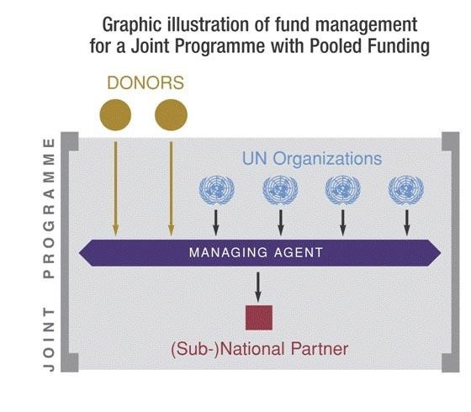

**Accountability**

1. Complete programme and financial accountability rests with the Managing Agent (MA). Where UNDP is the MA, its standard accountability for its programme resources applies (as set out in UNDP’s Results Management, and Finance and Budget Policies and Procedures).