Family Leave

- The purpose of family leave is to allow eligible staff members a period of time in the event of a family-related requirement. Family leave is a justification for leave, not an additional amount of leave. It expands the acceptable justification for taking uncertified leave without increasing the overall amount of leave.

Eligibility

- All internationally and locally recruited staff members governed under the UN Staff Regulations and Staff Rules are eligible for family leave.

Entitlement

- Eligible staff members may use all or part of the maximum seven working days of uncertified sick leave as family leave for family-related emergencies. Examples of family-related emergencies are:
- In the event of a death in the staff member’s immediate family; or
b) To take care of his/her child or an immediate family member who becomes ill etc.

Loss of Family Leave

- When an eligible staff member does not use all or part of his/her uncertified sick leave entitlement, he/she does not receive:
- Payment in lieu;
- Additional annual leave credit; or
c) Credit for the next leave year.

Relationship with Other Entitlements, Benefits and Options

Annual leave

- Staff members are not required to exhaust their accrued annual leave before taking family leave. Requests to take annual leave for family-related emergencies will be favourably considered.

Combination of half-time work with annual leave

- Subject to the needs of the Organization, requests to combine half-time work with annual leave for family-related emergencies will be given favourable consideration. (Example): Instead of taking one week of full-time annual leave, the staff member may request half-time annual leave over a two-week period, combined with half-time work.
Special leave without pay

- Subject to the exigencies of service, requests from staff members for SLWOP for a family-related emergency will be given favourable consideration.

Flexible Arrangements

- Subject to the needs of the Organization, requests for a flexible working arrangement (for example, flexitime, ten in nine days etc.) for family-related emergencies will be given

Flowchart

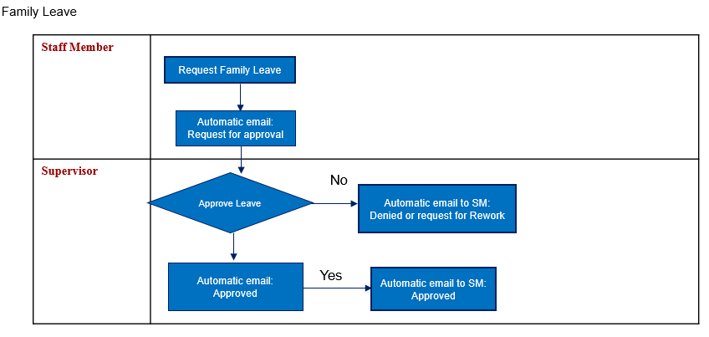
Roles and Responsibilities
Responsible Party | Responsibilities | Remarks
Staff member | - Approaching his/her supervisor and submitting a request for family leave  - Request amendment or deletion of an approved family leave request | · Any request to amend or delete an approved leave must be initiated by the staff member and recorded in UNALL
Supervisor | - Approving the request of the staff member  - Ensure the necessary parties are copied on communication to permit proper record keeping  - Making arrangements to ensure work of the unit is shared appropriately and does not lapse
HR Business Partner | - Providing advice and answering questions to ensure clarity and compliance with the policy
HR administrator | - Ensuring accurate administration surrounding implementation of the policy, including copies to files, etc.
Absence processor (Leave monitor)/HR associate | - Assist staff without access to UNALL to upload or register approved family leave request in UNALL  - Reconcile all monthly and yearly leave statements with UNALL  - Providing advice and answering questions on family leave | - All manual off-line leave requests and leave is taken must always be recorded in e-Services  - All monthly and/or annual leave statements must be reconciled with e-Services

