UNDP Standard Terms of Reference (ToR) for a
Development Project Board or Project Steering Committee
- December 2021 version -

Guidance Note for the applicability of this ToR:
One key responsibility of the Effectiveness Group in the Bureau for Policy and Programme Support (BPPS) is to oversee the standards, methods and guidance for quality programming in UNDP. This includes the development, management and revision of programme and project management prescriptive content and guidance that the entire organization must follow.
A key aspect of programming concerns how decisions are made. In UNDP, multi-stakeholder Programme Boards and Project Boards are established as the principal oversight and decision-making authority for a given programme or project. An effective board needs credible data, evidence, quality assurance and reporting to aid decision making. Boards also need to be accountable to donors and stakeholders to protect against conflicts of interest and fraud.
Currently, UNDP’s prescriptive content provides the overarching expectations to programming units on how programme and project boards should function. This can be found in the sections on Provide Oversight and Manage Change in the PPM.
This ToR responds to that request by providing generic guidance and standard text on the main duties and responsibilities of a project board; rules on the composition of the project board and categories of board member representation; protocols for project board operations (including addressing conflicts of interest); suggested outputs for board meetings; support functions to the Board; and other key matters.
This ToR is applicable for use in all UNDP development projects, defined as a programming instrument which “Delivers outputs where UNDP has accountability for design, oversight and quality assurance of the entire project.”
As noted, the ToR includes standard text and indications where project-specific text can be inserted or specific conditions added if applicable (indicated in brackets and/or yellow bold). This ToR should be read, completed and used together with the relevant sections of the POPP and the latest annotated UNDP Project Document template(s) or other funding instrument used for a given donor.
The ToR can be amended and customized in line with specific donor requirements, provided that the amendments do not contradict standard UNDP rules and regulations. If not applicable, relevant parts of the text should be deleted.
This TOR should be included as an Annex of the Standard Project Document (ProDoc). Given that the standard ProDoc already has Section IV. Project Management and Section VIII. Governance and Management Arrangements – which specifies the project organizational structure – this TOR will only focus on the roles and responsibilities of the Project Board. Detailed definitions and standard organization charts included here within, including accompanying explanations, can be found in POPP guidance at the corporate level. This ToR has limited mention of POPP prescriptive content on programme boards or steering committees (vis-à-vis linkages with project-level entities) but is not specifically focused on those bodies.
For further questions on this ToR please consult the PPM focal point for your unit/bureau. Please delete this note after completing this document for the project. The ToR starts from the next page.

UNDP Standard Terms of Reference (ToR) for the
[Project Board or Project Steering Committee] of [Insert Project Title and ID]

- Background

All UNDP projects must be governed by a multi-stakeholder board or committee established to review performance based on established monitoring and evaluation metrics and high-level implementation issues to ensure quality delivery of results. For the purpose of this ToR and to ensure standardization, henceforth, as regards project documentation, such a body shall only be referred to by one of two names: ‘Project Board’ or ‘Project Steering Committee.’ The [Project Board or Project Steering Committee] is the most senior, dedicated oversight body for a UNDP ‘Development Project’, which is defined in the PPM as an instrument where UNDP “Delivers outputs where UNDP has accountability for design, oversight and quality assurance of the entire project.”

- Duties and Responsibilities

The two prominent (mandatory) roles of the [Project Board or Project Steering Committee] are as follows:

- High-level oversight of the project (as explained in the “Provide Oversight” section of the PPM). This is the primary function of the [Project Board or Project Steering Committee]. The [Project Board or Project Steering Committee] reviews evidence of project performance based on monitoring, evaluation and reporting, including progress reports, monitoring missions' reports, evaluations, risk logs, quality assessments, and the combined delivery report. The [Project Board or Project Steering Committee] is the main body responsible for taking corrective actions as needed to ensure the project achieves the desired results. And its function includes oversight of annual (and as-needed) assessments of any major risks to the programme or project, and related decisions/agreements on any management actions or remedial measures to address them effectively.
The [Project Board or Project Steering Committee] also carries the role of quality assurance of the project taking decisions informed by, among other inputs, the project quality assessment. In this role the Board is supported by the quality assurer, whose function is to assess the quality of the project against the corporate standard criteria. This function is performed by a UNDP programme or monitoring and evaluation officer to maintain independence from the project manager regardless of the project ‘s implementation modality.
The [Project Board or Project Steering Committee] reviews updates to the project risk log.

- Approval of key project execution decisions (as explained in the “Manage Change” section of the PPM). The [Project Board or Project Steering Committee] has an equally important, secondary role in approving certain adjustments above provided tolerance levels, including substantive programmatic revisions (major/minor amendments), budget revisions, requests for suspension or extension and other major changes (subject to additional funding partner/donor requirements).

The [Project Board or Project Steering Committee] is responsible for making management decisions by consensus when required, including the approval of project plans and revisions, and the project manager’s tolerances. The [Project Board or Project Steering Committee] approves annual work plans and reviews updates to the project risk log.

Within the overall governance and management arrangements of the project, the role of the [Project Board or Project Steering Committee] as regards these two key functions (‘High-level oversight of the project’ and ‘Approval of key project execution decisions’) is distinct from the roles of entities involved in the implementation of the project, namely the implementing partner (IP), responsibilities parties (if applicable), service providers and project staff.

The diagram below outlines the main entities involved (and their respective responsibilities) in the ‘oversight/approval of key execution decisions’ layer and the ‘implementation’ layer of the project structure.

Diagram 1 – Standard Figure of Project Organization Structure vis-à-vis oversight & approval and implementation roles

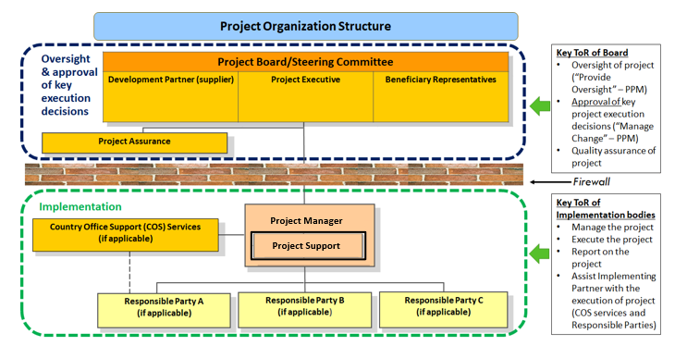

Optional text in NIM with COS and DIM project modalities: In cases where UNDP or a national government entity are concurrently playing roles and represented in both layers of the project organization structure, the entity must seek to separate its project oversight and implementation duties and describe in the relevant project document a: 1) satisfactory internal institutional arrangement for the separation of oversight and implementation functions in different departments of said entity and; 2) clear lines of responsibility, reporting and accountability within the entity between their oversight and implementation functions.

In order to ensure UNDP’s ultimate accountability, the [Project Board or Project Steering Committee] decisions should be made in accordance with the Quality Standards for Programming that shall ensure management for development results, best value money, fairness, integrity, transparency and effective national and international competition. An effective [Project Board or Project Steering Committee] needs credible data, evidence, quality assurance and reporting to aid decision making (see next section on supporting functions to the Board). The [Project Board or Project Steering Committee] also needs to be accountable to protect against conflicts of interest and fraud.

Specific responsibilities of the [Project Board or Project Steering Committee] include the following [this must be included in all ToRs – do not modify]:
- Provide overall guidance and direction to the project, ensuring it remains within any specified constraints, and promote gender equality and social inclusion (LNOB) in the project implementation;
- Review project performance based on monitoring, evaluation and reporting, including standard quality assurance checks, progress reports, risk logs, spot checks/audit reports and the combined delivery report;
- Address any high-level project issues as raised by the project manager and project assurance;
- Provide guidance on emerging and/or pressing project risks and agree on possible mitigation and management actions to address specific risks (including ensuring compliance with UNDP’s Social and Environmental Standards, Fraud/corruption, Sexual Exploitation and Abuse and Sexual Harassment);
- Agree or decide on project manager’s tolerances as required, within the parameters set by UNDP (Manage Change in the PPM) and the donor, and provide direction and decisions for exceptional situations when the project manager’s tolerances are exceeded;
- Advise on major and minor amendments to the project within the parameters set by UNDP and the donor;
- Agree or decide on a project suspension or cancellation, if required; (note that for GEF and GCF projects it is UNDP that decides to suspend or cancel and project and the [Project Board or Project Steering Committee] is informed/consulted only).
- Provide high-level direction and recommendations to the project management unit to ensure that the agreed deliverables are produced satisfactorily according to plans.
- Receive and address project level grievance, including overseeing whatever specific compliance and stakeholder response (or grievance) mechanisms have been put in place so that individuals and communities potentially affected by the project have access to effective mechanisms and procedures for raising concerns about the social and environmental performance of the project.
- Engage in the low value grant selection process where there is no Grant Selection Committee, as guided by the Low Value Grants – UNDP Operational Guide.

Note: Specific requirements may apply for donor-funded projects, such as GEF- or GCF-financed projects. Please refer to the provisions in the project document.

Additional responsibilities of the [Project Board or Project Steering Committee] can include, but are not limited to, the following [please include in the ToR as applicable]:
- Ensure coordination between the various donors and government-funded projects and programmes;
- Report to relevant inter-ministerial bodies or higher-level oversight bodies;
- Ensure coordination with multiple government agencies and their participation in project activities;
- Track and monitor co-financing for this project;
- Appraise the annual project implementation report, including the quality assessment rating report;
- Ensure commitment of human resources to support project implementation, arbitrating any issues within the project;
- Act as an informal consultation mechanism for stakeholders;
- Approve the Project Inception Report, Mid-term Review and Terminal Evaluation reports and corresponding management responses;
- Review the final project report package during an end-of-project review meeting to discuss lessons learned and opportunities for scaling up;
- Providing guidance or reporting protocols to technical committees or sub-bodies reporting to the Board (if applicable);

- Composition of the [Project Board or Project Steering Committee]

As noted in the diagram below, every [Project Board or Project Steering Committee] in a UNDP project has three categories of formal members (e.g. voting members). The role of every formal [Project Board or Project Steering Committee] member must correspond to one of these three roles and be identified accordingly in the project documentation.
Diagram 2 – Standard Figure for a Project Organization Structure
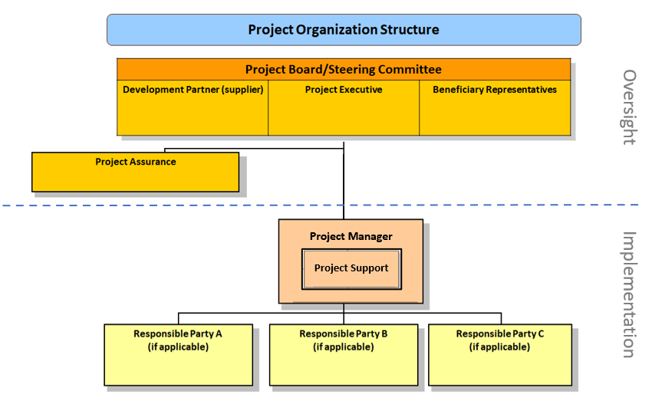

The three categories of [Project Board or Project Steering Committee] members are the following:

- Project Director/Executive(s): This is an individual(s) who represents ownership of the project and chairs (or co-chairs) the [Project Board or Project Steering Committee]. The executive usually is the most senior national counterpart for nationally implemented projects (typically from the same entity as the Implementing Partner), and it must be UNDP for projects that are direct implementation (DIM). In exceptional cases, two individuals from different entities can co-share this role and/or co-chair the [Project Board or Project Steering Committee]. If the project executive co-chairs the [Project Board or Project Steering Committee] with a representative of another category, it typically does so with a development partner representative. The Project Executive is: Add title (name is optional)

- Beneficiary Representative(s): This is an individual(s) representing the interests of those groups of stakeholders who will ultimately benefit from the project. Their primary function within the Board is to ensure the realization of project results from the perspective of project beneficiaries. Often representatives from civil society, industry associations, community groups or other government entities benefiting from the project can fulfil this role. If the project has a specific geographic focus, often representatives from the government entities in the targeted area/region will play this role. There can be multiple beneficiary representatives in a [Project Board or Project Steering Committee]. The Beneficiary Representative(s) is: Add titles (names are optional)

- Development Partner(s): Individuals representing the interests of the parties concerned that provide funding, strategic guidance and/or technical expertise to the project. There can be multiple development partners representatives in a [Project Board or Project Steering Committee]. The Development Partner(s) representative(s) is: Add titles here (names are optional) (note: in NIM and NGO-implementation projects, this is typically the UNDP Resident Representative or Deputy Resident Representative. Other funding partners can also jointly hold this role. As noted below, responsible parties cannot play this role)

A UNDP representative must always be represented in the [Project Board or Project Steering Committee] in either the project executive or development partner role. [In NIM and NGO-implementation projects, UNDP will typically occupy the role of development partner in the Board. In DIM projects, a UNDP representative will always play the role of project executive. The level of representation by UNDP on the Board is determined on a case-by-case basis but typically, for national projects, the board member is either the Resident Representative or the Deputy Resident Representative.]
Where applicable, representatives from responsible parties to the project cannot sit on the [Project Board or Project Steering Committee] as a formal voting member; they can (if requested) attend board meetings as observers. Since the chief responsibility of the Board is to provide high-level oversight of project implementation, to avoid any conflicts of interest, it is not appropriate for representatives of third party entities engaged by the project to provide services – whether responsible parties or contractors/service providers – to concurrently sit on the Board. Representatives of responsible parties can attend board meetings (as observers) but can have no official role in board decision-making. The same principle applies to the project manager who in attending and presenting at board meetings, does so in a non-voting capacity.
In cases where the inputs and guidance of responsible parties or other entities formally engaged in providing goods or services to the project are needed by the Board on a recurring basis, it is recommended to establish appropriate advisory or technical committees or working groups composed of those entities that can formally report to the Board, while ensuring the impartiality and integrity of board decisions happening independent of those bodies (see Section V of the ToR).
[Board representation in crisis setting: TBD]
- Standard [Project Board or Project Steering Committee] Protocols
The [Project Board or Project Steering Committee] must meet one time annually at a minimum. It is recommended that the timing of board meetings be agreed upon in advance and corresponds to key project reporting or work planning milestones. This [Project Board or Project Steering Committee] will meet [X] times annually according to this provisional schedule (insert scheduled meeting times if known).
[Project Board or Project Steering Committee] members cannot receive remuneration from project funds for their participation in the Board. However, it is allowable for board members to be reimbursed from project funds for certain reasonable, qualified expeses related to travel or lodging to attend board meetings. Such protocols are outlined in this ToR and the benefits are applicable to all eligible board members. [if applicable, insert guidance on this issue here].
All [Project Board or Project Steering Committee]s must have rules for quorum and documentation/minuting of board decisions. All board decisions and minutes should be kept by the project management unit and UNDP. Guidelines on decisions taken in between board meetings or virtually should be clearly elaborated in the Terms of Reference (ToR) of the [Project Board or Project Steering Committee]. [if applicable such as under a crisis setting or pandemic, insert guidance on this issue here].
Unless otherwise specified, [Project Board or Project Steering Committee] decisions are made by unanimous consensus. If a consensus cannot be reached within the Board, the final decision shall rest with the UNDP representative on the [Project Board or Project Steering Committee] or a UNDP staff member with delegated authority as the programme manager.
It is required that as per internationally recognized professional standards and principles of sound governance, conflicts of interest affecting board members in performing their duties must be formally disclosed if not avoidable. Where a board member has a specific personal conflict of interest with a given matter before the board, he/she must recuse oneself from their participation in a decision. No board member can vote or deliberate on a question in which he/she has a direct personal or pecuniary interest not common to other members of the board.
All board members should be presented with a ToR for the [Project Board or Project Steering Committee], which will include the responsibilities already outlined and indicate agreed board practices and logistics.
Note: Designated Board members must sign or otherwise indicate written acceptance of the final ToR (via formal signature of the ToR, an exchange of letters or e-mail acknowledgment) for the [Project Board or Project Steering Committee] as a precondition for serving on the [Project Board or Project Steering Committee]. Please see Annex A for possible options to codify this acceptance (which preferably would be done at the appraise and approve stage but which could also be done early in implementation). The formal written acceptance of the ToR by all board members will be documented and kept by UNDP.
- Standard Outputs of [Project Board or Project Steering Committee] Meetings
In its oversight function, the [Project Board or Project Steering Committee] will (at a minimum) review and assess the following project-related evidence at each meeting:
- Assessment of project progress to date against project output indicators (as documented in the project document results framework)
- Approval/review of annual work plans
- Assessment of the relevant Monitoring & Evaluation mechanisms, including all evaluations
- Review and assessment of the Project Risk Log (with updating/amendments as needed)
- Assessment of project spending, based on a review of the combined delivery report
- Review of required resources versus available funding (if applicabel) and steps taken to reduce funding gap identified at the project design stage
This will be in addition to the review and approval of any required project execution decisions.
The output of every [Project Board or Project Steering Committee] should be a written record (minutes) that captures the agenda and issues discussed and the agreed upon action items and decisions (if applicable). Each report should clearly document the members attending the meeting (as well as all participants in the meeting) and the modality used to agree on a certain action or decision (whether formal voting or no-objection or other mechanism). All records of board meetings should be documented and kept by UNDP in their quality assurance function (see next section).
- Support Functions to the [Project Board or Project Steering Committee]
There are two main entities/functions outside the [Project Board or Project Steering Committee] structure whose role is to report to the [Project Board or Project Steering Committee] and support board members in effectively fulfilling their roles: project assurance and project management.
The diagram below explains the primary role of these two entities in the context of their support to Board operations. A description of these two entities follows.

Diagram 3 – Standard Figure of Project Organization Structure – Board Support Entities

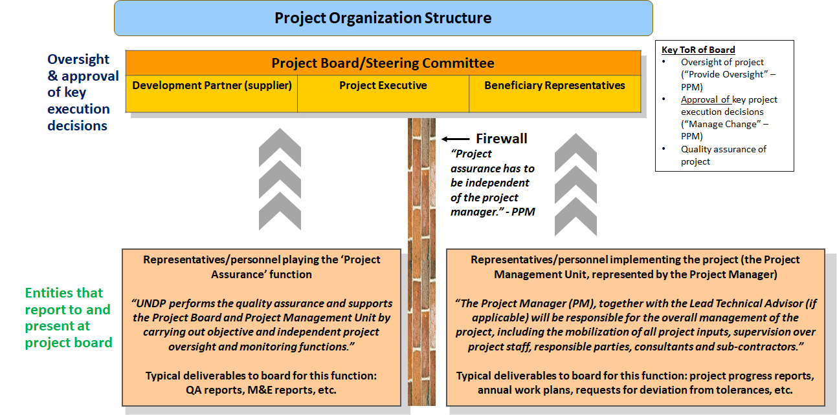

Project Assurance: Project assurance is the responsibility of each [Project Board or Project Steering Committee] member; however, UNDP has a distinct assurance role for all UNDP projects in carrying out objective and independent project oversight and monitoring functions. UNDP performs quality assurance and supports the [Project Board or Project Steering Committee] (and Project Management Unit) by carrying out objective and independent project oversight and monitoring functions, including applying UNDP’s social and environmental management system to ensure the SES are applied through the project cycle. The [Project Board or Project Steering Committee] cannot delegate any of its quality assurance responsibilities to the project manager. Project assurance is totally independent of project execution. [In the case where UNDP is also supporting project implementation, protocols should be put in place ensuring proper segregation between UNDP’s role in the Board and in the function of project assurance, and any concurrent role in implementation].
A designated representative of UNDP playing the project assurance role is expected to attend all [Project Board or Project Steering Committee] meetings and support board processes as a non-voting representative. It should be noted that while in certain cases UNDP’s project assurance role across the project may encompass activities happening at several levels (e.g. global, regional), at least one UNDP representative playing that function must, as part of their duties, specifically attend board meetings and provide board members with the required documentation required to perform their duties.
The UNDP representative playing the main project assurance function is: (Add name and title here. For NIM projects, this is typically CO programme manager/officer or monitoring & evaluation officer)
Project Support, this function is often covered by the Project Management Unit: The Project Manager (PM) (also called project coordinator) is the senior most representative of the Project Management Unit (PMU) and is responsible for the overall management of the project on behalf of the Implementing Partner, including the mobilization of all project inputs, supervision over project staff, responsible parties, consultants and sub-contractors. The project manager typically presents key deliverables and documents to the Board for review and approval, including progress reports, annual work plans, adjustments to tolerance levels and risk logs.

A designated representative of the PMU is expected to attend all board meetings and present the required progress reports and other documentation needed to support board processes as a non-voting representative.

The primary PMU representative attending board meetings is: (Add title here, name are optional)

Annex A – Acknowledgement of this ToR by each designated official [Project Board or Project Steering Committee] member

Note: The form/evidence for this acknowledgement must be included as an annex or codified in other ways (e.g. note to file or minutes of a board meeting)
The formal acknowledgement of the ToR by board members can be done via various procedures, including the following options:
- Having copies of the ToR be signed by each appointed board member at the Appraise and Approve stage (LPAC) and then having all signed copies attached as an annex to the Project Document
- Having the final ToR be signed by each appointed board member at the first project board meeting after Project Document signing with the approvals recorded in the minutes of the meeting
In both cases, the signature or acknowledgement should include the name, title and category of board representation for the person signing

Please insert the appropriate entity name in the relevant sections in the document. Where this ToR refers to “Board” it is intended to apply to both these entities and should be changed accordingly to match the entity chosen for the specific project
The responsibilities of the board in this regard should follow UNDP’s Social and Environmental Standards (SES) as codified in the PPM. It should be noted that while a project board can play a role in addressing or assisting with the compliance and stakeholder response (or grievance) mechanisms put in in place for a given project (as part of their quality assurance and oversight function), this will be in addition to and does not substitute for UNDP’s core responsibility to ensure compliance with the SES throughout the project management cycle as part of UNDP’s Programming Quality Assurance system.
With the exception of responsible parties or any firms/entities engaged by the project to provide technical expertise with project funds
UNDP has this special right since the ultimate legal and fiduciary accountability for a UNDP project, irrespective of modality, rests with UNDP and UNDP must (in line with its obligations to donors and to the Executive Board) be able to ensure that no action is taken by any body in a UNDP project that contravenes UNDP rules and regulations.
Including audit reports and spot checks.

