UNDP Risk Appetite Statement

Risk Appetite Statement

October 2021

Contents

1) Introduction 3
2) Summary risk appetite statement 4
3) Managing risks using the risk appetite 6
4) Risk appetite governance and implementation 7

Introduction
Navigating through the complexity of multiple uncertainties is at the core of UNDP’s quest for innovative solutions to development and organisational challenges. UNDP’s Enterprise Risk Management (ERM) system is designed to allow the organisation to be forward looking and manage the effect of uncertainties on objectives. The ultimate purpose of ERM is to ensure foresight and responsible, risk-informed decision-making across all levels of the organisation, thereby maximising results and impact while ensuring value for money and stewardship of donors’ resources.
UNDP’s risk appetite sets out UNDP’s internal preference regarding the level of risk to take in a given situation. It also reflects UNDP’s risk culture and the risk attitudes of key external stakeholders and partners.
The purpose of this Risk Appetite Statement (RAS) is to create a risk-enabled culture within UNDP, where risk-based decisions are taken, and opportunities are pursued according to the needs and circumstances of the project or programme, our development partners, and the resources and skills available. The RAS opens up discussions about risk and what is acceptable throughout the organization, acknowledging that different business units have different appetites and abilities or need to assume higher levels of risk. It provides guidance on the amount and type of risk UNDP is willing to accept or take to deliver its Strategic Plan through risk-informed development. UNDP takes risks to deliver its projects and programmes, to strengthen partnerships with host governments, to promote human rights and to create safe spaces for people. It also takes risks to promote innovation which, in turn, supports risk management by developing creative solutions and taking non-traditional approaches, opening itself up to new partnerships and opportunities to continue to achieve its ambitious development objectives for programme countries. This statement enables consistent and effective risk-informed decision taking by reaching, sharing, and communicating a common risk appetite at all levels of the organisation. It enables discussions with stakeholders regarding risk sharing, by setting out UNDP’s appetite for risk in a clear and consistent fashion, so that joint decisions can be taken on its management response. It encourages a pragmatic and flexible approach to risk management by enabling structured and consistent discussions about the risks that are to be accepted, the risks that are to be mitigated and risks that are to be avoided in pursuit of UNDP’s priorities. This Statement is supported by detailed guidance that shows how it is to be used in practice.
The RAS has been developed to enable delivery of the Strategic Plan by:
- Supporting well-thought-through and consistent risk-informed decision-making.
- Opening out and facilitating discussions across the organisation, with other UN agencies, stakeholders and beneficiaries about the types and levels of risks that UNDP is prepared to take to deliver its plans and those that it will not take.
- Making the best use of public funds by managing risks proportionately.
- Being flexible and allowing for planned, discussed and agreed deviations from the risk appetite where this is appropriate to support the delivery of UNDP’s ambitions and its mandate, always ensuring, however, that there are appropriate, agreed risk mitigation actions.
- Better understanding and planning for the risks associated with its plans to promote innovation and learning, find creative solutions and open itself up to new and stronger partnerships, especially with non-state actors and the private sector, and programming opportunities.
The RAS was developed based on a consultative process and is not a fixed statement. It will be reviewed and updated to support delivery of UNDP's Strategic Plan and reflect existing organizational capacities and priorities to take and effectively manage risks to deliver the Strategic Plan. Triggers for a review of the RAS may include:
- Major changes in the internal context/environment of UNDP, for example a change of priorities or a change in attitude to risk
- Major changes in the external context/environment of UNDP, for example a significant change in the donor base or interests, or a political shift that would affect the role of UNDP
- A major change in the business/operating model of UNDP, for example a shift in business processes and procedures, accountabilities or roles and responsibilities.
- New strategy definition, including when a new Strategic Plan is developed.

Learning from a RAS review, planned or ad hoc, must be captured in a lessons-learned register to inform future policy developments.

Summary risk appetite statement
The diagram below summarises the way in which the risk appetite statement supports ERM in UNDP, showing how risk appetite feeds into every aspect of enterprise risk management.

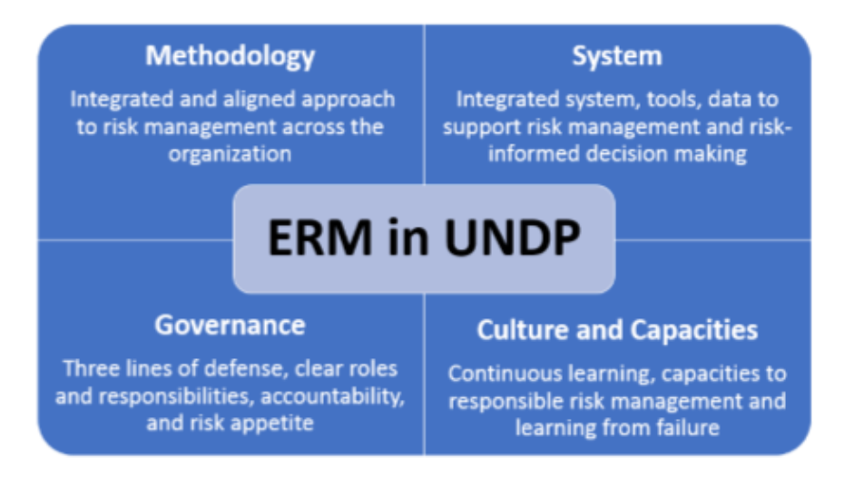
The guidance sets out the arrangements for implementation and governance
The RAS process is integrated into the decision-making process

This RAS supports innovation and learning by enabling better, innovative decisions

This statement sets out the methodology to assess and implement the RAS

The RAS places each category of risk on a risk-appetite scale that ranges from ‘minimal’ to ‘seeking’ as illustrated in the diagram below:
Open
Minimal
Cautious
Exploratory
Seeking

- Minimal risk appetite – Areas where UNDP will apply a strong control environment to reduce or minimize the likelihood that a risk will occur and/or reduce the impact of any risk.
- Cautious risk appetite – Areas where UNDP seeks low-risk delivery options and will pilot innovation only in a controlled environment.
- Exploratory risk appetite – Areas where UNDP strikes a balance between the potential upside benefits and downside risks of a decision and explores new solutions and options for delivery.
- Open risk appetite – Areas where UNDP has determined that the potential upside benefits outweigh the risks and will take informed risks. All potential options are considered.
- Seeking risk appetite – Areas where UNDP takes risks by working with new ideas and approaches, looking for innovation and recognizing that failures are an opportunity for learning and improving.
The risk appetite has been defined across eight risk categories, based on the ERM categories, and the overall risk appetite for each of those categories is given below. The Guidance sets out what each of these risk appetites means in practice through a series of examples.
Risk Category | Overall Risk Appetite
Social and Environmental  UNDP plans all of its project and programmatic activities to safeguard those who are affected by them and to do no harm, socially or environmentally, always behaving in an ethical fashion.  It takes positive steps to engage with disadvantaged groups and does not tolerate any form of discrimination or harassment. UNDP will mitigate these risks by ensuring that its personnel and partners are conscious of the controls that need to be implemented to safeguard people and the environment and to ensure that the “do no harm” principle is applied.  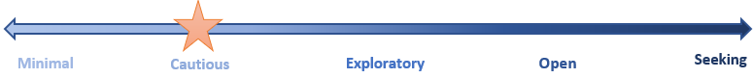 | Cautious
Financial  UNDP seeks to manage its financial resources effectively in order to deliver its objectives in a timely fashion while maintaining organizational sustainability and stability, minimizing fraud, and ensuring protection of assets. It allows some financial flexibility in pursuit of its objectives and when undertaking activities under development funds, but never in a way that threatens its core business activities, always aiming to deliver on the goals of the strategic plan. UNDP is transparent in all it does and safeguards its funds from the risk of fraud.  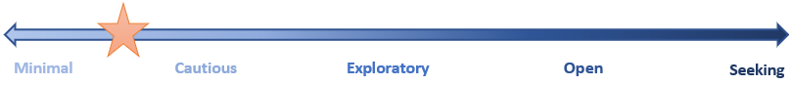 | Minimal to Cautious
Operational  UNDP encourages variance in operational delivery and quality to explore innovative approaches and work with new partners, provided this does not jeopardize stakeholder trust. UNDP continues to introduce new and innovative operational tools, procurement approaches, procedures, and mechanisms to strengthen delivery and continuity of operations and programme implementation. It regards failure as an opportunity to learn and develop.  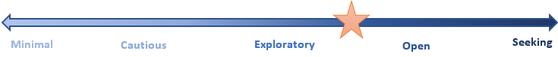 | Exploratory to Open
Organizational  UNDP takes an agile approach to stay relevant in all areas of intervention and takes informed risks to ensure organizational effectiveness, agility, learning and resilience. It ensures compliance with corporate governance rules and policies, and its ethical standards, while continuously exploring new and innovative ways of doing business to be a fit-for-purpose organization. | Exploratory to Open
Reputational  UNDP is a highly trusted and valued organisation and cannot compromise its ethical stance, credibility, and reputation among all its stakeholders (governments, donors, implementing partners, private sector, civil society, and beneficiaries, etc). UNDP wants to protect its organizational value and its reputation through effective and innovative delivery of its programmatic offer, meeting commitments, due diligence activities, partnerships and managing expectations, while exploring new options for delivery and partnerships and learning and developing from its pilots. | Cautious
Regulatory  UNDP will find legitimate ways through the legal and regulatory framework to deliver its strategic plans, including joining interpretations of regulations from other UN agencies with similar regulatory frameworks. | Cautious
Strategic  UNDP prioritizes the development and implementation of its strategy, seeking new and innovative ways to deliver high-value services, programmatic offers, and objectives, expanding, and diversifying its donor and partner pool while learning from any failures and always following its ethical principles.  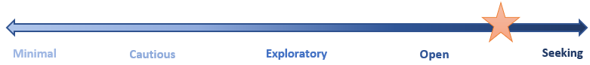 | Open to Seeking
Safety and Security  UNDP puts in place effective measures to reduce its exposure to security and safety risks affecting personnel, premises, assets and operations in order to enable the delivery of activities. Even in situations of significant risks, UNDP programmatic activities will deliver under appropriate and agreed mitigations and controls. UNDP will take necessary risks, including decisions at the appropriate level of delegated authority after all has been done to reduce risks to acceptable levels in accordance with the UNSMS Policy on Security Risk Management.  UNDP manages cybersecurity to safeguard the confidentiality and integrity of its information. | Cautious

Managing risks using the risk appetite
As UNDP works in a high-risk environment, risks will be identified that exceed the risk appetite. In these cases, there are four choices:
- Mitigate the risk through further controls.
- Tolerate the risk at its current level.
- Terminate the risk by doing something different, while still delivering the programme’s overall objectives.
- Transfer the risk to, or share it with, others.
A deliberate and documented discussion, informed by both qualitative and quantitative risk analysis, needs to take place to agree on the actions and decisions to be taken. For those risks that cannot be brought within the risk appetite in a proportionate and cost-effective fashion and cannot be avoided, approval to continue should be obtained in accordance with the standard governance arrangements. The guidance sets this out in greater detail.

Risk appetite governance and implementation
At UNDP, risk governance is delivered through the ‘three lines of defence model, which supports more effective risk management by introducing structured governance and oversight that clarifies and segregates roles and responsibilities. The RAS is governed and implemented in the same way and used to support thought-through and effective decision making (see the guidance for further details). Triggers for a RAS review are set out in section 1. Risk management accountability follows UNDP’s hierarchy so that the line manager of each unit is accountable for risk management in their area of responsibility as set out in UNDP’s Accountability Framework.
The RAS is implemented in a risk management culture of identifying, analysing and mitigating or enhancing risks to deliver programmatic priorities and the UNDP Strategic Plan. It supports the effectiveness of UNDP’s decentralized model, by helping to ensure a consistent approach to risk, at all levels, including country and regional levels. It is implemented in a flexible environment, where controls are used to enable effective delivery. In particular:
- Decisions are risk-informed: All ‘for decision’ reports require a risk appraisal, with risk scoring and an evaluation against the relevant risk appetite statements. Where activities are within the relevant risk appetite, controls should be reviewed to identify those that could be relaxed, releasing resources to manage those risks that are approaching or exceeding the relevant risk appetite. Where activities are near to or exceed the risk appetite, a risk-informed decision is taken regarding their management and delivery.
- Responsible risk-taking and innovation are rewarded: Understanding UNDP’s risk appetite across different domains enables consistent, conscious, deliberate, and thought-through risk taking and innovation, based on what UNDP is, and is not prepared to tolerate.
- Failures are acknowledged and learnt from: With appropriate governance mechanisms and controls, risks outside the appetite may be taken. In such cases, if failures arise, they present an opportunity to learn. However, where controls and the framework of governance are breached in taking risks, there should be a review to help UNDP understand what happened and ensure continuous improvement of the RAS and its use. In addition, UNDP learns from all its activities, to improve delivery and find new and more effective ways of implementing its programmes.
- Open communication on risk management issues and lessons learned and a culture of ‘working out loud’: Everyone has their own risk appetite and their own understanding of the level of risk that UNDP is prepared to take in order to deliver. Having a RAS enables open discussions around a known framework, both within and outside UNDP, rather than assumptions being made and acted on.

The United Nations Security Management System (UNSMS) Policy on Security Risk Management endorsed by the Chief Executives Board for Coordination (CEB) outlines the Acceptable Risk Model in which security risks are balanced with programme benefits. In this model, risks are accepted when benefits outweigh the risks.
Cyber Security is outside the UNSMS Security Risk Management and risks are managed by UNDP.
The “Three Lines of Defence” support more effective risk management by introducing structured governance and oversight that clarifies and segregates roles and responsibilities across three functions. The first line owns and manages risk directly. The second line of defence is responsible for risk oversight, monitoring and technical support. The third line, consisting of internal audit, provides independent assurance of the first two lines.

