B4. Provide Oversight (Review and Adjust)

- Appropriate management arrangements and oversight mechanisms need to be established at programme and project levels to ensure UNDP’s accountability for activities, results and the use of resources, while at the same time fostering national ownership and alignment to national processes. Minimum requirements for such management and oversight arrangements include the elements or functions described below and illustrated in Figure 1. To the extent possible, existing structures—national, regional and global, UN pooled fund and others—should be used to fulfil management arrangement functions.

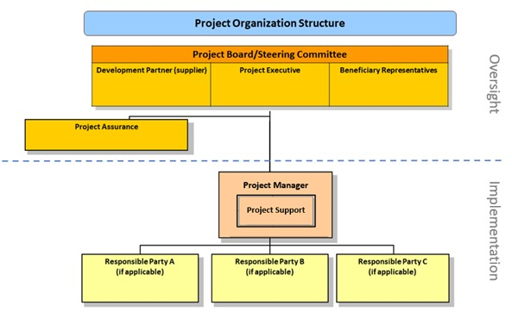

Oversight Mechanisms
- All UNDP programmes and projects must be governed by a multi-stakeholder board or committee established to review performance based on monitoring and evaluation, and address implementation issues to ensure quality delivery of results. In crisis contexts where constraints prevent the government from being able to participate in relevant programme and/or project boards, the Regional Bureau can grant approval for modified oversight mechanisms, taking risks and stakeholders into account.
- Programme oversight occurs through the country programme board, which is typically the joint national/UN steering committee used to monitor the Cooperation Framework but may be a dedicated board for the UNDP country programme. The board is a mechanism for consultation and consensus-based decision-making on programme issues. It is responsible for oversight of UNDP country programme implementation as well as its contribution to the Cooperation Framework. The board, at a minimum, comprises the heads (or their designated representatives) of the government coordinating agency and UNDP Resident Representative or head of office. If consensus cannot be reached within the joint national/UN steering committee, final authority on programmatic and financial decisions rests with the Resident Representative.
- If the country does not have a Cooperation Framework, a national mechanism for programme oversight should be used, if one exists. In all other cases, including for global and regional programmes, a UNDP programme board must be set up for programme oversight.
- To acknowledge the national ownership of all development results, the programme board must coordinate with relevant national mechanisms where possible, and partner within a coordinated mechanism covering all initiatives relevant to the corresponding outcome. Parallel mechanisms should not be set up for coordination where national ones exist.
- Project oversight is done through a project board, a multi-stakeholder governance mechanism that may also called a project steering committee or joint programme steering committee. The project document will state the required frequency of project reviews. Multiple projects in a portfolio may use the same board/committee for oversight, and existing mechanisms may be used, as long as the required composition and oversight functions are met. Joint results group boards may also be used, as long as individual projects are reviewed.
- The engagement facility and provision of services are governed through programme management oversight, and do not require separate oversight arrangements. For the provision of services, UNDP participates in any relevant oversight mechanisms of partners in accordance with signed partnership agreements.

Functions of Oversight Mechanisms
- Programme and project boards meet at designated decision points, at least once per year for an annual review, or as necessary. The purposes are to:
- Provide overall guidance and direction and agree on adjustments within provided tolerance levels (see Manage Change);
- Assess the achievement of results in the context of the Cooperation Framework and national results/outcomes;
- Assess the quality of programming against the quality criteria for Cooperation Framework and UNDP programming;
- Assess risks to the programme or project, and agree on management actions and resources to address them effectively; and
- Identify and address operational issues of programme and project implementation, including those that could lead to revisions of the Cooperation Framework, or country programme or project if required.
- In crisis settings, programme and project boards may meet virtually, through an exchange of letters, or remotely through teleconference.
- Assurance is the responsibility of each board member. The assurance role supports respective board members in carrying out oversight and monitoring functions. This role ensures appropriate management milestones are managed and completed.
- An annual review meeting should take place at the time of year most effective for reviewing results and making decisions. It should verify that the recommendations of the previous review were appropriately followed up and make recommendations to overcome any new issues or seize opportunities identified. Recommendations also support the preparation of inputs into the UNDP Results-Oriented Analysis Report and other reporting required by stakeholders/donors. Changes that could adversely impact the achievement of already approved results or that could result in a (re)allocation of earmarked resources are considered amendments that must be submitted to the regional bureau for review.
- The project board is responsible for making management decisions by consensus when required, including the approval of project plans and revisions, and the project manager’s tolerances. It reviews evidence on project performance based on monitoring, evaluation and reporting, including progress reports and the combined delivery report. The project quality assurance report and donor, UN pooled fund or vertical fund reports should be discussed with the board, along with management actions to improve quality. Board decisions are made in accordance with standards to ensure management for development results: best value for money, fairness, integrity, transparency and effective international competition. In case a consensus cannot be reached within the board, a final decision shall rest with the UNDP programme manager, the Resident Representative or staff member with delegated authority as the programme manager.
- The project board is consulted when a project manager's tolerances (normally in terms of time and budget) have been exceeded. There is a tolerance for failure, as long as it: (a) results in timely course correction that improves the design of the project, and (b) leads to explicit learning that is shared within UNDP and among external partners. The board authorizes any major deviation from the approved multi-year workplan and decides on project changes through appropriate revisions. It ensures that required resources are committed, arbitrates any conflicts in the project, and negotiates any issues between the project and external bodies. In addition, it approves the appointment and responsibilities of the project manager and any delegation of project assurance responsibilities. Potential members of the project board are reviewed and recommended for approval during the project appraisal committee meeting. Representatives of other stakeholders can be included on the board as appropriate.

Project Board Roles
- Project boards contain four roles:
  - Project director (also called executive): Represents project ownership and chairs the group. The director is normally the national counterpart for nationally implemented projects but can also be from UNDP.
  - Development partners (also called supplier): Individuals or groups representing the interests of the parties concerned that provide funding and/or technical expertise to the project. This typically includes implementing partners, UNDP and donors.
  - Beneficiary representative: Individuals or groups representing the interests of those who will ultimately benefit from the project. Their primary function within the board is to ensure the realization of project results from the perspective of project beneficiaries. Often civil society representative(s) can fulfil this role.
  - Project assurance: Project assurance is the responsibility of each project board member; however, UNDP has a distinct assurance role for all UNDP projects in carrying out objective and independent project oversight and monitoring functions. Project assurance has to be independent of the project manager. A UNDP programme or monitoring and evaluation officer typically holds the project assurance role on behalf of UNDP. For GEF- and GCF-financed projects, project assurance is undertaken as per the requirements of the vertical funds, and these services are covered by the fee provided by the vertical fund.

