Quick guide to downloading the Partner Capacity Assess Tool

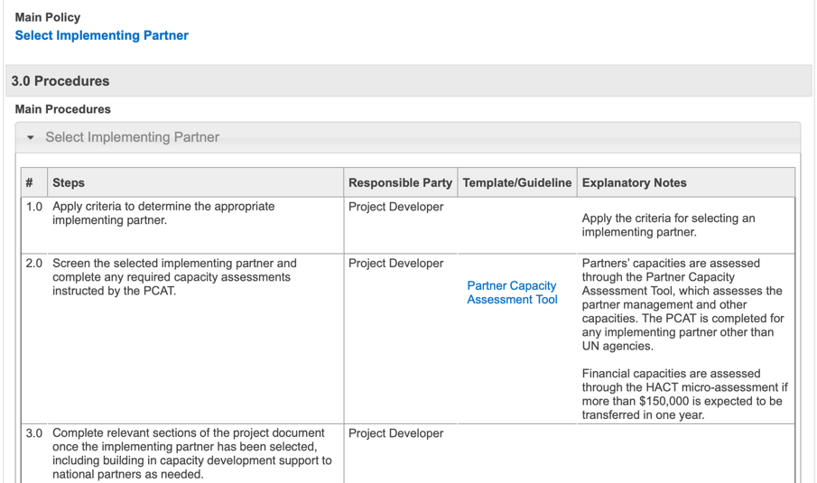
Step 1: Click the Partner Capacity Assessment Tool in the procedure table to download the file

Step 2: Click the ‘Enable Macros’ option
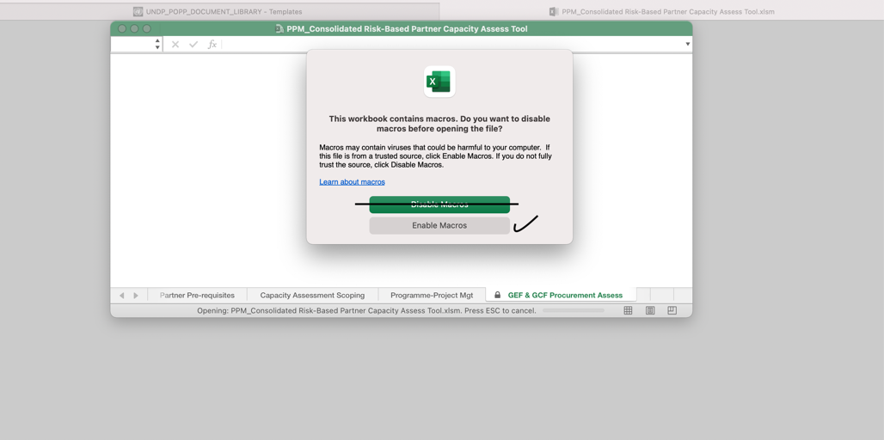
Step 3: Access document
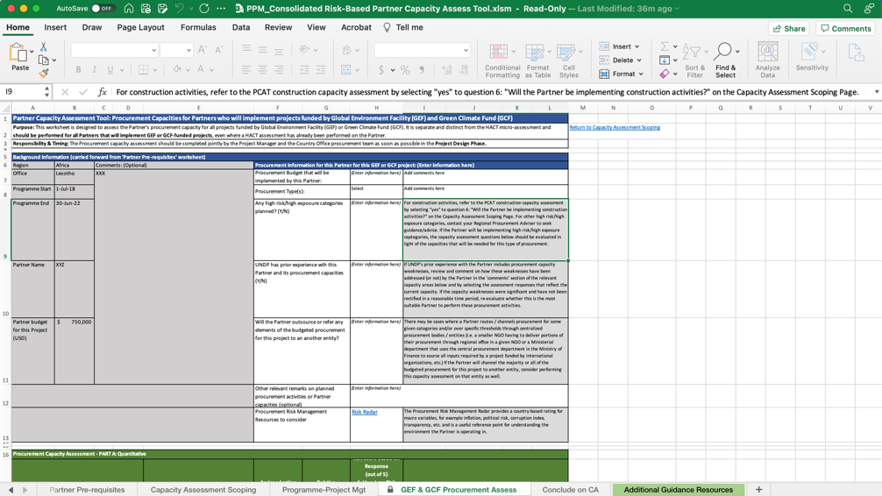

Quick guide to downloading the Partner Capacity Assess Tool (PCAT) in the Template Library

Step 1: Go to the POPP Template Library
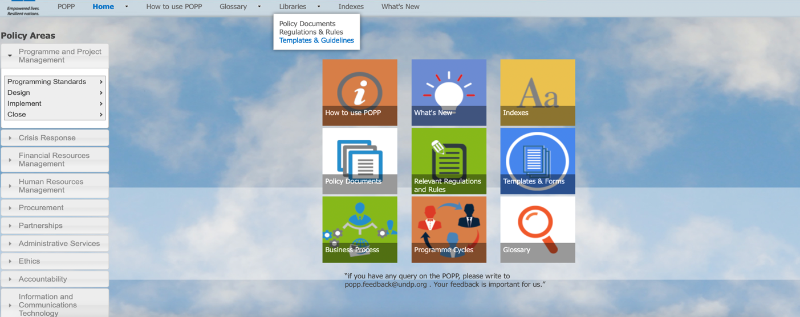

Step 2: Press ‘Control F’ on your keyboard and search for the Partner Capacity Assess Tool
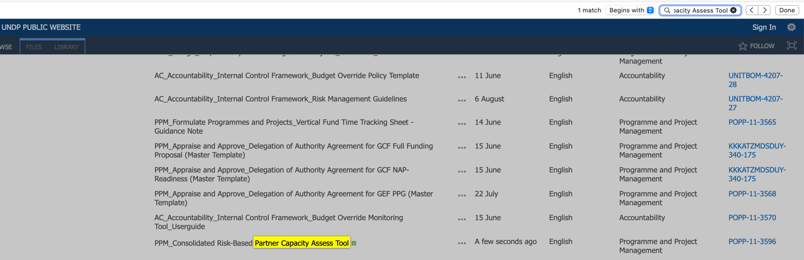

Step 3: Select the document and left click to choose the ‘Open link in New Tab’ option
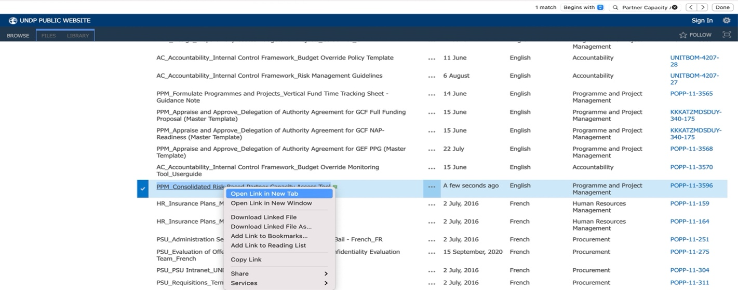

Step 4: Click ‘yes’ to open the file in Excel
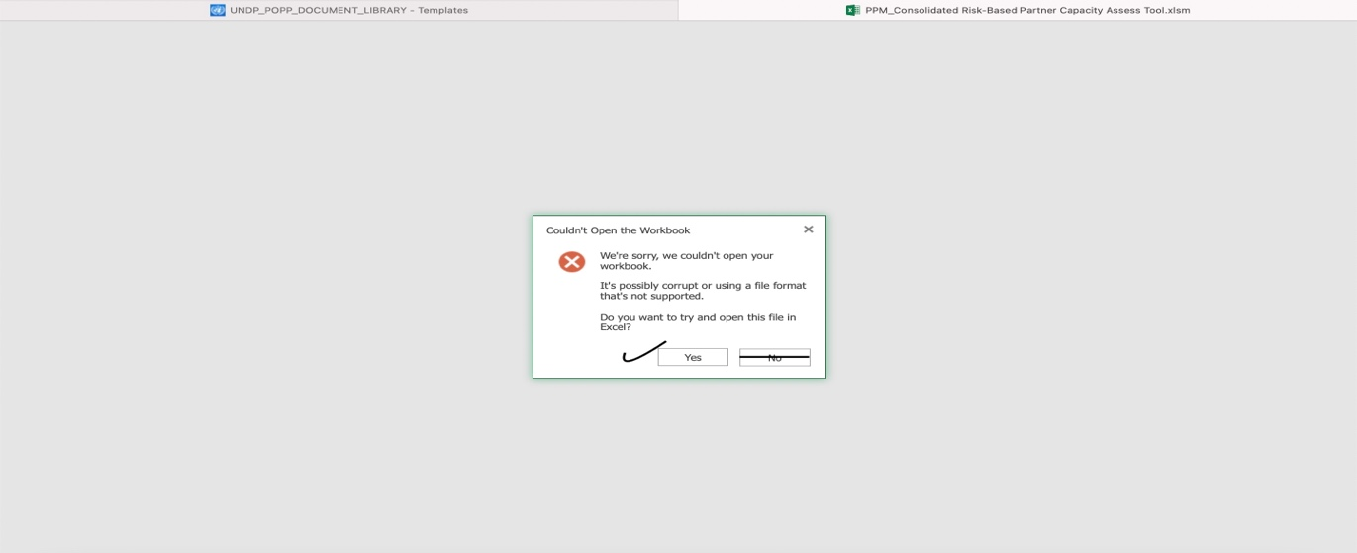

Step 5: Allow the page to open the link in Microsoft Excel
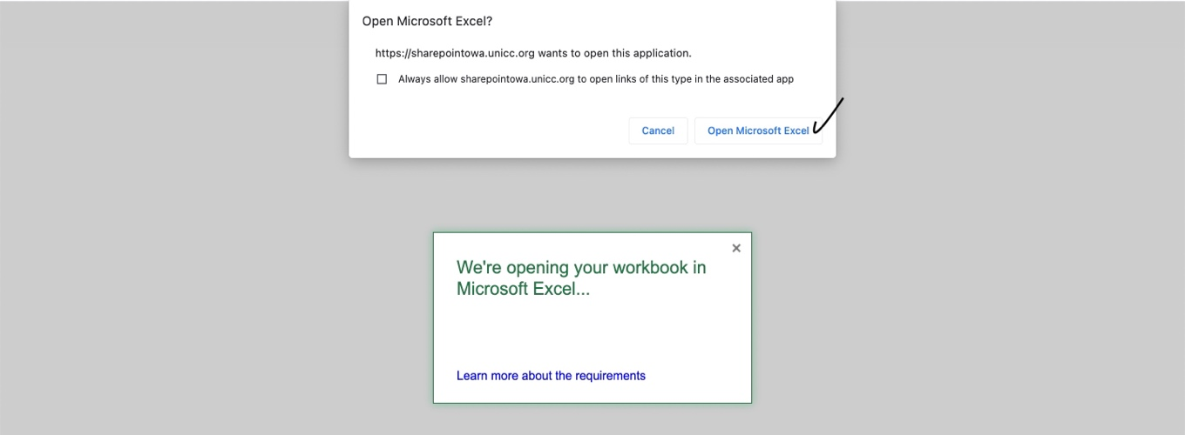

Step 6: Click the ‘Enable Macros’ option
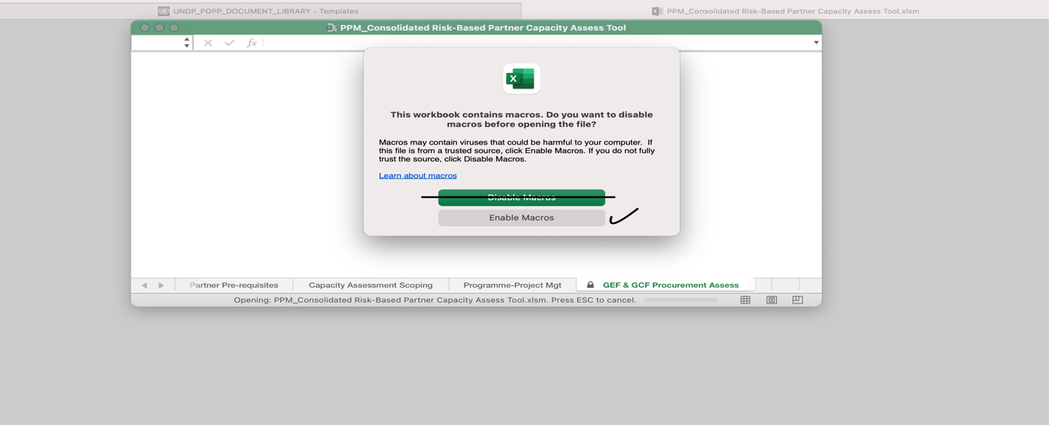

Step 7: Access document
