**Guidelines for Project Budgeting and Costing**

**Funding from the European Union**

***Background***

1. The European Union (EU) is among UNDP’s major (non-core) funding partners. Its priorities strongly align with those of UNDP, both programmatically and policy-wise[1].

1. EU contributions are earmarked to clearly defined “Actions” which can be fully funded by the EU or co-funded by other core and non-core resources. The EU has a direct corporate arrangement with the UN Secretariat, so the 1% coordination levy need not be budgeted.
2. Each EU contribution comes with a specific agreement, laying out the eligibility conditions. EU contractual terms have evolved in recent years. Conditions vary depending on the type of financial instrument (humanitarian streams versus development), and when the agreement was signed. To ensure that a project proposal’s design and budget are acceptable to the EU, please contact UNDP’s Brussels Helpdesk at [**ecsupport@undp.org**](mailto:ecsupport@undp.org).
3. This document focuses on the contractual setup for new EU contributions called the “**Contribution Agreement**”[2]. It replaced the 2016-18 PAGODA-2 agreement[3] and applies to all EU development assistance funds[4].
4. UNDP offices must assess and describe managerial and/or administrative costs in the “**Project Office**” section of Annex 1, as described in paragraph 6 below.
5. **EU Contribution Agreements consist of** **Special Conditions and 7 Annexes**:
6. Annex I – Description of the Action
7. Annex II – General Conditions
8. Annex III – Budget of the Action
9. Annex IV – Financial Identification Form
10. Annex V – Request for Payment
11. Annex VI – Communication & Visibility Plan
12. Annex VII – Management Declaration

The Agreement is legally binding and must be cleared as per specific procedures prior to signature.

***EU Eligibility Requirements for Project Expenses***

1. EU eligibility requirements for project expenses are defined in the Contribution Agreement’s **General Conditions** (Annex II). This critical annex defines **general managerial, financial, reporting,** and other **requirements to which UNDP, and in some cases, its partners, grant recipients, and/or contractors, must adhere**. Review of the General Conditions is therefore crucial prior to designing a project/programme. Given this complexity, EU-funded activities should be implemented under DIM or full Country Office Support to NIM modalities.
2. Non-compliance (perceived or real) with the General Conditions may lead the EU to declare underlying costs ineligible, and claim repayment (e.g. offset against any other EU-funded project under UNDP implementation).
3. The EU recognizes two types of eligible expenses: **direct** costs and **indirect** costs.
4. **Indirect** costs (called “remuneration” in the Contribution Agreement) equal 7% of the value of the direct costs. This corresponds to UNDP’s GMS charges in the project budget (as per the current corporate arrangement).
5. **Direct** costs can be any type of expense necessary for the implementation of the Action, as long as the EU’s cumulative eligibility criteria established in the General Conditions of the Contribution Agreement (Article 18.1) are met. Eligible direct costs must be:
   1. **Necessary** to carry out the Action, **directly** **attributable** to it, **arising** **directly** from its implementation, and **charged proportionally to actual use**;
   2. Incurred in accordance with the provisions of the (EU-UNDP) Agreement;
   3. **Incurred** by the organization, e.g. represent real expenditure borne by the UNDP;
   4. **Reasonable, justified, and in compliance with the principle of sound financial management** e.g. UNDP’s [POPP Programme and Project Management](https://popp.undp.org/taxonomy/term/76) policy;
   5. **Incurred during the Implementation Period** specified in the Special Conditions of the Agreement, except for costs related to final report, final evaluation, audit, and other costs linked to Action closure;
   6. **Identifiable and backed by supporting documents**, notably determined and recorded in accordance with UNDP’s [POPP Financial Accountability and Internal Controls](https://popp.undp.org/node/10796);
   7. **Covered by one of the estimated budget sub-headings (Annex III) and by activities described in Annex I**; and
   8. In compliance with the applicable tax and social legislation, in consideration of the organization's privileges and immunities.
6. **Direct support costs** (e.g. managerial and/or administrative in nature) can be eligible direct costs provided that the following conditions are met:

* **The costs are justified and described in the“Project Office”section of Annex I; and**
* **The costs meet the cumulative eligibility requirements for all direct costs noted in *Art. 18.1 General Conditions* as per paragraph 7 above**.

1. “**Project Office**” can include any or all of the following expenses[5]:
   1. **Project Implementation / Management** – Staff costs, including administration and management, directly assigned to the operations of the project office. The tasks listed in the Description of the Action (Annex I) assigned to project office staff must be directly attributable to Action implementation;
   2. **Official Travel and Transportation** – Travel and subsistence costs for staff and other persons directly assigned to the operations of the project office;
   3. **Rent, Utilities and Premise Maintenance** – Rental costs, or lease of equipment and assets composing the project office; maintenance and repair costs for project office operations;
   4. **Materials and Office Supplies** – Consumables and supply costs purchased for project office operations;
   5. **Other Action-Specific or Shared Cost Contributions (IT, Communications, Security and Medical Services)** – Facility management contracts, including security fees and insurance costs awarded for project office operations; energy and water, telecommunication services purchased for project office operations.
2. Some projects, such as **multi-country** projects, or projects implemented across a vast geographical area, require **several Project Offices**. This is acceptable if the conditions listed in paragraph 11 above are fulfilled.
3. Project office costs **must be actual costs**. To be eligible, the project office(s)-related charges must refer only to the ***capitalized and operating costs*** of the project office during the Action and the ***rate of actual use*** for the Action. UNDP must explain the methodology applied when the Budget of the Action was prepared. Moreover, UNDP must maintain all relevant financial and accounting records to demonstrate the eligibility of direct costs claimed for five years after the financial closure of the Agreement (to verify the mission’s purpose).
4. **Ineligible expenses** (e.g. costs which the EU will not consider eligible as direct costs) are:
   1. Bonuses, provisions, reserves, or non-remuneration-related costs. Employers' contributions to pension or other organization insurance funds may be ineligible if they do not exceed the actual payments made to these schemes, and the amount provisioned does not exceed the contribution that could have been made to an external fund;
   2. Full-purchase cost of equipment and assets, unless the asset or equipment is specifically purchased for the Action and ownership is transferred in accordance with the Agreement;
   3. Duties, taxes and charges, including VAT, that are recoverable/deductible by the organization;
   4. Return of capital;
   5. Debts and debt service charges;
   6. Provision for losses, debts or potential future liabilities;
   7. Banking charges for transfers to and from the EU;
   8. Costs incurred during the suspension of the Agreement, except minimum costs agreed explicitly by the EU when the suspension was enforced;
   9. Costs declared by the organization under another agreement financed by the European Union budget (including through the European Development Fund);
   10. In-kind contributions. The cost of staff assigned to the Action and actually incurred by the organization is not considered an in-kind contribution and may be declared as a direct eligible cost if it complies with the conditions; and
   11. Costs of land or buildings purchased, unless specified otherwise in the Special Conditions.
5. EU eligibility requirements are important for all phases of the project lifecycle – design, implementation and closure. The EU can request verification (as per the EU-UN [Financial and Administrative Framework Agreement](https://www.undp.org/content/dam/brussels/docs/Strategic%20Framework/un_fafa_consolidated_2018.pdf)) of UNDP-implemented projects at any stage of implementation, even after closure.

***Design Phase***

1. Annex III, “Budget of the action”, must include **all direct and indirect costs** associated with the programmatic and operational costs presented in Annex I, “Description of the Action”. Both documents are legally binding and, where applicable, must align with the UNDP Project Document.
2. As defined in the General Conditions, Annex III will determine the detail level and structure of financial reports. Annex I sets the narrative reporting format. Therefore, Annexes I and III should reflect consistency. Further, Atlas budgets should mirror Annex III to facilitate expense monitoring, spending limits, reports, audit, and verification.
3. Annex III should present estimated expenses such that the EU can assess the direct or indirect nature of the costs vis-a-vis EU eligibility requirements. Avoid using accounting jargon[6] and acronyms. Explain costs in simple terms[7]. To facilitate internal UNDP monitoring and management, Annex III can contain relevant Atlas account codes.
4. **Document the rationale and design process** of Annex III for each cost, especially those incurred by the Project Office. The EU often questions the costs shared or apportioned to the Action (e.g. if UNDP claims that 20% of a staff member’s time is required for the Action, the office must explain why and what directly results from the Action implemented).
5. Do not use lumpsums and flat-rates (e.g. UPL charges, 3% DPC, 4% procurement fee), as EU Delegations often question these. The EU has not validated UNDP’s simplified cost options. Therefore, Annex III must describe actual costs and demonstrate best value for money.
6. During the design phase, the developer must consider the following direct eligible costs of project offices:
7. **Estimate costs to be incurred by Implementing or Responsible Parties, listing by activity and nature**:
8. Project staff (local, international staff)
9. Project personnel (service contract holders, UNVs)
10. Contractual services (individual or company)
11. Travel and mission costs
12. Equipment, vehicle, and furniture, including depreciation
13. Transfers and grants, counterparts
14. Supplies, commodities, and materials
15. General operating and other direct costs
16. **Estimate costs to be incurred by UNDP** during project implementation:
17. Administrative and logistics services
18. Programmatic support, monitoring and evaluation activities:
19. Review project documents, workplans, budgets
20. Establish internal control frameworks for project
21. Review performance targets and assessments
22. Review and approve project budgets, vouchers, and purchase orders
23. Prepare or review terms of references or major service requirements
24. Monitor and evaluate substantive and financials
25. Prepare project briefs and technical guidance for project stakeholders
26. Coordinate project meetings, reporting, and project closure
27. Share best practices with project stakeholders
28. Support project advocacy networks
29. Communicate project effectiveness externally
30. **Estimate the amount of time UNDP staff will require to support the project directly**. This includes programme team, operations, and monitoring and evaluation support. The calculation can be based on the number of hours rendered daily/weekly/monthly, and then expressed as a percentage of the staff pro forma costs, plus fair share of operating expenses. Clearly indicate UNDP personnel, justified with project-related activities or deliverables. The calculation should be maintained in a file and made available if requested during a verification mission. See example below:

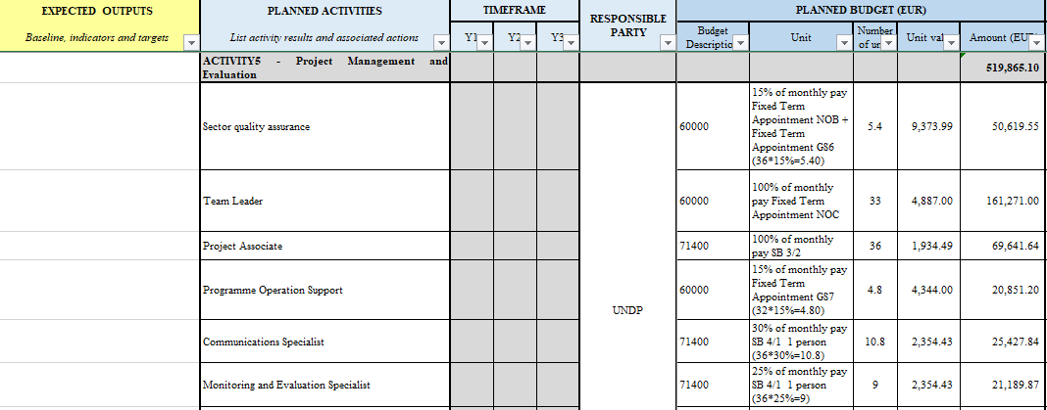

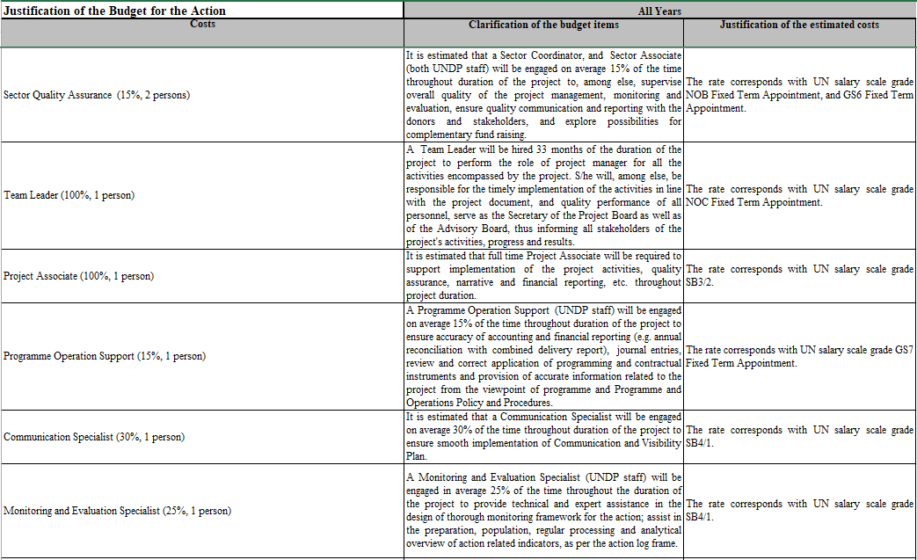

1. **Assess whether the implementation of the Action requires administrative and logistics services from UNDP**: These include recruitment, administration of staff benefits and entitlements, procurement of assets/equipment/services, or administrative logistics support. The following services could be required from the Country Office (CO):
   1. Financial services: Processing revenue, budget, expenses and project reporting at country level, based on requests from projects;
   2. Procurement services: Purchasing assets, plant, equipment, or services for projects;
   3. Human Resources: Recruitment and management of project personnel, including HR, security and general administration;
   4. Project management, reporting, and other guidelines;
   5. Logistics support: Travel, project staff and activity event management;
   6. Equipment and asset management: Technology maintenance, licenses, and project team and activity support.
2. Staff time can be justified and expressed as a percentage of UNDP staff/personnel engagement. The following example is for a project that deeply requires procurement services for successful implementation of the Action. CO staff time required for these functions is planned in the human resources section of the EU budget (see new budget template).
3. The above needs must be defined before sharing a project proposal with the EU.

***Implementation Phase***

The project implementation team and responsible CO or business unit (BU) ensure that the following is met:

1. **Terms of Reference**: The terms of reference of staff/personnel whose salaries are fully or partly charged to the EU funding, must link to the activities or deliverables indicated in the Description of the Action (Annex I) and costed in the Budget of the Action (Annex III).
2. **Timesheets**: If a staff/personnel member is not hired to allot 100% of his/her time toward the implementation of the Action, the actual time spent against the project implementation must be justified and documented e.g. in a timesheet, regularly verified, and signed by both the staff member and his/her supervisor.
3. **Multiple Charts of Accounts**: If a staff/personnel member is not hired to allot 100% of his/her time toward the implementation of the Action, the actual time spent against the project implementation must be justified and documented e.g. in a timesheet, regularly verified, and signed by both the staff member and his/her supervisor. Time and costs for staff providing services to the Action can be expressed by multiple Chart of Accounts (COAs) for the position management and a quarterly reconciliation, upon certification of timesheet. A sample time sheet is provided [here](https://intranet.undp.org/unit/ofrm/_layouts/15/WopiFrame.aspx?sourcedoc=/unit/ofrm/Financial%20Resource%20Management%20Policies/Staff%20TimeSheet_sample_2020_Annex%203.xlsx&action=default).
4. **Operating Expenses**: The fair share of staff operating expenses for programmatic and administrative support services are only allocated to the Action budget consistent with the staff time spent for EU projects.
5. **The BU responsible for implementation must closely monitor the commitments made and expenses incurred**. Should the estimates in Annex III no longer meet real needs, a formal budget revision must be requested through an addendum (rider) to the Contribution Agreement. Please note that EU rules do not allow retroactive amendments. Therefore, amendment requests must be filed at least one month before the change needs to occur. The EU may deny requests for changes not covered through addendums, as described in the General Conditions.

***Closure and Transition***

1. All project deliverables must be **finalized within the Implementation Period**, as per Article 2 of the Agreement’s Special Conditions. Only final reporting, evaluation, audit, and closure costs may be incurred after the Implementation Period. Verify eligibility, as per the specific EU-UNDP agreement/template.
2. Eligibility criteria vary as EU contract templates evolve. To verify current criteria, check the General Conditions of the signed contract, or contact the Brussels Office for assistance ([ecsupport@undp.org](mailto:ecsupport@undp.org)).
3. The CO or BU in charge must submit the final report as per requirements defined in the contribution-specific agreement. Final reports are due no later than six months after the Implementation Period ends (in some cases 3 months, e.g. EU humanitarian aid funds). Non-compliance with reporting deadlines may lead to recovery of funds.
4. The EU can carry out a verification mission based on a selection of transactions underpinning the financial report. This can occur as many as five years after the financial end of an Action. This period is counted from the moment all financial claims relating to the EU-UNDP agreement have been settled (e.g. provision of the final payment or return of unspent balances, as confirmed by official correspondence).
5. **Meticulous record keeping is essential**, as UNDP must be able to prove the eligibility of reported expenses at any point during implementation, as well as long after the operational and financial end of any Action. COs/BUs must ensure reconciliation between Atlas records and the financial reports submitted to the EU. In the absence of underlying documents, costs reported may be deemed ineligible and therefore recovered. Costs for which UNDP cannot demonstrate compliance with its own financial and/or accounting practices will also be considered ineligible.
6. Additionally, UNDP must be able to ensure that funding provided to implementing partners, grant recipients, and contractors (where applicable), was used for the intended purpose, and that EU-specific requirements (where applicable), were observed. The table below compares eligible direct costs by EU grants and UNDP projects:

|  |  |
| --- | --- |
| **Comparison – Eligibility of Direct Project cost between UNDP and EU project** | |
| **DIRECT COSTS**  **UNDP Programme Resources** | **Eligibility of DIRECT COSTS**  **EU funded Projects** |
| **Costs which can be directly linked to a particular project and traced to it in a reasonable and economically feasible way. In case of personnel, such costs should be costed fully, e.g.:** staff salary, benefits and entitlements, centrally managed costs, including payroll reserves for learning, ICT, JFA, MAIP, ASHI, EOS etc., office rent, utilities, communications, supplies, and office security.  Personnel may be from within UNDP, or contracted directly under a project.  **Direct costs include the following functions, in addition to activities described in the project document:**   * Project management * Project communications, advocacy, and funding partner visibility * Monitoring and evaluation of projects * Project briefings and technical guidance for project stakeholders * Project meetings, progress, and final reporting * Donor-specific reporting * Support to implementing and responsible parties * HACT assessments and all assurance activities   **The following functions/activities typically require sharing of personnel, including on staff contracts, to be paid by the project as Delivery Enabling Services under specific project activities*:**   * **Project Supervision and Coordination** * **Programme Coordination** * **Risk Management** * **Activities leading to project closure (checklist)** * **Administrative, Operational, and Other Shared Services** such as: * Creation of documents relating to revenue processing, budget, expenses, payments, vendor and project level reporting, requisitions, purchase orders, vouchers, payroll processing * Procurement of goods and services * Human resources (HR) services: recruitment and management of project personnel (recurrent personnel management, security and general administration briefings, trainings and learning tools) * Logistics services for office premises * Logistics support services such as travel and event management * Communication support for project personnel and activities * Equipment and asset management services, including information technology (IT) equipment, maintenance, licenses, and support for the project team and activities * **Contingency expenses** to cover unforeseen fluctuations in prices and exchange rates | The EU does not have an exhaustive list of eligible costs. However, in general, eligible, direct costs must be:   1. **Necessary** to carry out the Action, **directly** **attributable** to it, **arising** **directly** from its implementation, and **charged proportionally to actual use**; 2. Incurred in accordance with the provisions of the (EU-UNDP) Agreement; 3. **Actually** **incurred** by the organization, e.g. represent real expenditure borne by UNDP; 4. **Reasonable, justified, and comply with the principle of sound financial management** e.g. UNDP’s [POPP Programme and Project Management](https://popp.undp.org/taxonomy/term/76) policy; 5. **Incurred during the Implementation Period** as defined in the Special Conditions of the Contributing Agreement, except for costs related to the final report, evaluation, audit, and other costs linked to Action closure; 6. **Identifiable and backed by supporting documents**, notably determined and recorded in accordance with UNDP’s [POPP Financial Accountability and Internal Controls](https://popp.undp.org/node/10796); 7. **Covered by one of the estimated budget sub-headings (Annex III) and by activities described in Annex I**; and 8. Comply with the applicable tax and social legislation, in consideration of the organization's privileges and immunities.   The only exception is administrative/managerial support costs. To be eligible, such costs must be:   1. ***justified and described in the “Project Office” sections of Annex I;*** 2. ***meet the cumulative eligibility requirements for all direct costs (listed above)***.   Project Office costs can include the following:   1. Staff costs, including administrative and management personnel **directly assigned to the project office**. The tasks listed in Annex I, undertaken by such staff will be directly attributable to the implementation of the Action. 2. Travel and subsistence costs for staff and other persons **directly assigned to the project office**; 3. Depreciation costs, rental costs or lease of equipment and assets **composing the project office**. 4. Costs of maintenance and repair contracts **specifically awarded for project office operations**; 5. Costs of consumables and supplies **specifically purchased for project office operations**; 6. Costs of IT and telecommunication **services specifically purchased for project office operations**; 7. Costs of energy and water **specifically supplied for project office operations**; 8. Costs of facility management contracts, including security and insurance costs **specifically awarded for project office operations**; 9. Where project office costs are declared as **actual costs,** the organization declares as **eligible only the “portion of capitalized project office costs that correspond to the duration of the Action and the rate of actual use of the project office for the purposes of the Action**.” |
| Independent Audit and Evaluation  Quality Assurance (QA) Services | Project-specific audit – Yes.  Evaluation (mid-term/final) – Yes.  “Quality Assurance” would require additional clarifications, as “quality” is presumed given. |
| Policy advice and Quality Assurance  Office rent, utilities, communications, supplies, and office security or fair share of such costs as apportioned by the common service providers | Policy/programme advisory services could be direct costs, if described and costed in line with EU eligibility requirements.  for example: **time staff/personnel** spend **implementing** the activities/deliverables – Yes.  However, time that such persons spend **formulating** a project (e.g. before the implementation/eligibility period starts) – No.  Minimum staff involvement could be a direct cost if linked to the project’s closure, before submission of the final report to the EU.  **Share of office rent, communications, supplies, security** – could be direct costs if **described** in the project proposal and **“Project Office”** section of Annex I, and charged as **“the portion of capitalized project office costs that correspond to the duration of the Action and the rate of actual use of the project office for the purposes of the Action**.” |
|  | Formulation of workplans/milestones, monitoring, and assessment tools during the Implementation Period (as per the EU-UNDP Agreement) as described in the project proposal and Annex 1 of the EU-UNDP Agreement – Yes.  Formulation of operations workplans/milestones etc. which happen outside the eligibility period and not “by staff assigned to the implementation of the actions” – No. |
| *\*The services can be provided by UNDP personnel in different geographical locations. Please note:*  ***- For UNDP personnel above the P5 level on positions fully funded by core IB and GMS by nature of its functions,*** *reimbursement from project budgets is not allowed irrespective of services provided to projects. Such services generally fall under the indirect cost category.*  *-* ***For UNDP personnel at the P5 level or below****, his/her activities that are directly linked to a particular project may be charged as direct project costs. However, such activities should be charged judiciously, noting its leadership function, and may not exceed 40% of the person’s cost.*  *Note: As per the Board document (DP/2013/41) and associated Board decision (DP/2014/2), effective 1 January 2014, all P5 level positions and below can be multi-funded.* | |

1. For information about the EU and donor intelligence, please consult the [Brussels Representation Office](https://intranet.undp.org/unit/pb/liaison/brussels/default.aspx).
2. In place since January 2019.
3. The previous Pillar Assessed Grant or Delegation Agreement (PAGODA-2) template was in place from 2016 to 2018.
4. Humanitarian funding from the Directorate-General for European Civil Protection and Humanitarian Aid Operations (DG ECHO) remains contracted through the ECHO-IMDA template. As DG ECHO contributions represent less than 2% of the annual total of EU contributions secured by UNDP, they are not specifically targeted by this document.
5. See Article 7.1 Special Conditions, EU Contribution Agreement, as well as UNDP POPP Full Costing and Budgeting of Projects.
6. For example, “common services”, “terminal expenses”, etc.
7. For example, salaries/fees; travel & subsistence allowances; organization of trainings/conferences/events; rent and communication/visibility; office consumables; office equipment, etc.