KNOWLEDGE PRODUCT PRODUCTION AND QUALITY ASSURANCE

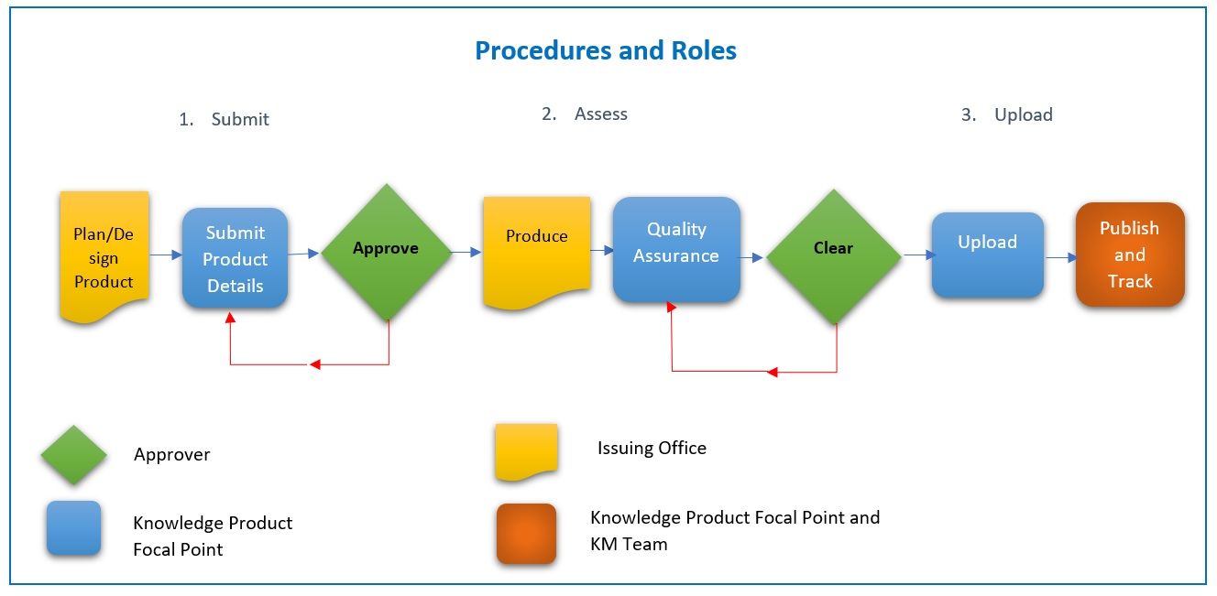

1.0 Regulations and Rules

2.0 Policy

1. Policy Statement. All UNDP knowledge products are subject to prescribed quality standards, follow prescribed quality assurance steps, be authorized for publishing at the level of the issuing office, and be accessible on UNDP’s public site. Knowledge products are distinct from communications products, which are not subject to this policy.

2. Application. This policy applies to all print, online and multi-media knowledge products produced by UNDP and for which the UNDP is an authoring party. It is optional for knowledge products for which UNDP is a sponsoring party, at the discretion of the organization authoring or commissioning the product.

3. Definitions. A UNDP knowledge product is “a branded published piece offering new insights and analysis that advances learning or increases understanding about a development issue and leads to improved development policies, programmes, practices, products, skills and competencies.” It is produced for the purpose of informing or influencing decision-makers, professionals or the interested public. Knowledge products may be classified under eight types: report, technical paper, guidance material, contributing paper, findings, dataset, brief, and think piece.

4. Quality Standards. All UNDP knowledge products must meet six quality standards: (1) the product is relevant to the organization’s or programme’s priorities; (2) the product demonstrates thought leadership; (3) the product is well-designed and internally consistent; (4) the product is assured of reaching its intended audience; (5) the intended impacts are clear and measurable; (6) an appropriate roll-out plan is included. To certify these standards are met, the approver/authorizing officer signs a Quality Standards Certification form through the online quality assurance process.

5. Quality Assurance. Quality assurance for UNDP knowledge products is a three step online process conducted by the Issuing Office. The Issuing Office appoints a Knowledge Product Focal Point who:

- Submits the planned knowledge product details (scope of work, budget, target audience etc.)
- Once the knowledge product is produced, assesses it against the quality standards, and
- Uploads the product for publishing on UNDP's public site

Two key decision points in the process certify the product meets the criteria. It is the role of the Approver, the authorizing officer within the issuing office, to:
- “Approve” is when the approver -the authorizing officer- certifies that the knowledge product has been adequately justified and its design details have been satisfactorily thought through to proceed with the production stage,
and
b) “Clear” is when the approver certifies that the product fully meets UNDP’s quality standards and can be finalized and issued. At each step the authorizing officer signs off on the Online Quality Assurance process.
Following its publication, the issuing office is also able to track and monitor the impact and the performance of the published knowledge product.

6. Key roles and delegation of authority.
Approver: the authorization to approve and clear a knowledge product for publication is done at the level of the authorizing officer/budget holder in the issuing office – the authority responsible for approving the allocation of a unit’s or project’s budget resources; e.g., the head of the office, the programme or the project executive issuing the product.

Issuing office is the bureau/department/office/team that designs and finances the production, roll out and publication of the knowledge product. The issuing office should also appoint a Knowledge Product Focal Point to oversee and coordinate the online quality assurance process and fulfill the policy requirements.

7. Other considerations. Critical reviews are an important step to guarantee the quality of the product. They are done by professionals within the issuing office and independent qualified persons.
The product’s type determines the nature of the review, the composition of the reviewers and whether an external review is called for.

8. Support tools.
- Online Quality Assurance process
- Tracking and Monitoring the performance and impact of the knowledge product
- All UNDP knowledge products should also adhere to UNDP’s publications guidelines spelled out in the Communications Toolkit, to ensure conformity with standards for material produced for external audiences.
- Knowledge Product Production Guidelines offer in-depth information on different knowledge product types, life cycle steps, production processes, and quality assurance standards.

