GUIDANCE ON KNOWLEDGE PRODUCT PRODUCTION AND QUALITY ASSURANCE POLICY

1. TYPES OF KNOWLEDGE PRODUCTS

A UNDP knowledge product is a branded published piece offering new insights and analysis that advances learning or increases understanding about a development issue or a professional practice, produced for the purpose of informing or influencing decision-makers, professionals or the interested public, and leading to improved development policies, programmes, practices, products, skills and competencies.

All UNDP knowledge products can be categorized under one of the following eight categories:
- Report – a polished presentation of a corporate position or professional viewpoint on a development issue, based on conclusions and recommendations derived from research, evidence or empirical findings. Reports are produced to influence key decision-makers, and as such are accompanied by a communications plan and supporting material designed to generate interest from the target audience and the media. Formats include, e.g. flagship reports, (thematic) reports; position papers; reviews; documentaries.
- Technical Paper – an in-depth investigation, commissioned under a technical assistance project or programme, of an issue the project/programme is expected to address. Technical papers are produced to fill specific knowledge gaps or contribute directly to project results. This product type is intended for the project stakeholders, particularly the experts and officials served by the client organizations themselves and is frequently branded or co-branded under the logo of the client organization as a “commissioned report”. Formats include, e.g. technical papers; assessments; studies; research papers; survey results.
- Guidance Material – instructions, suggestions or examples for practitioners to follow for ensuring sound implementation of a policy, process or practice. Guidance material is produced to influence practitioners in the domain, and as such would be supplemented by orientation or training and continual updating as the state-of-the-art advances. Formats may include e.g. guidance notes; how-to guides; toolkits.
- Contributing Paper – the initial articulation of a position or viewpoint, intended for consultation or contribution to a subsequent publication or a debate. Addressed primarily to others with expertise or influence on an issue. Formats may include discussion papers; background papers; working papers; conference papers; book chapters.
- Findings – an examination of projects, programmes, experiences or events, for the purpose of deriving insights for wider applicability. They are produced for the sponsors, managers and professionals working on the projects or programmes being reviewed but are also relevant to all professionals in the domain as contributions to future work, advisory products or prescriptive products. Formats may include e.g. project progress or final reports; event proceedings; case studies; lessons learned; evaluations.
- Dataset – an original compilation of data, information or knowledge-based resources to use for research, analysis or sourcing of knowledge or expertise. Data in dataset knowledge products represent the knowledge of domain specialists, and are distinct from simple “lists”, which are compiled from information only. Knowledge-based datasets are intended to be used as source material for other knowledge products and for analysis. Formats include “knowledge bases”; indexes; catalogues; rosters; infographics (sourced from original material and not as visualized representations of other products).
- Brief – a concise version of a corporate position or professional viewpoint on a development issue, including analysis and citations of supporting reference material. Briefs are also intended to influence decision-makers, and as “briefs” are more likely to be reviewed by those unable to devote the time or attention to a published report. Formats may include, e.g. policy notes, policy briefs; issue briefs.
- Think Piece – brief, thought-provoking writing advocating a viewpoint or presenting analytical conclusions of typically a single author, as a stand-alone piece or compendium. Since they are easily accessible on line, think pieces are targeted to a wide audience, including influencers, domain experts, development professionals generally, the engaged public and the media. The content mainly consists of informed opinion (although journal articles can be solid analytical pieces). Formats include journal articles; think pieces; opinion pieces; journal series.

Templates for knowledge products are available on the UNDP Knowledge and Advocacy Product site.

2. KNOWLEDGE PRODUCT LIFECYCLE STEPS

UNDP knowledge products have a 3-step lifecycle and two main decision points.
Appointed by the Issuing Office, the Knowledge Product Focal Point is responsible to take the knowledge product through the three steps noted on the Knowledge Products Quality Assurance Process site. S/he:
- Plans and submits product details (plan and submit)
- Assess the quality of a product (produce and clear)
- Uploads (upload, publish and track)

The Approver, typically the budget holder of the knowledge product, signs off the two main decision points of the quality assurance process. S/he:

- “Approves” that the design details have been satisfactorily thought through to proceed with the production stage, and
- “Clears” the form certifying that the product fully meets UNDP’s quality standards and can be finalized and issued.
At each step the approver signs off the online forms by following the 1 - 2 - 3 process online available on the Knowledge Products Quality Assurance Process site.

The process and the decision points are illustrated in the following diagram and in the “3.0 Procedures” section of the Knowledge Product Production and Quality Assurance policy page.
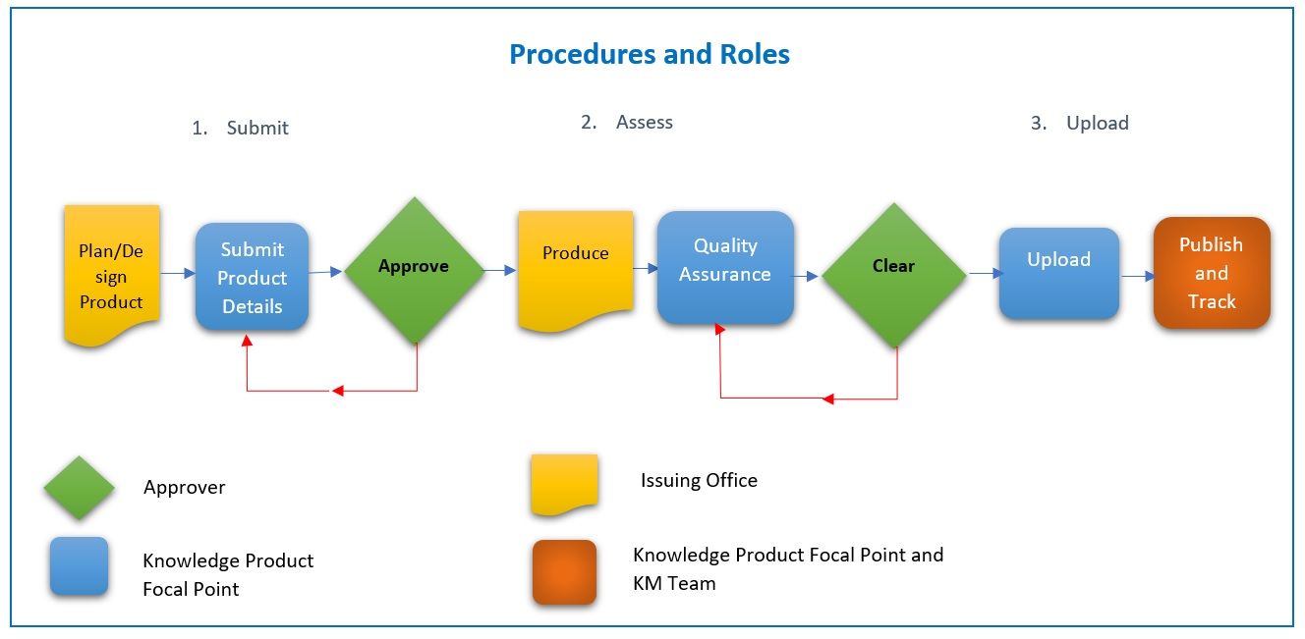

2.1. Submit a product (plan and submit)

A decision to produce a knowledge product can be done through any of the UNDP instruments used to allocate resources to priority initiatives – annual unit work plan; programme document; project or portfolio document; Engagement Facility document; or ad hoc proposal to, say, respond to a co-publishing offer. The initiation instrument would contain a “Knowledge Product Idea” paragraph, providing the information required to justify producing the product. The paragraph should have only the minimum information needed for consideration – product title, product type, intended audience, justification (rationale and priority), resource earmarking and planned issue date.

At this time the knowledge product’s design details should be fleshed out, to define the approach, communications effort, performance expectations, and production details, inputs and budget. For the products requiring substantial analytical depth and a relatively large resource investment – report, technical paper; guidance material; contributing paper – the “Knowledge Product Details” (Step 1 of the online quality assurance process) should be an annex to the programme or project or work plan it falls under, or presented as a self-standing project document. For the less substantial products – findings; dataset; brief; think piece – the Product Details should be 1-2 pages.

It is recommended that products requiring a relatively large resource investment – Reports in particular, but also Technical Papers, Guidance Material and Contributing Papers – should include a resourced communications plan for engaging the intended audience. Other product types should also have a communications effort, but it may not need to be articulated as a plan.

Approval by the product’s approver to proceed to the production stage would be based on the appraisal of the Product Details by the relevant review mechanism. For example, if the product is included in a project document or is a self-standing project, the appropriate mechanism would be the Local Project Appraisal Committee; if it is within an approved project it would be the Project Board.

2.2. Produce a product (produce and clear)

Steps for preparing an approved knowledge product are based on the production timetable and resources included in the Product Details. Corresponding communications activities should also be developed, particularly for reports, which call for a high visibility product release.

All products, once finalized in draft, should be subject to critical review. The product’s type determines the nature of the review, the composition of the reviewers and whether an external review is called for. This resource covers the review processes, suggested reviewers and considerations for each product type.

The product should also adhere to UNDP’s publication policy and other material in the Communications Toolkit issued by the Communications Group, Bureau for External Relations and Advocacy.

When the product draft has passed the critical review and the comments accommodated, it is considered final and submitted under a “Quality Standards Certification” (step 2 of the online quality assurance tool) to the approver for clearance to issue. The Certification form is the instrument spelling out how the product meets the quality standards for UNDP knowledge products. The approver signs the form, certifying that the product meets the quality standards, and is therefore “quality assured” and authorized to feature the UNDP logo.

2.3. Upload a product (upload, publish and track)

Once cleared, the product, along with the details and the signed forms, is uploaded on the internal knowledge products library for audit purposes. The purpose of this step is to maintain a record and address audit concerns.

Once uploaded, the product is published and disseminated according to the roll-out plan that was defined and budgeted for in the Project Details. All cleared knowledge products will be uploaded to UNDP’s public site. Issuing office can also request the publication of the knowledge product onto regional or country offices sites, as appropriate.
The KM Team (knowledge@undp.org) assists in publishing quality assured knowledge products on the UNDP Global Research and Publications Library

The issuing office should make efforts to track the impact of the knowledge product and measure and report its performance in terms of readership via the Knowledge Product Report application.
The service is managed by the Knowledge Management Team. For questions and information please contact knowledge@undp.org

3. QUALITY ASSURANCE AND QUALITY STANDARDS

It is incumbent on UNDP for every product it issues to be quality assured. In other words, if UNDP’s logo is affixed to it, the audience can be “assured” of a quality product.

Quality Assurance

The quality assurance process fixes the decision points where a UNDP knowledge product is certified as having met the criteria represented by that production step.

- Approve – The approver certifies that the knowledge product is adequately justified (it is of sufficient priority, relevance and timeliness to warrant production) and its design details have been satisfactorily thought-through to proceed to the production stage. In other words, the product should be sufficiently well designed, with a clearly identified target audience, strategy, communications plan, resource allocation, implementing arrangements and risk mitigation factors (if relevant) to warrant proceeding to the production stage. This step is represented by the signature of the approver on the Knowledge Product Details form (Step 1 of the online quality assessment: “Submit new publication”).

- Clear – The product should satisfy the six dimensions (below) which, taken together, demonstrate that product warrants certification as a UNDP knowledge product. This step is represented by the signature of the approver on the “Quality Standards Certification” form (Step 2 of the online quality assessment: “Assess Quality Standards”) allowing the product to feature the UNDP logo. After the approver certifies that the product fully meets UNDP’s quality standards for knowledge products and can be finalized, uploaded on the internal library, and issued on www.undp.org

After its publication on www.undp.org (and its regional and country level subsites, as appropriate) the knowledge product’s impact and performance can be measured via the online Knowledge Product Report made available by the Knowledge Management Team. For more information please contact knowledge@undp.org

Quality Standards

To be certified as quality assured, a UNDP knowledge product should meet the following six standards. These are contained in the “Quality Standards Certification Form,” which is submitted as a cover note to the knowledge product for signature by the authorizing officer.

1. The product is relevant to the organization’s or programme’s priorities
This Quality Standard ensures that the product warrants the time and budget allocated to produce it. The recommended way to establish this would be by the office’s acceptance of the initial Product Idea, where the product would have been considered as a priority relative to other initiatives proposed.

2. The product demonstrates thought leadership
This Quality Standard ensures that the product applies knowledge to take the topic further, by contributing new knowledge or disseminating existing knowledge. The recommended way to establish this is to include in the product design stage a scan of existing knowledge – both documented from libraries and undocumented from knowledge-sharing networks

3. The product is well-designed and internally consistent
This Quality Standard ensures that the product meets the highest standard of excellence as a professional work. The recommended way to establish this would be to have the product critically reviewed by professional peers, and to have it professionally edited.

4. The product is assured of reaching its intended audience
This Quality Standard ensures that the product will be seen by the persons it is produced for. The recommended way to establish this would be for the product to be accompanied by a targeted communications plan, including, if relevant, associated products and other supplementary material to generate interest.

5. The intended impacts are clear and measurable
This Quality Standard ensures that UNDP can confidently know what “success” looks like – e.g., whether the product meets expectations in terms of outcomes. The recommended way to establish this would be for the Product Details to include the metrics against which performance and impact would be judged.

6. A roll-out plan is included.
This Quality Standard ensures that the next steps after publication have been thought through, and are focused on maximizing prospects for reaching the target audience. The plan should be appropriate to the knowledge product. The recommended way to establish this would be to include the resourced roll-out plan as a budget item in the Product Details.

Note that the standards have a recommended way of being met. Recommendations are not mandatory, and so they could be substituted by another approach. This might happen, for example, if the product is co-published and the authorizing officer considers that following the partner’s quality standards would preclude the need to apply those of UNDP. It is up to the judgment of the authorizing officer to determine if a particular quality standard has been met.

