Accounts Payable

- An Accounts Payable invoice records a UNDP liability due to a supplier arising from the provision of goods or services to UNDP.
- There are 3 types of invoices:
- Standard invoice (includes PO and Non-PO invoices)
- Prepayment Invoice (Refer to prepayment section)
- Credit Memo (used to record deposits)

- An invoice is raised upon the receipt of goods and/or services and the presentation of a supplier's invoices or other payment request documents such as approved FACE Forms. Invoices can be created in the following ways:

- Supplier Portal – The supplier submits the PO and Non-PO invoice directly in the portal. This is the recommended approach.

- Directly in Quantum:
- The CO or BU invoice creator can create an invoice directly in Quantum for suppliers who are unable to use the Supplier Portal.
- Template bulk invoice upload for multiple suppliers – GSSC can create invoices for multiple suppliers using the same supporting documents, such as invitation letter for meeting participants . The clustered CO completes a spreadsheet with supplier details and other information and submits to GSSC through UNALL for bulk invoice upload.

- Thresholds for invoice approval:
Invoices are approved according to the following thresholds:
- 1st Level Manager approver: Invoice amount up to US $10,000
- 2nd Level Manager approver: Invoice amount up to US $50,000
- 3rd Level Manager approver: Invoice amount from $0 with no limit

- The following types of invoices can be created in Quantum:
- PO invoices are mandatory for purchases > US$5,000, assets > US$ 5,000, Individual Contracts – IC regardless of the amount. The use of a PO invoice below the threshold (where it applies) is optional.
- Non-PO invoices for purchases up to (<=) USD $5,000 and other payments that are not raised through POs such as staff advances, utility bills and MIP reimbursements, NIM Advances, NIM Direct Payment and NIM Reimbursement and so forth.
- Prepayment invoices (GL Account# 16005, 16105, 16106, 16107, 16108 and 14057, 16065, 16010,16015)
- Credit Memo is issued to record deposits.

PO Invoices

- The transaction cycle for a PO invoice begins at the point of e-requisition. It involves the creation of an e-requisition, a PO and receipt of goods /services in Quantum for an invoice to be created.
- PO Invoices can be submitted through the Supplier Portal directly by the Supplier or by the CO if the supplier does not use the Supplier Portal.
- Before a payment is released in Quantum, a three-way matching or a two- way match (as described below) is automatically done in Quantum. PO invoices are flexible in the way they can be sourced from the purchase order:
  - Multiple invoices can be created against a single PO;
  - Separate invoices can be used for different schedules on a PO;
  - Multiple invoices can be used for a single schedule on a PO;
  - Matching ensures that the total amount invoices does not exceed the schedule amounts by the permitted tolerance.
  - CO resolves validation errors from 3-way match
  - Invoices are auto approved and posted to the GL after the 3-way matching process
  - The GSSC reviews a sample of invoices and verifies against supporting documentation and approves the invoice

- However, note that supplier invoices should be entered separately rather than grouped by supplier into one PO invoice in Quantum. Grouping by supplier makes it difficult to locate and answer questions about individual supplier invoices and impacts the matching process (this is different from an invoice with multiple line items, which should also be entered as one invoice) .

Non-PO Invoices

- The transaction cycle for a non-PO invoice begins at the point of delivery of goods or services and submission of invoice by the supplier. Non-PO invoices do not require entry of an e-requisition, purchase order, or receipt in Quantum.

- Non-PO invoices can be submitted through the Supplier Portal directly by the supplier or directly in Quantum by the CO if the supplier does not use the Supplier Portal.

- Instances where Non-PO invoices are used:
  - Small value purchases of up to (<=) USD 5,000; e-requisitions/POs are not mandatory but recommended.
  - Advances and reimbursement to implementing partners Services for UN agencies for the payment of suppliers ; such cases usually involve direct payments. However, when UNDP is doing the procurement, an e-requisition, a PO and a PO invoice will be required.
  - Grants where a procurement process is not involved.
  - Staff advances including salary advance (see Payroll Section of the Policies and Procedures).
  - Payments using miscellaneous balance sheet items – such as UNFCU advances, petrol advances etc..

- The CO creates a non-PO invoice, does a first level approval and the invoice flows to GSSC for final approval.
- It should be noted that the payment for non-PO invoices should be recorded in the period that the goods/services were incurred by the implementing partners.

Flowchart
PO invoice Processing Flowchart
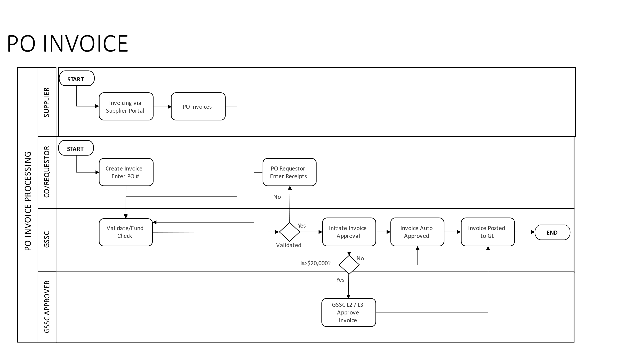

Non-PO invoice Processing Flowchart
