**IPSAS COMBINED DELIVERY REPORT**

The adoption of the International Public Sector Accounting Standards (IPSAS) by the United Nations Development Programme (UNDP) will take place on 1 January 2012. This accounting policy change will alter the way UNDP recognises expenses in the Combined Delivery Report (CDR), from 2012 onward, as outlined below. Please also refer to the template of the new CDR further below.

UNDP’s CDR under the United Nations System Accounting Standard (UNSAS), reflects expenditure based on disbursements and commitments. IPSAS CDR, however, will present expenses, (formerly expenditure) that reflect costs related to goods delivered and services rendered. Unlike UNSAS, commitments (purchase orders) will not form part of the project expenses under IPSAS.

IPSAS also requires UNDP to record fixed assets (property, plant and equipment and intangibles) purchased for use in projects, spreading their costs over their useful life, instead of charging the full amount to the project in the year of purchase. As a result, expenses in the CDR for each reporting period will include only a portion (i.e., depreciation and amortization) of the total cost of an asset(s) until it is completely depreciated or amortized. In addition, all inventory items (goods and materials produced for distribution, within projects) will be recorded as expenses only when they are consumed or distributed.

In addition, UNDP will introduce a “Funds Utilisation” page that will show outstanding NEX advances, un-depreciated fixed assets, unamortized intangibles, inventory, prepayments, and commitments of projects. (See Page 2)

**Combined Delivery Report (including the Executive CDR)**

*Government Expenses -* Continues to reflect the total disbursements by the implementing partner as reported on the Financial Report (for non-harmonised country programme) or Funding Authorization and Certification of Expenditure (FACE) (for harmonised-country programme). This column will be unchanged.

*UNDP Expenses* - Displays expensesdirectly incurred by UNDP on behalf of the project, either through direct support for nationally executed projects or direct implementation. It will include cost of goods delivered, services rendered, total employee benefits, depreciation and amortization of fixed assets. The UNSAS report showed disbursements and committed expenditure as a single figure, whereas in the IPSAS report commitments (purchase orders) will not form part of the project expenses. Furthermore, under IPSAS, UNDP will record expenses related to employee benefits when services are rendered, not when cash is paid, as is the current practice. This treatment will improve transparency of project expenses by recognising unpaid costs owed for benefits, such as annual leave, after-service health insurance, repatriation entitlement, separation, and more.

*UN Agencies Expenses* - Shows only expenses incurred by UN agencies, acting as responsible parties to the project. This expense will be derived from project delivery reports (PDRs) reported to UNDP and accepted by the implementing partner as part of valid project expenses.

*Total Expenses* – Includes combined totals of government disbursements, UNDP expenses, and UN agencies’ expenses.

**Funds Utilization**

*This is a new section of the CDR report. It will disclose utilisation of project funds as of the reporting period and consists of the following:*

*Outstanding NEX Advances* - Portion of funds advanced to governments and implementing partners where a financial report or FACE form is pending. These amounts are not recorded as expenses until the financial report or FACE form is received.

*Undepreciated Fixed Assets -* Undepreciated assets (property, plant and equipment) represent the portion of fixed asset costs not yet charged as an expense that will be recognised as expense over the remaining useful life of the assets.

*Inventory* - Includes goods and materials that have been purchased but have not yet been consumed or distributed as part of a UNDP project. These purchases are not yet charged as an expense.

*Unamortized intangibles* -Unamortized intangibles represent the portion of intangible costs not yet charged as an amortization expense that will be recognized as expense over the remaining useful life of the assets.

*Prepayments* – Shows advance payments made by UNDP to vendors for procuring goods and services for a project. These payments are not yet charged as an expense.

*Commitments* - Represents purchase orders and/or legally binding vendor contracts entered into, but where goods or services have not yet been delivered or rendered by the end of the reporting period**.** These commitments are not charged as an expense until the goods are delivered or services rendered.

**###**

IPSAS COMBINED DELIVERY REPORT

**Key Changes**

* **New design provides comprehensive information** related to programme delivery in accordance with IPSAS
* **UNDP Expenses** column includes receipts and disbursements, and excludes obligations
* **Encumbrances** column—between **UN Agencies** and **Total Expenses** columns—is removed; only goods and services are recognized as expense under IPSAS



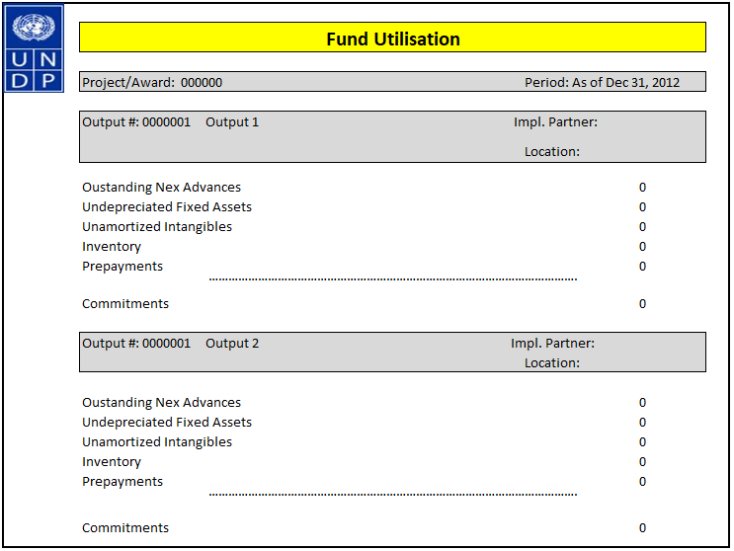

**A**

|  |  |  |  |  |  |  |  |  |  |  |  |
| --- | --- | --- | --- | --- | --- | --- | --- | --- | --- | --- | --- |
| **A**  **This section of the CDR report discloses utilisation of project funds as of the reporting period.**   |  | | --- | |  | |  |  |  |  |  |  |  |  |  |  |
|  |  |  |  |  |  |  |  |  |  |  |
|  |  |  |  |  |  |  |  |  |  |  |
|  |  |  |  |  |  |  |  |  |  |  |
|  |  |  |  |  |  |  |  |  |  |  |
|  |  |  |  |  |  |  |  |  |  |  |