DPC Position Type – Atlas HCM
- When to use “Structure Post – DPC” – “SP – DPC” position type?

The positions that primarily provide policy advisory or implementation support services to development projects are considered as “DPC” positions.

The new position type “SP-DPC” should be used for all positions at P5 and below levels that meet the following criteria:

- Provide a) project implementation support services; b) development effectiveness services that are within a project implementation framework, based on the job description and workload studies in addition to their support to UNDP’s organizational effectiveness results;
- Eligible, hence, for a co-funding from a) development funds for their support to programme and b) institutional budget (core IB and XB) for their contribution to achieve effectiveness and efficiency in UNDP.

- How to Use of SP-DPC position type in Atlas by business units

The offices have to enter “SP-DPC” position type with an effective date in Atlas for GS and NO local positions. For all IP positions the offices should send a request for update to GSSU Position Management Team at GSSU Position mgt gssu.positionmgt@undp.org.

- How to update the Existing Positions:

- Offices should review the current positions and update the position type to “SP-DPC that meet the above criteria with a retroactive date when the position began with a co-funding from programme and management funds;
- Effective date on the position data should be same as the effective date on position funding distribution with multiple COA.

A list of positions that meet the SP-DPC can be found in DPC implementation report

- How to enter the SP-DPC position type for New Positions:

- The offices have to review the job descriptions of the position carefully and establish a funding accordingly based on their discussion with programme and project managers
- The offices shall enter the position type “SP-DPC” with the effective date of the position
- The offices shall enter the position COA with multiple funding lines –
- COA of the office institutional budget project;
- COA of the development projects funded from TRAC or non-core resources such as cost-sharing and trust funds

Atlas screens and navigations are provided below:

- Global Payroll & Absence Mgmt>Time and Labor/GL Costs> GP GL/GP RA Maintenance > Position distribution entry - Take note of the date when the post became “SP-DPC”:
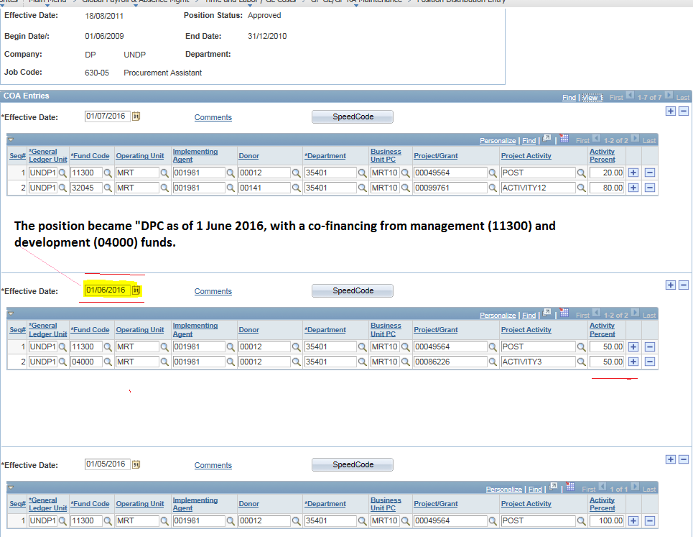

- Atlas HCM/Organization Development/Position Management/Maintain Positions/Budgets/Update Position

- Enter the position number ; Add a new page by clicking on + sign;
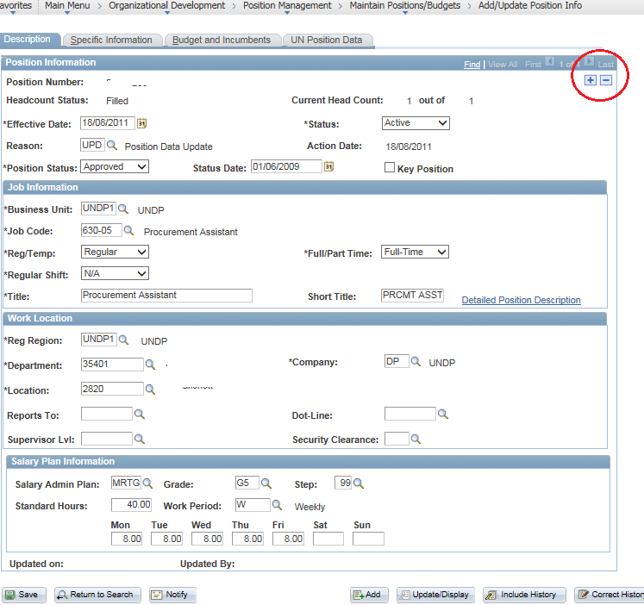

- Enter EOD when the post became “DPC”.
- In this example, enter 1 June 2016 in the position information “Effective date” field.
- Reason: enter UPD (Position Data Update)

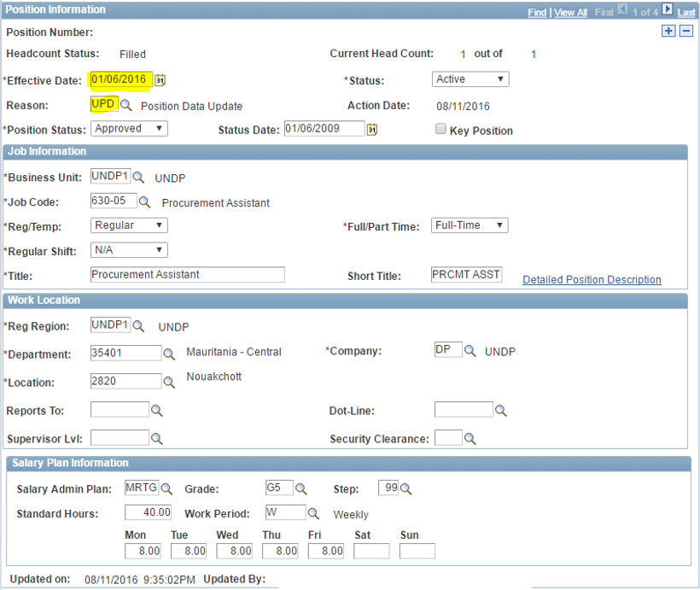

- Click on the “UN Position Data” tab
- Effective Date: automatically reflects the new date
- Position Type: select “Structure Post-DPC”
- Additional Position Info box - insert a description
- Save

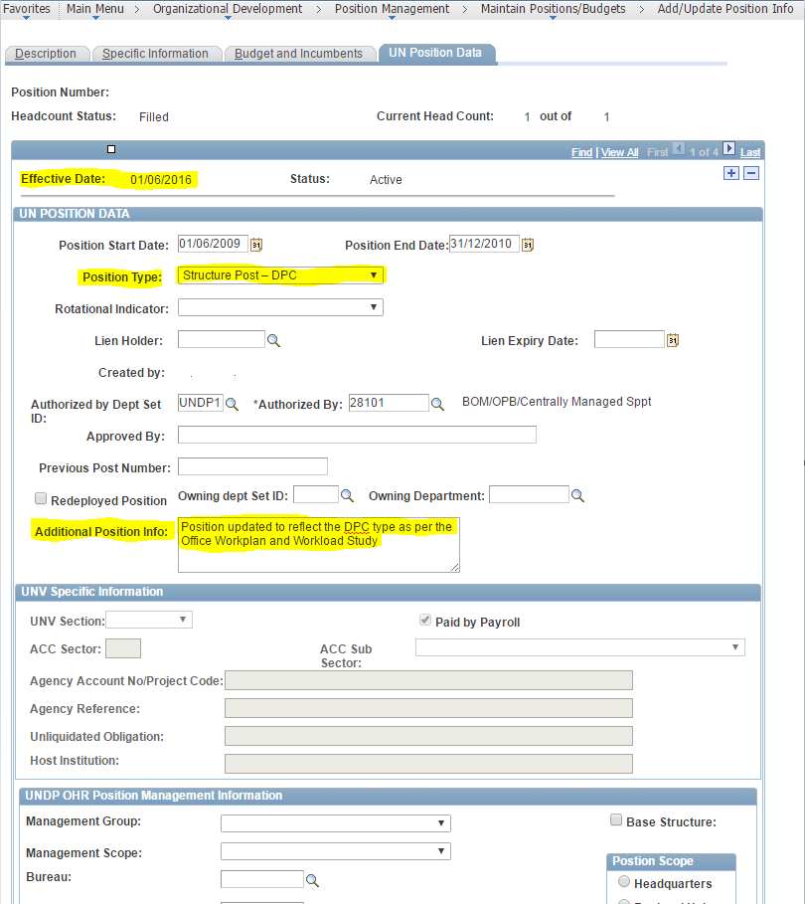

All D1 and above positions should be funded from a single source of fund, unless otherwise advised by OFM HQ.

