Developing a business case for local presence

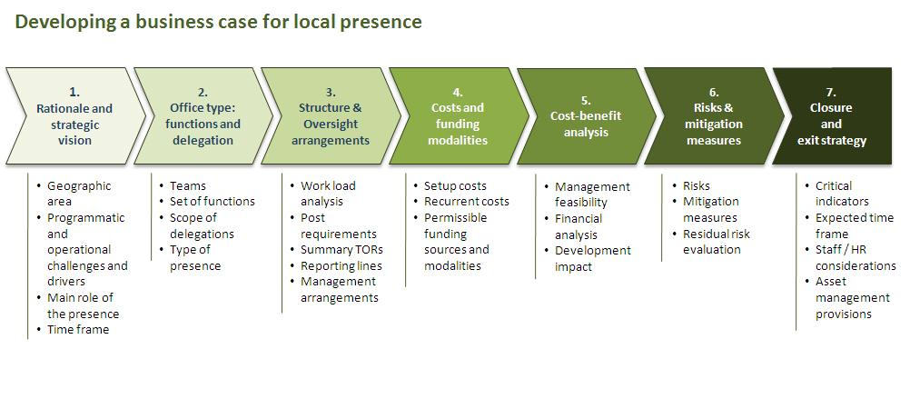
- The business case establishes the rationale for investing in a local presence and includes an evaluation of prospective impact on: a) delivering development results; b) cost efficiency; and c) financial sustainability. It also addresses key management considerations regarding security, staff wellbeing and relationship management with the host Government. It should be developed in 7 steps (see above chart), consisting the following elements:
- Rationale & vision
- Office type: teams, functions and scope of delegation
- Structural overview (including an organization chart with reporting lines and all planned personnel, highlighting those that will be redeployed from the main office and, if any, additional staff)
- Oversight and management arrangements
- Costing (including set-up and operational costs) and funding model
- Cost / benefit analysis of costs and the expected development impact of the local presence as compared to a scenario where the office is operating from the capital only
- Risk analysis and management (including security, staff well-being and relationship-management with host Government); note that a full security and blast risk assessment is required before the presence can be established; it might be included into the business case
- Time or criteria-based provision for closing the office (“sunset clause”) and exit strategy (In exceptional cases where the local presence is expected to remain in place over a longer period of time and where neither time nor criteria-based provisions for closure can be defined, a sustainability strategy replaces the exit strategy).
- Country Offices are required to submit the completed business case of a sub office for approval to the relevant Regional Bureau. Approved business cases are to be kept on file for future audit purposes. For the establishment of project offices, a careful analysis of costs, benefits and risks is expected to be part of the project documentation approved by the senior management of the Country Office (see “Clearing a local presence”).

- The person designated to manage the development of a business case (“designated manager”) and all involved colleagues (“task team”) should follow the steps described for this sub process, consulting relevant Country Office units and senior management, as required.

- Please also see Guidance note, chapter I.1 (“Business case”), for best practices and detailed process guidance for each component of the business case.

- Business case should include:
- Defined rationale and strategic vision
- List of functions, teams and scope of delegation
- Staffing table (positions), organizational chart
- Overview of roles and responsibilities for key business processes
- Reviewed ICF
- Presence budget including setup and recurrent costs
- Presence-specific risk log
- Provision for closing office and exit strategy
- Written delegation of authority
Rationale and strategic vision
- In defining the rationale and strategic vision for a local presence, the Country Office should analyze the programmatic and operational challenges in the geographic area where the local presence is proposed. The expected role and impact of the local presence and time frame for its existence should be defined taking into consideration these challenges.

- UNDP presence outside the Country Office may be considered in the following circumstances:
- Scope and volume of portfolio: i.e. UNDP is responsible for delivering a significant volume of relief or development activities in a particular geographic area. A local presence allows scaling up delivery capacities in a targeted and efficient manner.
- Logistical challenges: i.e. poor infrastructure or significant distances within a country inhibit timely and cost-effective operations to the point that it is more economical to establish a local-level office.
- Proximity to local Government: i.e. successful delivery of development activities requires UNDP to be situated closer to local political or administrative entities. A local presence would allow for more continuous interaction with, and support to, local authorities.
- Need for intensified interaction at the local level: i.e. interaction with social or political groups at the local level is required to achieve development results. A continuous local UNDP presence would facilitate partnership and confidence building, especially where logistical and political circumstances limit mobility.
- Distinct local needs: i.e. a geographic area within a country is characterized by recovery or development challenges distinct from the rest of the country. In border regions, this might require collaboration between Country Offices. A local presence would allow better targeting and implementation of area-specific support and might serve as an operational hub for multiple Country Offices.
- Political visibility and positioning: i.e. local level visibility is deemed essential for political or strategic reasons. This may or may not be associated with future programming opportunities.
- While security considerations should not be the primary drivers the establishment of a local presence, they might be a contributing factor. This would apply especially in cases where UNDP staff members are spread out across several locations, and bringing them together in one concentrated location would provide strengthened security.
Office type: teams, functions and scope of delegation
- The office type is determined by the specific set of functions performed by the presence and the scope of delegation provided. There are three different types of UNDP-supported presences outside the Country Office:
- UNDP project offices
- UNDP sub offices
Project offices
- TA project office staff has no formally delegated representational and coordination functions beyond the project level. Its functions are limited to implementation, monitoring and reporting services at the project level. It can house one or more projects. Additionally, staff may undertake project scoping or planning activities for future project implementation. Given the limited duration of most projects, project offices should be designed flexibly to allow for scaling up and down in response to changing circumstances. Projects are also encouraged to share premises, both as a cost-saving measure and also to capture synergies through informal coordination and collaboration. The formal responsibility for coordination and oversight, however, remains with the Country Office. All personnel in projects offices are funded from project budgets, and work exclusively in support of their projects. Functions performed by a project office are limited to:
- Project transactions (HR, Procurement, Finance)
- Project activities implementation oversight, monitoring and reporting
- Provision of technical implementation support
- Project-related liaison with project partner
UNDP sub offices
- It is managed by a Head of Office holding a staff contract and formal (written) delegated authority to represent UNDP at the local level. In contrast to the project office, the sub office represents the entire UNDP country programme at the local level and performs delegated management functions such as programme and operations oversight, assurance, programme coordination, and partnership building. In consultation with the UNDP Country Office management, the Head of Office sets the strategic direction at the local level and oversees all office activities. The size of a sub office can vary significantly in terms of the number of projects, staffing, budget, and scope of responsibilities. A sub office can undertake functions of a project office. In addition, it performs one or more of the following functions:
- Representation of UNDP with UNCT & partners at local level
- Programme formulation / assurance
- Results reporting
- Project oversight
- Local evaluation coordination
- Donor / partner liaison
- Policy advice
- Operations support, including security
- Resource mobilization & communication
- Managerial oversight
Structure and oversight arrangements
- Careful design of structures, processes, and management arrangements at an early stage will ensure that the local presence can carry out all anticipated functions required and that staff at Country Office and local levels enjoys a shared understanding of roles and responsibilities.

- Staffing decisions should consider the possible relocation of staff from the Country Office as well recruitment of new staff, along with the type and duration of contracts, distribution of functions via job descriptions, and reporting lines.

- Decisions on the number of positions located in the local presence should be based on an estimation of the portfolio volume as well as the type and number of activities to be managed at the local level. In some instances, a detailed estimation of expected workload (see guidance note, chapter I.1.2, Step 3) may be helpful to determine the required / desired number of posts. Final decisions on staffing structures will be subject to the financial analysis described in the next section.

- While the preparation of job descriptions can be left to a later stage, key tasks for (a) each team and (b) each post should be determined. An organizational chart showing reporting lines within the local office and between the local office and the Country Office is also required (see guidance note, chapter I.1.2, Step 3).

- Key business processes that will involve or be managed by the local office can also be developed at a later stage. However, it is recommended to establish these during the first 3 month after the launch of operations.

- The Country Office is fully responsible for programmatic and operational oversight of the local presence. Detailed oversight arrangements need to be determined as part of the business case. As a minimum, the Country Office should field 6-monthly programme and operations oversight missions that assess compliance of activities managed at the local level with UNDP rules and regulations. It is recommended to combine these missions with training activities provided by experienced Country Office members to staff deployed at the local level.
Costs and funding modalities
- A realistic evaluation of costs for the set-up and maintenance of the local presence will be undertaken to establish feasibility and identify funding options.

- Two types of costs should be distinguished: initial set-up costs and recurrent monthly or annual costs. Set-up costs might include (but are not necessarily limited to):
  - Establishing MOSS compliance
  - Renovation of offices
  - Communication infrastructure
  - Office equipment
  - Transportation (vehicles)
- Recurrent costs include:
  - Staffing costs
  - Monthly operating costs (fuel, electricity, communication, etc.)
  - Equipment maintenance costs
  - Rent for offices
  - Security-related costs (guards, etc.)
- Anticipated costs should be compared against expected available funding and income. This needs to be analyzed and documented. This analysis will inform the final decisions on the staffing structure of the presence.

- Note that premises and the security risk and blast assessments might have a significant impact on both set-up and running (recurrent) costs. In addition, security clearance provided by the HQ Senior Security Manager is a precondition for the establishment of the office. In risk-prone environments, you should therefore identify potential premises and carry out security-related assessments as early as possible, ideally before the finalization of the business case.

- Permissible funding sources depend on the type of presence and associated functions:
- Project offices undertake project implementation, monitoring, and reporting activities. They are funded by development project resources (core and/or non-core). Funds should cover the entire cost of operations, which are reflected in development project budgets. CO management resources can supplement these resources for a limited period of time to fund gaps in project resources or as investments in the start-up and running costs of local-level presences. Office costs should be shared among beneficiary projects according to clearly defined criteria (such as: square meter occupied by project, number of staff, etc.).
- In the case of sub offices, each project funds its share of total costs related to project implementation functions performed by the office. UNDP representation, management and oversight are funded from the Biennial Support Budget (BSB) of the Country Office and/or extra-budgetary income. These funds should be allocated by the Country Office in direct proportion to the size of the associated core and/or non-core programme budgets managed by the sub office. This entails allocation / redeployment of resources and capacity from the Country Office to the local presence. In addition, corporate funding can be requested when local funding constraints are present and the need for establishing such a local-level presence is organizationally critical. For details, see the sub-process “clearing a presence”. Corporate funding can include the costs of key personnel, such as the Head of Office and Operations Manager, as well as operational costs related to the setup of the local presence.
- Country Offices that need to establish or scale up local presences in response to emergencies may apply for support and corporate funding through the SURGE mechanism. To reduce costs, Country Offices are strongly encouraged to collaborate with partner agencies and share premises wherever possible.

- All costs related to ensuring MOSS compliance by local presences are normally covered by extra-budgetary resources, programme resources, or a combination of both. Any remaining funding gaps should be brought to the attention of the headquarters Senior Security Manager. Based on a funding request to the Security Office, Bureau for Management Services, funding for these measures might be provided on a case by case basis. For further details, please refer to “Operational Guidelines with regards to the UN Mandated Security Measures Required for UNDP Personnel and Premises”.
Cost-benefit analysis
- The cost-benefit analysis builds on the first 4 components of the business case. It summarizes and evaluates the prospective contribution of the local presence on: a) delivering development results; b) cost efficiency and financial sustainability; and c) management feasibility. It should consider relations to counterparts and partners, staff security and staff well-being and clearly establish that the benefits of establishing the presence outweigh involved costs and challenges. As such, the cost-benefit analysis should consider the entire timeframe of the local presence and take into consideration anticipated future benefits (see guidance note, chapter I.1.2, Step 5).
Risks and mitigating measures
- The analysis of risks entails the systematic review of potential problems and the definition of appropriate mitigation measures to reduce the probability that the risk will materialize.

- In line with corporate policy on risk management, the risk matrix should be used and the following risk categories considered:
- Environmental
- Financial
- Operational
- Organizational
- Political
- Regulatory
- Staff security
- Strategic
- In determining probability and impact, risks are prioritized and specific mitigation measures defined. If residual risks remain high, the feasibility of setting up the presence should be reconsidered.

- Country Offices that conduct security risk and blast assessments during the development of the business case (typically in risk-prone environments) should integrate these into the overall risk assessment.
Provisions for closure and exit strategy
- The final step of the design phase is the definition of a time or criteria-based provision for closing the office (“sunset clause”) accompanied by an exit strategy that provides directions on the management of staff and assets, notably: staff relocation, termination of contracts (when required), transfer or relocation of assets and the safe-guarding of office files and official records.

- Senior management will communicate provisions for closure and the related exit strategy, including roles and responsibilities, to all involved staff during the establishment of the presence.

- In exceptional cases where the local presence is expected to remain in place over a longer period of time and where neither time nor criteria-based provisions for closure can be defined, a sustainability strategy replaces the exit strategy. Regional Bureau approval of the sustainability strategy is required.

  - Business case template
  - Template for delegation of authority
  - Budget template
  - Funding modality template
  - Sample risk assessment matrix
  - Office closure plan template
  - Guidance note for establishing UNDP-supported presences outside the Country Office

If you have problems downloading the excel budget template, please read this guide.

