Setting up a local presence

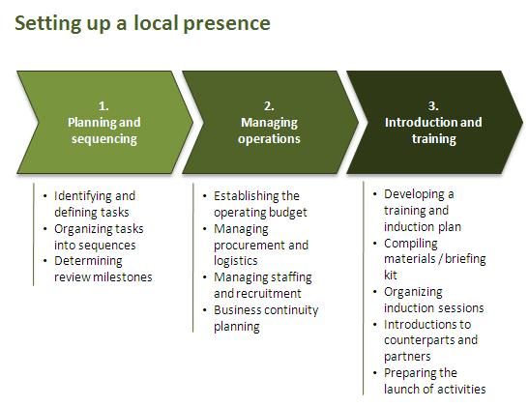
Planning and sequencing
- All activities necessary to set up a local presence should be organized into sequences to ensure proper planning and setup of the presence. It is recommended to establish a specific set-up plan that includes and sequences all activities required to set up the local presence, notable as relates to the establishment of an operating budget, recruitment, procurement as well as to induction and training. Relevant headquarters units should be informed and consulted as appropriate.

- Note that the set-up of a local presence requires the amendment / updating of the business continuity plan (BCP) of the office. Depending on the size of the presence, the Country Office might also decide to develop a separate business continuity plan for the local presence that is linked with the Country Office BCP. Please refer to the business continuity management guidance provided by the Security Office for further details.

Managing operations
- The operating budget should be established before the procurement and recruitment of staff will be launched. Note that all operations relating to the setting up of a local presence are governed by UNDP rules and regulations.

- As a best practice for UNDP sub offices, it is recommended to establish an operating budget of the local presence in a separate management project before launching recruitment and procurement activities. If processes are exceptionally time-critical, you might consider the publication of vacancies as well as of tenders (as appropriate) before the operating budget is fully funded with the approval of the Regional Bureau..

- Any procurement and recruitment activity beyond the publication of tenders and vacancies, however, should be suspended until required funding is available and the budget operational inQuantum.
Induction and training
- Appropriate induction and training is required to ensure that all staff to be deployed in the newly established presence has the minimum information and knowledge about the UNDP and the programme country required to successfully carry out assigned functions.

- Therefore, all newly recruited staff should receive a proper induction to UNDP and the Country Office. The induction should include information about the country including local living conditions in the location of the presence, the configuration of the local presence, management arrangements between the presence and the Country Office as well as general information about UNDP.

- As a best practice, it is recommended to establish an induction kit that compiles all relevant documents and information. In addition, the learning manager of the Country Office should organize induction sessions for newly recruited staff in the Country Office staff is deployed to the local presence.

- The development of a specific learning plan for staff deployed to the local presence should be considered.
Please note that MOSS compliance of the local presence and security clearance are required before staff can be deployed to the local presence.

