**Service Clearing Account (SCA) for non-Quantum UN Agencies: Charging, Billing and Fee Collection**

1. Page Content

Structure Element - Description

1. For UN Agencies who do not use Quantum (the “non-Quantum Agencies”), a dedicated **Service Clearing Account (SCA)** is established for each Agency. Through the SCA, all global prefunding received from UN Agencies are recorded, and all services provided by UNDP Offices to these UN Agencies are recorded. A dedicated Service Clearing Account is not applicable to Quantum Agencies (UNFPA, UN Women, UNU, UNCDF, UNV, UNITAR).
2. To ensure the UN Agency has sufficient funds deposited with UNDP in order for UNDP to provide services, a budget sufficiency check is performed based on the chart field combination of “Fund” (**Quantum fund code 12000**) and “Donor” (a dedicated donor code for each [Agency](https://undp.sharepoint.com/sites/UNAgencies/_layouts/15/guestaccess.aspx?guestaccesstoken=jvclwov2rLFgsJ8wNMcocN8wbm0eB2zmYkLVhB0%2bll8%3d&docid=2_07d6573565c2943c89a167ea69077b4f1&rev=1)). As long as the UN Agency has enough funds deposited with UNDP, the budget check will pass and be valid.
3. UNDP’s Office of Financial Management (OFM) also monitors the levels of prefunding and alerts UN Agencies if their SCA prefunded balance on deposit with UNDP is low and reaches agreed thresholds for replenishment. The SCA is managed and overseen by the OFM and managed on a day-to-day basis by the Global Shared Services Centre (GSSC).
4. Please refer the procedure section of [POPP](https://popp.undp.org/node/11671) UN Agency Services for a step-by-step process of processing AP invoice on behalf of non-Quantum agencies.
5. UNDP Agency Service Portal has been designed to improve service delivery to Agencies and automate the associated billing process for UNDP Offices. The portal will allow UN agencies that require UNDP services to access all services covered under the Universal Price List (UPL) and Local Price Lists in a centralized portal. This portal replaces the outdated processes where, UN agency service requests were mostly managed through offline, email-based processes, that have differed across UNDP. The Agency portal has the following benefits:

* An easy-to-use service request interface, integrated with Quantum, for all UNDP offered services.
* UN Agencies can view and manage their requests, follow-up and interact with service providers across UNDP.
* Billing and collection of service fees automated and linked to Quantum finance module (Service Clearing Account), saving offices time.
* Transparency and visibility of all UN Agency services provided by UNDP globally.

1. The UNDP Agency Service Portal, built in the same technology as UNall (ServiceNow), will be integrated with Quantum and the data warehouse. The below visual shows the end-to-end UNDP Agency Service Portal process:

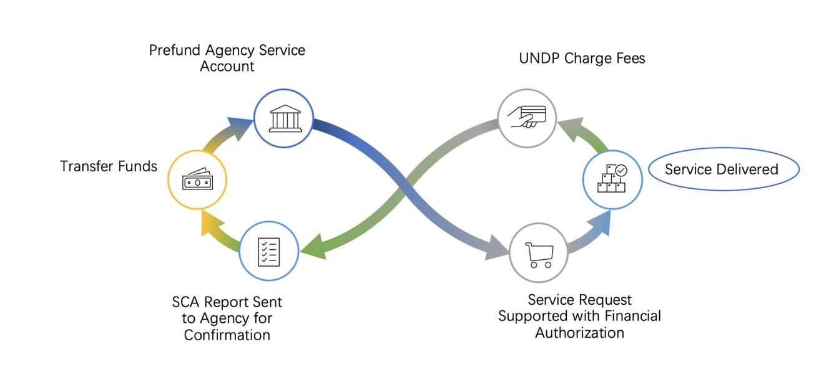

1. Each UNDP Country Office will be able to request access to the portal through their respective Identity and Access Management (IDAM)/Argus focal point. Access should be granted to all colleagues responsible for completing UN agency service requests in their office. These are typically Finance and General Operations colleagues. UN Agencies nominate the staff that will need portal access to submit services requests to UNDP.
2. Country Offices are required to submit a Complete Local Price List and services template by following the instructions provided in the LPL template file.
3. If Offices have questions regarding the UNDP Agency Services Portal, questions can be added to the dedicated [UNDP Agency Service Portal Teams space.](https://eur03.safelinks.protection.outlook.com/?url=https%3A%2F%2Fteams.microsoft.com%2Fl%2Fteam%2F19%253auOArYNT5p2YaaikanXPqcsNOqfn5I-GfNCxQEcophdE1%2540thread.tacv2%2Fconversations%3FgroupId%3Ddcd616fc-d93a-4e8d-9249-7c50fe8ee6ab%26tenantId%3Db3e5db5e-2944-4837-99f5-7488ace54319&data=05%7C01%7Cmulugeta.tarekegn%40undp.org%7C5d40071b492d4a2fbbb708dade39dd90%7Cb3e5db5e2944483799f57488ace54319%7C0%7C0%7C638066637352359559%7CUnknown%7CTWFpbGZsb3d8eyJWIjoiMC4wLjAwMDAiLCJQIjoiV2luMzIiLCJBTiI6Ik1haWwiLCJXVCI6Mn0%3D%7C3000%7C%7C%7C&sdata=oZ%2BLNUKrDPKRxYyAs%2BIB1QLm3HwCl8yZuUyRVHsO80Q%3D&reserved=0)
4. Non-Quantum Agencies are charged for services provided by UNDP Offices through the UN Agency Portal and Global Payroll fee.

The automated process posts the service fees to the following COAs:

|  |  |  |  |  |  |  |
| --- | --- | --- | --- | --- | --- | --- |
| **Amount** | **Account** | **OperUnit** | **Fund** | **DeptId** | **Project** | **Donor** |
| Debit | 73505 | CO | 12000 | CO dept | CR project | Agency |
| Credit | 54015 | CO | 11302 | CO dept | BLANK | BLANK |

1. Payroll Management and Processing Fees by GSSC:

1. Payroll processing services provided at the Global Shared Service Centre (GSSC) to Agency personnel who are administered in Quantum HCM (Staff, UNVs and PSA holders) are cost recovered through monthly payroll process. The service fees are charged to the respective employee position’s COAs every payroll month, and are posted to the GL along with other payroll transactions.
2. The automated payroll process generates the following accounting entries:

|  |  |  |  |  |  |  |
| --- | --- | --- | --- | --- | --- | --- |
| **Amount** | **Account** | **OperUnit** | **Fund** | **DeptId** | **Project** | **Donor** |
| Debit | 65135 or  77396 or  71540 or  71405 | As per position COA | 12000 | As per position COA | As per position COA | Agency |
| Credit | 55012 | GPS OU | 11808 | GPS dept | BLANK | BLANK |

1. For ad hoc services that cannot be standardized across different Country Offices due to their nature, LPL can be applied in the Agency portal to enable generation of the following accounting entries.

|  |  |  |  |  |  |  |  |
| --- | --- | --- | --- | --- | --- | --- | --- |
| **Amount** | **Account** | **OperUnit** | **Fund** | **DeptId** | **Project** | **Donor** | **Value** |
| Debit | 73505 | your unit | 12000 | Your dept | CR project | Agency | Service fee |
| Credit | 54015 | Your unit | 11302 | Your dept | BLANK | BLANK | Service fee |

1. The Service Clearing Account (SCA) Reconciliation process between UNDP and the UN Agencies is detailed in the [Year-end Letter from UNDP to Agencies](https://undp.sharepoint.com/sites/UNAgencies/2015%20Yearend%20Letter%20from%20UNDP/Forms/AllItems.aspx).