A 1.1 Policy on Portfolios
Portfolio Approaches for systems transformation
Contents
- CONTEXT AND CONCEPT 3
  - Policy justification 3
  - Purpose of the Policy 3
  - What is a Portfolio 3
- DESIGN AND APPROVAL OF A PORTFOLIO 6
- Portfolio design 6
- Portfolio Theory of Change 7
- Portfolio Results Framework 7
- Funding a portfolio 8
- Portfolio Appraisal and Approval 9
- IMPLEMENTING A PORTFOLIO 9
- Implementing Partners in a Portfolio 9
- Portfolio Governance and Management 11
- Portfolio Partnerships & Stakeholders 14
- Transitioning ongoing Projects to Portfolios 14
- Closing a Portfolio 15
- IMPACT OF A PORTFOLIO 15
- Portfolio Monitoring, Evaluation, and Learning 15
- Portfolio Evaluation 16
- Monitoring & Compliance 16

Document Name |  | Policy on Portfolios
Language |  | English
Responsible (Unit) |  | BPPS (Effectiveness Group)
Creator (individual) |  | Faiza Effendi faiza.effendi@undp.org
Subject (Taxonomy) |  | Quality Programming; Portfolio,
Mandatory Review |  | one year from the date of issuance
Audience |  | All UNDP staff members and personnel
Applicability |  | The policy describes the core components that constitute a  portfolio applicable to all business units
Replaces |  | “Designing Portfolios of Projects” section (para 28, 29, 30) in Formulate Programme and Projects.
Is part of |  | Programme and Project Management
Related documents |  | Portfolio Template and Portfolio Template Guidance.
Version | Date | Author(s) | Revision Notes
1.0 | 21 March 2024 | EfG/SIU

Provide feedback/ask questions: portfolio.improvement@undp.org

CONTEXT AND CONCEPT

Policy justification

Today’s most vexing challenges won’t be addressed through individual or collective project logic. Rather, as system challenges, they require system responses. Portfolios are born out of an ongoing transformation captured in the current UNDP Strategic Plan 2022-2025:
“UNDP will look beyond sectoral challenges for opportunities for transformative change. It will continue to deliver projects, but will increasingly plan, align, and manage them as portfolios… A portfolio approach means understanding issues from a systems perspective, leveraging linkages across interventions to achieve broader goals. This requires a different risk appetite, prepared to explore innovative options”.

Purpose of the Policy
This policy defines the key principles and requirements for the design, approval, implementation, monitoring, reporting, and evaluation of UNDP portfolios.

What is a Portfolio
A portfolio is a programming delivery instrument, which contributes to one or more country programme outcomes and engages one or more implementing partners to address system level challenges for strategic development results

  - Portfolio principles and values
Portfolios are:
    - a discovery-based way of working.
    - designed to address complex, system challenges where change is emergent and dynamic, defying linear
causality or predictability.
    - a deeply collaborative, integrative, and cross disciplinary endeavor.
    - based on continual learning and adaptability. This in turn requires a high degree of curiosity, drive to improve, trust and sense of psychological safety of all involved.
These principles and values underpinning the overall organizational philosophy of a portfolio. Shortcomings in any of them may jeopardize the success of a portfolio.

Programmes, Portfolios and Projects

The table below captures the key elements of Country Programmes, Projects, and Portfolios:

 | Country Programme | Portfolio | Project
Definition | A UNDP programme is a plan for effectively contributing to outcome level development results through UNDP’s project modalities: portfolios, development projects, the engagement facility and development services  (PPM, Formulate  Programmes and Projects) | A portfolio is a programming delivery instrument, which contributes to one or more country programme outcomes and engages one or more implementing partners to address system level challenges for strategic development results.  (Portfolio policy) | A development project is a time-bound instrument to deliver outputs that contribute to an outcome- level development change reflected in the programme. (PPM, Formulate Programme and Projects).
Theory of change | Required in programmes. Theory of Change (ToC) -or hypothesis – should highlight the strategy and the pathways to test the hypothesis. Risks, partnerships, and target groups are necessary elements of the analysis. During programme implementation it is important to regularly revisit the TOC to determine whether the programme strategy would need to be adjusted. | Required in portfolios ToC – or hypothesis- describes the process of  how the portfolio(s) effort to affect change would be initiated, implemented, and adjusted by analyzing the reaction of the wider system to the initial interventions and how the portfolio(s) contribute to programme outcomes. | Required in projects.  A clear link to the programme’s theory of change is required.  It should articulate the causal chain related to the development challenge and its underlying assumptions.
Results | Country programmes contribute to UNSDCF/Country Programme Document outcomes via one or more portfolios and other programming interventions. | Portfolios contribute to one or more country programme outcomes. Portfolio results sit between country programme outputs and outcomes. | Projects contribute to only one country programme outcome.

Approval | Country programmes are approved by the Executive Board.  The Regional Director is accountable to the Executive Board for the quality and results of the Cuntry Programmes | Portfolios are approved by the Local Portfolio Assessment Committee The accountability for the quality and results of the country portfolios rests with the UNDP Resident Representative. For regional portfolios, accountability rests with the Regional Bureau and, for global portfolios with the Bureau for Policy and Programme Support. | Projects are approved by the Local Project Assessment Committee  The accountability for the quality and results of the project rests with the UNDP Resident Representative. For regional projects, accountability rests with the Regional Bureau, and for global projects with the Bureau for Policy and Programme Support.
Governance | Programme Board (UNDP + Country Coordinating Ministry) | Portfolio Board (UNDP + one or more Implementing Partners and other relevant stakeholders) | Project Board (UNDP + one Implementing Partner and other relevant stakeholders)
Quality Assurance and Appraisal | Country Programme Documents are quality assured by BPPS. Country Programme  Documents are not subject to Social and Environmental Screening Procedures (SESP). | Quality assurance of portfolios is conducted by the Country Office.  Quality assurance includes SESP. Regional portfolios are quality assured by the Regional Bureau. Global portfolios are quality checked by the Bureau for Policy and Programme Support. | Quality assurance of projects is conducted by the Country Office.  Quality assurance includes SESP. Regional projects are quality assured by the Regional Bureau. Global projects are quality checked by the Bureau for Policy and Programme Support.
Implementation | Country Programmes are implemented via its projects and portfolios. | A portfolio is implemented through its workplans delivered by one or more Implementing Partners. | A project is implemented through its workplan delivered by one implementing partner.
Risk Management | Done in Quantum+ by the Country Office programme risk register | Done in Quantum, by the Portfolio Management Team and the office senior management (DRR or RR) | Done in Quantum, by the Portfolio Management Team and the office senior management (DRR or RR)

Managing Change | Revisions including changes at outcome level require Executive Board approval.  Revisions at the output level require Programme Board approval and are presented for the Executive Board’s information. | Portfolio Shared Results Committee reviews the implementing partners’ work plans and takes corrective actions, including approving adjustments and substantive revisions (major/minor amendments) to the work plans. | Project Board reviews the implementing partners’ work plans and takes corrective actions, including approving adjustments and substantive revisions (major/minor amendments) to the work plans.
Reporting | Done in the ROAR | Done via the Portfolio Annual Results Report | Done via the Annual Results Report
Evaluation | Country programmes are evaluated by the IEO with the Independent Country Programme Evaluations (ICPEs) | Portfolios are evaluated by the Country Office with Decentralized Evaluations (D.E.), informed by the D.E. guidance. | Projects are evaluated by the Country Office with Decentralized Evaluations (D.E.), informed by the D.E. guidance.
Audit | No audit required for CPDs | Subject to audit | Subject to audit

DESIGN AND APPROVAL OF A PORTFOLIO
This section outlines the requirements for the design, funding, appraisal, and approval of a portfolio.

Portfolio design
A portfolio is designed to contribute to system level results. Portfolios are designed by business units at global, regional, and country level in line with this Policy, using the portfolio document template and utilizing the Portfolio Document Template Guidance. Depending on which business unit develops a portfolio, results:

  - At the country level, portfolios contribute to one or more United Nations Sustainable Development Cooperation Framework (UNSDCF)/ Country Programme Document (CPD) outcomes and sit between CPD outputs and outcomes.
  - At the regional level, portfolios contribute to one or more Regional Programme Document (RPD) outcomes.
  - At the global level, portfolios contribute to one or more Strategic Plan (SP) outputs and one of more
SP outcomes.
The below diagram captures how a portfolio is situated within the existing Programme and Project Management (PPM) environment of other programming delivery instruments.

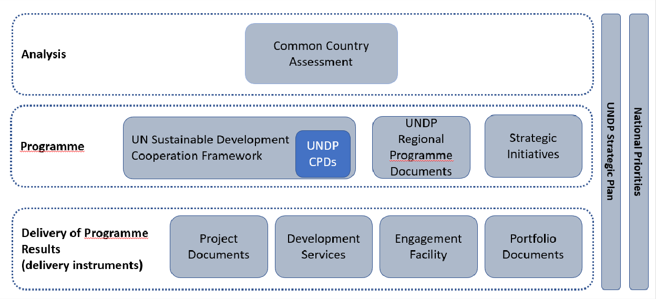

Portfolio Theory of Change
In designing the portfolio, the business unit must articulate a portfolio Theory of Change (ToC) hypothesis, describing how the portfolio(s) effort to affect change will be initiated, implemented, and adjusted by measuring the reaction of the wider system to the portfolio interventions, and what issues will need to be addressed to build momentum towards change. Portfolios at country level should also identify what the portfolios’ unique contribution is to the UNSDCF/CPD Outcomes, at regional level to Regional Programme outcomes, and at global level to, Strategic Plan outputs and outcomes. This analysis informs the design of the portfolio results framework.

Portfolio Results Framework
The portfolio results framework must describe, through a narrative, its contribution to the Country Programme Document (CPD), Regional Programme Document (RPD) or the Strategic Plan (SP) outcome and outputs. The narrative can illustrate the intermediate outcome at which the portfolio intends to operate.

The results framework articulates the portfolio objectives and its contribution to outcomes at country, regional and global level, which in turn facilitates corporate reporting as per the policy on Report. A results framework captures systems level change. It also captures gains made in terms of momentum and learning.

As the portfolio work evolves, it is possible that new and unexpected portfolio contributions emerge. As such, it is important to update the contributions the portfolio is making in meeting the UNSDCF/CPD objectives regularly.
Material changes (substantial change) to the portfolio outputs must be approved by the Portfolio Board. This includes the inclusion of new implementing partners and folding in of ongoing projects with their

respective implementing partners under the portfolio. More details on the role of the portfolio board are provided in the section below on portfolio governance and management.
Related indicators to monitor progress and evaluate performance rooted in strong evidence must be developed. A Portfolio Results Framework identifies the targets that the portfolio aspires to reach at the end of the portfolio. These are set at the beginning of the portfolio and revisited during Portfolio Board meetings based on portfolio learning and adaptation.

Funding a portfolio

The portfolio will identify all tangible and intangible resources [Portfolio Document Template Guidance] necessary for its long-term success. This resource envelope will include an overall indicative budget, inclusive of all work plans and portfolio costs over its entire lifecycle in line with Results Based Budgeting principles.
All anticipated programmatic, operational, and indirect costs to support the portfolio need to be identified, estimated and fully costed in the portfolio budget. This includes areas of work that directly support the portfolio, such as communication, human resources, monitoring, evaluation, learning, procurement, finance, audit, policy advice, quality assurance, reporting, programmatic and financial capacity assessments, management, etc. All services which are directly related to the portfolio need to be reflected in the portfolio document. A detailed list of components to be budgeted is available here.
Each work plan will be implemented and managed by the identified implementing partner which has signed the portfolio document and the relevant work plan. The work plan shall be fully costed as per UNDP policies, and resources for each work plan will be allocated in advance. At least 15 percent of the portfolio resources should be invested in gender-responsive results.

The portfolio document will outline a resource mobilization strategy for crowding in diverse sources of funding necessary for the long-term success of a portfolio. As per procedure, business units are required to include the resources that need to be mobilized for the portfolio as part of their resource mobilization strategy. Resources for a portfolio are mobilized from various sources. They may include funding from UNDP regular resources, government cost-sharing, donor contributions, multi-donor trust funds, vertical or trust fund financing, the private sector, and others.
Portfolios can be resourced from resources which are pooled to fund all the work plans under a portfolio or earmarked for one or more work plans under a portfolio. Accordingly, donor agreements will clarify if they are pooling funds for the entire portfolio or earmarking funds to specific work plans under the portfolio. Reporting on results follows the corporate reporting policy: Report. Expenditure and refund adhere to UNDP’s Financial Regulations and Rules.
Direct costs for portfolio management will either be allocated to interventions as stated in the workplan, or separate funding will be allocated to cover such costs.
Cost-recovery, including direct portfolio/project costs, inclusive of adequately estimated cost of UNDP staff time from the country, region or HQ level, and indirect costs must be clearly included in the budget in accordance with the Cost Recovery Policy.
A portfolio document is approved based on a financing plan; not all funding needs to be available at the start of the portfolio. If adequate resources are not available to fully fund the entire portfolio, the

multiyear work-plans must be clearly prioritized, indicating which outputs will be funded first with resources available at the time of signing the portfolio. Legal commitments cannot be entered into until the resources are available.
Changes to the resource envelope of a portfolio work plan will be managed by the Portfolio Shared Results
Committee (PSRC), see section 13.

Portfolio Appraisal and Approval
Portfolios implemented at country level require the approval of the portfolio document by the government development coordination authority. Approval must be granted following the appraisal process in the policy on Appraise and Approve. The provisions on appraisal and approval of projects in the policy on Appraise and Approve apply to portfolios.

Portfolios implemented at regional or global level require the approval of the Bureau Director of the relevant region.
The portfolio document is approved by the Local Portfolio Appraisal Committee (LPAC). UNDP and the Implementing Partners (see policy on Select Implementing Partner) will sign the portfolio document and the corresponding workplan. Signatures/approval of Implementing Partners is secured as per the policy on Appraise and Approve.

Portfolios must adhere to UNDP’s quality standards for programming.

IMPLEMENTING A PORTFOLIO

Implementing Partners in a Portfolio
For portfolios at country level, the UNDP Resident Representative will be accountable for portfolio results. For portfolios at regional level, the relevant UNDP Bureau Directors are accountable for portfolio results.

Implementing Partners are responsible for the results as detailed in the multiyear workplan.
Portfolios may be implemented by several Implementing Partners. Each workplan will be implemented by one Implementing Partner. The relationship between the Implemented Partners and UNDP is formalized through their signature/approval of the portfolio document (approval is secured as per the policy on appraise and approve), including the workplan that the IP is responsible for implementing. .

Each Implementing Partner will have overall ownership of and responsibility for the portfolio outputs under its respective workplan. Separate multiyear work-plans and budgets must be prepared for, and approved by, each Implementing Partner. All multiyear work-plans contribute to the system change in the portfolio results framework. The accountability of each implementing partner for the portfolio outputs must be clearly delineated in the portfolio document.
All Implementing Partners are required to comply with the legal provisions reflected in the portfolio document. The portfolio document, with the corresponding workplans, will constitute the equivalent of a “project document” for purposes of (i) the Financial Regulations and Rules and (ii) Article 1 of the

Standard Basic Assistance Agreement or similar agreement governing the assistance of UNDP in a country.
The portfolios may not feature a singular classification of either National Implementation (NIM) including Country Office Support (COS) to National Implementation; Direct Implementation (DIM), Civil Society Organization/Non-Governmental Organization Implementation; United Nations Agencies Implementation; and Non-UN Intergovernmental Organizations Implementation Modality because different work-plans may be implemented under different implementation modalities. The implementation modality applicable to each workplan will be clarified in the respective workplan.

Work-plans implemented by UNDP will follow the requirements applicable to the direct implementation modality (DIM). Under DIM, UNDP may engage Responsible Parties (as per the policy on Select Responsible Parties and Grantees) to take advantage of their specialized skills to provide goods and/or services, to carry out programme activities and deliver results.

Work-plans implemented by the government will follow the requirements applicable to the national implementation modality (NIM). Work plans where Implementing Partners request for UNDP support will follow the requirements applicable to the CO Support Services for effective and timely implementation.
The same requirements applicable to implementing partners and responsible parties for UNDP projects under National Implementation (NIM) including Country Office Support (COS) to National Implementation, Direct Implementation (DIM), Civil Society Organization/Non-Governmental Organization Implementation; United Nations Agencies Implementation; and Non-UN Intergovernmental Organizations Implementation Modality apply to portfolios.
- Risk management
The portfolio document will identify and manage portfolio level risks with associated mitigating measures in line with the ERM policy methodology and approach. These risks will be systematically reviewed by the Portfolio Board. The Portfolio Shared Results Committee will manage more immediate risk mitigation measures or adjustments. See para 13 on Governance and Management of Portfolios.

All risk assessment instruments, including but not limited to Partner Capacity Assessment (PCAT), Harmonized Approach to Cash Transfer (HACT), Social and Environmental Standards, and Quality Assurance, will apply to portfolios. Engagement with private sector on portfolios will be in line with the policy on Private Sector Partnerships and Policy on Due Diligence and Partnerships with the Private Sector.
- Internal control

The portfolio management team will be comprised of a portfolio manager and portfolio team members that will be responsible for the implementation and operational success of the portfolio. While the portfolio may appoint or source personnel from the Country Office, Bureau, or Headquarters Unit (depending on whether the portfolios are implemented at the country, regional or global level), or recruit as per funds availability, personnel who are part of the portfolio management team must be separate from the team performing portfolio quality assurance, in line with UNDP’s Internal Control Framework.

Portfolio Governance and Management
The portfolio governance and management structure is comprised of a Portfolio Board, a Portfolio Shared Results Committee, Portfolio Assurance and a Portfolio Management Team.

Appropriate management arrangements and oversight mechanisms need to be established to ensure UNDP’s accountability for activities, results and the use of resources, while at the same time fostering national ownership and alignment to national processes. Management and governance arrangements that articulate portfolio roles, responsibilities, and accountabilities and that ensure appropriate functional separations and reporting lines between oversight roles and implementation/execution roles in line with UNDP’s Internal Control Framework must be in place. Refer to the policies on Implementing Partners, Responsible Parties, and Oversight.

The respective roles and responsibilities are as follows:
Portfolio Board
Development Partner(s)
Executive
Beneficiary
Representative(s)
Portfolio Assurance
(Programme Team)
Portfolio Shared Results Committee (PSRC)
Portfolio Management Team
Overseeing the Common Results Framework and the Common Risk Framework
1st Implementing Partner
(Managing Work Plan 1)
2nd Implementing Partner
(Managing Work Plan 2)
3rd Implementing Partner
(Managing Work Plan 3)
Responsible Party A Responsible Party B
(if applicable) (if applicable)
Responsible Party C Responsible Party D
(if applicable) (if applicable)
Responsible Party E
(if applicable)
Responsible Party F
(if applicable)
Portfolio Manager
Oversight

Governance Diagram: This is another option of a governance visual for business units to consider
Management
when developing portfolios.

While there is a clear hierarchy between the Portfolio Board and the Portfolio Shared Results Committee as per their respective mandates, the visual conveys a way of working that is premised on a continuous dialogue, in line with the dynamic management of a portfolio.

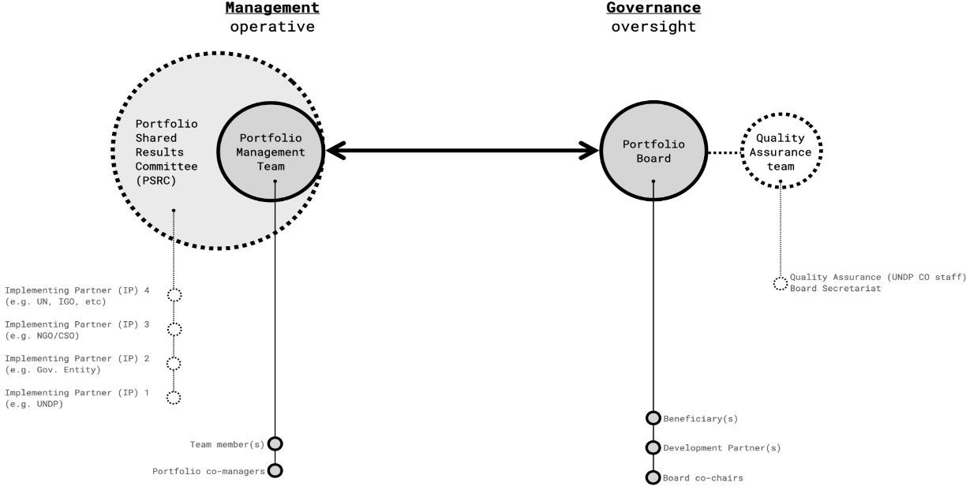

Portfolio Board: Each portfolio will have only one Portfolio Board. The Portfolio Board will provide high- level oversight of the portfolio, risk management and portfolio assurance. It approves the inclusion of new implementing partners at the time of portfolio approval as well as during the implementation.
The Portfolio Board may fold in ongoing projects with their respective implementing partners under the portfolio; provided that: the projects are aligned and integrated into the portfolio theory of change; they share a common portfolio results framework, they are integrated into an updated multiyear work plan approved by the respective implementing partner(s); and they secure agreements from the implementing partners on being member of the existing Portfolio Board and the Portfolio Shared Results Committee.

The Portfolio Board approves each multiyear work plan and their corresponding milestones. Portfolio milestones are approved yearly by the Portfolio Board, for each subsequent 12-month period of work.

The Portfolio Board assesses any major risks to the portfolio and related decisions/agreements on any management actions and adjustments. Also, the Portfolio Board assesses the results achieved at the portfolio level and contribution to country programme outcomes and the portfolio objective.
The Portfolio Board also reviews how integration and intersectionality are pursued in achieving greater impact to the portfolio's objectives and the country programme outcomes.
In addition, the Portfolio Board identifies new partnerships for the portfolio based on the identified new policy spaces resulting from the portfolio implementation and to ensure sustainability and identifies new resource mobilization opportunities.

The Portfolio Board makes decision on suspension of and extension of the portfolio (not the individual work plans under the portfolio delegated to the Implementing Partners) subject to partner commitment and funding.

The Portfolio Board is required to meet at least once a year.

A Portfolio Board membership is comprised of:
- Executive(s): Individual(s) who represent(s) ownership of the portfolio and chair(s) the Board.
- Beneficiary Representative(s): Individual(s) representing the interests of those groups of stakeholders who will ultimately benefit from the portfolio.
- Development Partner(s): Individuals representing the interests of the parties concerned that provide funding, strategic guidance and/or technical expertise to the portfolio. This is typically the UNDP Resident Representative or Deputy Resident Representative. There can be multiple development partners’ representatives on Portfolio Board.
The Portfolio Shared Results Committee (PSRC) is formed by representatives of all implementing partners, led by the UNDP Resident Representative or Deputy Resident Representative. As a team, the PSRC works collaboratively to review the implementing partners’ work plans. In doing so, it actively contributes to collective portfolio learnings and shared results and facilitates the dynamic improvement of the portfolio and its associated work plans.

The PSRC is convened at least four (4) times a year. The PSRC is responsible for taking corrective actions, including approving adjustments above provided tolerance levels, including substantive revisions (major/minor amendments) to the work plans, reallocating resources from one work plan to another, associated budget revisions, requests for suspension or extension of work plans and other changes to the work plans, subject to additional funding and in line with donor agreements.

The Portfolio Assurance, delegated to UNDP, supports the Portfolio Board by carrying out objective and independent oversight and monitoring functions, as well as providing administrative support. This role ensures appropriate portfolio management milestones are managed and completed includinhe application of the Gender Marker to all work plans under the portfolio in line with the Gender Equality Strategy. Typically held by a UNDP Officer(s), Portfolio Assurance is independent of the Portfolio Manager as per the UNDP’s Internal Control Framework.

The Portfolio Management Team manages the day-to-day planning, coordination and administration of the portfolio and its resources. The Portfolio management team supports the implementing partners in the establishment of the annual milestones as part of the annual planning exercise. It reports to the Portfolio Board and supports board members in effectively fulfilling their roles. A Portfolio Management team will be comprised of:
- The Portfolio Manager(s) who is responsible for the overall portfolio management and presents key results to the Portfolio Board. The Portfolio Manager is responsible for organizing a PSRC. Upon approval of the Portfolio Document, the CO will assign responsibility to manage the portfolio until the appointment/recruitment of a Portfolio Manager by UNDP. The Portfolio Manager also updates the

portfolio risk register, ensuring necessary risks identified in different work plans are tracked and that associate treatment measures are in place.
- Portfolio Team Members are active collaborators in ensuring the operational success of the portfolio. Members may be appointed/sourced by the CO staff or be recruited, subject to availability of resources. It is generally highly recommended that portfolios leverage cross-CO capacity and don’t become extensions of a single existing project. Personnel/staff who are part of the Portfolio Management Team should be separated from the team responsible for quality assurance of the portfolio, in line with the UNDP Internal Control Framework.
- Governance in Crises Contexts: In case of Level 2 and Level 3 Crises, the functions of the Portfolio Board and the Portfolio Shared Results Committee can be performed by the Crises Board for timely decision making and necessary adjustments to address the immediate needs posed by the context.

Portfolio Partnerships & Stakeholders
Portfolio stakeholders are people, groups or individuals who have either influence or interest in the outcome of the portfolio.

A portfolio is underpinned by a robust, growing, and active social network of change. Its design process will entail building dialogue with potential partners and donors on the portfolio. These may include formal, institutional stakeholders in the system the portfolio seeks to transform. Stakeholder mapping may be used to identify both the traditional as well as non-traditional actors relevant to the portfolio.
Portfolios operate with a clear strategy that helps identify partnerships (both financial and non-financial) for the overall success of the portfolio.

The portfolio will clearly identify target groups and other potentially affected groups with strategies for how they will be engaged as active partners throughout the portfolio life cycle. Target groups’ perceptions of development challenges and needed solutions must be incorporated into the portfolio engagement strategy. This is to ensure that potentially affected people are aware of and have access to mechanisms to submit concerns about the social and environmental impacts of a portfolio (ref. UNDP’s Social and Environmental Compliance Review and Stakeholder Response Mechanism).

Transitioning ongoing Projects to Portfolios
Development of a portfolio from ongoing projects will require the development of a portfolio results framework anchored in an updated theory of change, to ensure that work plans of the ongoing projects contribute to a common intermediate portfolio outcome, the establishment of a Portfolio Board and a Portfolio Shared Results Committee, as well as a separate multiyear work plan for each implementing partner. Once a portfolio is established, individual project outputs will be closed as needed.

Resources can be mobilized for the portfolio, and allocated to any work plan in the portfolio, depending
on the need. Any reallocation across work plans must be done through a formal budget revision.

Closing a Portfolio
Work-plans implemented under a portfolio document by various implementing partners may have different start and end dates. Therefore, a multiyear work plan can be closed individually under a portfolio document.
Multiyear work plans should be closed in a timely manner to manage fiduciary risk, meet donor expectations, avoid costly extensions, and enable the timely transfer of assets for the sustainability of results. Closing a multiyear work plan under a portfolio is considered complete when one of the following closure conditions are triggered:
  - By approaching the agreed end date of the work plan, unless partners agree to extend the
duration and adequate budget is available.
  - When a work plan delivers its planned outputs as verified by the Portfolio Shared Results Committee.
  - The Portfolio Board recommends closing or canceling the multiyear work plan. Closing of work- plans must adhere to the policy on Close and Transition.
Transfer or Disposal of Assets
Assets may be transferred to the implementing partners, or other UNDP-financed projects, or may be disposed of by sale or donation. The portfolio document shall contain a designated section about assets financed by the portfolio and how they should be dealt with. If this has not been specified in the portfolio document, the UNDP programme manager/Resident Representative shall obtain the agreement of the government and if relevant, the donor with respect to the transfer and/or disposal of assets.
See Disposal and Write-Off (Furniture and Equipment) and policy on Close and Transition for more information.

IMPACT OF A PORTFOLIO

Portfolio Monitoring, Evaluation, and Learning
A portfolio’s monitoring, evaluation, and learning (MEL) processes are guided by the following MEL processes:
  - Foster continuing learning and adaptation.
  - Set the ground for reporting and accountability by ensuring that monitoring evidence informs
periodic validation of portfolio shifts and their relevance to achieving the development outcomes.
  - Capture UNDP contribution to system change and the UNSCDF/CPD, RPD or SP Outcomes
  - Track performance of the portfolio in terms of system learning, system momentum and system change.
  - Ensure compliance with prevailing Monitoring, Evaluation and Learning policies with adequate human and financial resources.
  - Ensure that all portfolio-related SESP documents are updated to reflect any changes to the overall
design.
UNDP polices on monitoring and evaluation apply to portfolios.

- Portfolio Reporting
Reporting on portfolio results and financial expenditure will have to adhere to the corporate results reporting policy.

Portfolio Evaluation
The evaluation plan for a portfolio is required as part of the MEL plan at the time of approval. Resources must be allocated for portfolio evaluation in the portfolio budget.

Monitoring & Compliance

Compliance with the policy will be tracked by the Office of Audit and Investigations through regular audits to assess the effectiveness of risk management, the adequacy and effectiveness of controls and the governance processes to provide assurance and support necessary improvements.

