# Guidance on DPC Exception Report

The DPC Exception Report is used to identify transactions where DPC accounts are used and do not net to zero in any single transaction.

For example, if you have used 64397 in a debit entry, the same amount should also be used in a credit entry with the same account 64397 in this transaction. The same should apply for account 74596.

## **Processing DPC Exception Report**

This report can be found under Payables >Invoices.

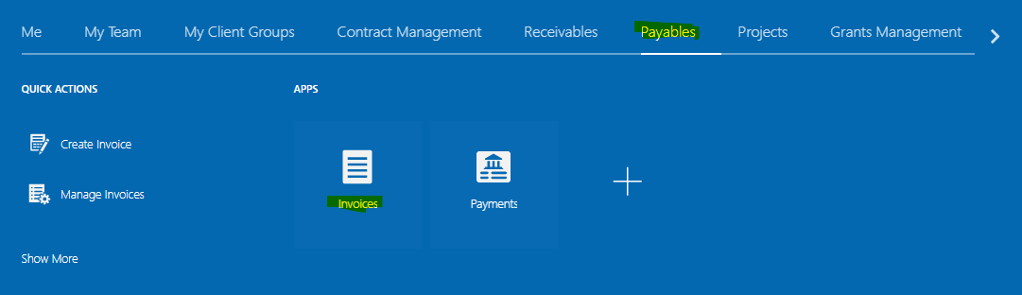

Once you have entered the Invoices Dashboard, go to the right of the screen and click on the ‘Reports and Analytics’ icon. You will see the UN DPC Account Exception Report there.

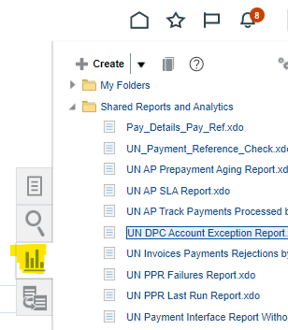

Click on the UN DPC Account Exception Report and a pop-up box will appear.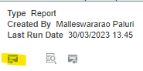

Click on the View icon. Another window will be launched to input your report criteria.

## DPC Exception Report Criteria and Results

This report is run by only 2 criteria.

* Agency: UNDP
* Year: current year

Click on Apply.

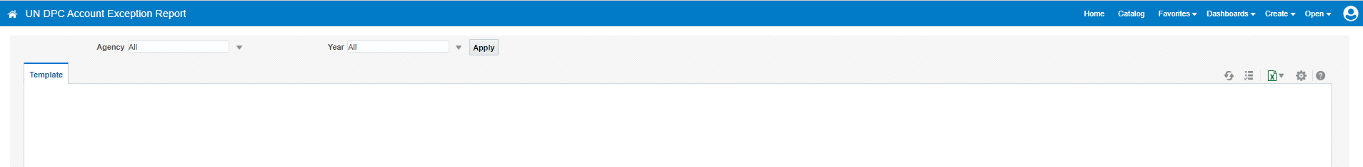

Once the report has been extracted, it will create an excel file for you automatically and save it in your default Downloaded folder.

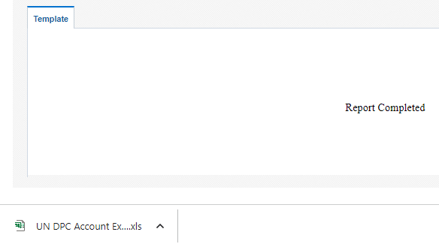

## Sample Excel Report Results



## **Creating a Pivot table for analysis:**

Click on the left corner arrow on the excel table as shown below to select the excel report.



Click on the insert and then click on the pivot table.



A small screen will pop-up; click OK.

The new page will appear as shown below.



On the right of the screen (PivotTable Fields), please choose the required fields as shown below.



## Sample Pivot table Results



From a sample above, Invoice Number “*AN_Invoice 1 from 19.01.2023*” did not use same DPC account code on both debit and credit side. They debited $13 to DPC Staff account 64397 but credited $-13 to DPC GOE Account 74596. This is incorrect.

* The correct entries should use the same DPC account code on both sides that will result to zero amount for each DPC account code. For example, Dr. Account 64397 $13 to development project and Cr. Account 64397 $-13 to DPC Pre-financing project (or relevant project). To make a correction of the DPC Account exception, the wrong account code should be corrected from its transaction source. For example, if it is an account error/typo from an Invoice, please correct it from the original Invoice. However, if it is an error from several transactions and/or from several transaction sources, the Zero-Dollar Invoice can be used.