General Management Support (GMS) Fee Set Up and Collection

- Refer POPP Cost Recovery from Other Resources - General Management Support (GMS).

- This section describes the cost recovery rate (GMS fee) collection and set up in the Quantum Project Management module.

- Effective collection of cost recovery income is a major component of overall compliance with UNDP’s cost recovery policy. Furthermore, it ensures that the right capacities to manage the non-core resources are sustainably funded. The process starts with the proper negotiation of each donor agreement to reflect the correct cost recovery rate (see POPP Cost Recovery from Other Resources - General Management Support (GMS) and continues with the appropriate project set up and the GMS fee to enable UNDP to collect the cost recovery income accurately, transparently, in a timely manner, and in full adherence to the terms stipulated in the donor agreement.

- Compliance with the cost recovery policy requires offices to set up the project budget in Quantum, including a separate budget line for the GMS component, and reflect the GMS rate and the method of the GMS income collection as ‘earn as you go’. The ‘earn-as-you-go' method charges the GMS fee on a transactional basis as expenses are incurred, and automatically credits the office Extra-budgetary accounts, based on the GMS methodology and the department distributions that therefore apply.

- Any exceptions to ‘earn as you go’ must be supported by a sound business case and be approved by the Chief Finance Officer. Requests for exceptions will only be considered for transition purposes and will be for a limited time frame.

- The office shall monitor the GMS fee project set-up on a regular basis to ensure that the information is complete and accurate; to ensure income is being collected; and to guarantee it is recorded as Extra-budgetary income..

- The cost recovery income collection method shall remain the same throughout the duration of the project

Budgeting for the GMS fee in Quantum

- The full amount of the contribution shall be programmed as part of the project budget, including a separate budget line for the GMS fee component.

- The cost recovery rate is charged on the programmable budget. For example, on a $1.0 million contribution, with an 8% GMS fee, the programmable budget is $0.926 million and the GMS budget is $0.074 million. Use the GMS rate calculator to determine amounts for project programmable budget and GMS budget. [Note: GEF and MP project budgets do not include the GMS budget, it only includes the programmable budget. The GMS budget is maintained by GEF and MP units at HQ.]

- The budgeting of the GMS fee component in the project budget ensures that internal Quantum system processes can be run on a regular basis and ‘earn-as-you go’ on actual expenses, extra-budgetary income earned is collected in a timely manner. Failure to reflect the GMS fee at project budget set up and the GMS fee component in the project budget shall only delay this process.

- In the project budget the GMS fee shall always be reflected with the budget account 75100. A separate GMS budget line per each activity, fund and donor COA combination shall be set up.

- GMS expense account code in Quantum for ‘earn as you go’ is 75105 This account is automatically used by the Quantum burden schedule batch process.

Setting up the GMS fee in Quantum

- The GMS fee is entered in the Quantum Grants Module. The navigation in Quantum is Grants Management/ Edit Award Details/Financial Tab.
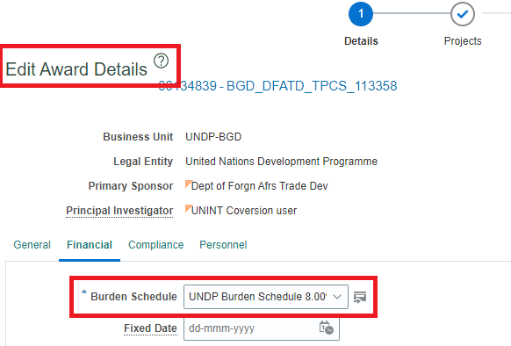

- The GMS fee shall be entered only for GMS collection method, ‘earn as you go’.

- The GMS fee is entered at the award-fund-donor level. Each award is linked to a specific project.

- The GMS fee calculation is integrated into Quantum for maximum automation and minimal data entry. Country offices should create a UNALL case with GSSC after award creation to activate their contract and also indicate Distribution Modality type to complete setup of GMS. Upon selection of GMS distribution modality by GSSC,department percentages are automatically populated for income distribution.

- Except for Vertical Funds ( Global Fund, GEF, Green Climate Fund (GCF) and Montreal Protocol (MP)), GMS income will no longer be distributed across internal units of UNDP starting from 2017. GMS from Vertical Funds will continue to be distributed internally based on the pre-2017 management decision.

- GMS fee rates for GEF, Green Climate Fund (GCF) and Montreal Protocol (MP) are entered in the same Award page but do not follow the same delivered Burden Schedule process in Quantum. The offices can obtain the GMS rates and distributions of GEF and MP projects using the same Quantum query for UNDP offices. .

- The accountability for ensuring that the GMS rate is correctly entered in timely manner in Quantum Award under Grants Management Module to ensure collection of GMS income rests with the project managing office.

- A project shall charge the same cost recovery rate for all donors, however, there are instances where the rates are different and within the cost recovery policy, such as when a project has a combination of programme country (government) cost sharing (GMS fee is a minimum of 3%) and third party costing sharing contributions (GMS fee is a minimum of 8%).

- For UNDSS (Fund Code 68100) and UNDOCO Common Coordination Fund (Fund Code 680xx), the administrative support fee covers both implementation support and GMS fee and is managed separately by HQ units in BMS and DOCO.

If you experience problems trying to open the GMS rate calculator, please follow this guide

